Why then do we continue in this miserable condition? Because nearly the whole of the produce of our labour is stolen from us by human beings. There, comrades, is the answer to all our problems. It is summed up in a single word- Man. Man I the only real enemy we have… This is my message to you, comrades: Rebellion!
- Old Major

Let the ruling classes tremble at a communist revolution. The proletarians have nothing to lose but their chains. They have a world to win. Workingmen of all countries, unite!
-Karl Marx, The Communist Manifesto

“Soon or late the day is coming,
Tyrant Man shall be o’erthrown,
And the fruitful fields of England
Shall be trod by beasts alone.”

All the power to the people of labour!
And away with all the parasites!
This is our final
and decisive battle;
With the Internationale
humanity will rise up!
-Written during the Paris Commune of 1871

And so, almost before they knew what was happening, the Rebellion had been successfully carried through: Jones was expelled, and the Manor Farm was theirs.

The cruel enemy is making his last efforts and the moment is near when our valiant Army, in concert with our glorious Allies, will finally overthrow the enemy.
In these decisive days in the life of Russia we have thought that we owed to our people the close union and organisation of all its forces for the realisation of a rapid victory; for which reason, in agreement with the Imperial Duma, we have recognized that it is for the good of the country that we should abdicate the Crown of the Russian State and lay down the Supreme Power.
-Vladimir Lenin

Pre-eminent among the pigs were two young boars named Snowball and Napoleon… Napoleon was a large, rather fierce-looking Berkshire boar, the only Berkshire on the farm, not much of a talker, but with a reputation for getting his own way. Snowball was a more vivacious pig than Napoleon, quicker in speech and more inventive, but was not considered to have the same depth of character. [Chapter II]

Each had his own following, and there were some violent debates. At the Meetings Snowball often won over the majority by this brilliant speeches, but Napoleon was better at canvassing support for himself in between times. [Chapter V]

I think that from this standpoint, the prime factors in the question of stability are such members of the C.C. [Central Committee] as Stalin and Trotsky. I think relations between them make up the greater part of the danger of a split, which could be avoided, and this purpose, in my opinion, would be served, among other things, by increasing the number of C.C. members to 50 or 100.
Comrade Stalin, having become Secretary-General, has unlimited authority concentrated in his hands, and I am not sure whether he will always be capable of using that authority with sufficient caution. Comrade Trotsky*, on the other hand, as his struggles against the C.C. on the question of the People.s Commissariat for Communications has already proved, is distinguished not only by outstanding ability. He is personally perhaps the most capable man in the present C.C., but he has displayed excessive self-assurance and shown excessive preoccupation with the purely administrative side of the work.
These two qualities of the two outstanding leaders of the present C.C. can inadvertently lead to a split, and if our Party does not take steps to avert this, the split may come unexpectedly.
Lenin, 24 December 1922
Stalin is too rude and this defect, although quite tolerable in our midst and in dealing among us Communists, becomes intolerable in a Secretary-General. That is why I suggest the comrades think about a way of removing Staling from that post and appointing another man in his stead who in all other respects differs from Comrade Stalin in having only one advantage, namely, that of being more tolerant, more loyal, more polite, and more considerate to the comrades, less capricious, etc. This circumstance may appear to be a negligible detail. But I think that from the standpoint of safeguards against a split, and from the standpoint of what I wrote above about the relationship between Stalin and Trotsky, it is not a detail, or it is a detail which can assume decisive importance.

All the other male pigs on the farm were porkers. The best known among them was a small fat pig named Squealer, with very round cheeks, twinkling eyes, nimble movements, and a shrill voice. He was a brilliant talker, and when he was arguing some difficult point he had a way of skipping from side to side and whisking his tail which somehow was very persuasive. The others said of Squealer that he could turn black into white.

Pravda- Former daily newspaper published in Moscow and distributed nationwide, the official organ of the Communist Party of the Soviet Union (191891). It was founded in St. Petersburg as an underground paper by Vladimir Ilich Lenin and two colleagues in 1912. As a Soviet state newspaper and central source of information and education, it offered well-written articles and analyses on science, economics, cultural topics, and literature as well as materials to indoctrinate and inform readers on communist theory and programs.

The work of teaching and organizing the others fell naturally upon the pigs, who were generally recognized as being the cleverest of the animals… Their most faithful disciples were the the cart-horses, Boxer and Clover. These two had great difficulty in thinking anything out for themselves, but having once accepted the pigs as their teachers, they absorbed everything that they were told, and passed it on to the other animals by simple arguments.
The pigs did not actually work, but directed and supervised the others. With their superior knowledge, it was natural that they should assume the leadership.

I assert:
- that no movement can be durable without a stable organisation of leaders to maintain continuity;
- that the more widely the masses are spontaneously drawn into the struggle and form the basis of the movement and participate in it, the more necessary is it to have such an organisation, and the more stable must it be (for it is much easier for demogogues to sidetrack the more backward sections of the masses);
- that the organisation must consist chiefly of persons engaged in revolutionary activities as a profession;
- that in a country with an autocratic government, the more we restrict the membership of this organisation to persons who are engaged in revolutionary activities as a profession and who have been professionally trained in the art of combating the political police, the more difficult will it be to catch the organisation, and
- the wider will be the circle of men and women of the working class or of other classes of society able to join the movement and perform active work in it....
-Vladimir Lenin

The three [pigs] had elaborated old Major’s teachings into a complete system of thought, to which they gave the name of Animalism.

Bolshevism:
- The strategy developed by the Bolsheviks between 1903 and 1917 with a view to seizing state power and establishing a dictatorship of the proletariat.
- Soviet Communism.

It happened that Jessie and Bluebell had both whelped soon after the hay harvest, giving birth between them to nine sturdy puppies. As soon as they were weaned, Napoleon took them away from their mothers, saying that he would make himself responsible for their education. (p. 35)

Cheka: an organization under the Soviet regime for the investigation of counterrevolutionary activities. It executed many real and alleged enemies of Lenin's regime from its formation in 1917 until 1922 when it was replaced by the OGPU.

Snowball, who had studied an old book of Julius Caesar’s campaigns which he had found in the farmhouse, was in charge of the defensive operations. As the human beings approached the farm buildings, Snowball launched his first attack. (p. 40)

The Military Writings of Leon Trotsky

THE ORGANIZATION OF THE RED ARMY

Speech at the First All-Russia Congress of Military Commissars,
June 7, 1918
Comrades, we are present at a congress of exceptional importance. The parties represented in this assembly have behind them a great revolutionary past. Nevertheless, at this time we are learning, and we must succeed in learning, how to build our own revolutionary socialist army, which shall be the complete contrary of those regiments, now demobilised, which were held together by the will of the masters, who introduced compulsory discipline into them. Before us lies the task of creating an army organised on the principle of comradely trust and revolutionary labour-order. This is, without any doubt, an extraordinarily great, complex and difficult task. Incidentally, the bourgeois press writes a lot about our having only now, at last, understood that to defend the country an armed force is needed. That is nonsense, of course: we knew, even before the October Revolution, that so long as the class struggle continues between the exploiters and the working people, any revolutionary state must be strong enough to repulse successfully the imperialist onslaught. The Russian Revolution, unprecedented in strength, could not, of course, retain the old Tsarist army, within which had been formed, like a stout strong point, a heavy class discipline that established a bond of compulsion between soldier and commander.

Rumors of a wonderful farm, where the human beings had been turned out and the animals managed their own affairs, continued to circulate in vague and distorted forms, and throughout that year a wave of rebelliousness ran through the countryside. (p. 39)

domino theory- the theory that a political event in one country will cause similar events in neighboring countries, like a falling domino causing an entire row of upended dominoes to fall.

Napoleon, with the dogs following him, now mounted on to the raised portion of the floor where Major had previously stood to deliver his speech. He announced that from now on the Sunday-morning meetings would come to an end… In future all questions relating to the working of the farm would be settled by a special committee of pigs, presided over by himself. (p. 54)

But in a socialist society there can be, it would seem, no terror of the exploiters. From whom is it necessary to defend the Soviet citizens? The answer is clear: from the bureaucracy. Stalin was frank enough to recognize this. To the question: Why are secret elections necessary? he answered verbatim: “Because we intend to give the Soviet people full freedom to vote for those whom they want to elect.” Thus humanity learns from an authoritative source that today the “Soviet people” cannot yet vote for those whom they want to elect. It would be hasty to conclude from this that the new constitution will really tender them this opportunity in the future. Just now, however, we are occupied with another side of this problem. Who, exactly, is this “we” who can give or not give the people a free ballot? It is that same bureaucracy in whose name Stalin speaks and acts. This exposure of his applies to the ruling party exactly as it does to the state, for Stalin himself occupies the post of General Secretary of the Party with the help of a system which does not permit the members to elect those whom they want.
-Trotsky, The Revolution Betrayed 1936
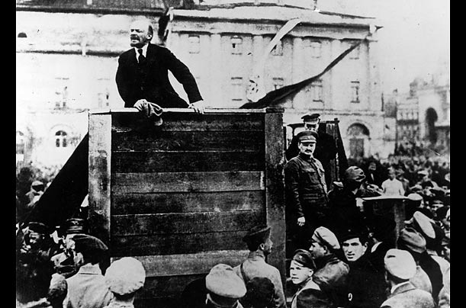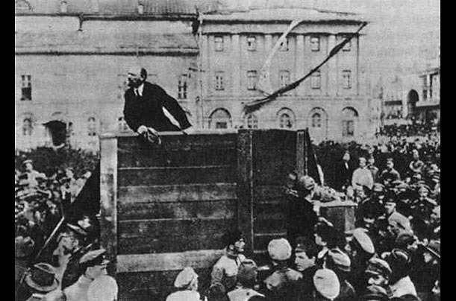
This is a famous picture of Lenin addressing his Red Army as they prepare to go to the Polish front during the Russian Revolution. What we, as well as the Russians who saw these inspiring pictures, is that fellow Central Committee members were also present. Leon Trotsky stands on the right of the podium and Lev Kamenev who is behind him. Though they were part of this turning point in history, they were removed because Stalin saw them as threats to his power. They were purged and their contributions slowly removed from the historical records.

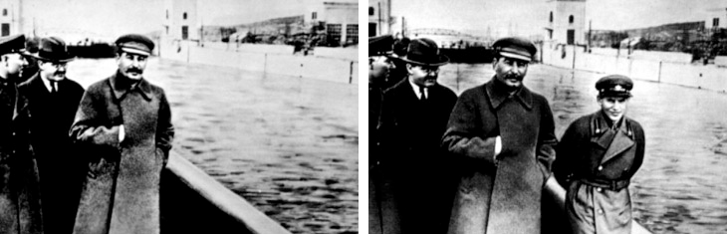
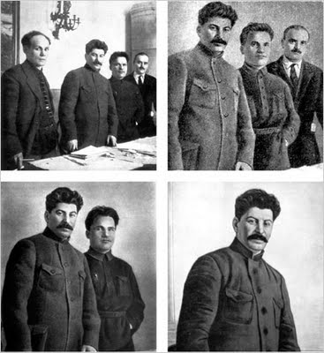

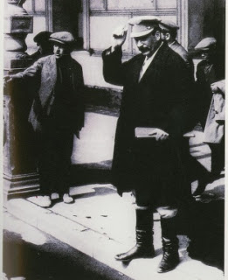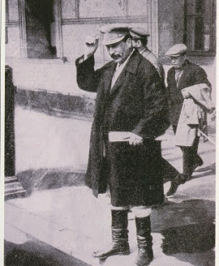

There was also something called "Personal Responsibility", which meant that not only could Soviet citizens not be caught mentioning the names of people who had suddenly "disappeared", but they could not keep books or publications of any kind with photos of "enemies" of Stalin's regime. Citizens had to black out offending photos and names themselves on any piece of property they had. Below a dutiful citizen has violently removed Trotsky's face. Stalin tried to have the revolutionary's name and image removed from history.

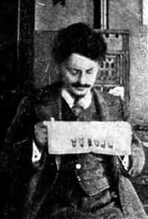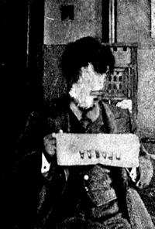

Below is one of the saddest images from the book. A propaganda photo of Stalin with a six year old girl, who is cheerfully presenting the dictator with a bouquet of flowers. The photo became an icon. Stalin later had the girl's father and mother murdered. In the original photo there was also a smiling man present at the ceremony in the background. He was airbrushed out after Stalin had him murdered.

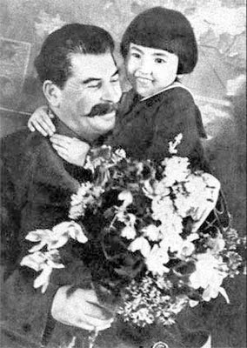

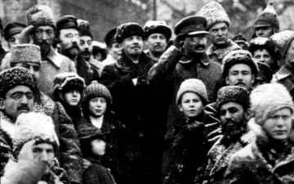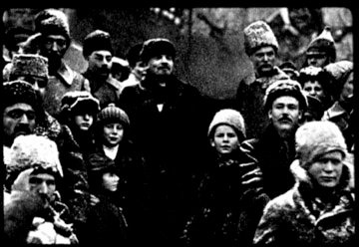

1861-1864 Peasant emancipation, Disappointment with emancipation leads to peasant violence and unrest

1868 Tsar Nicholas II born

1870 Vladimir Ilyich Lenin is born

1879 Leon Davidovich Trotsky is born

1894 Tsar Alexander III dies, Nicholas II assumes the throne

1917 Feb After several days of demonstrations in Petrograd (formally St Petersburg) the government orders troops to open fire. The next day these troops mutiny. The Tsar abdicates when he hears that Moscow too has joined the Revolution. An agreement is reached between the Petrograd Soviet and the Provisional Government headed by Lvov.
1917 May Milyukov resigns. Members of the Mensheviks and the Socialist Revolutionaries join the government.
1917 Sept The Bolsheviks win control of the Petrograd Soviet.
In the countryside peasant seizure of land from the gentry continues and reaches the level of near insurrection in Tambov.
1917 Oct The Bolsheviks overthrow the Provisional government on the eve of the meeting of 2nd All-Russia Congress of Soviets.
1917 26/27 Oct Soviet proclamations on land and peace. Death Penalty abolished.
1917 30 Oct Kerensky repulsed outside Petrograd
1917 2 Nov Bolsheviks gain Moscow
1917 Nov 12-14 Elections to the Constituent Assembly. Socialist Revolutionaries the largest party.
1917 12 Dec Left-SRs join Sovnarkom
1917 Dec (early) Congress of Socialist Revolutionaries results in victory for the left under Chernov. Likewise Menshevik Congress gives victory to Martov's Menshevik internationalists.
1918 Jan 5th The Constituent Assembly in which the Bolsheviks are a minority meets for one day before being suppressed. Earlier that day a demonstration is fired on by Bolshevik units and several demonstrators are killed
1918 10-18 Jan 3rd Soviet Congress
1918 Jan 28th Trotsky denounces the German Peace Terms as unacceptable and walks out of the peace negotiations at Brest- Litovsk.
1918 Feb 1/14 Russia adopts Western (Gregorian) calendar.
1918 Feb 18th The Germans invade Russia which is all but defenceless as virtually the entire army has deserted.
1918 March The Bolsheviks accept the dictated peace of Brest-Litovsk.
1918 May (late) The Czechoslovak legion mutinies against the Bolshevik government. Using the railways they are able to sweep away Bolshevik control from vast areas of Russia. The Socialist Revolutionaries support the rising.
1918 July Fifth Soviet Congress. The left SRs assassinate the German ambassador and are in turn crushed by the Bolsheviks.
1919 White Armies attack the Bolsheviks from all directions but the Red Army is finally victorious.
1920 14 Nov. Last White army under Wrangel evacuates the Crimea
1921 Peasant unrest sweeps Russia. These risings are suppressed but the New Economic Policy is proclaimed that gives the peasants the right to sell their grain surpluses
1921 1-17 Mar The old Bolshevik stronghold of Kronstadt rises demanding free election to the Soviets but is suppressed.
1924 Lenin dies. Trotsky is defeated by a triumvirate of Stalin, Kamenev and Zinoviev. Though Stalin stays in the background it is he who is the real power as the other two will shortly discover.
January 1924: The Communist Party denounces Trotsky and his ideology
February 1924: Petrograd is renamed Leningrad
August 1924: More than 10,000 people are killed in an uprising in Georgia
Month? 1924: The Soviet Union adopts a constitution based on the dictatorship of the proletariat
1925: Volgograd is renamed Stalingrad
January 1925: Trotsky is forced to resign as head of the Red Army
April 1925: Nikolai Bukharin introduces the thesis of "Socialism in One Country" that is adopted by Stalin against Trotsky's "Permanent Revolution"
November 1927: Trotsky and Zinoviev are expelled from the Communist Party
January 1928: Trotsky is exiled to Alma Aty
January 1928: Stalin launches a new persecution of kulaks (the second "peasant war") that causes more than one thousand riots in two years
December 1928: The Solovetski concentration camp has 38,000 prisoners while new camps have been established in the region
February 1929: Trotsky is deported to Turkey
April 1929: The Soviet Union launches the first Five-Year Plan for rapid industrialization of the Soviet Union
June 1929: All prisoners condemned to more than three years of prison are sent to work camps
April 1929: The Soviet Union announces a plan of "mass collectivization" October 1929: The Pravda calls for "total collectivization", signaling the definitive end of the NEP
November 1929: Stalin calls for full collectivization and orders the persecution of "kulaks" (rich farmers), a campaign that will cause the deportation of 15 million peasants to the Arctic regions and the death of 6.5 million peasants
December 1929: 1,778,000 people are convicted of crimes in 1929
January 1930: The government launches a campaign against entrepreneurs
February 1930: Peasants stage more than 1,000 peasant revolts against collectivization and more than 20,000 people are arrested in the Ukraine alone
March 1930: Peasants stage more than 6,500 peasant revolts against collectivization with thousands of people killed
April 1930: The GPU establishes the "GULAG" (Chief Administration of Corrective Labor Camps and Colonies) to handle prisoners in labor camps July 1930: The Gulag manages 140,000 prisoners
1930: More than 20,000 people are sentenced to death in the Soviet Union
1930: 1.8 million peasants are deported in 1930-31, about 300,000 die and more than 100,000 are used in labor camps to contribute to the economy (railways, canals, mines, construction...)
1932: One million people in Kazakhstan die of famine (caused by forced collectivization), and two million emigrated (1.5 million to China and 500,000 to Central Asia)
January 1933: Mass starvation in Ukraine ("Holodomor") caused by Stalin's forced collectivization kills five million people in 1933
January 1933: Stalin orders that people be forbidden to leave the areas affected by the famine
June 1933: At least 203,000 people are held in labor camps in Siberia
June 1933: Mass deportation of Gypsies from Moskow to Siberian work colonies
July 1933: City dwellers are rounded up and deported to the countryside to help with the harvest
December 1934: Stalin's collaborator Sergey Kirov is assassinated and blame is placed on Trotsky, prompting Stalin to begin the "Great Terror" to annihilate the Communist Party's left and right wings, led respectively by Leon Trotsky and Nikolai Bukharin
December 1934: More than 500,000 people are held in the Gulag
April 1935: The NKVD rounds up street kids and deports them to work colonies (more than 150,000 between 1935 and 1939)
December 1935: The Gulag has 800,000 prisoners in camps and 300,000 in colonies
August 1936: Accused of a conspiracy led by Leon Trotsky against the Soviet government, Lev Kamenev and Grigory Zinoviev are executed ("Trial of the Sixteen")
January 1937: Trotsky moves to Mexico
March 1937: Stalin launches a campaign against "deviationism" that leads to the arrest of thousands of intellectuals (including scientists such as Andrei Tupolev and Sergei Korolev and writers such as Isaac Babel and Osip Mandelstam)
May 1937: Stalin begins the purge of the Red Army (in 18 months 3 out of 5 marshals, 13 out of 15 army generals, 8 out of 9 admirals and a total of 35,000 officers are liquidated)
July 1937: Trotskyist agent Rudolf Klement is liquidated in France
August 1937: Stalin orders the liquidation of several ethnic groups (Germans, Poles, Japanese, Finns, etc)
September 1937: Trotskyist agent Ignaz Reiss is liquidated in Switzerland
November 1937: Stalin orders a great purge of the Polish communist party
December 1937: 285,000 Greeks living in Russian cities are deported to Siberia and to the north
March 1938: Bukharin and Rykov are tried, forced to confess and executed in a show trial ("Trial of the Twenty One")
September 1938: Trotsky founds the Fourth International
November 1938: Lavrenti Beria replaces Nikolai Ezhov as head of the secret police (NKVD), an event that ends the "Great Terror" (1.5 million people have been arrested in two years, 680 thousand have been executed, and more than 100 thousand have died in camps)
August 1939: Stalin and Hitler sign a non-aggression pact including the partition of Poland (and assigns the Baltic states, Finland and Romania's Bessarabia to the Soviet Union)
September 1939: Germany invades Poland and starts World War II
September 1939: The Soviet Union invades Poland a few days after Germany and annexes the territories lost in 1921 (12 million Belarussians, Ukrainians and Poles)
June 1940: The Soviet Union introduces draconian work laws (including a seven-day work week)
August 1940: Trotsky is assassinated in Mexico and Stalin is the only survivor of the six members of the original Politburo (principal policy making committee of the communist party) of the October Revolution (the other five having been executed or assassinated)

The photos on the cover of the New Park Publications version of The Platform of the Joint Opposition shows the leadership and initial signatories of the Platform. They represent, in it's majority, the “General Staff” of the Leninist leadership of the October Revolution. From top to bottom they are:
Leon Trotsky, A. Kamanev, A. Joffe, Pyatakov, K. Radek, C. Rakovsky, G. Zinoviev, A. Smilga, Preobrazhensky, Lashevich, Sosnovsky, Boguslavsky, Drobnis, Serebryakov, Alsky, Beloborodov, Muralov, Ishchenko and I.N. Smirnov. All were either imprisoned and/or shot on orders from the Stalinist leadership of the Communist Party of the Soviet Union.

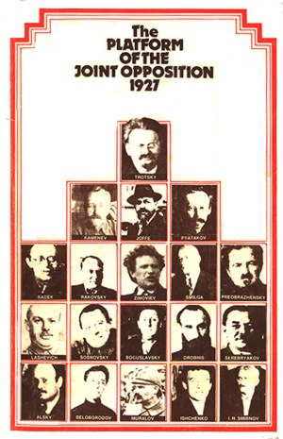

Up to this point Stalin had (with the loyal collaboration of the opposition) contained the struggle within the party. He had successfully ousted the opposition from most of the key positions in the party. The summer of 1926 saw the intensive united action of both tendencies of the Opposition, i.e. of both Zinovievist and Trotskyist. Stalin countered with expulsions, disciplining, shutting down meetings and the use of violence, driving the opposition underground.

Then Stalin stole a little of the Opposition’s thunder, pledging wage rises for poorer workers and, utilizing his monopoly of the press, distorted Trotsky’s views and launched a campaign to boost the “theory” of Socialism in one country and further intimidate the Opposition.

