|  |  |  |  |  |  |
| --- | --- | --- | --- | --- | --- |
|  | Monday | Tuesday | Wednesday | Thursday | Friday |
| W  E  E  K  1 |  |  | Entry Event  Fox News/ Arab Spring  Set up | Sc Aim: What was ab Absolutism?  Foucault? | Aim: How did absolutist rulers centralize political authority?  Louis XIV- Sun King  Limited/constitutional monarchy |
| W  E  E  K  2 | Aim: How did the Scientific Revolution change the way people viewed the world?  Copernicus  Galileo  Geocentrism  Heliocentrism  Newton | Aim: How did the Enlightenment react against absolutism?  Locke  Rousseau  Voltaire | Aim: What centrifugal forces existed in France during the 1780s? (Phase 1)  American Revolution  Bread riots  Storming of the Bastille | Aim: What did the liberal phase of the revolution consist of? (Phase 2)  Tennis Court Oath  Declaration of Rights of man and of the Citizen | Aim: How should France proceed?  Seminar between liberals, moderates, and radicals |
| W  E  E  K  3 | Aim: How did the liberal phase become the radical phase?  (Phase 3)  Reign of Terror  Robespierre  guillotine | Aim: Did Napoleon spread or reject revolutionary ideals? (Phase 4)  Napoleonic Code | Aim: How did the French Revolution influence the Haitian revolution and revolutions in Latin America? | Aim: How can we compare the Arab Spring the Age of Revolutions?  Join groups: Tunisia, Libya, Egypt, Yemen, Bahrain, Syria | Aim: How can we begin our project? |

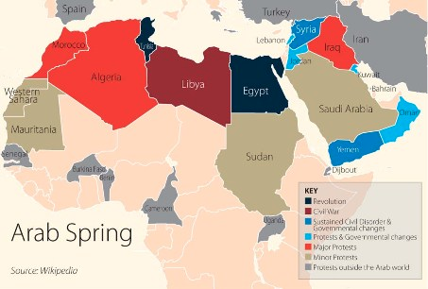

**Is the Arab Spring Over?**

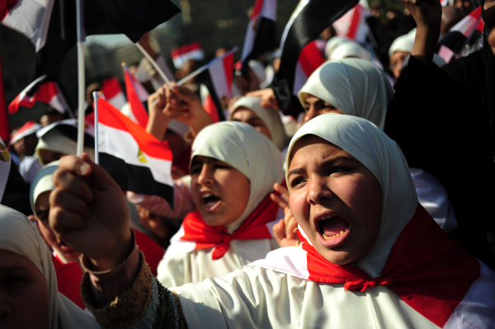

Ann Coulter has stated that the Arab Spring is a movement that has been caused by “savages”. Many people in America have claimed that the Arab Spring has in fact led to the “Arab Winter”. In our unit, we will analyze the sequence in events of the Arab Spring, compare them to past revolutions like the French, Haitian, and Latin American Revolutions of late 18th/early 19th centuries to decide whether or not the Arab Spring is in fact over.

Essential Questions that we will explore:

1. How long does it take until a revolution is successful? A year? 100 years?
2. What motivates people more- ideas or economics?
3. What is more important- political freedom or stability?

In order to analyze this spectacular moment in current history adequately, we must look at historic revolutions from the past 300 years:

1500 1600 1700 1800 1900 2000

^

2010

The Arab Spring

Protests break out in Tunisia, Libya, Egypt, Syria, Yemen, Bahrain…

^

1600s

The Scientific Revolution

^

Early 1800s

Revolutions in

Latin America

^

1791-1804

The

Haitian

Revolution

^

1776

The

American

Revolution

^

1789

The

French

Revolution

^

1700s

The

Enlightenment