- TASK CARD Nationalism and Industrialization

Aim: How did nationalism unite and divide people in the 19th century?

a) Definition of Nationalism and National Anthem Analysis

b) Case Study 1: Germany in the 1860s
Case Study 2: Modern day Syria

c) Categorizing types of states

Aim: What were the causes and effects of the industrial revolution?

d) Industrial Revolution Causes and Effects

e) Primary Source analysis vs. Modern Industrialization in China

Aim: What were competing economic theories during industrialization?

f) The Rise of Industrial Capitalism

g) The Rise of Communism

h) Answer Aim
****************After all tasks completed, Check In with Zander****************

Key Terms: nationalism, Otto von Bismarck, nation-state, stateless nation, multi-national state, 2nd agricultural revolution, Industrial Revolution, Adam Smith, capitalism, means of production, laissez-faire, Karl Marx, communism, proletariat, bourgeoisie

Aim: How did nationalism unite and divide people in the 19th century?
1a: Nationalism definition and National Anthem Analysis
Definition

Nationalism- a devotion to the interests and culture of one's nation.

Review:

Nationalism first became dominant in France during the French revolutionary wars. People felt nationalism because they were no longer subjects to a king, but rather a _____________ of a _____________.

Super interesting quote:
[A nation is] a group of people united by a mistaken view about the past and a hatred of their neighbors.
-Ernst Renan
Your Interpretation of super interesting quote:

What is Ernst Renan saying about the nature of nationalism? Do you think that Renan has a positive or a negative view of nationalism?

La Marseillaise was composed by Claude-Joseph Rouget de Lisle in 1792 and was declared the French national anthem in 1795. Here it is translated into English. | Annotate these two nationalist anthems to discern similarities between nationalist sentiments. | Max Schneckenburger:  The Watch on The Rhine [a river in Germany], 1870
Let's go children of the fatherland,  The day of glory has arrived!  Against us tyranny's  Bloody flag is raised! (repeat)  In the countryside, do you hear  The roaring of these fierce soldiers?  They come right to our arms  To slit the throats of our sons, our friends!  Grab your weapons, citizens!  Let us march! Let us march!  May impure blood water our fields!  Frenchmen, as magnanimous warriors,  Bear or hold back your blows!  Spare these sad victims,  Regretfully arming against us.  But not these bloodthirsty despots,  All of these animals who, without pity,  Tear their mother's breast to pieces!  Sacred love of France,  Lead, support our avenging arms!  Liberty, beloved Liberty,  Fight with your defenders! (repeat)  Under our flags, let victory  Hasten to your manly tones!  May your dying enemies  See your triumph and our glory! |  | They stand, a hundred thousand strong,  Quick to avenge their country's wrong;  With filial love their bosoms swell,  They'll guard the sacred landmark well!  Chorus: Dear Fatherland, no danger thine;  Firm stand thy sons to watch the Rhine!  The dead of an heroic race  From heaven look down and meet this gaze;  He swears with dauntless heart, "O Rhine,  Be German as this breast of mine!"  Chorus: Dear Fatherland, no danger thine;  Firm stand thy sons to watch the Rhine!  While flows one drop of German blood,  Or sword remains to guard thy flood,  While rifle rests in patriot hand,  No foe shall tread thy sacred strand!  Chorus: Dear Fatherland, no danger thine;  Firm stand thy sons to watch the Rhine!
Based on your annotations, what similarities do both of these patriotic anthems share? See if you can notice at least 4 similarities between these rival nations.

1b: Nationalism Case Study 1: Germany
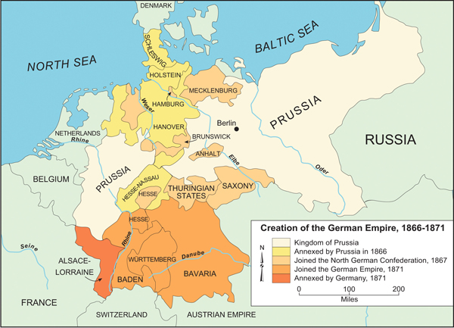 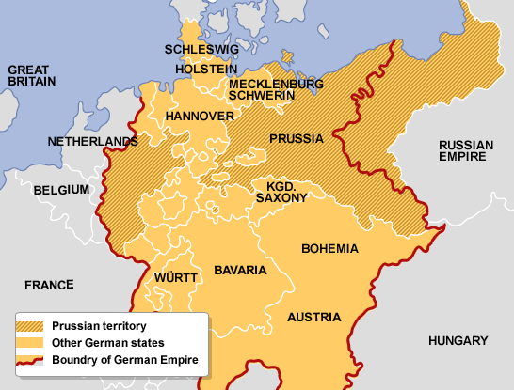Otto von Bismarck: The Iron Chancellor
Germany achieved national unity in the mid-1800s. Beginning in 1815, 39 German states formed a loose grouping called the German Confederation. The Austrian Empire was a multi-national state that dominated the confederation. However, Prussia was ready to unify all the German states. Prussia had a mainly German population, which gave it the power to unify Germany into a nation state.
William I became Prussia’s king in 1861 and a year later appointed Bismarck as his chief minister. Though technically deferring to William, in reality Bismarck was in charge, manipulating the king with his intellect and the occasional tantrum while using royal decrees to bypass the power of elected officials.
In 1864 Bismarck began the series of wars that would establish Prussian power in Europe. He attacked Denmark to gain the German-speaking territories of Schleswig-Holstein and two years later provoked Emperor Franz-Josef I into starting the Austro-Prussian War (1866), which ended in a swift defeat for the aging Austrian empire.
Bismarck was even more bold in his conduct of the Franco-Prussian War (1870-71). Seeing the opportunity to unify Germany’s loose confederations against an outside enemy, Bismarck stirred political tensions between France and Prussia, famously editing a telegram from William I to make both countries feel insulted by the other. The French declared war, but the Prussians and their German allies won handily. Prussia annexed the French border provinces of Alsace and Lorraine and crowned William emperor of a unified Germany (the Second Reich) in the Hall of Mirrors at Versailles—a tremendous insult to the French. Germany had now created a German nation-state.
- Based on your reading on Otto von Bismarck, how did Bismarck use nationalism to unite Germany?

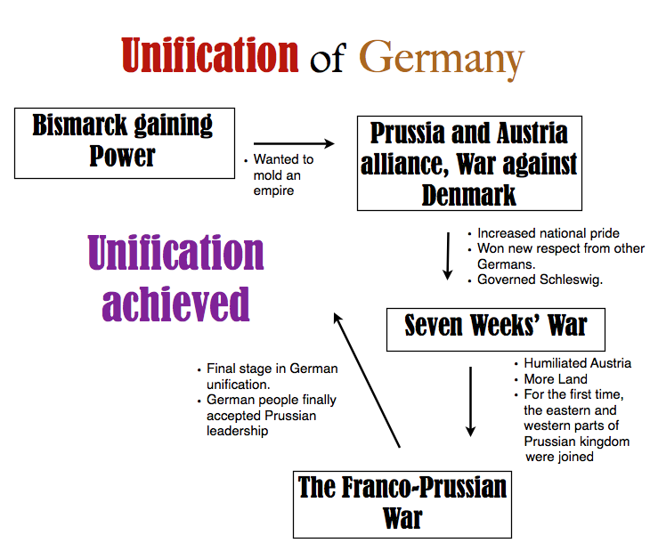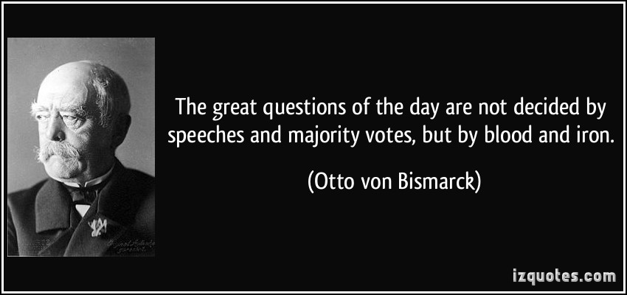
2. Nationalism began as a left-wing phenomenon in revolt against the conservative values of monarchy and the church. It was an ideology associated with democracy and the creation of constitutional governments that protected the rights of the citizens of a nation. Analyze Bismarck’s use of nationalism while answering the following questions:
Based on the quote above, do you think Bismarck would be placed on the left or the right of the political spectrum? Does Bismarck’s nationalism differ from the nationalism of the French Revolution? Use evidence to support your claim.

Case Study 2: Kurdistan
Watch this clip from Vice News on Kurdistan in Syria. [Zander will show this at the end of the class on Friday, November 14.] Keep this question in mind as you watch: How is nationalism a force that unites and divides?

Notes on the Kurds during the Syrian Civil War
How is nationalism a force that unites and divides? Who/what does it unite? Who/what does it divide?

Based on what you see in the video, do you believe that ISIS is trying to build a nation-state or a multi-national state? Why or why not?

1c: Categorizing types of states
Read each case study and decide where the government is a…..

Nation-state: a sovereign state whose citizens are relatively homogeneous in factors such as language or culture.
Multi-national state: a sovereign state which is viewed as comprising two or more nations.
Stateless nation: an ethnic group, religious group, linguistic group or other cohesive group which is not the majority population in any nation state.

Case Study | Map | Nation-state, Multi-national state, or stateless nation? Why?
The Kurds are a largely Sunni Muslim people with their own language and culture, most Kurds live in the generally contiguous areas of Turkey, Iraq, Iran, Armenia and Syria – a mountainous region of southwest Asia generally known as Kurdistan ("Land of the Kurds"). The breakup of the Ottoman Empire after the war created a number of new nation-states, but not a separate Kurdistan. Kurds, no longer free to roam, were forced to abandon their seasonal migrations and traditional ways. | 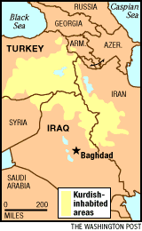
Ottoman Empire was empire created by Turkish tribes in Anatolia. One of the most powerful states in the world during the 15th and 16th centuries, it spanned more than 600 years and came to an end only in 1922, when it was replaced by the Turkish Republic and various successor states in southeastern Europe and the Middle East. At its height the empire included most of southeastern Europe to the gates of Vienna, including modern Hungary, Serbia, Bosnia, Romania, Greece, and Ukraine; Iraq, Syria, Israel, and Egypt; North Africa as far west as Algeria; and most of the Arabian Peninsula. | 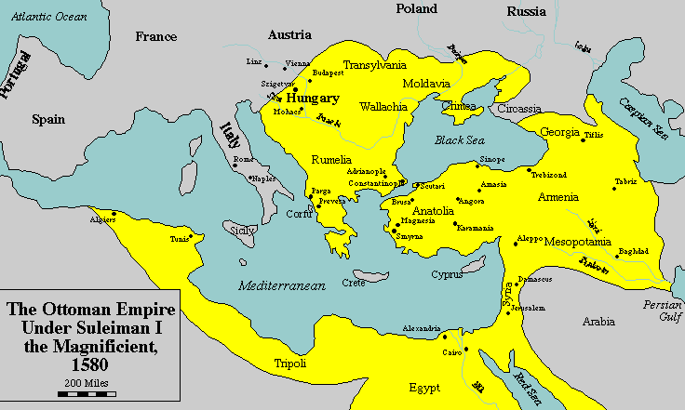
Tibet has had a tumultuous history, during which it has spent some periods functioning as an independent entity and others ruled by powerful Chinese and Mongolian dynasties. China claims a centuries-old sovereignty over the Himalayan region. But the allegiances of many Tibetans lie with the exiled spiritual leader, the Dalai Lama, seen by his followers as a living god, but by China as a separatist threat. China sent in thousands of troops to enforce its claim on the region in 1950. Some areas became the Tibetan Autonomous Region and others were incorporated into neighboring Chinese provinces. Thousands of Tibetans are believed to have been killed during periods of repression and martial law. | 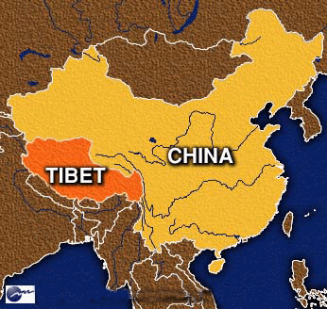
Austro-Hungarian Empire-A former dual monarchy of central Europe consisting of Austria, Hungary, Bohemia, Moravia, Slovakia, and parts of Poland, Romania, Slovenia, Croatia, and Italy. It was formed in 1867 after agitation by Hungarian nationalists within the Austrian empire and lasted until 1918. | 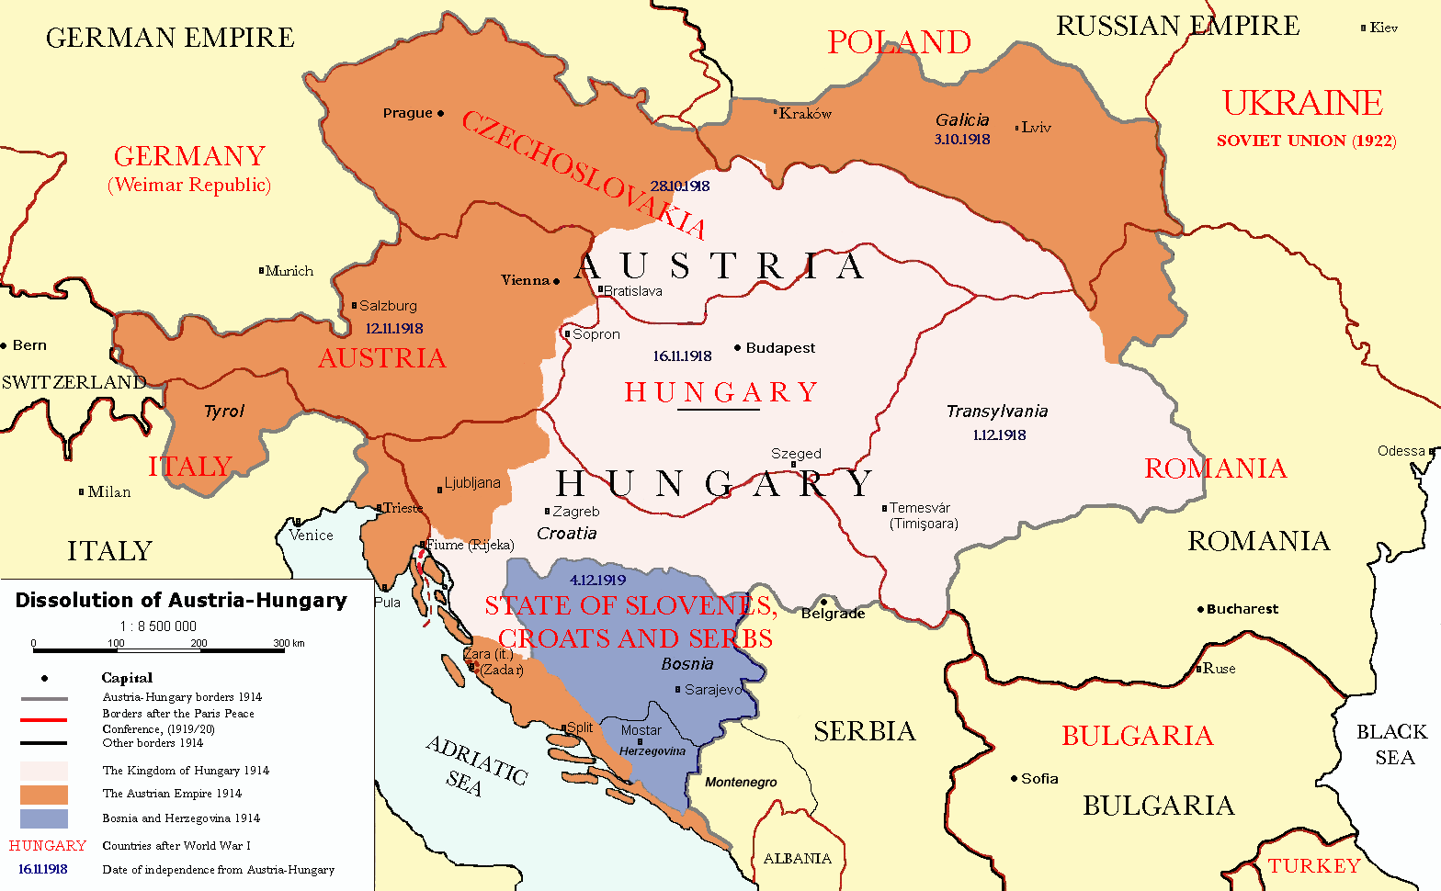
Japanese society is linguistically and culturally homogeneous, composed of 98.5% ethnic Japanese, with small populations of foreign workers. Japanese society, who still tend to preserve the idea of Japan being a monocultural society and with this ideology of homogeneity, has traditionally rejected any need to recognize ethnic differences in Japan, even as such claims have been rejected by such ethnic minorities. Former Japanese Prime Minister Tarō Asō has once described Japan as being a nation of "one race, one civilization, one language and one culture". | 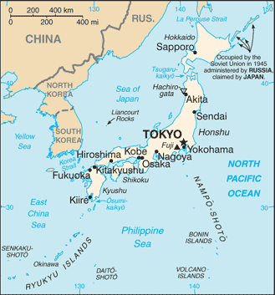

1d) The Causes and Effect of the Industrial Revolution
Aim: What were the causes and effects of the industrial revolution?

[F.Y.I. the Industrial Revolution is a bit on the boring side for me so I’m trying to make this as painless as possible. I do think you will find the video on China interesting though….- Zander]

The 19th century was a time of change. A new agricultural revolution consisted of new practices such as crop rotation brought an abundance of food. For example, a farmer might plant a field with wheat one year, which would exhaust the soil’s nutrients. The next year he/she would plant a root crop, such as turnips, to restore nutrients. This improvement to agriculture led to an abundance of food, which in turn led to an increase in population. In England, common land from feudal times became fenced in and privatized by wealthy landowners. Rural workers were now displaced and moved to the city to find work. Due to this process of urbanization, former peasants fled to the city to get dangerous jobs in factories. New energy and power sources were developed to power the industrial economy. The steam engine revolutionized transportation by leading to steamboats and railroads. New transportation allowed people and goods to travel very quickly. This new industrial economy relied on child labor to operate machines or mine for minerals or coal. Factories led to mass production of goods for the middle and upper classes [bourgeoisie], while the lower classes suffered in the poor working conditions.

https://www.youtube.com/watch?v=B3u4EFTwprM
Watch the Crash Course video on the Industrial Revolution. Stop when you reach 7:37. Using my description and the John Green clip, fill out this chart:

1e) Primary Source and secondary source analysis of workers in a factory

Read this primary source from a testimony from a famous report on textile factories published in 1832.

Sadler: What is the nature of your illness?
Hebergam: I have damaged lungs. My leg muscles do not function properly and will not support the weight of my bones.
Sadler: A doctor has told you that you will die within the year, is that correct?
Hebergam: I have been so told.
Sadler: Did he tell you the cause of your illness?
Hebergam: He told me that it was caused by the dust in the factories and from overwork and insufficient diet…
Sadler: To what was his (your brother’s) death attributed?
Hebergam: He was cut by a machine and died of infection.
Sadler: Do you know of any other children who died at the R______ Mill?
Hebergam: There were about a dozen died during the two years and a half that I was there. At the L______ Mill where I worked last, a boy was caught in a machine and had both his thigh bones broke and from his knee to his hip the flesh was ripped up the same as it had been cut by a knife. His hand was bruised, his eyes were nearly torn out and his arms were broken. His sister, who ran to pull him off, had both her arms broke and her head bruised. The boy died. I do not know if the girl is dead, but she was not expected to live.

Based on your historical analysis, what is the purpose of this report? What is Sadler’s role?

Why do you think people like Hebergam would choose to work at such a place?

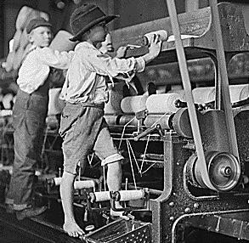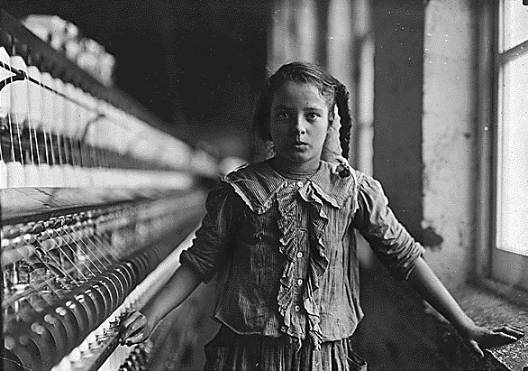
The clip below explores the workings of a modern factory in China. Compare and contrast this video with the primary source from the Sadler commission. What is similar about the two sources? What is different?
https://www.youtube.com/watch?v=7U0N7tVcy5s

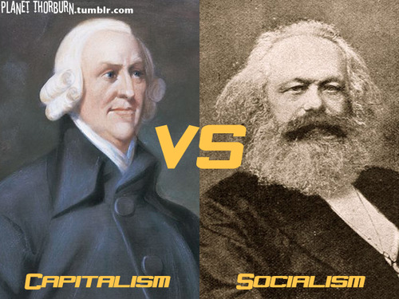
1f) The Rise of Industrial Capitalism
Aim: What were competing economic theories during industrialization?
Adam Smith was a Scottish economic thinker who was influenced by Enlightenment ideals. The industrial revolution led to the rise of industrial capitalism in the late 18th and early 19th century. Capitalism is an economic system that features private ownership of the means of production (such as factories, offices, and shipping enterprises) and in which market forces determine the way in which goods are produced.
Adam Smith believed in laissez-faire capitalism, which is French for “let do.” The principle of laissez-faire discourages any kind of government involvement in the economy. Being a man of the Enlightenment, he believed that the natural laws of supply and demand existed in business. Adam Smith wrote The Wealth of Nations in 1776, which argued that unregulated exchange of goods and services would help everyone, not just the rich. Smith contended that if more goods are produced at lower prices, everyone can afford them capitalists could re-invest profits into new ventures. Thus, economic competition is what results in a thriving economy.
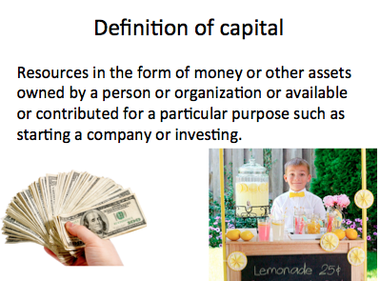
Look at the example on the left. What capital does this little boy have to run his business?

1g) The Rise of Communism
The Industrial Revolution led to criticism of industrial capitalism. As you read the following excerpt from Karl Marx’s The Communist Manifesto, circle any ideas that you believe to be communist ideas. Underline anything that represents the opposite of communism. You will list these characteristics in the T-Chart on page _____.
The following is an excerpt from the first chapter of Karl Marx and Frederick Engels, The Communist Manifesto (1848)
The history of all existing societies is the history of class struggles.
The modern bourgeois society that has sprouted from the ruins of feudal society has not done away with class antagonisms. It has but established new classes, new conditions of oppression, new forms of struggle in place of the old ones. Our time, the rule of the bourgeoisie, possesses, however, this distinctive feature: it has simplified the class antagonisms: Society as a whole is more and more splitting up into two great hostile camps, into two great classes, directly facing each other: Bourgeoisie and Proletariat.. .
According to Marx, how has oppression changed/shifted since the dawn of history? When he published this in 1848, who did he argue was the oppressor and who represented the oppressed?

[On Property]
The distinguishing feature of communism is not the abolition of property generally, but the abolition of bourgeois property. But modern bourgeois private property is the final and most complete expression of the system of producing and appropriating products that is based on class antagonisms, on the exploitation of the many by the few.
In this sense, the theory of the Communists may be summed up in the single sentence: Abolition of private property.
The Communists are further reproached with desiring to abolish countries and nationality.
The workers have no country. We cannot take from them what they have not got. Since the proletariat must first of all acquire political supremacy, must rise to be the leading class of the nation, must constitute itself the nation, it is, so far, itself national, though not in the bourgeois sense of the word.
Religion is the sigh of the oppressed creature, the heart of a heartless world, and the soul of soulless conditions. It is the opium of the people.
Let the ruling classes tremble at a communist revolution. The proletarians have nothing to lose but their chains. They have a world to win.
Proletarians of all countries, unite!

Now, plot what Marx describes as representing or not representing communism in the T-chart.
Characteristics of Communism | Not characteristics of Communism

Using your notes, write your working definition of communism:

Write your working definition of capitalism:

If you are confused, watch the rest of the John Green video starting at 7:37[optional]:
https://www.youtube.com/watch?v=B3u4EFTwprM

Listen to the following 2 songs…

The following 2 songs represent the economic ideas of either capitalism or communism. Listen to the songs and read the lyrics. Which song would Karl Marx rock out to? Which song would make Adam Smith get down? Use at least 1 lyric from each song as evidence to support your claim.
Song 1: https://www.youtube.com/watch?v=RwUGSYDKUxU
Song 2: https://www.youtube.com/watch?v=l_2JztFSSQQ

1h) Answer Essential Question: How did the emergence of nationalism and industrialism in the 19th century shape the modern world?

Be sure to use all of the words in the word wall: nationalism, Otto von Bismarck, nation-state, stateless nation, multi-national state, 2nd agricultural revolution, Industrial Revolution, Adam Smith, capitalism, means of production, laissez-faire, Karl Marx, communism

Multi-national state- a sovereign state which is viewed as comprising two or more nations.
nation-state: a sovereign state whose citizens are relatively homogeneous in factors such as language or culture.
Bourgeoisie- middle class. In Marx’s terms, capitalists who own the means of production
Proletariat- workers/working class people

