2) TASK CARD May 12th – May 15th

a) Fahrenheit 9/11 Analysis
b) Interactive Timeline Analysis
c) Restrepo Trailer
d) Guantanamo Bay
e) Find 2014 article to annotate
f) Discussion
g) Answer Aim
****************After all tasks completed, Check In with Zander****************

Key Terms: Bush Doctrine , Guantanamo Bay, Operation Enduring Freedom, Osama bin Laden, Hamid Karzai, NATO

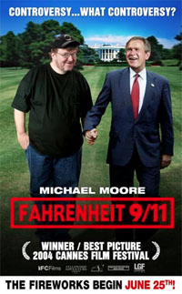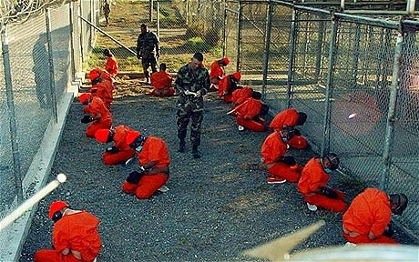

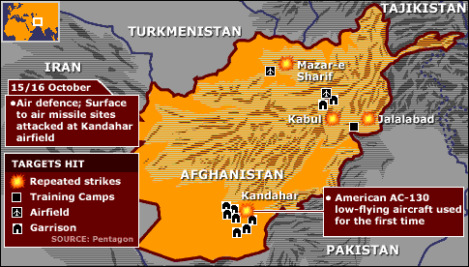

The Bush Doctrine: Foreign Policy based on the idea that the U.S. should take preemptive action against threats to its national security

Task 2a

Farhenheit 9/11
Watch this clip from director Michael Moore’s film Fahrenheit 9/11. As you are watching, note how Moore edits the film together to make his argument. What images do you see? What is he saying? Who is he interviewing?

14:14-47:08

https://www.youtube.com/watch?v=dMTf9hneV6Y

Fahrenheit 9/11  14:14-47:08 | Images/Sound | Words/Narration | Interviews
How is Michael Moore using film to as a medium to make his thesis?

What is Michael Moore’s main argument in this clip? How does he use images and sound to make his argument? Do you believe he is on the left or the right of the political spectrum?

Task 2b
Analysis of Timeline of the War in Afghanistan

http://www.nbcnews.com/id/33210358/ns/world_news-south_and_central_asia/t/us-war-afghanistan/

Click on the link to find an interactive timeline of the War in Afghanistan. For each year, choose 2 events that you believe are the 2 most important dates for that year. Summary the 2 events. Based on the 2 events you chose in the middle column, make a generalization about the whole year of the War in Afghanistan.

Date | 2 pieces of most  significant evidence | Analysis: Use your evidence to make a generalization about the progress of the War on Terror in this year
2001
2002
2003
2004
2005
2006
2007
2008
2009
2010
2011

Based on your choice of events for each year, summarize the trajectory (path) of the War in Afghanistan from 2001 to 2011.

Task 2c
Restrepo

https://www.youtube.com/watch?v=yt7YVy_ajtc

Watch the Restrepo trailer. What images and audio do you see and hear in the clip? What are the soldiers saying?

Task 2d

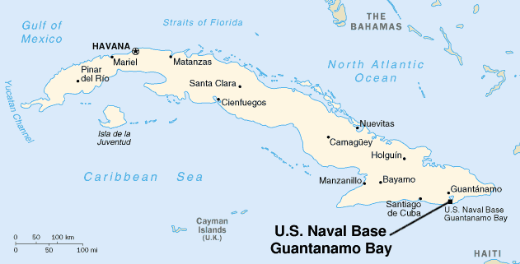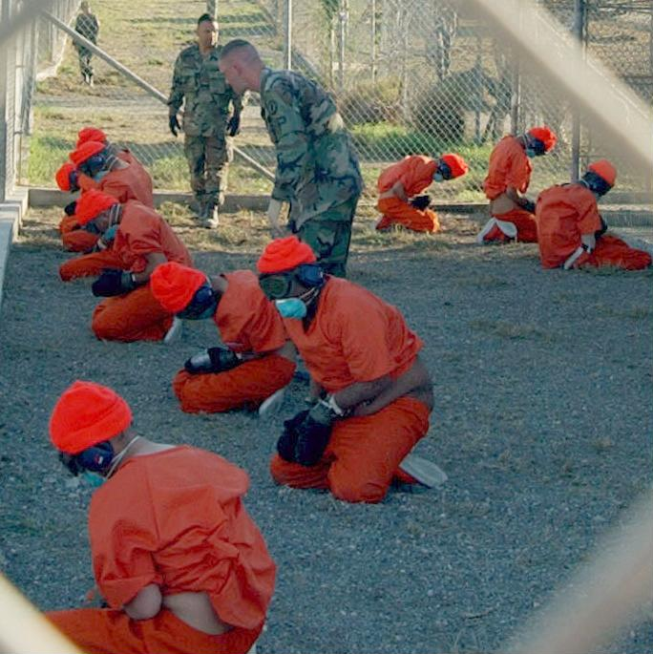

Guantánamo Bay- a bay on the southeastern coast of Cuba. It is the site of a US naval base established in 1903, where suspected members of al-Qaeda and the Taliban were held from 2002.

Read and annotate the following editorial written for the NY Times last year:

Gitmo Is Killing Me

Op-Ed Contributor

By SAMIR NAJI al HASAN MOQBEL
NY TIMES, April 14, 2013
ONE man here weighs just 77 pounds. Another, 98. Last thing I knew, I weighed 132, but that was a month ago.
I’ve been on a hunger strike since Feb. 10 and have lost well over 30 pounds. I will not eat until they restore my dignity.
I’ve been detained at Guantánamo for 11 years and three months. I have never been charged with any crime. I have never received a trial.
I could have been home years ago — no one seriously thinks I am a threat — but still I am here. Years ago the military said I was a “guard” for Osama bin Laden, but this was nonsense, like something out of the American movies I used to watch. They don’t even seem to believe it anymore. But they don’t seem to care how long I sit here, either.
When I was at home in Yemen, in 2000, a childhood friend told me that in Afghanistan I could do better than the $50 a month I earned in a factory, and support my family. I’d never really traveled, and knew nothing about Afghanistan, but I gave it a try.
I was wrong to trust him. There was no work. I wanted to leave, but had no money to fly home. After the American invasion in 2001, I fled to Pakistan like everyone else. The Pakistanis arrested me when I asked to see someone from the Yemeni Embassy. I was then sent to Kandahar, and put on the first plane to Gitmo.
Last month, on March 15, I was sick in the prison hospital and refused to be fed. A team from the E.R.F. (Extreme Reaction Force), a squad of eight military police officers in riot gear, burst in. They tied my hands and feet to the bed. They forcibly inserted an IV into my hand. I spent 26 hours in this state, tied to the bed. During this time I was not permitted to go to the toilet. They inserted a catheter, which was painful, degrading and unnecessary. I was not even permitted to pray.
I will never forget the first time they passed the feeding tube up my nose. I can’t describe how painful it is to be force-fed this way. As it was thrust in, it made me feel like throwing up. I wanted to vomit, but I couldn’t. There was agony in my chest, throat and stomach. I had never experienced such pain before. I would not wish this cruel punishment upon anyone.
I am still being force-fed. Two times a day they tie me to a chair in my cell. My arms, legs and head are strapped down. I never know when they will come. Sometimes they come during the night, as late as 11 p.m., when I’m sleeping.
There are so many of us on hunger strike now that there aren’t enough qualified medical staff members to carry out the force-feedings; nothing is happening at regular intervals. They are feeding people around the clock just to keep up.
During one force-feeding the nurse pushed the tube about 18 inches into my stomach, hurting me more than usual, because she was doing things so hastily. I called the interpreter to ask the doctor if the procedure was being done correctly or not.
It was so painful that I begged them to stop feeding me. The nurse refused to stop feeding me. As they were finishing, some of the “food” spilled on my clothes. I asked them to change my clothes, but the guard refused to allow me to hold on to this last shred of my dignity.
When they come to force me into the chair, if I refuse to be tied up, they call the E.R.F. team. So I have a choice. Either I can exercise my right to protest my detention, and be beaten up, or I can submit to painful force-feeding.
The only reason I am still here is that President Obama refuses to send any detainees back to Yemen. This makes no sense. I am a human being, not a passport, and I deserve to be treated like one.
I do not want to die here, but until President Obama and Yemen’s president do something, that is what I risk every day.
Where is my government? I will submit to any “security measures” they want in order to go home, even though they are totally unnecessary.
I will agree to whatever it takes in order to be free. I am now 35. All I want is to see my family again and to start a family of my own.
The situation is desperate now. All of the detainees here are suffering deeply. At least 40 people here are on a hunger strike. People are fainting with exhaustion every day. I have vomited blood.
And there is no end in sight to our imprisonment. Denying ourselves food and risking death every day is the choice we have made.
I just hope that because of the pain we are suffering, the eyes of the world will once again look to Guantánamo before it is too late.
Samir Naji al Hasan Moqbel, a prisoner at Guantánamo Bay since 2002, told this story, through an Arabic interpreter, to his lawyers at the legal charity Reprieve in an unclassified telephone call.
____________________________________________________________________________________
Watch these 2 clips from Barack Obama’s speech on Guantanamo Bay given last year:
https://www.youtube.com/watch?v=iF68kds0Rnw

https://www.youtube.com/watch?v=uzzLrr2Q2rI
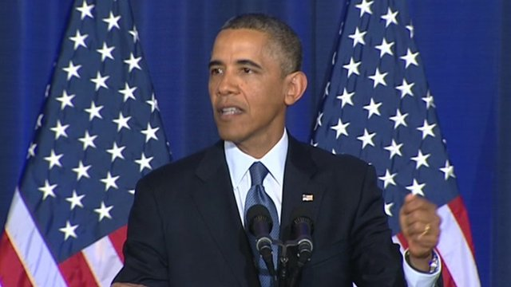
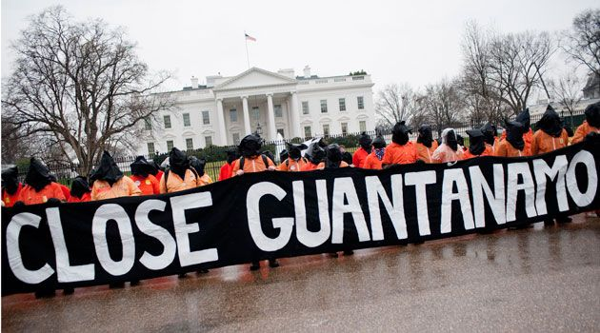
Based on the clips that you saw, answer the following questions: Why has Guantanamo Bay become a controversial symbol of the War on Terror? Do you believe that Barack Obama is responsible for the failure to close Guantanamo Bay? Why or why not?

Task 2e
Find an article from 2014 that was written in the New York Times, The Guardian, The Economist, Al Jazeera or from the BBC about Afghanistan. Annotate the article and use it in your response to Task 2g. Be sure to staple your article to this packet.

Task 2f
Group Discussion

Time discussion begins________ Time Discussion Ends ________

Guiding Questions….. | Interesting Points Made by…
Is the War in Afghanistan justified?

Was Guantanamo Bay necessary to fight the War on Terrorism?

Is torture, or “enhanced interrogation” a valid way to get information from terrorists?

Has the War on Terror been won in Afghanistan?

Task 2g
Answer the Aim: What has been the trajectory of the War in Afghanistan? Based on your article that your chose, has the War on Terror been won in Afghanistan?

*************Check in with Zander before moving on to Task 3********

