3) TASK CARD May 16th – May 21th

a) Saddam Hussein Bio
b) Fahrenheit 9/11 Analysis
c) Interactive Timeline Analysis
d) No End in Sight Analysis
e) Control Room Analysis
f) Reza Aslan on the Islamic Reformation
g) Find 2014 article to annotate
h) Discussion
i) Answer Aim
****************After all tasks completed, Check In with Zander****************

Key Terms: Shock and Awe, Ba’athist Party, Saddam Hussein, IEDs (improvised explosive device), WMDS (weapons of mass destruction)

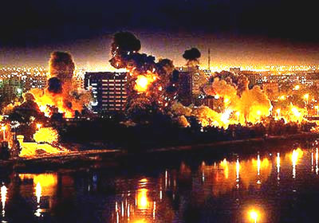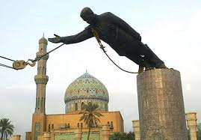

Task 3a
Saddam Hussein Biography

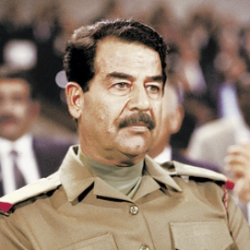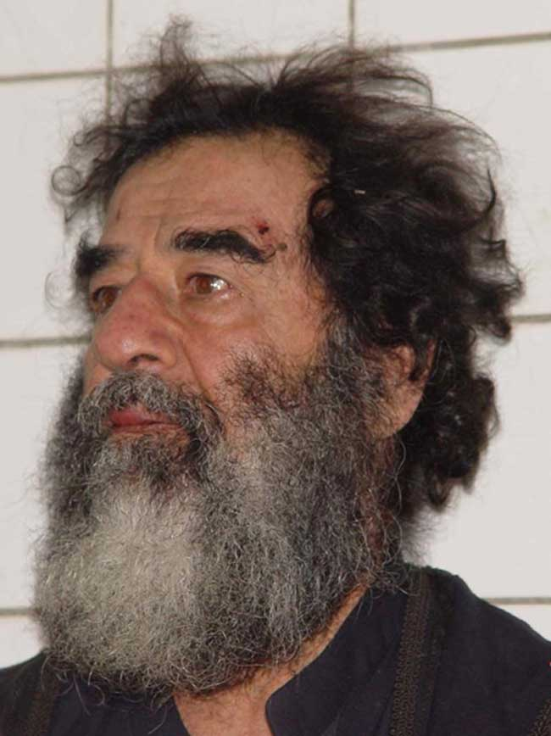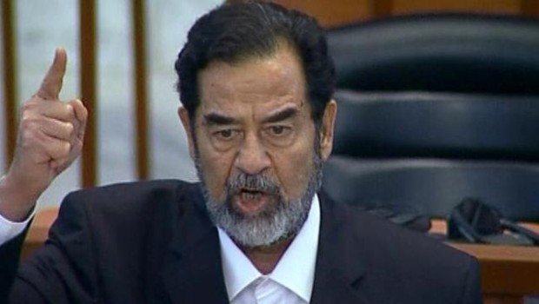

http://www.biography.com/people/saddam-hussein-9347918#capture-trial-and-execution&awesm=~oD4SEPFjIr7z07

Annotate the following biography to make note of key political turning points in Saddam Hussein’s life. Feel free to watch the short video on the link as well.
ANNOTATIONS

Synopsis
Born on April 28, 1937, in Tikrit, Iraq, Saddam Hussein was a secularist who rose through the Baath political party to assume a dictatorial presidency. Under his rule, segments of the populace enjoyed the benefits of oil wealth, while those in opposition faced torture and execution. After military conflicts with U.S.-led armed forces, Hussein was captured in 2003. He was later executed.

Early Life
Saddam Hussein was born on April 28, 1937, in Tikrit, Iraq. His father, who was a shepherd, disappeared several months before Saddam was born. A few months later, Saddam's older brother died of cancer. When Saddam was born, his mother, severely depressed by her oldest son's death and the disappearance of her husband, was unable to effectively care for Saddam, and at age 3 he was sent to Baghdad to live with his uncle, Khairallah Talfah. Years later, Saddam would return to Al-Awja to live with his mother, but after suffering abuse at the hand of his stepfather, he fled to Baghdad to again live with Talfah, a devout Sunni Muslim and ardent Arab nationalist whose politics would have a profound influence on the young Saddam. After attending the nationalistic al-Karh Secondary School in Baghdad, in 1957, at age 20, Saddam joined the Ba'ath Party, whose ultimate ideological aim was the unity of Arab states in the Middle East.

Rise to Power
ANNOTATIONS

In 1968, Saddam participated in a bloodless but successful Ba'athist coup that resulted in Ahmed Hassan al-Bakr becoming Iraq's president and Saddam his deputy. During al-Bakr’s presidency, Saddam proved himself to be an effective and progressive politician, albeit a decidedly ruthless one. He did much to modernize Iraq's infrastructure, industry, and health-care system, and raised social services, education, and farming subsidies to levels unparalleled in other Arab countries in the region. He also nationalized Iraq's oil industry, just before the energy crisis of 1973, which resulted in massive revenues for the nation. During that same time, however, Saddam helped develop Iraq's first chemical weapons program and, to guard against coups, created a powerful security apparatus, which included both Ba'athist paramilitary groups, and which frequently used torture, rape and assassination to achieve its goals.
In 1979, when al-Bakr attempted to unite Iraq and Syria, in a move that would have left Saddam effectively powerless, Saddam forced al-Bakr to resign, and on July 16, 1979, Saddam Hussein became president of Iraq. Less than a week later, he called an assembly of the Ba'ath Party. During the meeting, a list of 68 names was read out loud, and each person on the list was promptly arrested and removed from the room. Of those 68, all were tried and found guilty of treason and 22 were sentenced to death. By early August 1979, hundreds of Saddam's political foes had been executed.

Decades of Conflict
The same year that Saddam ascended to the presidency, Ayatollah Khomeini led a successful Islamic revolution in Iraq's neighbor to the northeast, Iran. Saddam, whose political power rested in part upon the support of Iraq's minority Sunni population, worried that developments in Shi-ite majority Iran could lead to a similar uprising in Iraq. In response, on September 22, 1980, Saddam ordered Iraqi forces to invade the oil-rich region of Khuzestan in Iran. The conflict soon blossomed into an all-out war, but Western nations such as the United States and much of the Arab world, fearful of the spread of Islamic radicalism and what it would mean to the region and the world, gave their support firmly behind Saddam, despite the fact that his invasion of Iran clearly violated international law. During the conflict, these same fears would cause the international community to essentially ignore Iraq's use of chemical weapons, its genocidal dealing with its Kurdish population and its burgeoning nuclear program. On August 20, 1988, after years of intense conflict that left hundreds of thousands dead on both sides, a ceasefire agreement was finally reached.
In the aftermath of the conflict, seeking a means of revitalizing Iraq's war-ravaged economy and infrastructure, at the end of the 1980s, Saddam turned his attention toward Iraq's wealthy neighbor, Kuwait. Using the justification that it was a historical part of Iraq, on August 2, 1990, Saddam ordered the invasion of Kuwait. A UN Security Council resolution was promptly passed, imposing economic sanctions on Iraq and setting a deadline by which Iraqi forces must leave Iraq. When the January 15, 1991 deadline was ignored, a UN coalition force headed by the United States confronted Iraqi forces, and a mere six weeks later, had driven them from Kuwait. A ceasefire agreement was signed, the terms of which included Iraq dismantling its germ and chemical weapons programs. The previously imposed economic sanctions levied against Iraq remained in place. Despite this and the fact that his military had suffered a crushing defeat, Saddam claimed victory in the conflict.
ANNOTATIONS

The Gulf War's resulting economic hardships further divided an already fractured Iraqi population. During the 1990s, various Shi-ite and Kurdish uprisings occurred, but the rest of the world, fearing another war, Kurdish independence or the spread of Islamic fundamentalism did little or nothing to support these rebellions, and they were ultimately crushed by Saddam's increasingly repressive security forces. At the same time, Iraq remained under intense international scrutiny as well. In 1993, when Iraqi forces violated a no-fly zone imposed by the United Nations, the United States launched a damaging missile attack on Baghdad. In 1998, further violations of the no-fly zones and Iraq's alleged continuation of its weapons programs led to further missile strikes on Iraq, which would occur intermittently until February 2001.

Saddam's Fall
ANNOTATIONS

Soon after the September 11, 2001 attacks on the World Trade Center in New York City, Soviet intelligence relayed information to the U.S. government that indicated Iraq was planning further terrorist attacks against the United States. In his January 2002 State of the Union address, U.S. President George W. Bush named Iraq as part of his so-called "Axis of Evil," along with Iran and North Korea, and claimed that the country was developing weapons of mass destruction and supporting terrorism.
Later that year, UN inspections of suspected weapons sites in Iraq began, but little or no evidence that such programs existed was ultimately found. Despite this, on March 20, 2003, under the pretense that Iraq did in fact have a covert weapons program and that it was planning attacks, a U.S.-led coalition invaded Iraq. Within weeks, the government and military had been toppled, and on April 9, 2003, Baghdad fell. Saddam, however, managed to elude capture.

Capture, Trial and Execution
In the months that followed, an intensive search for Saddam began. While in hiding, Saddam released several audio recordings, in which he denounced Iraq's invaders and called for resistance. Finally, on December 13, 2003, Saddam was found hiding in a small underground bunker near a farmhouse in ad-Dawr, near Tikrit. From there, he was moved to a U.S. base in Baghdad, where he would remain until June 30, 2004, when he was officially handed over to the interim Iraqi government to stand trial for crimes against humanity.
During the trial, Saddam would prove to be a belligerent defendant, often boisterously challenging the court's authority and making bizarre statements. On November 5, 2006, Saddam was found guilty and sentenced to death. The sentencing was appealed, but was ultimately upheld by a court of appeals. On December 30, 2006, at Camp Justice, an Iraqi base in Baghdad, Saddam was hanged, despite his request to be shot. He was buried in Al-Awja, his birthplace, on December 31, 2006.
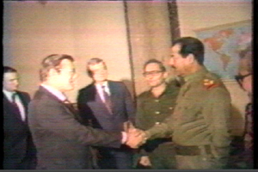
Donald Rumsfeld greeting Saddam Hussein in Baghdad in 1983. The United States sold weapons to Saddam during the Iran-Iraq war. Donald Rumsfeld later went on to be the Secretary of Defense for George W. Bush during the Iraq war 20 years later.

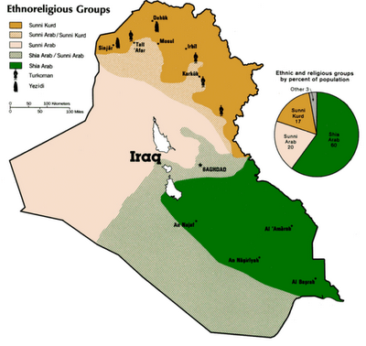

1. Give a brief summary of what you believe to be the 4 major turning points in Saddam’s political career.

2 .Why did the United States support Saddam in the 1980s? How did our “friend” become our enemy? What does this change tell you about the nature of geopolitics [international relations]?

Task 3b
Farhenheit 9/11
Watch this clip from director Michael Moore’s film Fahrenheit 9/11. As you are watching, note how Moore edits the film together to make his argument. What images do you see? What is he saying? Who is he interviewing?

1:07-1:24

https://www.youtube.com/watch?v=dMTf9hneV6Y

Fahrenheit 9/11  1:07-1:24 | Images/Sound | Words/Narration | Interviews
How is Michael Moore using film to as a medium to make his thesis?

What is Michael Moore’s main argument in this clip? How does he use images and sound to make his argument? Do you believe he is on the left or the right of the political spectrum?

Task 3c
Analysis of Timeline of War in Iraq

Date | 2 pieces of most  significant evidence | Analysis: Use your evidence to make a generalization about the progress of the War on Terror in this year
2003
2004
2005
2006
2007
2008
2008
2009
2010
2011
Today?

Task 3d
No End in Sight

38:51-45:00

https://www.youtube.com/watch?v=ykpf5nDIs9M

Paul Bremer was the Administrator of the Coalition Provisional Authority of Iraq following the 2003 invasion. He served in this capacity from May 11, 2003, until June 28, 2004, effectively serving as Head of State of the internationally recognized government of Iraq.

The film No End in Sight claims that Bremer made 3 key decisions that paved the way for an insurgency in Iraq.

An insurgency is an armed rebellion against a constituted authority.

Bremer’s 3 decisions | Notes of Film | How do you think this will affect Iraq? Why?
1.
2.
3.

Task 3e
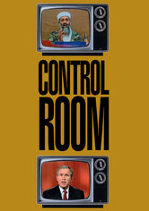

News vs. Propaganda: Control Room

Control Room is a 2004 documentary film about Al Jazeera and its relations with the US Central Command, as well as the other news organizations that covered the 2003 invasion of Iraq.
Director: Jehane Noujaim

https://www.youtube.com/watch?v=RmPUx7OH1T8

Watch until 31:13.

Iraqi Citizens reactions to war | U.S. Military Reactions to War | Images/footage of war

Based on your notes of what you have seen, do you think there is a possibility of objectivity when covering a war? How much does ethnocentrism influence our understanding of events? Why or why not?

Task 3f

Reza Aslan on the “Islamic Reformation”

https://www.youtube.com/watch?v=7rKka6IZGo0

Reza discusses what he calls the “Islamic Reformation”. Take out your notes on Martin Luther, the Protestant Reformation, and the subsequent religious wars in Europe. Complete the Venn Diagram comparing the Protestant Reformation with the Sunni and Shia violence that is taking place in Iraq.

Based on your analysis, do you agree with Reza that Islam is going through its own reformation?

Task 3g
Find an article from 2014 that was written in the New York Times, The Guardian, The Economist, Al Jazeera or from the BBC about Afghanistan. Annotate the article and use it in your response to Task 2h. Be sure to staple your article to this packet.

Task 3h

Group Discussion

Time discussion begins________ Time Discussion Ends ________

Guiding Questions….. | Interesting Points Made…
What has been the trajectory of the War in Iraq?
Was the war in Iraq justified? Why or why not?

Task 3i
Answer the Aim: What has been the trajectory of the War in Iraq? Based on your article that your chose, has the War on Terror been won in Afghanistan?

*************Check in with Zander before moving on to Task 4********

