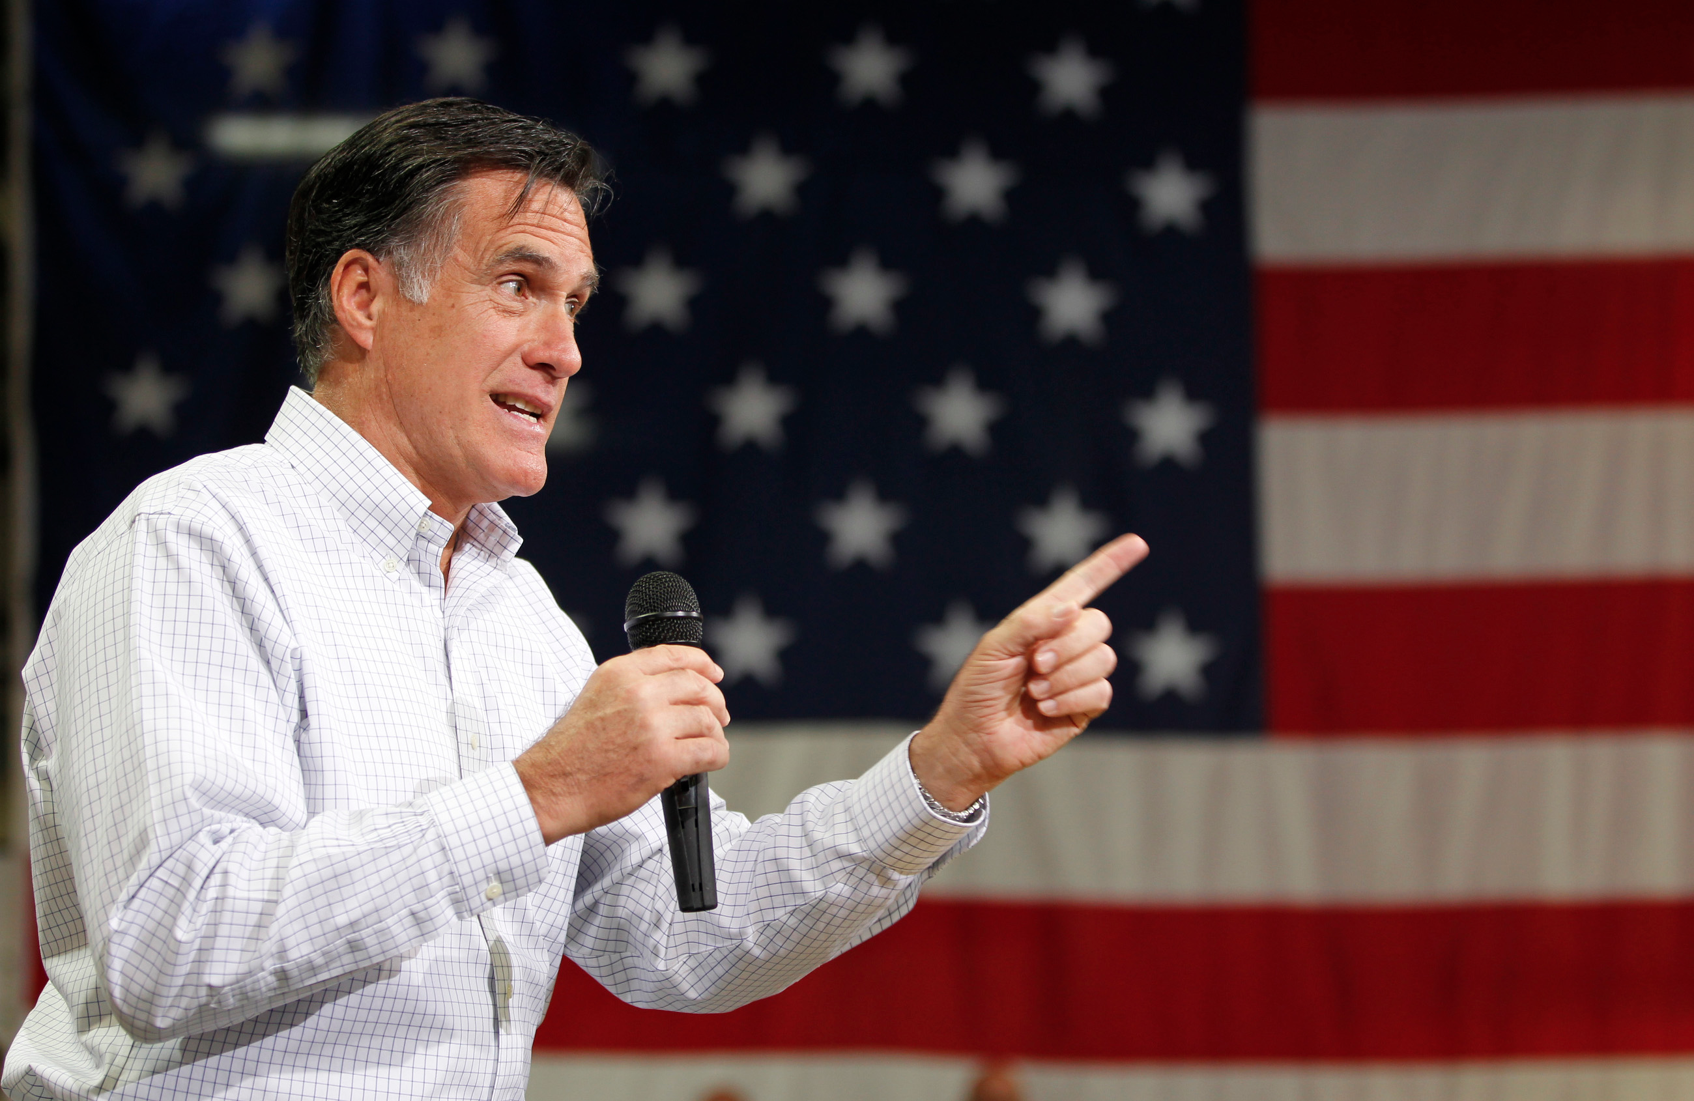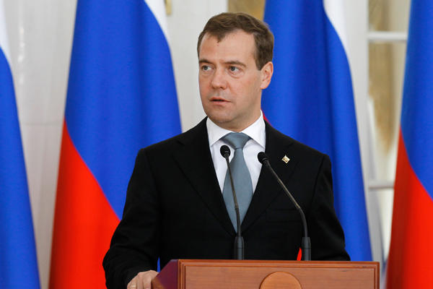
"This (Russia) is without question our number one geopolitical foe, they fight for every cause for the world's worst actors.”
Former Presidential candidate Mitt Romney

"I always get very cautious when I see a country resort to phrasings such as ‘number one enemy.’ It is very reminiscent of Hollywood and certain period of history. I would advise two things to all US presidential candidates, including the person you just mentioned. My first advice is to listen to reason when they formulate their positions. Reason never harmed a presidential candidate. My other advice is to check their clocks from time to time: it is 2012, not the mid-1970s.”

-Russian President Dmitry Medvedev

Last year Mitt Romney made some controversial statements about the relationship between United States and Russia. After WWII, both countries were entrenched in what was known as the Cold War for the second half of the 20th century. Romney’s comments have been dismissed by critics as representing “Cold War nostalgia”, while others agree with Romney that Russia is still a country to be reckoned with.

Earlier this month, communist North Korea released a disturbing film of missiles destroying New York City. Just last week, the North Korean government administered its third nuclear test. President Obama responded by stating, “These provocations do not make North Korea more secure. Far from achieving its stated goal of becoming a strong and prosperous nation, North Korea has instead increasingly isolated and impoverished its people through its ill-advised pursuit of weapons of mass destruction and their means of delivery.”

These alarming events beg the question- Is the Cold War over?

Operation Super-Commie-Fragile-Realistic-Exposing-Allegations

Dear Members of the Operation SCFREA Task Force,

You have been given a task by the United Nations Security Council to investigate this claim that the Cold War may still be alive and well. Since 9/11, many funds and resources have been devoted to counter-terrorism, while the ideological tensions that defined the Cold War have been neglected for the last 10 years. The UN recognizes that this blind spot could potentially be dangerous. Your group’s task is to choose one country that was involved in the Cold War (not the U.S.) and prepare a memo that details the country’s history on political change, human rights, geography, technology, and economics from 1950 to the present day in order to determine whether or not Romney’s claim is valid. Your mission is crucial to maintaining international peace.

After the memo is prepared, we will conduct a 2 day UN summit that will address the following essential questions:

- Is the Cold War over?
- Are democratic governments less warlike than dictatorships?
- Did the collapse of the Soviet Union prove that Communism and Socialism are unworkable and/or undesirable ideals?

Group Memo Rubric
Outcome | Exceeds | Meets | Not Yet
Conclude  Infer meanings, analyze information and develop valid ideas based on evidence and analysis. | Group developed conclusions by looking at different sources and synthesizing ideas to support their claim. 5+ themes are explored thoroughly to answer driving question. | Group developed conclusions by looking at different sources and synthesizing ideas to support their claim. 4 themes are explored to answer driving question.
Investigate  Ask and refine a researchable question, design a valid experiment or inquiry and gather appropriate info to complete the inquiry. | Multiple primary and secondary sources were researched in pursuit of answering the driving question.  ___Over 20 sources cited in memo  ___ Each student’s research log includes 5 annotated sources, 3 of which are from an academic journal found in a database  ___ Sources footnoted in Chicago Style fashion | Multiple primary and secondary sources were researched in pursuit of answering the driving question.  ___ 20 sources cited in memo  ___ Each student’s research log includes 5 annotated sources, 3 of which are from an academic journal found in a database  ___ Sources footnoted in Chicago Style fashion

Memo Rubric- Individual Member Assessment
To be graded HARSHLY by your peers

Collaborate  Work effectively with others to achieve common goals. Student listened and showed willingness to compromise in order to produce a well researched memo in a real-world context. | ___ Student listened and showed willingness to compromise in order to produce a well researched memo in a real-world context.  ___ Student always met deadlines and went above and beyond to complete task | ___ Student listened and showed willingness to compromise in order to produce a well researched memo in a real-world context.  ___ Student met deadlines
Plan  Seek and obtain feedback and assess progress, make adjustments, as needed, to achieve goals. Persevere in the face of difficulty to search for multiple solutions. | Student frames and clarifies goals and makes deliberate plans for how to achieve them.  ___Student completed research log by deadlines decided by group  ___ Student Planning in Brief tool completed in detail during research process with input by group member | Student frames and clarifies goals and makes deliberate plans for how to achieve them.  ___Student completed research log by deadlines decided by group  ___ Student Planning in Brief tool completed during research process with input by group member

Unit Bookends: From Animal Farm to UN Summit

1. Read Animal Farm: Annotate chapters + complementary sources in Reading Log

We are going to begin the unit by reading George Orwell’s Animal Farm. Readings should be completed outside of class. As you read, you should be annotating the chapters in a reading log that I will provide for you. Your reading log must be completed as you read because I may allow you to use it on reading quizzes. Every day we will start class by discussing the chapter. We will then read and analyze primary sources that I will provide for you that complement the Animal Farm readings. During this time you should be discussing the significance with your group and annotating the documents in your reading log.

2. Research for Memo/Summit. Lead class discussion on your country

After we finish the novel, your group will embark on your research of your chosen country. Every research log should have at least 5 sources cited: 1 reference (encyclopedia/text book), 2 primary sources, and 2 secondary sources found on a database. After a full week of researching, your group will present your findings and lead a discussion (approximately 20 minutes) that pertains to our driving question- Is the Cold War over? This should be a powerpoint-less experience. I will assist by printing off any materials you need to facilitate your discussion. Make sure you email me with your materials 1 day before you would like the class to read them (for homework or in-class). The point of this is to prepare you for the UN Summit so conversation will have more flow and less ebb.

Rubric for Group-led Discussion

Outcome | Exceeds | Meets | Not Yet
Communicate  Based on Group-led discussion of country | ___ Group facilitated thoughtful discussion  ___ Group provided more than 5 “thick” questions used to stoke discussion  ___ No awkward silence due to the engaging nature of materials/questions  ____Group attempted to involve less talkative peers | ___ Group facilitated thoughtful discussion  ___ Group provided 5 “thick” questions used to stoke discussion  ___ Little awkward silence due to the engaging nature of materials/questions

- In-class Thematic Essay

Thematic Essay: Political Systems

Political systems have affected the history and culture of nations and societies

Task: Choose two different political systems and for each

-Describe the characteristics of the political system
-Discuss how the political system has affected the history or culture of a specific nation or society

You may use any politcal system from your study of global history and compare it to communism. Some suggestions you might wish to consider include absolute monarchy, constitutional monarchy, parliamentary democracy, direct democracy, theocracy, and fascism.

Outcome | Exceeds | Meets | Not Yet
Communicate | Ideas and information understood, mindful of audience, purpose and setting. Student richly supports thesis with many relevant facts, examples, and details. | Ideas and information understood, mindful of audience, purpose and setting. Student supports thesis with relevant facts, examples, and details.
Argue | Evidence supports a strong thesis and all sub-theses. Evidence is pulled from notes and a variety of sources. | Evidence supports thesis and sub-theses. Evidence is pulled from notes and a variety sources.
Be Precise | Accurately represents ideas and language of the time periods discussed. Painstaking effort was given to capture details in order to properly compare and contract the eras. | Accurately represents ideas and language of the time periods discussed.
Conclude | Evidence is more analytical than descriptive (applies, analyzes, evaluates, and creates information) | Evidence is both descriptive and analytical (applies, analyzes, evaluates and/or creates information)

- UN Summit

The culminating project of this unit will be a Socratic Seminar that will address the essential questions of the unit. We will develop “thick” questions as a class before the seminar. Everyone will be playing the role of a different character from their group’s research. Every student must stay in character and participate. This requires you to really know your character and his or her positions and views.

Individual Student Rubric
Outcome | Exceeds | Meets | Not Yet
Discern  Based on annotations in Animal Farm/ Primary Sources Reading Log | ___ Annotations are detailed and show in depth understanding of the allegory and the actual events that the novel is based on | ___ Annotations are detailed and show in depth understanding of the allegory and the actual events that the novel is based on
Conclude  Based on Analysis in Animal Farm/ Primary Sources Reading Log | ___ Analysis revealed thoughtful exploration of the themes and events that connect the allegory to the historical events that they are based on | ___ Analysis revealed exploration of the themes and events that connect the allegory to the historical events that they are based on
Communicate  Based on partner’s observations/ videotape from UN Summit | ___Student spoke more than 5 times.  ___Student contributed to discussion as her character  ___ Student demonstrated understanding of major themes through contributions to conversation | ___Student spoke more than 5 times.  ___Student contributed to discussion as her character  ___ Student demonstrated understanding of major themes through contributions to conversation

