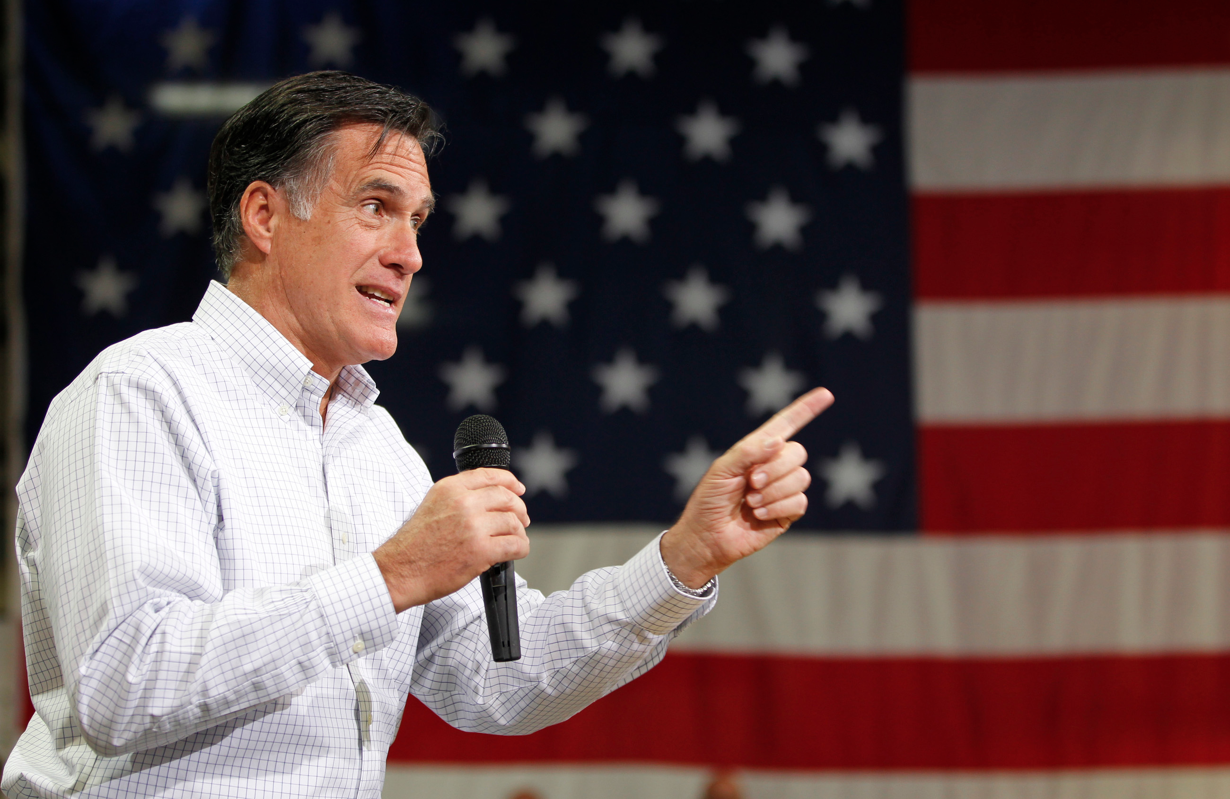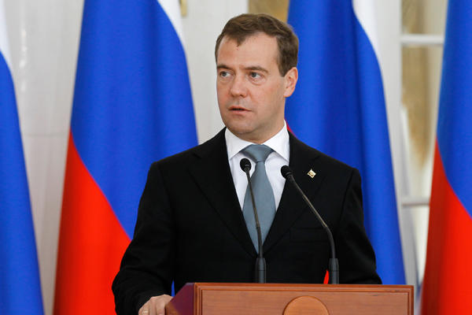
"This (Russia) is without question our number one geopolitical foe, they fight for every cause for the world's worst actors.”
Former Presidential candidate Mitt Romney

"I always get very cautious when I see a country resort to phrasings such as ‘number one enemy.’ It is very reminiscent of Hollywood and certain period of history. I would advise two things to all US presidential candidates, including the person you just mentioned. My first advice is to listen to reason when they formulate their positions. Reason never harmed a presidential candidate. My other advice is to check their clocks from time to time: it is 2012, not the mid-1970s.”

-Russian President Dmitry Medvedev

Last year Mitt Romney made some controversial statements about the relationship between United States and Russia. After WWII, both countries were entrenched in what was known as the Cold War for the second half of the 20th century. Romney’s comments have been dismissed by critics as representing “Cold War nostalgia”, while others agree with Romney that Russia is still a country to be reckoned with.

A few years ago, Kim Jong Un became the new leader of North Korea after his father passed. Not long after the transition, communist North Korea began releasing disturbing films of missiles destroying New York City. The North Korean government have been administering nuclear tests. President Obama responded by stating, “These provocations do not make North Korea more secure. Far from achieving its stated goal of becoming a strong and prosperous nation, North Korea has instead increasingly isolated and impoverished its people through its ill-advised pursuit of weapons of mass destruction and their means of delivery.”

These alarming events beg the question- Is the Cold War over?

Operation Super-Commie-Fragile-Realistic-Exposing-Allegations

Dear Members of the Operation SCFREA Task Force,

You have been given a task by the United Nations Security Council to investigate this claim that the Cold War may still be alive and well. Since 9/11, many funds and resources have been devoted to counter-terrorism, while the ideological tensions that defined the Cold War have been neglected for the last 10 years. The UN recognizes that this blind spot could potentially be dangerous. Your group’s task is to choose one country that was involved in the Cold War (not the U.S.) and prepare a memo that details the country’s history on political change, economics, and individuals from 1950 to the present day in order to determine whether or not Romney’s claim is valid. Your mission is crucial to maintaining international peace.

After the memo is prepared, we will conduct a UN summit that will address the following essential questions:

- Is the Cold War over?
- Are democratic governments less warlike than dictatorships?
- Did the collapse of the Soviet Union prove that Communism and Socialism are unworkable and/or undesirable ideals?
Group Memo Rubric
Outcome | Exceeds | Meets | Not Yet
Conclude  Infer meanings, analyze information and develop valid ideas based on evidence and analysis. | Group developed conclusions by looking at different sources and synthesizing ideas to support their claim. Themes of economics, political systems, individuals and geography are explored thoroughly to answer driving question.  __ Memo is more analytical than descriptive by using analysis of evidence to prove thesis | Group developed conclusions by looking at different sources and synthesizing ideas to support their claim. Themes of economics, political systems, individuals and geography are explored thoroughly to answer driving question.  ___ Memo is equal parts analytical and descriptive in attempts to prove thesis
Argue  Build a case for and defend conclusions reached, based in sound logic and valid evidence. Question and critique the arguments of others as warranted. | __ Memo makes a strong argument that the Cold War is still going on vs. the Cold War being a thing of the past  __ Evidence chosen supports thesis  __ Counterclaim is addressed  __ Memo is written from perspective of current leader of country | _ Memo makes a clear argument that the Cold War is still going on vs. the Cold War being a thing of the past  __ Evidence chosen supports thesis  __ Counterclaim is addressed  __ Memo is written from perspective of current leader of country
 | Monday | Tuesday | Wednesday | Thursday | Friday
Week 1 |  |  | 3.4  Entry Event  Aim: What is the Scope of the next unit?  HW: Read Chapter 1 | 3.5  Aim: What is Communism?  HW: Read Chapter 2 | 3.6  Aim: Why did the Russian Revolution begin?  Timeline DBQ activity,  “Internationale”  HW: Read Chapters 3-4
Week 2 | 3.9  Aim: How does Lenin’s  “What is to be done?” reflected in Orwell’s allegory?  HW: Read Chapter 5-6 | 3.10  Aim: How can we illuminate the beginning of Orwell’s allegory by looking at primary sources?  Start Animal Farm/Primary Source sorting activity | 3.11  Finish Animal Farm/Primary Source sorting activity  HW: Read Chapters 7-8 | 3.12  Aim: How did Stalin impact the Soviet Union?  Stalin- 5 Year Plans, Cult of Personality  HW: Read Chapters 9-10 | 3.13  Aim: How can we illuminate the end of Orwell’s allegory by looking at primary sources?  Primary source/Final Chapters of Animal Farm Sorting activity
Week 3 | 3.16  Finish sorting activity, continue analysis  Chapters 6-10 | 3.17  Aim: How did the Cold War begin?  Introduction to Cold War  Iron Curtain Speech  Marshall Plan  Berlin Wall  NATO vs. Warsaw Pact | 3.18  Aim: How did China’s and the Soviet Union’s brand of communism change in the 80s?  Fall of Soviet Union  Glasnost  Perestroika  Deng Xiaoping’s 4 modernizations | 3.19  North Korea Vice | 3.20  TYWLS WORKS
Week 4 | 3.23  Bourdain Cuba | 3.24  Research Day | 3.25  Research Day | 3.26  STUDENT LED CONFERENCES | 3.27  Research Day
Week | 3.30  Research Day | 3.31  Memo | 4.1  Memo | 4.2  Memo | 4.3  Memo  HW: Annotate DBQ documents
Week 6 | 4.6  SPRING BREAK  ANNOTATE DOCS | 4.7  SPRING  BREAK  ANNOTATE DOCS | 4.8  SPRING  BREAK  ANNOTATE DOCS | 4.9  SPRING BREAK  ANNOTATE DOCS | 4.10  SPRING  BREAK  ANNOTATE DOCS
Week | 4.13  Pre-Socratic Seminar | 4.14  Socratic Seminar  UN Summit | 4.15  In class DBQ | 4.16  Entry Event to Underground Movements | 4.17

Unit Bookends: From Animal Farm to UN Summit

- Read Animal Farm: Annotate chapters + complementary sources in Reading Log

We are going to begin the unit by reading George Orwell’s Animal Farm. Readings should be completed outside of class. As you read, you should be annotating the chapters in a reading log that I will provide for you. Your reading log must be completed as you read because I may allow you to use it on reading quizzes. Every day we will start class by discussing the chapter. We will then read and analyze primary sources that I will provide for you that complement the Animal Farm readings. During this time you should be discussing the significance with your group and annotating the documents in your reading log.

2. Research for Memo/Summit. Lead class discussion on your country

After we finish the novel, your group will embark on your research of your chosen country. Every research log should have at least 5 sources cited: 1 reference (encyclopedia/text book), 2 primary sources, and 2 secondary sources found on a database.

- Document-Based Question on the Cold War
You will be given the documents to annotate during Spring Break.

Individual Student Rubric
Outcome | Exceeds | Meets | Not Yet
Discern  Based on annotations in Animal Farm/ Primary Sources Reading Log | ___ Annotations are detailed and show in depth understanding of the allegory and the actual events that the novel is based on | ___ Annotations are sufficient and show understanding of the allegory and the actual events that the novel is based on
Conclude  Based on Analysis in Animal Farm/ Primary Sources Reading Log | ___ Analysis revealed thoughtful exploration of the themes and events that connect the allegory to the historical events that they are based on | ___ Analysis revealed exploration of the themes and events that connect the allegory to the historical events that they are based on
Communicate  Based on partner’s observations from UN Summit | ___Student helps drive discussion.  __ Student addresses questions to students who have not spoken  ___Student contributed to discussion as her character  ___ Student demonstrated understanding of major themes through contributions to conversation | ___Student speaks multiple times  ___Student contributed to discussion as her character  ___ Student demonstrated understanding of major themes through contributions to conversation

