Four Elements of Documentary:
- Interviews
- Cutaways
- Chill Footage
- Process Footage
1) Interviews
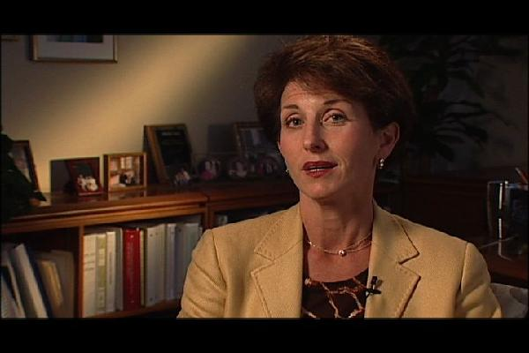
Frame the person using negative space, have them fill roughly 1/3 of the screen, on the left or right side. Make sure their "Gaze" is into the Negative space.
Leave room behind the subject, never interview someone right in front of a wall. Leave 4-15 feet between the subject and the wall, you will notice the person's shadow disappear from the wall. Watch out for reflections in people's glasses ,turn them away from facing the window to solve the problem.
The Background influences the way the person is perceived. When I walk in to shoot an interview, the first thing I do is look for a background that will reveal something about my subject. Build your questions from people's answers. repeat their last few words, ask "open ended questions" ( ones that can not be answered with a "Yes" or "No". For example, "Can you describe?", or "tell me about this...".

2) Cutaways
Cutaways: These are "Stand-alone" shots, similar to still photography.
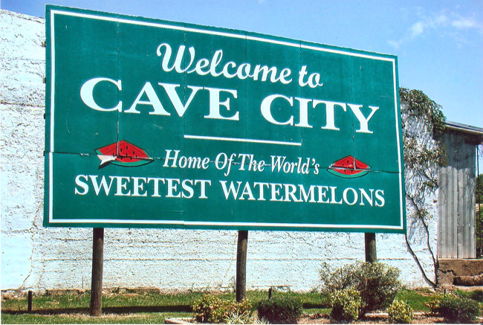
Shoot tons of Cutaways, and you life will be easier in the editing room.. Cutaways can be store signs, close ups of ashtrays, a clock on the wall, people's faces, a candle, a shot of a highway. I always get shots of the exteriors of every place I film, and some neighborhood shots. I try and treat my cutaways like still photographs. This is the time you can squeeze some visual poetry out of documentary. Always keep your eyes open for little "shots" that evoke something about the truth of the situation you are filming. Hold your shots still..don't move the camera....you will make it "move" in the editing process by cutting many of these together. Record 8-12 seconds for each shot.
There are three basic types of Cutaways that I suggest you always search for.
- Story Telling Shots- Images of "Welcome to " signs, exterior shots of houses where interviews were filmed, Images of your character entering and leaving a building, Wide shots of Cities or towns from ontop of a hill or large building. These will allow you to tell your story with out always having to use a narrator ..That's why I call them story telling Cutaways.
- Emotional Cutaways- Since film has the unique ability to make people feel...the way to construct emotional sequences is to first film shots that have emotional content built into them. For example a solitary man sitting on a park bench...two people walking hand in hand...A close up of a hand while they are praying...shot of a candle ....incense burning...people hugging...
- General Coverage- These are very important..if you are filming a race car contest...you had better get shots of people watching the race...cheering...the hot dog stand...people lined up to get in...Ushers tearing ticket stubs at the entrance (close-ups)...people cooking out in the middle of the raceway...a close op of flags, loudspeakers and race track signage. You will need all of these....get lot's of general coverage shots or you will be sorry.

3) "Chill Footage" cinema verite
Chill Footage is just a funny name for "Observational Footage". It is often called Cinema Verite.
We just want you to Chill and not talk to your subject...just follow them around with your camera...as they interact with the world around them Tell your subjects to "Pretend I am not here".
This observational material helps you uncover the "Emotional "part of your subject's Character

Process Footage
Process Footage: This is when you film the making of your documentary. Think of it like combing the Behind The Scenes footage of your film with the Documentary itself. You can be on-camera ( like the guy in Super Size Me or Michael Moore)...perhaps we just hear your off-screen voice, with a glimpse of you thru- out the film. If you need shots of you on location, give the camera to a "civilian" for a few minutes .

