3) TASK CARD Was WWI a “just war?”

a) Long and Short Term Causes of the War
b) Trench Warfare
c) Propaganda
d) New Technology
e) Mid-War Developments
f) Fighting against the Ottoman Empire
g) Treaty of Versailles
h) Collapse of the Ottoman Empire/ The Mandate System
i) “Just” War Discussion
j) Answer Essential Question
****************After all tasks completed, Check In with Zander****************

Key Terms: Alliance, Balkan powder keg, Schlieffen Plan, mobilize, western front, eastern front, trench warfare, war of attrition, 1st Battle of the Marne, propaganda, chemical warfare, Arab Revolt, guerrilla warfare , 2nd Battle of the Marne, Treaty of Versailles, Mandate System, Kemal Ataturk

3a: Long Term Causes of the War
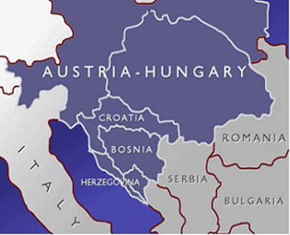
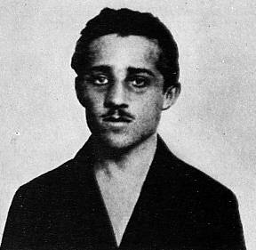
"I am a Yugoslav (Serbian ) nationalist, aiming for the unification of all Slavs, and I do not care what form of state, but it must be free from Austria."

“I could see the archduke and his wife. I reached for my gun, leaned forward, and pointed at my enemy.”

“I suggest that you nail me to a cross and burn me alive. My flaming body will be a torch to light my people on their path to freedom.”

-Gavrilo Princip, Assassin by day, Hipster by night

Read these quotes from the primary source was responsible for the immediate cause of WWI. Why was Franz Ferdinand (heir to the throne of Austria-Hungary) killed?

The beginning of WWI began with a political act of violence. How do we classify political acts of violence today? (Hint: This is review from last year…)

Trace this ridiculously corny but helpful fake-Twitter timeline of the day that Archduke Franz Ferdinand was killed. Choose what you believe to be the 4 most important events of this morning to construct your own timeline of the assassination.

http://www.hstry.co/timelines/franz-ferdinand-s-assassination

Date/Time | Event

The Balkan region has often been called the “powder keg” of Europe [as in gunpowder]. Why was it called this? How did the Black Hand’s goals lead to a spark?

http://www.canadiangeographic.ca/magazine/jun14/assets/map/

Look at the interactive map of the beginning of WWI.

- List the powers in the Triple Alliance:_______________________________________________
- List the powers in the Triple Entente: _______________________________________________
- Click on the United Kingdom and Germany. Why was the relationship between the United Kingdom and Germany heating up in the decades before the outbreak of WWI?

Annotate the following text from my man Chris Harman. Try to note all of the various social, political and economic forces that could be seen as long term causes to WWI.

Chris Harman, “The road to war.” A People’s History of the World, 2008. | ANNOTATIONS
The fact that imperialism meant wars between colonial powers as well as the enslavement of colonized peoples had been shown as early as 1904, when Russia’s drive east towards the Pacific led it into direct conflict, in northern China, with Japan’s drive west through Korea.
Twice it seemed as if a similar clash of interests in Morocco might lead to war between France and Germany, in 1906 and 1911. But the truly dangerous area was south east Europe, the Balkans, where each of the Great Powers regarded particular local states as its clients. There were wars between these states in 1912 and 1913. First Serbia, Greece, Montenegro and Bulgaria fell upon the remaining Turkish territories of Macedonia and Thrace, leaving Turkey with only Istanbul and a narrow strip of eastern Thrace. Then Greece,
Serbia and Romania, encouraged by the Great Powers, fell upon Bulgaria. The wars were marked by atrocities on all sides. Sections of the urban middle classes wanted to create and expand ‘modern’ linguistically uniform nation-states. But the rural populations were almost everywhere mixtures of different ethnic groups speaking different dialects and languages. The only way to carve out secure ‘ethnically pure’ nation-states was through wars involving the expulsion and even extermination of civilians who did not fit the necessary criteria. The first war ended in the Treaty of London, and the second in the Treaty of Bucharest. But these did nothing to remove the underlying pressures leading to war, and the same pressures existed in much of Austro-Hungarian Eastern Europe as in the former Ottoman areas. The whole region was a gigantic explosive cocktail. Just how explosive was shown in July 1914, when the Austrian Archduke Franz Ferdinand paid an official visit to Sarajevo, the capital of the Austrian-run province of Bosnia. He was assassinated by a nationalist who stood for driving out the Austrians and integrating the province into neighboring Serbia. What happened next is well known: the Austrian government declared war on Serbia; the Russian government feared a challenge to its own position and declared war on Austria; Germany identified its interests with Austria’s and moved against Russia; France felt it had to prevent Germany defeating Russia and becoming the dominant European power; Britain threw its weight behind France and went to war against Germany, using the movement of German troops through Belgium as an excuse. Within a week, 44 years of peace in Western Europe—the longest period anyone could recall—had given way to a war involving all the major states. Wars, like revolutions, often seem to be triggered by the most minor of events. This leads people to see them as accidental, a result of a random chain of misjudgments and misunderstandings. But, in fact, the minor events are significant because they come to symbolize
the balance between great social or political forces. A sparkplug is one of the cheapest components in a motor car, and cannot move anything by itself. But it can ignite the explosive force of petrol vapor in the engine. In the same way, an assassination or a tax rise can be of little importance in itself, but can bring about clashes between states or great social forces. Behind the long chain of diplomatic activity in the summer of 1914 lay a very simple fact. The rival imperialisms which had emerged as each capitalism tried to solve its own problems by expanding across state boundaries now collided right across the world. Economic competition had turned into competition for territories, and the outcome depended on armed might. No state could afford to back down once the chain of confrontations had been set off by the Sarajevo assassination, because no state could risk a weakening of its global strength. The same imperialism which had stimulated economic growth and a belief in the inevitability of progress was now to tear the heart of Europe apart.

Above, Chris Harman writes, “an assassination or a tax rise can be of little importance in itself, but can bring about clashes between states or great social forces.”

What great social forces is Harman discussing? Sure, the assassination of Archduke Franz Ferdinand started the war, but what long-term social forces that began in the 19th century led to the eruption of WWI? Find at least 4 possible causes.

3b: Trench Warfare

“The Schlieffen Plan”- from the BBC
“Germany had been preparing for war long before 1914. In fact, Germany had started drawing up a plan for war - the Schlieffen Plan - in 1897. It took nine years to finalize, but it was based on the theory that Germany would be at war with France and Russia at the same time. It did not prepare for many of the events that occurred in July and August 1914. It was based on the belief that, if the country went to war, Germany would be faced with a war on two fronts with France and Russia.
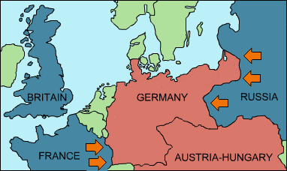

This map shows the war faced by Germany on two fronts
The Schlieffen plan assumed that France was weak and could be beaten quickly, and that Russia was much stronger, but would take longer to mobilize its army.”

What is the goal of the Schlieffen Plan?

First Battle of the Marne, taken from Howard Zinn’s A People’s History of the United States

In the first Battle of the Marne, the British and French succeeded in blocking the German advance on Paris. Each side had 500,000 casualties.
The killing started very fast, and on a large scale. In August 1914, a volunteer for the British army had to be 5 feet 8 inches to enlist. By October, the requirement was lowered to 5 feet 5 inches. That month there were thirty thousand casualties, and then one could be 5 feet 3. In the first three months of war, almost the entire original British army was wiped out.
For three years the battle lines remained virtually stationary in France. Each side would push forward, then back, then forward again- for a few yards, a few miles, while the corpses piled up. In 1916 the Germans tried to break through at Verdun; the British and French counterattacked along the Seine, moved forward a few miles, and lost 600,000 men. One day, the 9th Battalion of the King's Own Yorkshire Light Infantry launched an attack- with eight hundred men. Twenty-four hours later, there were eighty-four left. The war had become a war of attrition.
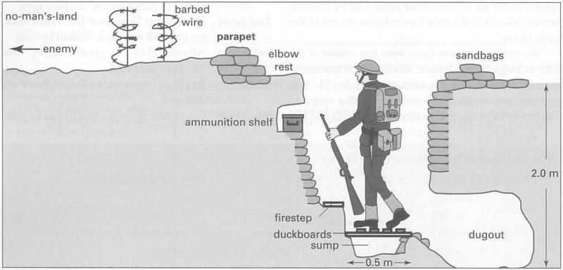

http://www.youtube.com/watch?v=D_FpvJmtaug

According to Zinn, after the first Battle of the Marne the war on the western front was defined by trench warfare. What was trench warfare? Was the Schlieffen Plan a success? Use evidence from Zinn and A Very Long Engagement to support your claim.

Aftermath by S. Sassoon.
HAVE you forgotten yet?...
Do you remember the dark months you held the sector at Mametz--
The nights you watched and wired and dug and piled sandbags on parapets?
Do you remember the rats; and the stench
Of corpses rotting in front of the front-line trench--
And dawn coming, dirty-white, and chill with a hopeless rain?
Do you ever stop and ask, 'Is it all going to happen again?'
Do you remember that hour of din [noise] before the attack--
And the anger, the blind compassion that seized and shook you then
As you peered at the doomed and haggard faces of your men?
Do you remember the stretcher-cases lurching back
With dying eyes and lolling heads--those ashen-grey
Masks of the lads who once were keen and kind and gay?
Have you forgotten yet?...
Look up, and swear by the green of the spring that you'll never forget.
Read the excerpt of the poem above. What defined Siegfried’s life in the trench? Why do you think Sassoon in intent on not forgetting?

3c: Propaganda

Propaganda- information, esp. of a biased or misleading nature, used to promote a particular political cause or point of view

Read and annotate the excerpt from historian Howard Zinn below.

Historian Howard Zinn's account of US involvement in World War I, the reasons behind it, and working class resistance to it.
This article is an extract from Zinn's People's history of the United States
"War is the health of the state," the radical writer Randolph Bourne said, in the midst of the First World War. Indeed, as the nations of Europe went to war in 1914, the governments flourished, patriotism bloomed, class struggle was stilled, and young men died in frightful numbers on the battlefields-often for a hundred yards of land, a line of trenches.
The supreme fulfillment of that responsibility was taking place in Europe. Ten million were to the on the battlefield; 20 million were due to the hunger and disease related to the war. And no one since that day has been able to show that the war brought any gain for humanity that would be worth one human life. The rhetoric of the socialists, that it was an "imperialist war," now seems moderate and hardly debatable. The advanced capitalist countries of Europe were fighting over boundaries, colonies, spheres of influence; they were competing for Alsace-Lorraine, the Balkans, Africa, the Middle East.
The war came shortly after the opening of the twentieth century, in the midst of exultation (perhaps only among the elite in the Western world) about progress and modernization. One day after the English declared war, Henry James wrote to a friend: "The plunge of civilization into this abyss of blood and darkness ... is a thing that so gives away the whole long age during which we have supposed the world to be ... gradually bettering."
Back home, the British were not told of the slaughter. One English writer recalled: "The most bloody defeat in the history of Britain . . . might occur . . . and our Press come out bland and copious and graphic with nothing to show that we had not had quite a good day-a victory really..." The same thing was happening on the German side; as Erich Maria Remarque wrote in his great novel, on days when men by the thousands were being blown apart by machine guns and shells, the official dispatches announced "All Quiet on the Western Front."
The people of France and Britain were not told the extent of the casualties. When, in the last year of the war, the Germans attacked ferociously on the Somme [river in northern France], and left 300,000 British soldiers dead or wounded, London newspapers printed the following,
“WHAT CAN I DO?
How the Civilian May Help in this Crisis.
Be cheerful...
Write encouragingly to friends at the front...
Don't repeat foolish gossip.
Don't listen to idle rumors.
Don't think you know better than Haig [leader of the British army].”

Image A Image B
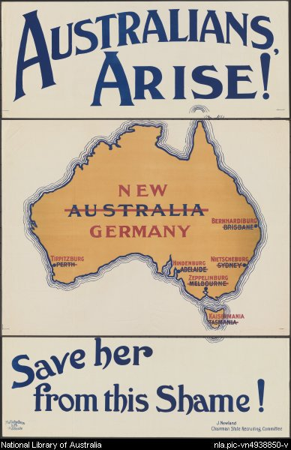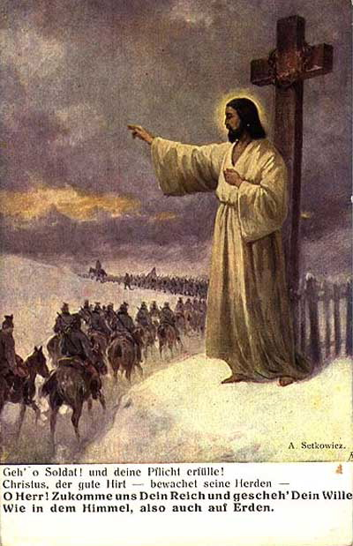

Analyze the London newspaper and compare its propaganda techniques to image A and image B. What different types of propaganda tactics do the examples above employ? Why would they be effective in swaying public opinion?

3d: New Technology

Watch the clip from the film A Very Long Engagement. What technology is being used to fight this war? Why does the soldier do what he does in the second half of the clip? http://www.youtube.com/watch?v=j9NrElifkXU

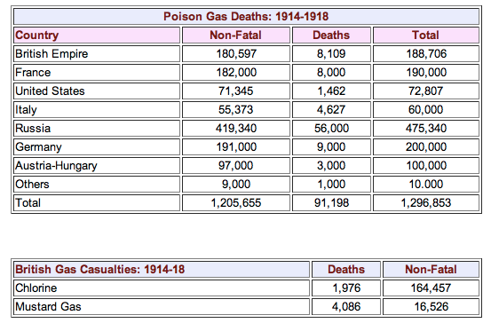

Were there more fatalities on the eastern front or the western front from 1914-1918? Why?

Chemical warfare was feared not only because of it was an effective weapon, but also due to its psychological impacts. Based on the famous poem by Willfred Owen, why would chemical warfare cause psychological torture?

“GAS! Gas! Quick, boys!-- An ecstasy of fumbling,
Fitting the clumsy helmets just in time;
But someone still was yelling out and stumbling
And floundering like a man in fire or lime.--
Dim, through the misty panes and thick green light
As under a green sea, I saw him drowning.
In all my dreams, before my helpless sight,
He plunges at me, guttering, choking, drowning.”

Wilfred Owen- “Dulce et Decorum Es”

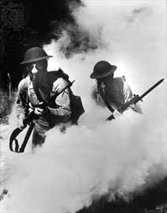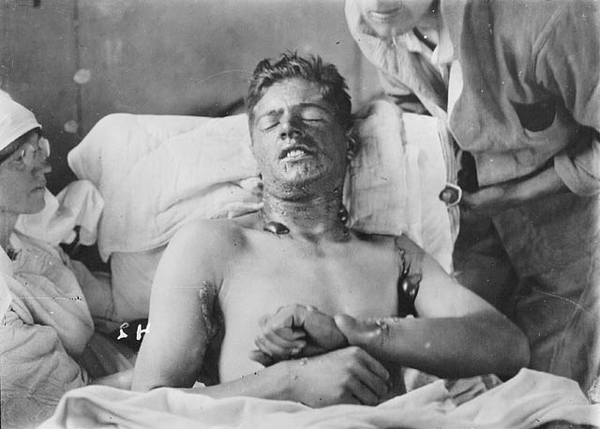

3g: Mid- War Developments: Russia out, America in

In 1917 a revolution occurred in Russia. Since we will be delving into that rich subject later on in our Cold War unit, we will get into the specifics later. The unpopularity of the war in Russia caused Russia to exit the war in 1917. However, the United States joined the war effort the very same year. Read and annotate another passage from Zinn’s classic, A People’s History of the United States to determine Zinn’s argument for the reason why the belated entry into WWI.

Into this pit of death and deception carne the United States, in the spring of 1917. Mutinies were beginning to occur in the French army. Soon, out of 112 divisions, 68 would have mutinies; 629 men would be tried and condemned, 50 shot by firing squads. American troops were badly needed.
President Woodrow Wilson had promised that the United States would stay neutral in the war: "There is such a thing as a nation being too proud to fight." But in April of 1917, the Germans had announced they would have their submarines sink any ship bringing supplies to their enemies; and they had sunk a number of merchant vessels. Wilson now said he must stand by the right of Americans to travel on merchant ships in the war zone. "I cannot consent to any abridgement of the rights of American citizens in any respect. . . ."
As Richard Hofstadter points out (The American Political Tradition): "This was rationalization of the flimsiest sort.. . ." The British had also been intruding on the rights of American citizens on the high seas, but Wilson was not suggesting we go to war with them. Hofstadter says Wilson "was forced to find legal reasons for policies that were based not upon law but upon the balance of power and economic necessities."
It was unrealistic to expect that the Germans should treat the United States as neutral in the war when the U.S. had been shipping great amounts of war materials to Germany's enemies. In early 1915, the British liner Lusitania was torpedoed and sunk by a German submarine. She sank in eighteen minutes, and 1,198 people died, including 124 Americans. The United States claimed the Lusitania carried an innocent cargo, and therefore the torpedoing was a monstrous German atrocity. Actually, the Lusitania was heavily armed: it carried 1,248 cases of 3-inch shells, 4,927 boxes of cartridges (1,000 rounds in each box), and 2,000 more cases of small-arms ammunition. Her manifests were falsified to hide this fact, and the British and American governments lied about the cargo.
Hofstadter wrote of "economic necessities" behind Wilson's war policy. In 1914 a serious recession had begun in the United States. J. P. Morgan later testified: "The war opened during a period of hard times. ... Business throughout the country was depressed, farm prices were deflated, unemployment was serious, the heavy industries were working far below capacity and bank clearings were off." But by 1915, war orders for the Allies (mostly England) had stimulated the economy, and by April 1917 more than $2 billion worth of goods had been sold to the Allies. As Hofstadter says: "America became bound up with the Allies in a fateful union of war and prosperity."
Prosperity depended much on foreign markets, it was believed by the leaders of the country. In 1897, the private foreign investments of the United States amounted to $700 million dollars. By 1914 they were $3 billion. Wilson's Secretary of State, William Jennings Bryan, while a believer in neutrality in the war, also believed that the United States needed overseas markets; in May of 1914 he praised the President as one who had "opened the doors of all the weaker countries to an invasion of American capital and American enterprise."
The industrialists and the political leaders talked of prosperity as if it were classless, as if everyone gained from Morgan's loans. True, the war meant more production, more employment, hut did the workers in the steel plants gain as much as U.S. Steel, which made $348 million in profit in 1916 alone? When the United States entered the war, it was the rich who took even more direct charge of the economy. Financier Bernard Baruch headed the War Industries Board, the most powerful of the wartime government agencies. Bankers, railroad men, and industrialists dominated these agencies.
A remarkably perceptive article on the nature of the First World War appeared in May 1915 in the Atlantic Monthly. Written by W. E. B. Du Bois, it was tided "The African Roots of War." It was a war for empire, of which the struggle between Germany and the Allies over Africa was both symbol and reality: "In a very real sense Africa is a prime cause of this terrible overturning of civilization which we have lived to see." Africa, Du Bois said, is "the Land of the Twentieth Century," because of the gold and diamonds of South Africa, the cocoa of Angola and Nigeria, the rubber and ivory of the Congo, the palm oil of the West Coast.
Du Bois saw more than that. He was writing several years before Lenin's Imperialism, which noted the new possibility of giving the working class of the imperial country a share of the loot. He pointed to the paradox of greater "democracy" in America alongside "increased aristocracy and hatred toward darker races." He explained the paradox by the fact that "the white workingman has been asked to share the spoil by exploiting 'chinks and niggers."' Yes, the average citizen of England, France, Germany, the United States, had a higher standard of living than before. But: "Whence comes this new wealth? ... It comes primarily from the darker nations of the world-Asia and Africa, South and Central America, the West Indies, and the islands of the South Seas."
Du Bois saw the ingenuity of capitalism in uniting exploiter and exploited-creating a safety valve for explosive class conflict. "It is no longer simply the merchant prince, or the aristocratic monopoly, or even the employing class, that is exploiting the world: it is the nation, a new democratic nation composed of united capital and labor."
The United States fitted that idea of Du Bois. American capitalism needed international rivalry-and periodic war-to create an artificial community of interest between rich and poor, supplanting the genuine community of interest among the poor that showed itself in sporadic movements. How conscious of this were individual entrepreneurs and statesmen? That is hard to know. But their actions, even if half-conscious, instinctive drives to survive, matched such a scheme. And in 1917 this demanded a national consensus for war.
The government quickly succeeded in creating such a consensus, according to the traditional histories. Woodrow Wilson's biographer Arthur Link wrote: "In the final analysis American policy was determined by the President and public opinion." In fact, there is no way of measuring public opinion at that time, and there is no persuasive evidence that the public wanted war. The government had to work hard to create its consensus. That there was no spontaneous urge to fight is suggested by the strong measures taken: a draft of young men, an elaborate propaganda campaign throughout the country, and harsh punishment for those who refused to get in line.

What is Zinn’s thesis on the late U.S. entry into WWI? Where does he fall on the political spectrum?

What did African-American intellectual, W.E. Dubois, argue was the cause of the U.S. joining WWI? If Dubois’ analysis is true, how does that complicate Marx’s class war against capitalism? (Yes, this is a bit of a hard question…)

3f: Fighting against the Ottoman Empire

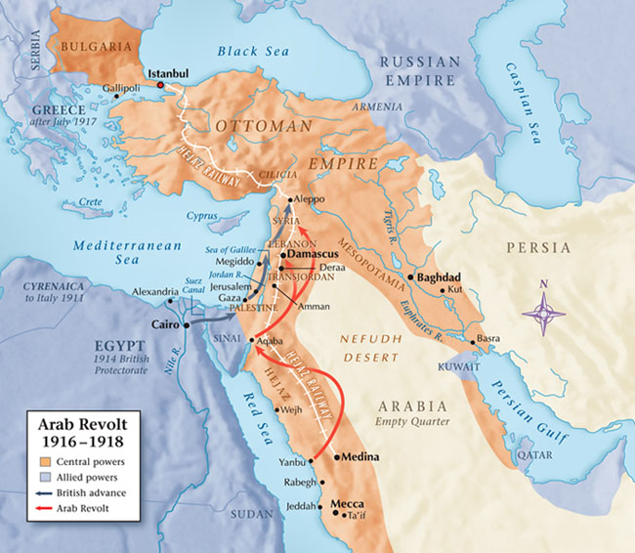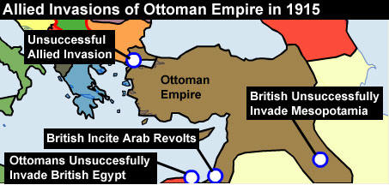
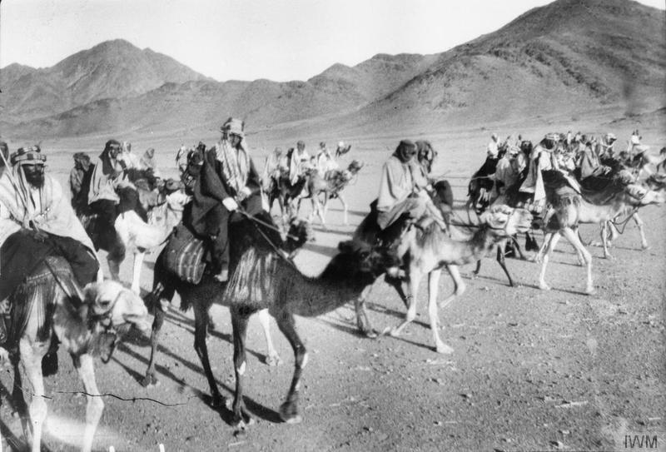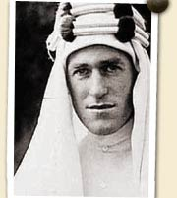
Annotate the Source Below | ANNOTATIONS
Though the Ottoman Empire—in a period of relative decline since the late 16th century—had initially aimed to stay neutral in World War I, it soon formed an alliance with Germany and entered the war on the side of the Central Powers in October 1914. The Turks fought fiercely and successfully defended the Gallipoli Peninsula against a massive Allied invasion of Australians and New Zealanders in 1915-1916, but by 1918 defeat by invading British and Russian forces and an Arab revolt had combined to destroy the Ottoman economy and devastate its land, leaving some six million people dead and millions more starving.
Born on August 16, 1888, in Caernarvonshire, Wales, T.E. Lawrence served in the British military, becoming involved in Middle Eastern affairs and playing a key role in the Great Arab Revolt. Lawrence joined Amir Faisal al Husayn's revolt against the Turks as political liaison officer, leading a guerilla campaign that harassed the Turks behind their lines. After a major victory at Aqaba—a port city on the southern coast of what is now Jordan—Lawrence's forces supported British General Allenby's campaign to capture Jerusalem. By 1918, Lawrence had been promoted to lieutenant colonel and was awarded the Distinguished Service Order and the Order of Bath by King George V, but politely refused the medals in support of Arab independence.
As early as the first week of October 1918, both the Ottoman government and several individual Turkish leaders contacted the Allies to feel out peace possibilities. Britain, whose forces then occupied much of the Ottoman territories, was loath to step aside for its allies, particularly France, which according to an agreement concluded in 1916 would take control of the Syrian coast and much of modern-day Lebanon. In a move that enraged his French counterpart, Georges Clemenceau, Prime Minister David Lloyd George negotiated an immediate armistice with Turkey without consulting France. Though Britain alone would engineer the Ottoman exit from the war, the two powerful Allies would continue to grapple over control in the region at the Paris Peace Conference, and for years beyond. The Treaty of Mudros ended Ottoman participation in World War I and effectively marked the dissolution of a once mighty empire. From its ruins, the victors of the First World War attempted to use the post-war peace negotiations to create a new, more unpredictable entity: the modern Middle East.

How did the Allies’ fight against the Ottoman Empire make WWI truly a “world” war? Who was involved in this fight against the Ottoman Turks?

Watch the 3 clips below:

Battle of Gallipoli
https://www.youtube.com/watch?v=d-kVrdc9g_s

Lawrence of Arabia and the Arab Revolt
http://www.youtube.com/watch?v=XgmdcZEz_b0

https://www.youtube.com/watch?v=vR3FPplcJGg

Based on the different clips from the respective films Gallipoli and Lawrence of Arabia, what types of different war tactics are being used against the Ottoman Empire? Historians often say that WWI was so bloody because it was a war that used traditional combat techniques with new technology. How do these clips illustrate that point?

3g: Treaty of Versailles

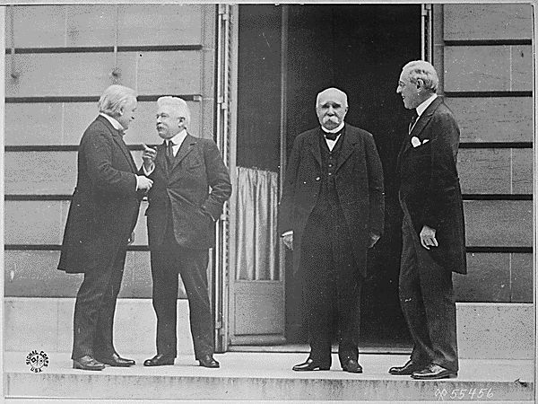
Most of the terms of the Treaty of Versailles were set at the Paris Peace Conference, which was dominated by (l-r) Lloyd George of Great Britain, Vittorio Orlando of Italy, Georges Clemenceau of France, and Woodrow Wilson of the United States.

After Russia left the war, Germany turned its attention to the Western Front. Victory seemed within reach since Germany was only 40 miles away. In July 1918, the Allies and Germans clashed at the Second Battle of the Marne. 350 allied tanks smashed through German lines. With the arrival of 2 million more American troops, the Allies advanced toward Germany. The stalemate that had begun at the First Battle of the Marne in 1914 had now ended after the success of the Second Battle of the Marne. The central powers soon crumbled. Bulgarians and Ottomans surrendered. On November 9, 1918, Germany’s Kaiser Wilhelm II stepped down and Germany was declared a republic. Finally, on November 11, 1918, Germany and France signed an armistice, an agreement to stop fighting. The allied powers then decided the fate of the world….

Annotate the selected Articles below:

Treaty of Versailles, Jun 28, 1919

On June 28,1919, the Allied powers presented the Treaty of Versailles to Germany for signature. The following are the key territorial and political clauses.
Article 22. Certain communities formerly belonging to the Turkish Empire have reached a stage of development where their existence as independent nations can be provisionally recognized subject to the rendering of administrative advice and assistance by a Mandatory [i.e., a Western power] until such time as they are able to stand alone. The wishes of these communities must be a principal consideration in the selection of the Mandatory.

Article 42. Germany is forbidden to maintain or construct any fortifications either on the left bank of the Rhine or on the right bank to the west of a line drawn 50 kilometers to the East of the Rhine.

Article 45. As compensation for the destruction of the coal mines in the north of France and as part payment towards the total reparation due from Germany for the damage resulting from the war, Germany cedes to France in full and absolute possession, with exclusive right of exploitation, unencumbered and free from all debts and charges of any kind, the coal mines situated in the Saar Basin....

Article 119. Germany renounces in favor of the Principal Allied and Associated Powers all her rights and titles over her overseas possessions.

Article 159. The German military forces shall be demobilized and reduced as prescribed hereinafter.

Article 160. By a date which must not be later than March 31, 1920, the German Army must not comprise more than seven divisions of infantry and three divisions of cavalry. After that date the total number of effectives in the Army of the States constituting Germany must not exceed 100,000 men.

Article 231. The Allied and Associated Governments affirm and Germany accepts the responsibility of Germany and her allies for causing all the loss and damage to which the Allied and Associated Governments and their nationals have been subjected as a consequence of the war imposed upon them by the aggression of Germany and her allies.

Article 232. The Allied and Associated Governments recognize that the resources of Germany are not adequate, after taking into account permanent diminutions of such resources which will result from other provisions of the present Treaty, to make complete reparation for all such loss and damage. The Allied and Associated Governments, however, require, and Germany undertakes, that she will make compensation for all damage done to the civilian population of the Allied and Associated Powers and to their property during the period of the belligerency of each as an Allied or Associated Power against Germany.

Based on the selection of articles from the Treaty of Versailles, what were two of the allies’ main goals? How did they achieve them?

3h: Collapse of Empires/ Mandate System
The end of WWI had a extraordinary impact on the world map. The Ottoman Empire, Austro-Hungarian Empire and German Empire were dissolved. New nation-states replaced the multi-national Austria-Hungary. Turkey became a republic under the leadership of Kemal Ataturk. But what happened to the rest of the non-Turkic Ottoman Empire?
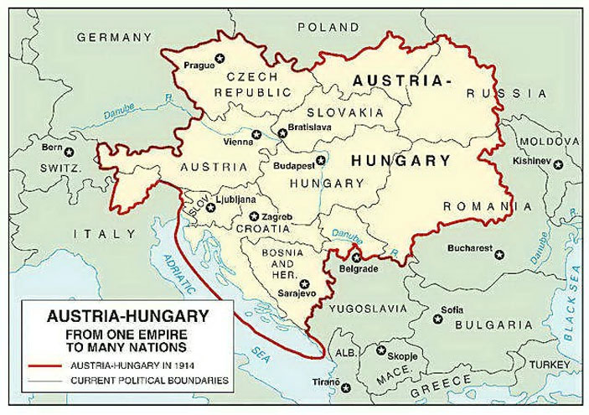 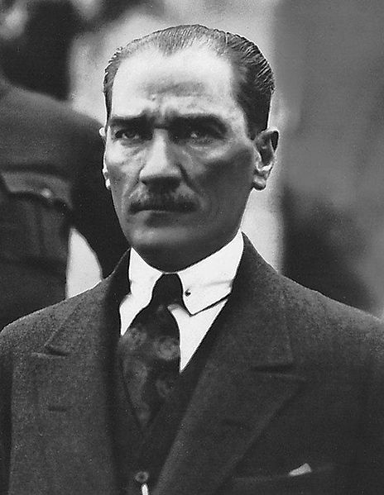 The nations of Austria-Hungary Kemal Ataturk of Turkey World War I transformed the Middle East in ways it had not seen for centuries. The Europeans, who had colonized much of the Ottoman Empire in the 19th century, completed the takeover with the territories of Arabia, Iraq, Syria, Lebanon and Palestine. Turkish general and statesman Kemal Ataturk became president of the new Republic of Turkey from 1923–38. As the first president of the Turkish republic, he abolished the caliphate and introduced other policies designed to make Turkey a modern secular state.
The modern boundaries of the Middle East emerged from the war. So did modern Arab nationalist movements and embryonic Islamic movements. NPR's Mike Shuster reports on World War I and its aftermath as he continues his series on the history of Western involvement in the Middle East.
With the onset of WWI, the French and the British sent armies and agents into the Middle East, to foment revolts in the Arabian Peninsula and to seize Iraq, Syria and Palestine. In 1916, French and British diplomats secretly reached the Sykes-Picot agreement, carving up the Middle East into spheres of influence for their respective countries. That agreement was superceded by another which established a mandate system of French and British control, sanctioned by the new League of Nations.
Under the mandate system, Syria and Lebanon went to the French. The British took over Palestine and three Ottoman provinces of Mesopotamia and created modern-day Iraq.
"Everyone understood at the time that this was a thinly disguised new form of colonialism...," says Zachary Lockman, professor of Middle East history at New York University. "The British and French had no thought of going anywhere anytime soon, and fully intended to remain in control of these territories for the indefinite future."
But almost immediately after the war, Arab resistance movements emerged to challenge European dominance.
Truthloader: The Origins of recent Middle East Conflict
https://www.youtube.com/watch?v=h2jdWMV4YpU

Lawrence of Arabia: Sykes-Picot Agreement
https://www.youtube.com/watch?v=fBrw53I8QU0

Watch the 2 clips above on the Sykes-Picot agreement. What was the purpose of the agreement? What impact would it have on the world for the rest of the 20th century? How does T.E. Lawrence take the news in the clip from Lawrence of Arabia?

3i: Discussion

First world war: an imperial bloodbath that’s a warning, not a noble cause
by Seumas Milne
They were never going to be able to contain themselves. For all the promises of a dignified commemoration, the right-wing held back for less than 48 hours into the new year before launching a full-throated defense of the "war to end all wars". The killing fields of Gallipoli and the Somme had been drenched in blood for a "noble cause", declared Michael Gove. The slaughter unleashed in 1914 had been a "just war" for freedom.
Hostility to the war, the education secretary complained, had been fostered by left-wingers and comedians who denigrated patriotism and painted the conflict as a "misbegotten shambles".
Boris Johnson went further. The war was the fault of German expansionism and aggression, London’s mayor pronounced, and called for Labor’s shadow education secretary Tristram Hunt to be sacked forthwith if he doubted it. The Conservatives were backed up by a team of more-or-less loyal historians. Max Hastings reckoned it had been fought in defense of "international law" and small nations, while Antony Beevor took aim at "anti-militarists".
This is all preposterous nonsense. Unlike the second world war, the bloodbath of 1914-18 was not a just war. It was a savage industrial slaughter perpetrated by a gang of predatory imperial powers, locked in a deadly struggle to capture and carve up territories, markets and resources.
Germany was the rising industrial power and colonial Johnny-come-lately of the time, seeking its place in the sun from the British and French empires. The war erupted directly from the fight for imperial dominance in the Balkans, as Austria-Hungary and Russia scrapped for the pickings from the crumbling Ottoman empire. All the ruling elites of Europe, tied together in a deathly quadrille of unstable alliances, shared the blame for the murderous barbarism they oversaw. The idea that Britain and its allies were defending liberal democracy, let alone international law or the rights of small nations, is simply absurd.
It’s not just that 40% of men and all women in Britain were denied the vote in 1914 – unlike Germany, which already had full male suffrage [right to vote] – or that the British empire was allied with the brutal autocracy of tsarist Russia.
Every single one of the main warring states was involved in the violent suppression of the rights of nations throughout the racist tyrannies that were their colonial empires. In the decades before 1914, about 30 million people died from famine as colonial officials enforced the export of food in British-ruled India, slaughtered resisters in their tens of thousands and set up concentration camps in South Africa.
Britain was supposed to have gone to war to defend the neutrality of "plucky little Belgium" – which had itself presided over the death of 10 million Congolese from forced labor and mass murder in the previous couple of decades. German colonialists had carried out systematic genocide in what is now Namibia in the same period.
As to international law, Britain’s disdain for it was demonstrated when Germany had asked by what right it claimed territory in Africa a few years before. London refused to reply. The answer was obvious: brute force. This was the "liberal" global order for which, in the words of the war poet Wilfred Owen, the ruling classes "slew half the seed of Europe, one by one".
In reality, it wasn’t just the seed of Europe they sacrificed, but hundreds of thousands of troops from their colonies as well. And in case there were any doubt that all the main combatants were in the land-grabbing expansion game, Britain and France then divvied up the defeated German and Ottoman empires between them, from Palestine to Cameroon, without a thought for small nations’ rights, laying the ground for future disasters in the process.
Gove and his fellow war apologists worry that satirical shows such as Blackadder have sapped patriotism by portraying the war as "a series of catastrophic mistakes perpetrated by an out-of-touch elite". The incompetence and cynicism of generals and politicians certainly had horrific results. But it was the nature of the war itself that was most depraved [immoral].
Fortunately, the revisionists lost the argument among the public long ago – just as Gove has largely lost his battle to impose an imperial agenda on the school history curriculum. They will keep trying though, because historical debates are about the future as much as the past – and so long as imperial conflict is discredited, future foreign military interventions and occupations will be difficult to sell.
For the rest of us, this year’s anniversary should be a reminder that empire in all its forms, militarism and national chauvinism lead to bloodshed and disaster. It also contains a warning about the threat from the rise and fall of great powers. China is no imperial Germany, but the US – allied with Japan – is a declining global power in a region in which it is tightening its military grip. It’s not 1914, but the dangers are clear.

The Great War was a Just War

By Gary Sheffield | Published in History Today Volume: 63 Issue: 8 2013

Britain was right to fight Imperial Germany in 1914.
At that point in Britain’s history, it was important that there was a war that ensured that Europe could continue to be a set of countries which were strong and which could be working together.’ Such was the view of Maria Miller, the culture secretary, on why the First World War was fought, given on BBC Radio 4’s flagship Today program on June 10th, 2013. Her comments were greeted with ridicule. She was responding to the journalist and historian Max Hastings, who had stated that most historians held Germany and Austria-Hungary primarily responsible for the outbreak of the First World War. While recently there has been an attempt to spread the blame, particularly by pinning responsibility on Russia, this indeed remains the mainstream position among serious historians. In the debate over war guilt, what happened next is often ignored. However the conflict started, Germany took full advantage to carry out a war of conquest and aggression. Britain’s First World War was a war of national survival, a defensive conflict fought at huge cost against an aggressive enemy bent on achieving hegemony in Europe.
As it stands, the Government’s position of neutrality regarding the meaning of the war denies the commemorations [ceremony of remembrance] the context necessary to make sense of them. The UK’s leading historian of the First World War, Professor Sir Hew Strachan, who is a member of the Government’s own advisory committee, early on described official plans for the commemoration as ‘conceptually empty’. Strachan’s criticisms remain valid. The Government has explicitly disavowed trying to create any particular ‘narrative’, but by refusing to set the commemorations into the context of the origins of the war and the aggression of the Central Powers, this is exactly what it has done. Merely commemorating the sacrifice of British troops without explaining why they died tacitly [silently] gives support to the dominant popular view that the war was futile [pointless] and the deaths meaningless. So does the fact that the original program of official commemorations included defeats such as Gallipoli and the First Day on the Somme, but omitted the great victories of 1918 that won the war.
The reason for the Government’s squeamishness has been blamed on what might be termed the Basil Fawlty/Noël Coward approach – ‘don’t mention the war/let’s not be beastly to the Germans’ – but concern at domestic reaction is probably more important. In 1994 and 2004, the time of the 50th and 60th anniversaries of D-Day, Conservative and Labor governments had no problem in blaming Nazi Germany for the Second World War or in celebrating the defense of democracy. But it seems the First World War is different. It is hard to overestimate the extent to which the idea of the war being ‘futile’ and the battles meaningless bloodbaths conducted by callous and criminally incompetent generals is (to use an appropriate word) ‘entrenched’. In a two-decade career as a public historian, putting forward alternative views on television, radio and in the press, I have become well aware that daring to suggest that Blackadder Goes Forth is not actually a documentary brings forth paroxysms of anger. I therefore have some sympathy for politicians who do not want to offend members of the electorate: after all, they want to be re-elected. Dr. Andrew Murrison, MP, the prime minister’s lead for the centenary commemorations, deserves great credit for breaking ranks to state that for the British the war was just.
There is much in the Government’s commemoration plans that should be applauded, but I cannot approve of the decision, for political reasons, to take the path of least resistance by maintaining its non-judgmental stance. No one wants to see five years of German-bashing, but we run the risk of missing a (literally) once in a century opportunity to educate the public about the war. For the government to show leadership by showcasing the wealth of scholarly research that undermines the Blackadder view might be politically risky, but it is the right thing to do.
Professor Gary Sheffield takes up the Chair of War Studies at the University of Wolverhampton in September 2013. He is the author of The Chief: Douglas Haig and the British Army (Aurum, 2011).
Points made that WWI was not a just war | Points made that WWI was a just war

Group Discussion: Use self-created thick questions and the chart above to guide your discussion. Be sure to use evidence from the task to make your point!

Time discussion begins________ Time Discussion Ends ________
Guiding Questions….. | Interesting Points Made…
Was WWI a just war?

3j) Answer Essential Question: Was WWI a “just war?”

Be sure to use all of the words in the word wall: Alliance, Balkan powder keg, Schlieffen Plan, mobilize, western front, eastern front, trench warfare, war of attrition, 1st Battle of the Marne, propaganda, , chemical warfare, Arab Revolt, guerrilla warfare, 2nd Battle of the Marne, Treaty of Versailles, Mandate System, Kemal Ataturk

Mobilize- organize troops for active service; prepare for war
war of attrition- gradually reducing strength of opposing side through sustained attack; bleeding the enemy to death
guerrilla war- irregular fighting, typically against larger regular forces; unconventional warfare
Stalemate-a situation in which further action or progress by opposing or competing parties seems impossible

