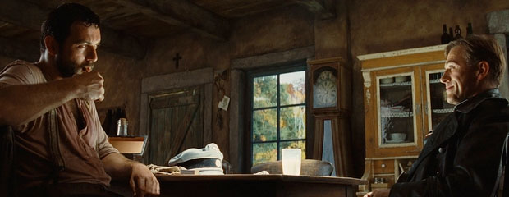
Driving Question: How Do You Stop a Genocide?

Take a moment to list everything you remember learning about WWII:

We are going to watch the first scene from director Quentin Tarantino’s brilliant and bizarre film, Inglourious Basterds. I want you to analyze the three parties involved. What are each person’s goals? How does each person try to achieve his/her goals?

Character(s) | What are his/her goals? | How does the character attempt to achieve these goals?
Hans Landa
French Dairy Farmer
???????
Write your definition of genocide: __________________________________________
We all know that genocide is horrible. However, the purpose of this unit will not only be analyzing the Holocaust, but atrocities committed by all sides during WWII.
Daniel Greenfield, a journalist, stated:
“There was no other way to stop the genocide that Germany and Japan had been inflicting on Europe and Asia except through a way of war that would kill countless civilians. A refusal to fight that war would not have been the moral course. It would have meant that the Allies would have continued to serve as the silent partners in genocide. The same thing is true today.”
Is Greenfield right? Is violent force the only way to put a stop to human rights violations and atrocities? In this unit we will study the causes and effects of WWII while addressing the atrocities committed by allied and axis powers. We will then choose another genocide that has happened in the last century to compare and contrast it to the Holocaust. In groups you will create a short documentary that addresses how human rights were violated in your case study as well as how the atrocity came to an end. As a group you need to address the driving question in your short documentary.
W  E  E  K  1 | 1.12 | 1.13  What is genocide?  Inglourious Basterds | 1.14  Why were the inter-war years considered an “age of anxiety?” | 1.15  What is fascism? | 1.16  How did National Socialists (Nazis) consolidate and hold on to power?
W  E  E  K  2 | 1.19  Martin Luther King Jr. Day.  Go see Selma.  Or listen to his “I have a dream” speech. Seriously, it’s incredible. | 1.20  Why was the policy of appeasement employed? | 1.21  How did WWII begin? | 1.22  How did WWII end? | 1.23  How did Nazi policy lead to the Holocaust?  Homework: Read Zinn over regents week to prepare for Socratic Seminar
W  E  E  K  3 | 2.2  Watch The Pianist | 2.3  How does the “Universal Declaration of Human Rights” apply to atrocities committed in WWII? | 2.4  How can we debate the moral justifications of WWII?  Socratic Seminar | 2.5  Documentary Analysis 1  Triumph of the Will  Night and Fog | 2.6  Documentary Analysis 2  Start project in groups

