Neolithic Revolution →How did agricultural advancements impact society?
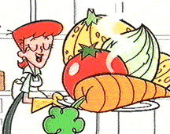

ANCIENT CIVILIZATIONS
CIVILIZATIONS
GEOGRAPHY
RELIGION
GOVERNMENT
CONTRIBUTIONS
EGYPT
MESOPOTAMINA/
SUMERIA
INDUS RIVER VALLEY

CHINA

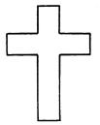

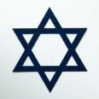
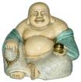
Belief Systems/Religions
SYSTEM
Symbol
Major Beliefs
Text
MISC

Islam

Christianity

Judaism

Confucianism

Buddhism

Hinduism

Animism

Tang and Song Dynasties: Ancient China
Gentry
PEASANTS
Describe each level of society

Merchants

What was the role of women in China?

Eastern half of the Roman Empire that lasted until 1453
BYZANTINE EMPIRE
What was the capital of the Byzantine Empire?

Justinian’s Code
Preservation of Greco-Roman Culture
Orthodox Christian Church

EFFECT ON RUSSIA
Cyrillic alphabet
Autocratic Government

Orthodox Christianity

Golden Age of Islam

Art and Literature

Math and Science
Medicine
Economics
Law

MIDDLE AGES aka Dark Ages

THE MIDDLE AGES HAD THREE IMPORTANT ELEMENTS
POLITICAL
SOCIAL
ECONOMIC

FEUDALISM MANORIALISM CATHOLIC CHURCH
In return for land or a fief, loyalty was promised to the King.

What was chivalry?

How were these groups different?

The Crusades: Histories most successful failure
Reasons for Crusades
1

2

3

4

5
Europeans failed to conquer and hold the Holy land.
Effects
1

2

3

4

5

JAPAN
Describe Japan’s geography:

Impact of geography:
Geography

Shintoism → Uniquely Japanese religion that stresses love of nature
→ Shrines are located in places of natural beauty

Religion

List two ways in which Japan was influenced by Korea or China

1

2

Cultural Diffusion

Japanese
Feudalism

Define Bushido

The Tokugawa Shogunate _______________________ Japan from the outside world. This is asked every year on the regents so know it!

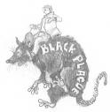
Black Plague or Black Death ---think
“Ring around the Rosie”!!!

Life in the Dark Ages

List 2 causes of the Renaissance

Renaissance
1

2

LED TO
In writing?

Humanism

In Art: What does it look like?

The Renaissance: ______________________________________________________
_____________________________________________________________________
I wrote that the end justified the means. Who am I?
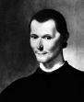
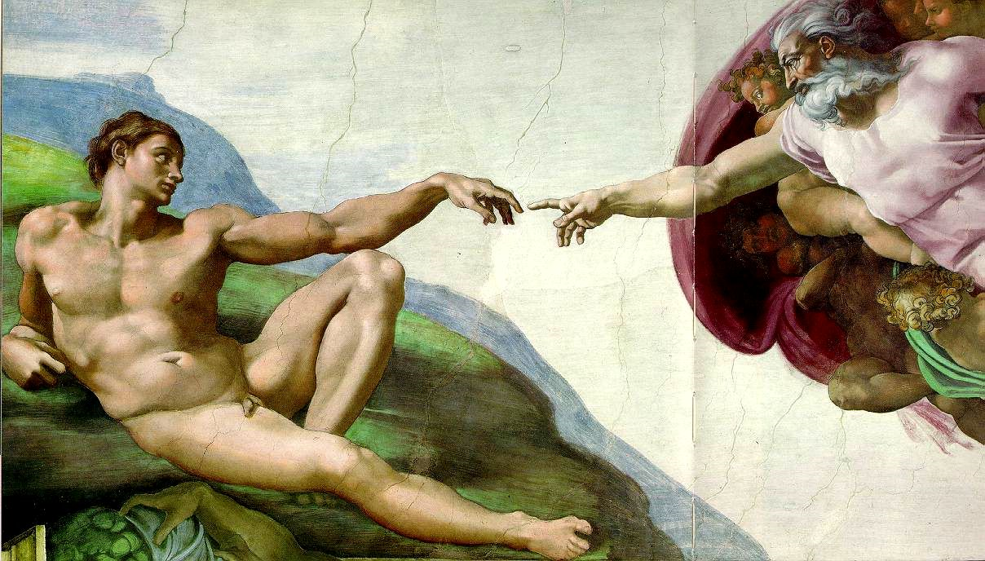

Renaissance Art | Renaissance Writing | Technology

Reformation
CAUSES OF THE REFORMATION
This causes the church to

So…..

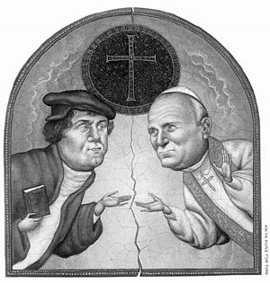
NEW
DENOMINATIONS FORM

1)

2)

3)

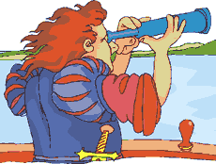
THE AGE OF EXPLORATION

The Three Causes of the Age of Exploration

G:____________ G:_______________ G:_______________
Vasco da Gama
Christopher Columbus
EXPLORERS

Ferdinand Magellan

Conquistadors
Reasons for Success
Who did he conquer?

HERNANDO CORTES
1.

2.

3.

FRANCISCO PIZARRO

MS. EDWARDS

Peninsulares: Europeans born in Spain

Creoles: European descent, born in the colonies

Mestizos/Mulattos: A mix of European and
And Native American or African

Africans and Native American

Eurocentrism=____________________________________________________________
Causes: What did the Europeans need?
Effects: List two negatives of the slave trade
1.

2.

THE SLAVE TRADE

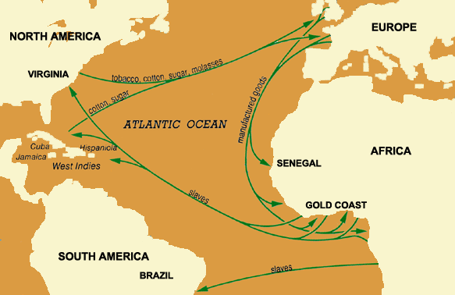
This trade route was known as the ________

____________.

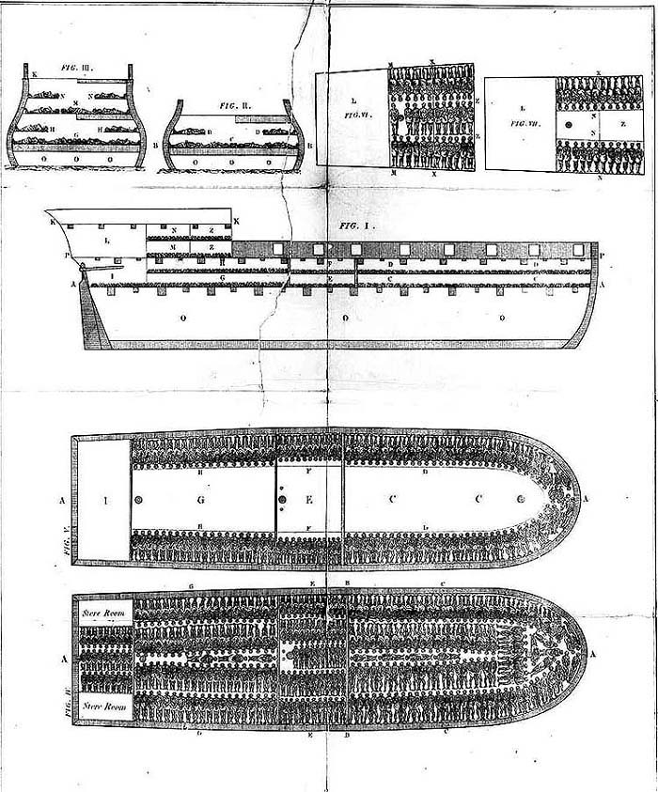

The Columbian Exchange
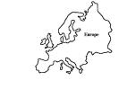
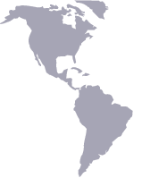

This is an example of ____________ ______________.

Goods from the Americas

Goods from Europe

Define MERCANTILISM:
COLONY
PARENT COUNTRY

What is sent to the parent country?

What is sent to the colony?

It’s good to be the King.

The Age of Absolutism
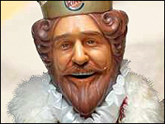

COUNTRY
FACTS
MONARCH

Promoted the Divine right theory. This theory stated that

Admired by Machiavelli!!!

SPAIN
Philip II

FRANCE
Louis XIV

THE SUN KING



RUSSIA
Westernization is………

Peter the Great

England
English Bill of Rights and Magna Carta

GLORIOUS REVOLUTION

Scientific Revolution:


Scientist
Accomplishments

Copernicus

Galileo

Newton

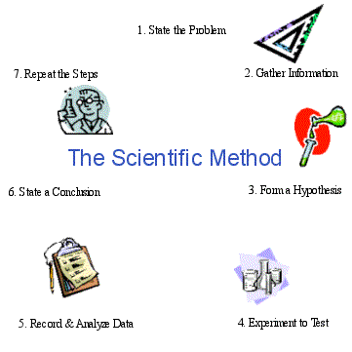

The Scientific Revolution emphasized reason to solve problems.
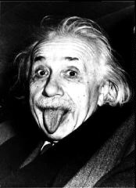

Do you really know the impact of the Scientific Revolution. OK then. PROVE IT!!!!!

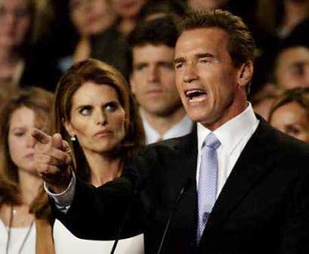

- How did the Scientific Revolution change the way Europeans looked at the world?

- How did the Scientific Revolution reflect the values of the ancient Greeks?

- How did the Scientific Revolution lead to the Enlightenment?

ENLIGHTENMENT :
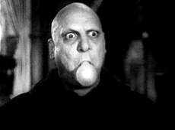

John Locke

Voltaire

Hobbes

Montesquieu

Enlightenment Thinker
Beliefs

IMPACT OF THE ENLIGHTENMENT

REVOLUTIONS

What event is illustrated by each picture?

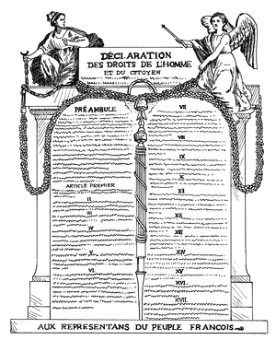
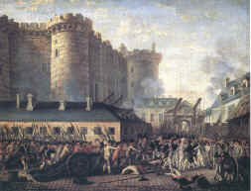

FRANCE

CAUSES OF THE FRENCH REVOLUTION

POLITICAL
ECONOMIC
SOCIAL

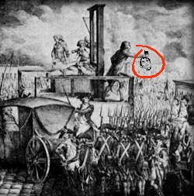
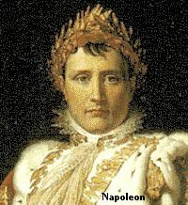

Explain my code.
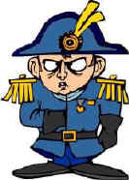

Because of my greatness, the greatness of French people and the greatness of French culture, the rest of Europe became jealous. My ability to conquer helped spark one of the most important movements in the modern world. It is known as _____________________, or love of ones country.

List two revolutions that inspired those in Latin America.
1.
2.
Latin America

Who was Toussaint L’Ovuverture?

Who was Simon Bolivar?

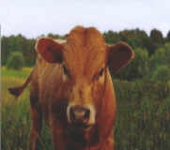
The agricultural Revolution:
1. increased production of _______________

2. Introduction of mechanization

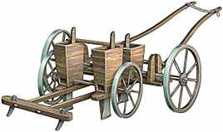
The Industrial Revolution

SEED DRILL by Jethro Tull

List three causes and explain them.
1.

2.

3.
Define factory:

Mass production:

Improved transportation. Explain
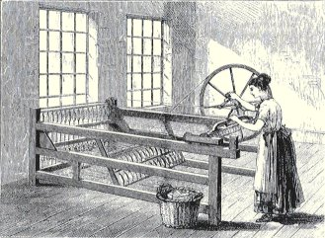

What did business owners gain from selling stock in their companies?
Laissez-Faire economics. Define and explain.

EFFECTS OF THE INDUSTRIAL REVOLUTION

How was class structure reformed by industrialization?
Describe living and working conditions of early industrial cities.

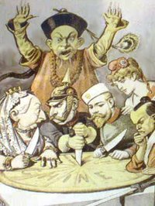
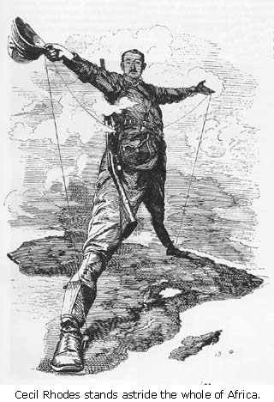
CAUSES
IMPERIALISM

INDIA

AFRICA

CHINA

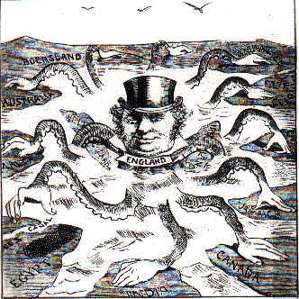

WWI
WWI
Explain each cause of WWI
M
A

A

N

I

Central Powers
1.

2.

3.
Allied Powers
1.

2.

3.

Trench Warfare =

How did the US get involved?

Treaty of Versailles:

What was Bloody Sunday?

Long Term Causes→explain each
1.

2.

3.

4.

Bolshevik Revolution

NEP=

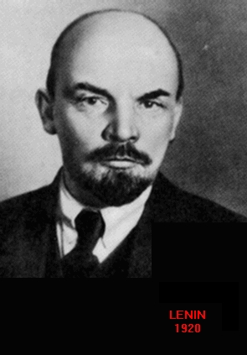

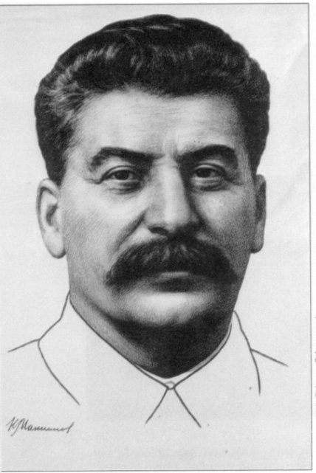

Define: Totalitarian Rule

Command Economy

Five-year plan

Collectives

Lenin died.
Who is this man?

What was the Great Purge?

Why did Stalin starve his people?

Independence Movements

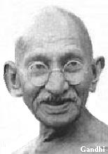

Kwame Nkrumah

Jomo Kenyatta
South Africa

Apartheid

Nelson Mandela

Rise of Dictatorships to WWII

MUSSOLINI’S RISE
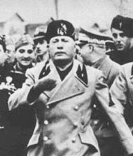

HITLER’s RISE
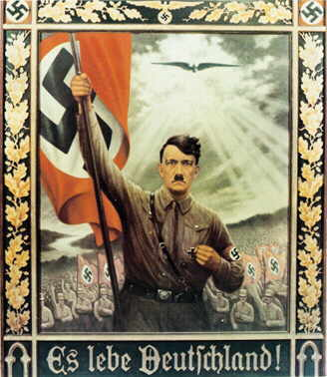

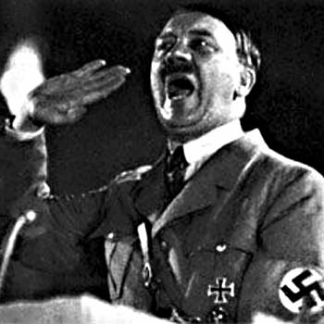

COUNTRIES BECOME AGGRESSIVE IN THE HOPES OF BECOMING POWERFUL

JAPAN

ITALY

GERMANY

APPEASEMENT:

AXIS
1

2

3

ALLIES
1

2

3

4

Define Blitzkrieg.

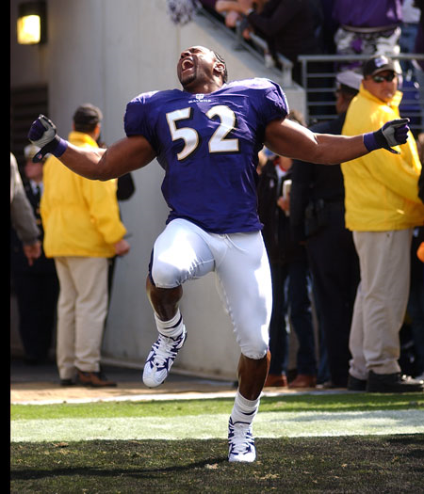

End of the War

How did the war end in Eurpope?

How did the war in the Pacific end?

What areas were the atomic bombs dropped?

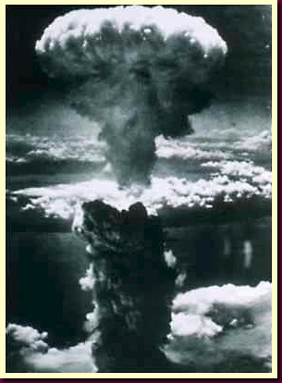

COLD WAR
Germany
As a result of WWII, ______________________________ and ____________________ emerged at the world’s leading superpowers. The ideological conflict between these two nations is known as the ________________ __________________.

Truman Doctrine

Marshall Plan
Berlin Airlift

Two Rival Alliances were ___________________ and _____________________ ______________.

“Hot Spots” of the Cold War

Hot Spot
Describe the conflict.
List nations involved with the conflict.

Bay of Pigs

Cuban Missile Crisis

Cuba
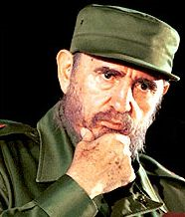

Korean War

Vietnam War

CHINESE COMMUNIST REVOLUTION
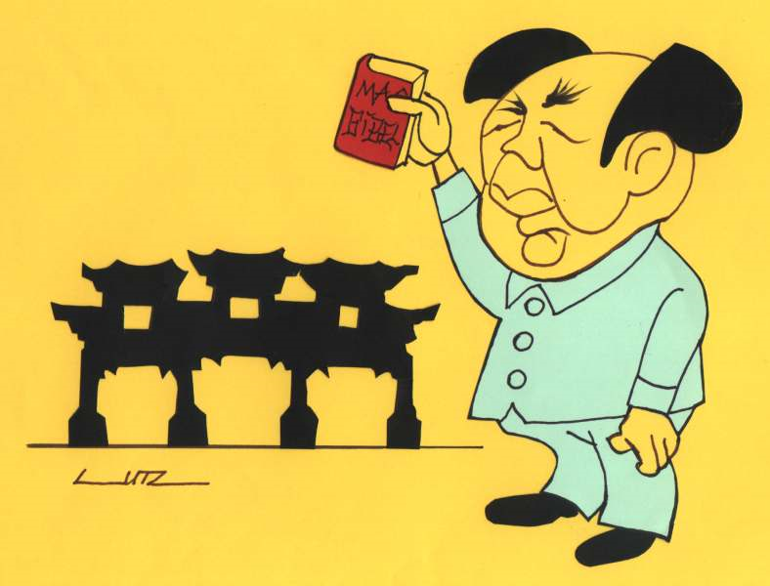

Who was Mao Zedong?

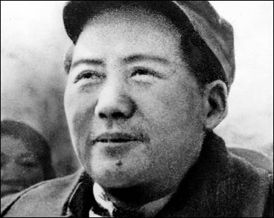

Mao made several changes

What was the goal of the Great Leap Forward?

Overall:

What was the Cultural Revolution? Who were the Red Guards?

Which of my programs were similar to Mao’s?
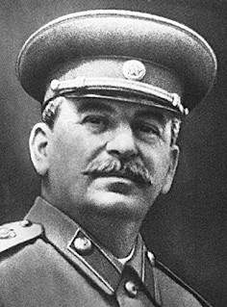
List Deng Xiaoping’s four modernizations?

1.

2.

3.

4.

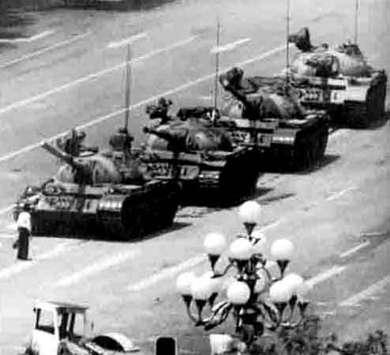

What event is illustrated in this picture?

COLAPSE OF THE SOVIET UNION
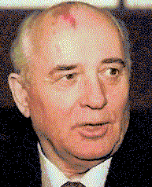
Perestroika

Glasnost
Democratization

FALL
OF
THE
USSR

EFFECTS
1.

2.

3.

4.


The fall of the Berlin Wall was a symbolic end to Communist control over Eastern Europe.

Genocides
 |  | Holocaust | Armenia | Cambodia | Rwanda | Darfur
Who
What
When
Where
Why

