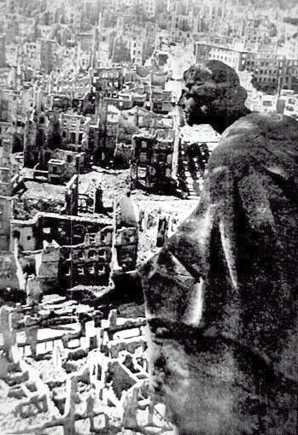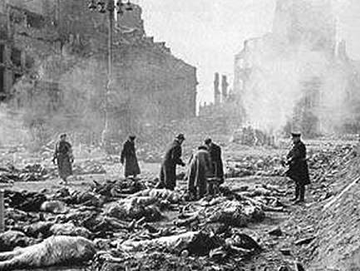

Document Set 3: The Firebombing of Dresden by the Allied Powers

Dresden, Germany, February 1945: Five raids, with over 650,000 incendiaries dropped,
created a firestorm that covered eight square miles, totally destroying 4,200 acres.
Around 135,000 people died. The city center was buried under 18 million cubic meters of rubble. So many people died that the corpses had to be burned in mass piles.

Document Set 3, part 1

An eyewitness account of the bombing
Elisabeth, who was a young woman of around 20 at the time of the Dresden bombing, has written memoirs for her children in which she describes what happened to her in Dresden. Seeking shelter in the basement of the house she lived in she writes, “Then the detonation of bombs started rocking the earth and in a great panic, everybody came rushing down. The attack lasted about half an hour. Our building and the immediate surrounding area had not been hit. Almost everybody went upstairs, thinking it was over but it was not. The worst was yet to come and when it did, it was pure hell. During the brief reprieve, the basement had filled with people seeking shelter, some of whom were wounded from bomb shrapnel.
“One soldier had a leg torn off. He was accompanied by a medic, who attended to him but he was screaming in pain and there was a lot of blood. There also was a wounded woman, her arm severed just below her shoulder and hanging by a piece of skin. A military medic was looking after her, but the bleeding was severe and the screams very frightening.

“Then the bombing began again. This time there was no pause between detonations and the rocking was so severe, we lost our balance, and were tossed around in the basement like a bunch of ragdolls. At times the basement walls were separated and lifted up. We could see the flashes of the fiery explosions outside. There were a lot of fire bombs and canisters of phosphorous being dumped everywhere. The phosphorus was a thick liquid that burned upon exposure to air and as it penetrated cracks in buildings, it burned wherever it leaked through. The fumes from it were poisonous. When it came leaking down the basement steps somebody yelled to grab a beer (there was some stored where we were), soak a cloth, a piece of your clothing, and press it over your mouth and nose. The panic was horrible. Everybody pushed, shoved and clawed to get a bottle.
“I had pulled off my underwear and soaked the cloth with the beer and pressed it over my nose and mouth. The heat in that basement was so severe it only took a few minutes to make that cloth bone dry. I was like a wild animal, protecting my supply of wetness. I don't like to remember that.
“The bombing continued. I tried bracing myself against a wall. That took the skin off my hands -- the wall was so hot. The last I remember of that night is losing my balance, holding onto somebody but falling and taking them too, with them falling on top of me. I felt something crack inside. While I lay there I had only one thought -- to keep thinking. As long as I know I'm thinking, I am alive, but at some point I lost consciousness.
“The next thing I remember is feeling terribly cold. I then realized I was lying on the ground, looking into the burning trees. It was daylight. There were animals screeching in some of them. Monkeys from the burning zoo. I started moving my legs and arms. It hurt a lot but I could move them. Feeling the pain told me that I was alive. I guess my movements were noticed by a soldier from the rescue and medical corps.”

Document Set 3, part 2
An RAF memo issued to airmen on the night of the attack said:
Dresden, the seventh largest city in Germany and not much smaller than Manchester is also the largest unbombed builtup area the enemy has got. In the midst of winter with refugees pouring westward and troops to be rested, roofs are at a premium, not only to give shelter to workers, refugees, and troops alike, but to house the administrative services displaced from other areas. At one time well known for its china, Dresden has developed into an industrial city of first-class importance.... The intentions of the attack are to hit the enemy where he will feel it most, behind an already partially collapsed front... and incidentally to show the Russians when they arrive what Bomber Command can do.

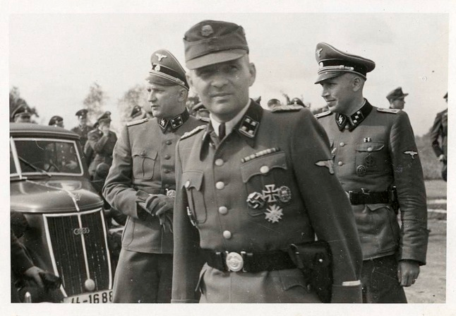
Document 1: Rudolf Hoess, Commandant of Auschwitz:
Testimony at Nuremburg, 1946
Rudolf Hoess born in 1900, , joined the SS in 1933, and eventually commanded the massive extermination center of Auschwitz, whose name has come to symbolize humanity's ultimate descent into evil. This is his signed testimony at the Post-War trials of Major War Criminals held at Nuremburg.
l commanded Auschwitz until 1 December,1943, and estimate that at least 2,500,000 victims were executed and exterminated there by gassing and burning, and at least another half million succumbed to starvation and disease, making a total dead of about 3,000,000. This figure represents about 70% or 80% of all persons sent to Auschwitz as prisoners, the remainder having been selected and used for slave labor in the concentration camp industries. Mass executions by gassing commenced during the summer 1941 and continued until fall 1944.1 personally supervised executions at Auschwitz until the first of December 1943 and know by reason of my continued duties in the Inspectorate of Concentration Camps WVHA2 that these mass executions continued as stated above. All mass executions by gassing took place under the direct order, supervision and responsibility of RSHA.31 received all orders for carrying out these mass executions directly from RSHA. 6. The "final solution" of the Jewish question meant the complete extermination of all Jews in Europe.
l was ordered to establish extermination facilities at Auschwitz in June 1941. When I set up the extermination building at Auschwitz, l used Cyclon B, which was a crystallized Prussic Acid which we dropped into the death chamber from a small opening. It took from 3 to 15 minutes to kill the people in the death chamber depending upon climatic conditions. We knew when the people were dead because their screaming stopped. We usually waited about one half hour before we opened the doors and removed the bodies. After the bodies were removed our special commandos took off the rings and extracted the gold from the teeth of the corpses. Another improvement we made over Treblinka was that we built our gas chambers to accommodate 2,000 people at one time, whereas at Treblinka their 10 gas chambers only accommodated 200 people each. The way we selected our victims was as follows: we had two SS doctors on duty at Auschwitz to examine the incoming transports of prisoners. The prisoners would be marched by one of the doctors who would make spot decisions as they walked by. Those who were fit for work were sent into the Camp. Others were sent immediately to the extermination plants. Children of tender years were invariably exterminated since by reason of their youth they were unable to work. Still another improvement we made over Treblinka was that at Treblinka the victims almost always knew that they were to be exterminated and at Auschwitz we endeavored to fool the victims into thinking that they were to go through a delousing process.

Very frequently women would hide their children under the clothes but of course when we found them we would send the children in to be exterminated. We were required to carry out these exterminations in secrecy but of course the foul and nauseating stench from the continuous burning of bodies permeated the entire area and all of the people living in the surrounding communities knew that exterminations were going on at Auschwitz . 8. We received from time to time special prisoners from the local Gestapo office. The SS doctors killed such prisoners by injections of benzine. Doctors had orders to write ordinary death certificates and could put down any reason at all for the cause of death. 9. From time to time we conducted medical experiments on women inmates, including sterilization and experiments relating to cancer. Most of the people who died under these experiments had been already condemned to death by the Gestapo.
Document 4: The Bombings of Hiroshima and Nagasaki
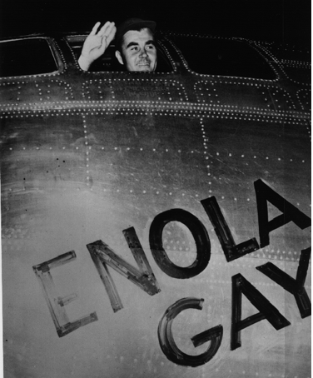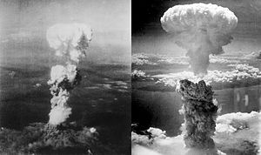
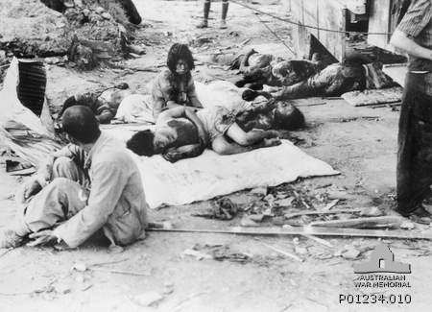
Only two nuclear weapons have been used in the course of warfare, both by the United States near the end of World War II. On 6 August 1945, a uranium gun-type fission bomb code-named "Little Boy" was detonated over the Japanese city of Hiroshima. Three days later, on 9 August, a plutonium implosion-type fission bomb code-named "Fat Man" was exploded over Nagasaki, Japan. These two bombings resulted in the deaths of approximately 200,000 people—mostly civilians—from acute injuries sustained from the explosions.^{[3]} The role of the bombings in Japan's surrender, and their ethical status, remain the subject of scholarly and popular debate.
From President Harry Truman, after the Hiroshima Bombing, August 9, 1945
The world will note that the first atomic bomb was dropped on Hiroshima, a military base. That was because we wished in this first attack to avoid, insofar as possible, the killing of civilians. But that attack is only a warning of things to come. If Japan does not surrender, bombs will have to be dropped on her war industries and, unfortunately, thousands of civilian lives will be lost. I urge Japanese civilians to leave industrial cities immediately, and save themselves from destruction.
I realize the tragic significance of the atomic bomb.
Its production and its use were not lightly undertaken by this Government. But we knew that our enemies were on the search for it. We know now how close they were to finding it. And we knew the disaster, which would come to this Nation, and to all peace-loving nations, to all civilization, if they had found it first.
That is why we felt compelled to undertake the long and uncertain and costly labor of discovery and production.
We won the race of discovery against the Germans. Having found the bomb we have used it. We have used it against those who attacked us without warning at Pearl Harbor, against those who have starved and beaten and executed American prisoners of war, against those who have abandoned all pretense of obeying international laws of warfare. We have used it in order to shorten the agony of war, in order to save the lives of thousands and thousands of young Americans.
We shall continue to use it until we completely destroy Japan's power to make war. Only a Japanese surrender will stop us.

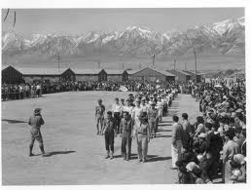
Document 2: Japanese Internment Camps in the United States
After the December 7, 1941, attack on Pearl Harbor, the United States Government swiftly moved to begin solving the "Japanese Problem" on the West Coast of the United States. In the evening hours of that same day, the Federal Bureau of Investigation (FBI) arrested selected "enemy" aliens, including 2,192 who were of Japanese descent. The California government pressed for action by the national government, as many citizens were alarmed about potential activities by people of Japanese descent.
On February 19, 1942, President Franklin D. Roosevelt signed Executive Order 9066, which authorized the Secretary of War to designate military commanders to prescribe military areas and to exclude "any or all persons" from such areas. The order also authorized the construction of what would later be called "relocation centers" by the War Relocation Authority (WRA) to house those who were to be excluded.^{[47]} This order resulted in the forced relocation of over 120,000 Japanese Americans, two-thirds of whom were native-born American citizens. The rest had been prevented from becoming citizens by federal law. Over 110,000 were incarcerated in the ten concentration camps located far inland and away from the coast.
THIS UNIVERSAL DECLARATION OF HUMAN RIGHTS as a common standard of achievement for all peoples and all nations, to the end that every individual and every organ of society, keeping this Declaration constantly in mind, shall strive by teaching and education to promote respect for these rights and freedoms and by progressive measures, national and international, to secure their universal and effective recognition and observance, both among the peoples of Member States themselves and among the peoples of territories under their jurisdiction.

Article 1.
All human beings are born free and equal in dignity and rights. They are endowed with reason and conscience and should act towards one another in a spirit of brotherhood.

Article 2.
Everyone is entitled to all the rights and freedoms set forth in this Declaration, without distinction of any kind, such as race, colour, sex, language, religion, political or other opinion, national or social origin, property, birth or other status. Furthermore, no distinction shall be made on the basis of the political, jurisdictional or international status of the country or territory to which a person belongs, whether it be independent, trust, non-self-governing or under any other limitation of sovereignty.

Article 3.
Everyone has the right to life, liberty and security of person.

Article 4.
No one shall be held in slavery or servitude; slavery and the slave trade shall be prohibited in all their forms.

Article 5.
No one shall be subjected to torture or to cruel, inhuman or degrading treatment or punishment.

Article 6.
Everyone has the right to recognition everywhere as a person before the law.

Article 7.
All are equal before the law and are entitled without any discrimination to equal protection of the law. All are entitled to equal protection against any discrimination in violation of this Declaration and against any incitement to such discrimination.

Article 8.
Everyone has the right to an effective remedy by the competent national tribunals for acts violating the fundamental rights granted him by the constitution or by law.

Article 9.
No one shall be subjected to arbitrary arrest, detention or exile.

Article 10.
Everyone is entitled in full equality to a fair and public hearing by an independent and impartial tribunal, in the determination of his rights and obligations and of any criminal charge against him.

Article 11.
(1) Everyone charged with a penal offence has the right to be presumed innocent until proved guilty according to law in a public trial at which he has had all the guarantees necessary for his defence.
(2) No one shall be held guilty of any penal offence on account of any act or omission which did not constitute a penal offence, under national or international law, at the time when it was committed Nor shall a heavier penalty be imposed than the one that was applicable at the time the penal offence was committed.

Article 12.
No one shall be subjected to arbitrary interference with his privacy, family, home or correspondence, nor to attacks upon his honour and reputation Everyone has the right to the protection of the law against such interference or attacks.

Article 13.
(1) Everyone has the right to freedom of movement and residence within the borders of each state.
(2) Everyone has the right to leave any country, including his own, and to return to his country.

Article 14.
(1) Everyone has the right to seek and to enjoy in other countries asylum from persecution.
(2) This right may not be invoked in the case of prosecutions genuinely arising from non-political crimes or from acts contrary to the purposes and principles of the United Nations.

Article 15.
(1) Everyone has the right to a nationality.
(2) No one shall be arbitrarily deprived of his nationality nor denied the right to change his nationality.

Article 16.
(1) Men and women of full age, without any limitation due to race, nationality or religion, have the right to marry and to found a family. They are entitled to equal rights as to marriage, during marriage and at its dissolution.
(2) Marriage shall be entered into only with the free and full consent of the intending spouses.
(3) The family is the natural and fundamental group unit of society and is entitled to protection by society and the State.

Article 17.
(1) Everyone has the right to own property alone as well as in association with others.
(2) No one shall be arbitrarily deprived of his property.

Article 18.
Everyone has the right to freedom of thought, conscience and religion; this right includes freedom to change his religion or belief, and freedom, either alone or in community with others and in public or private, to manifest his religion or belief in teaching, practice, worship and observance.

Article 19.
Everyone has the right to freedom of opinion and expression; this right includes freedom to hold opinions without interference and to seek, receive and impart information and ideas through any media and regardless of frontiers.

Article 20.
(1) Everyone has the right to freedom of peaceful assembly and association.
(2) No one may be compelled to belong to an association.

Article 21.
(1) Everyone has the right to take part in the government of his country, directly or through freely chosen representatives.
(2) Everyone has the right to equal access to public service in his country.
(3) The will of the people shall be the basis of the authority of government; this shall be expressed in periodic and genuine elections which shall be by universal and equal suffrage and shall be held by secret vote or by equivalent free voting procedures.

Criticisms of the Charter
A number of scholars in different fields have expressed concerns with the Declaration's alleged western bias. These include Irene Oh (Religion and Ethics), Abdulaziz Sachedina (Religion), Riffat Hassan (Theology) and Faisal Kutty (Law). Riffat Hassan argues as follows:
"What needs to be pointed out to those who uphold the Universal Declaration of Human Rights to be the highest, or sole, model, of a charter of equality and liberty for all human beings, is that given the Western origin and orientation of this Declaration, the "universality" of the assumptions on which it is based is - at the very least - problematic and subject to questioning. Furthermore, the alleged incompatibility between the concept of human rights and religion in general, or particular religions such as Islam, needs to be examined in an unbiased way." ^{[27]}
Irene Oh argues that one of the ways to reconcile the two is to approach it from the perspective of comparative ethics.
Kutty writes: "A strong argument can be made that the current formulation of international human rights constitutes a cultural structure in which western society finds itself easily at home ... It is important to acknowledge and appreciate that other societies may have equally valid alternative conceptions of human rights."[

Event | Description of Doc. | Human Rights Violated
The Holocaust
1939-1945
6 million dead
Internment of Japanese Americans
Firebombing of Dresden, Germany by Allied powers
February, 1945
35,000- 135,000 dead (Historians still debate this figure)
Bombings of Hiroshima and Nagasaki by allied powers
August, 1945

Approximately 200,000 dead

