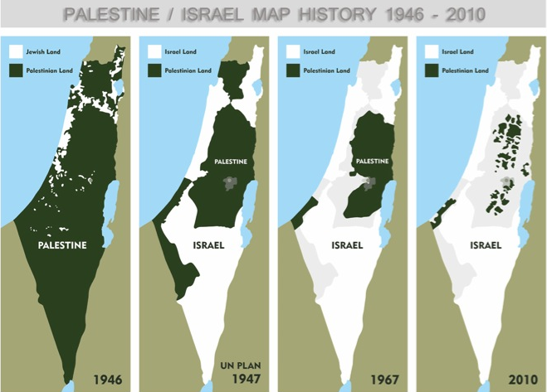

4.23 Aim: What is the diaspora and how did it affect the growth of Zionism?

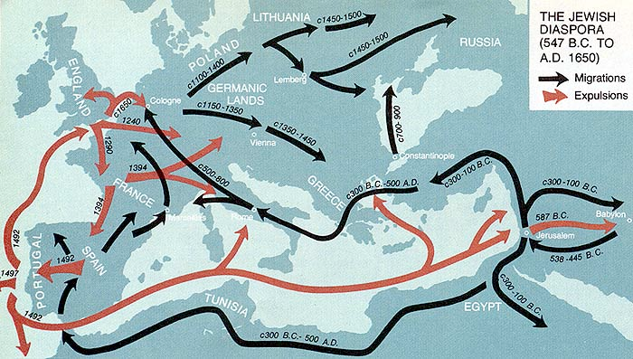

1493 Etching of Jewish Massacre in Europe
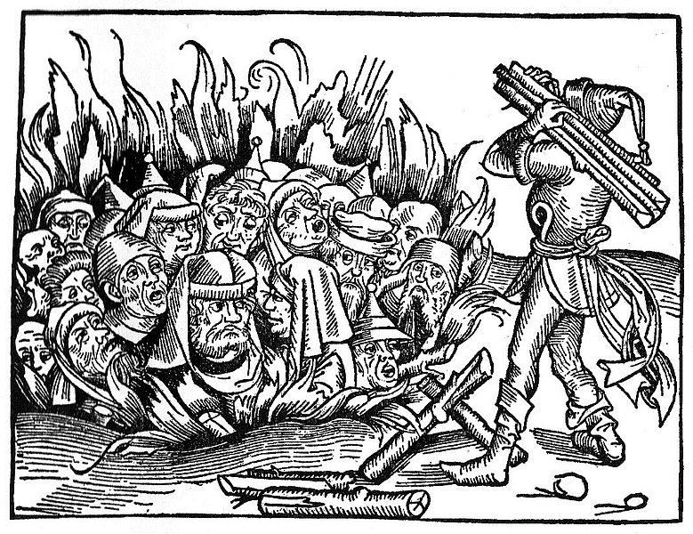
1788 CE The Answer Of The Shaikh Hasan Al Kafrawi, The Shafiite [Professor of canon law in Cairo,]
"Entrance into Muslim territory by infidels of foreign lands under the pact guaranteeing protection to the tolerated peoples is permitted only for the time necessary to settle their business affairs. If they exceed this period, their safe-conduct having expired, they will be put to death or be subject to the payment of the head-tax.[Jews and Christians of foreign lands must pay a special head-tax if they wish to remain permanently in Muslim lands.] As to those with whom the ruler may have signed treaties, and with whom he, for whatever motive, may have granted a temporary truce, they form only the smallest fraction. But they, too, must not pass the fixed limit of more than four months [without paying the tax], particularly if this occurs at a time when Islam is prosperous and flourishing. The Most-High has said [Qu'ran 2: 2341: 'They should wait four months,' and he has again said [47:37]: 'Do not show any cowardice, and do not at all invite the unbelievers to a peace when you have the upper-hand and may God be with you.'
"Their men and women are ordered to wear garments different from those of the Muslims in order to be distinguished from them. They are forbidden to exhibit anything which might scandalize us, as, for instance, their fermented liquors, and if they do not conceal these from us, we are obliged to pour them into the street."
Written by the humble Hasan al Kafrawi, the Shafiite. [1772 CE]
1896 Theodor Herzl: On the Jewish State

The idea which I have developed in this pamphlet is a very old one: it is the restoration of the Jewish State.
The world resounds with outcries against the Jews, and these outcries have awakened the slumbering idea.
. . .
We are a people-one people.
We have honestly endeavored everywhere to merge ourselves in the social life of surrounding communities and to preserve the faith of our fathers. We are not permitted to do so. In vain are we loyal patriots, our loyalty in some places running to extremes; in vain do we make the same sacrifices of life and property as our fellow citizens; in vain do we strive to increase the fame of our native land in science and art, or her wealth by trade and commerce. In countries where we have lived for centuries we are still cried down as strangers, and often by those whose ancestors were not yet domiciled in the land where Jews had already had experience of suffering. The majority may decide which are the strangers; for this, as indeed every point which arises in the relations between nations, is a question of might. I do not here surrender any portion of our prescriptive right, when I make this statement merely in my own name as an individual. In the world as it now is and for an indefinite period will probably remain, might precedes right. It is useless, therefore, for us to be loyal patriots, as were the Huguenots who were forced to emigrate. If we could only be left in peace....
. . .
[However,] oppression and persecution cannot exterminate us. No nation on earth has survived such struggles and sufferings as we have gone through. Jew-baiting has merely stripped off our weaklings; the strong among us were invariably true to their race when persecution broke out against them....
However much I may worship personality-powerful individual personality in statesmen, inventors, artists, philosophers, or leaders, as well as the collective personality of a historic group of human beings, which we call a nation-however much I may worship personality, I do not regret its disappearance. Whoever can, will, and must perish, let him perish. But the distinctive nationality of Jews neither can, will, nor must be destroyed. It cannot be destroyed, because extemal enemies consolidate it. It will not be destroyed; this is shown during two thousand years of appalling suffering. It must not be destroyed .... Whole branches of Judaism may wither and fall, but the trunk will remain.
. . .
The Jewish Question
No one can deny the gravity of the situation of the Jews. Wherever they live in perceptible numbers, they are more or less persecuted. Their equality before the law, granted by statute, has become practically a dead letter. They are debarred from filling even moderately high positions, either in the army, or in any public or private capacity. And attempts are made to thrust them out of business also: "Don't buy from Jews!"
Attacks in Parliaments, in assemblies, in the press, in the pulpit, in the street, on journeys-for example, their exclusion from certain hotels-even in places of recreation, become daily more numerous. The forms of persecutions varying according to the countries and social circles in which they occur....
. . .
The Plan
Let the sovereignty be granted us over a portion of the globe large enough to satisfy the rightful requirements of a nation; the rest we shall manage for ourselves.
The creation of a new State is neither ridiculous nor impossible. We have in our day witnessed the process in connection with nations which were not largely members of the middle class, but poorer, less educated, and consequently weaker than ourselves. The Governments of all countries scourged by Anti-Semitism will be keenly interested in assisting us to obtain the sovereignty we want.
The plan, simple in design, but complicated in execution, will be carried out by two agencies: The Society of Jews and the Jewish Company.
The Society of Jews will do the preparatory work in the domains of science and politics, which the Jewish Company will afterwards apply practically.
The Jewish Company will be the liquidating agent of the business interests of departing Jews, and will organize commerce and trade in the new country.
We must not imagine the departure of the Jews to be a sudden one. It will be gradual, continuous, and will cover many decades. The poorest will go first to cultivate the soil. In accordance with a preconceived plan, they will construct roads, bridges, railways and telegraph installations; regulate rivers; and build their own dwellings; their labor will create trade, trade will create markets and markets will attract new settlers, for every man will go voluntarily, at his own expense and his own risk. The labor expended on the land will enhance its value, and the Jews will soon perceive that a new and permanent sphere of operation is opening here for that spirit of enterprise which has heretofore met only with hatred and obloquy.
There were Jew leaders who called for the return of the Jews to Palestine for decades before Theodor Herzl (1860 1904) wrote his influential pamphlet, The Jewish State. But Herzl's work pushed the formation of a political movement to establish a Jewish homeland in Palestine. The first Zionist Congress, convened by Herzl, was held in Basel, Switzerland, in 1897. Herzl was less attached to Palestine than some other "Zionists", and considered at one stage the creation of a Jewish state in what is now Uganda.

4.24 Aim: How did conflicting promises by the British contribute to future disputes in Palestine?

Sir Henry McMahon:
Letter to Ali ibn Husain, 1915

As for those regions lying within those frontiers wherein Great Britain is free to act without detriment to the interests of her ally, France, I am empowered in the name of the Government of Great Britain to give the following assurances and make the following reply to your letter:

(1) Subject to the above modifications, Great Britain is prepared to recognize and support the independence of the Arabs in all the regions within the limits demanded by the Sherif of Mecca.

(2) Great Britain will guarantee the Holy Places against all external aggression and will recognize their inviolability.

(3) When the situation admits, Great Britain will give to the Arabs her advice and will assist them to establish what may appear to be the most suitable forms of government in those various territories.

(4) On the other hand, it is understood that the Arabs have decided to seek the advice and guidance of Great Britain only, and that such European advisers and officials as may be required for the formation of a sound form of administration will be British.

(5) With regard to the vilayets of Bagdad and Basra, the Arabs will recognize that the established position and interests of Great Britain necessitate special administrative arrangements in order to secure these territories from foreign aggression, to promote the welfare of the local populations and to safeguard our mutual economic interests. I am convinced that this declaration will assure you beyond all possible doubt of the sympathy of Great Britain towards the aspirations of her friends the Arabs and will result in a firm and lasting alliance, the immediate results of which will be the expulsion of the Turks from the Arab countries and the freeing of the Arab peoples from the Turkish yoke, which for so many years has pressed heavily upon them.

McMahon was British High Commissioner in Egypt and Ali Ibn Husain was the Sherif of Mecca during the First World War. In a series of ten letters from 1915 to 1916 McMahon tried to attract Arab support against the Ottoman Empire. The following excerpt is from a letter from October 24, 1915. The implied promise is of British support of an independent Arab state.
1916 The Sykes-Picot Agreement
It is accordingly understood between the French and British governments:
That France and Great Britain are prepared to recognize and protect an independent Arab states or a confederation of Arab states (a) and (b) marked on the annexed map, under the suzerainty of an Arab chief. That in area (a) France, and in area (b) Great Britain, shall have priority of right of enterprise and local loans. That in area (a) France, and in area (b) Great Britain, shall alone supply advisers or foreign functionaries at the request of the Arab state or confederation of Arab states.
That in the blue area France, and in the red area Great Britain, shall be allowed to establish such direct or indirect administration or control as they desire and as they may think fit to arrange with the Arab state or confederation of Arab states.
That in the brown area there shall be established an international administration, the form of which is to be decided upon after consultation with Russia, and subsequently in consultation with the other allies, and the representatives of the Shereef of Mecca.
That Great Britain be accorded (1) the ports of Haifa and Acre, (2) guarantee of a given supply of water from the Tigres and Euphrates in area (a) for area (b). His Majesty's government, on their part, undertake that they will at no time enter into negotiations for the cession of Cyprus to any third power without the previous consent of the French government.
That Alexandretta shall be a free port as regards the trade of the British empire, and that there shall be no discrimination in port charges or facilities as regards British shipping and British goods; that there shall be freedom of transit for British goods through Alexandretta and by railway through the blue area, or (b) area, or area (a); and there shall be no discrimination, direct or indirect, against British goods on any railway or against British goods or ships at any port serving the areas mentioned.
The negotiations with the Arabs as to the boundaries of the Arab states shall be continued through the same channel as heretofore on behalf of the two powers.
It is agreed that measures to control the importation of arms into the Arab territories will be considered by the two governments.

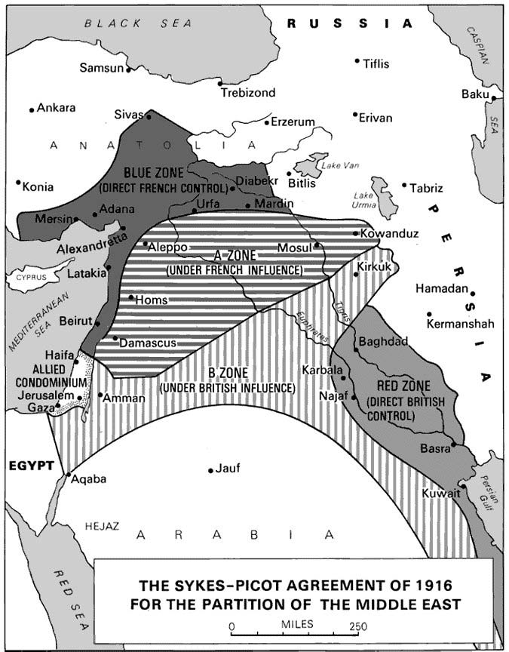

1917- The Balfour Declaration

This letter to Lord Rothschild, by the British Foreign Secretary Arthur James Balfour, was aimed at Jewish support for the Allies in the First World War. The letter, known as the "Balfour Declaration" became the basis movement to create a Jewish state in Palestine. The letter was published a week later in The Times 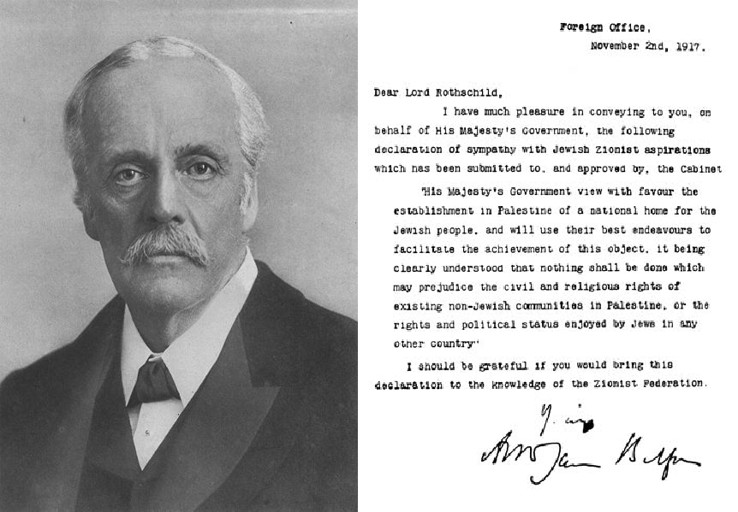

A.J. Balfour (1848-1930):
Defense of the Palestine Mandate, 1922

A.J. Balfour (1848-1930) was British Prime Minister from 1902-1905 and later the Foreign Secretary responsible for the "Balfour Declaration". In 1922 he responded to an attack on the British promise to the Jewish People in this speech.

My noble friend told us in his speech, and I believe him absolutely, that he has no prejudice against the Jews. I think I may say that I have no prejudice in their favor. But their position and their history, their connection with world religion and with world politics is absolutely unique. There is no parallel to it, there is nothing approaching to a parallel to it, in any other branch of human history. Here you have a small race originally inhabiting a small country, I think of about the size of Wales or Belgium, at any rate of comparable size to those two, at no time in its history wielding anything that can be described as material power, sometimes crushed in between great Oriental monarchies, its inhabitants deported, then scattered, then driven out of the country altogether into every part of the world, and yet maintaining a continuity of religious and racial tradition of which we have no parallel elsewhere. That itself, is sufficiently remarkable, but consider-it is not a pleasant consideration, but it is one that we cannot forget-how they have been treated during long centuries, during centuries which in some parts of the world extend to the minute and the hour in which I am speaking; consider how they have been subjected to tyranny and persecution; consider whether the whole culture of Europe, the whole religious organization of Europe, has not from time to time proved itself guilty of great crimes against this race. I quite understand that some members of this race may have given, doubtless did give, occasion for much ill-will, and I do not know how it could be otherwise, treated as they were; but, if you are going to lay stress on that, do not forget what part they have played in the intellectual, the artistic, the philosophic and scientific development of the world. I say nothing of the economic side of their energies, for on that Christian attention has always been concentrated. I ask your Lordships to consider the other side of their activities. Nobody who knows what he is talking about will deny that they have at least - and I am putting it more moderately than I could do - rowed all their weight in the boat of scientific, intellectual and artistic progress, and they are doing so to this day. You will find them in every University, in every center of learning; and at the very moment when they were being persecuted, when some of them, at all events, were being persecuted by the Church, their philosophers were developing thoughts which the great doctors of the Church embodied in their religious system. As it was in the Middle Ages, as it was in earlier times, so it is now. And yet, is there anyone here who feels content with the position of the Jews? They have been able, by this extraordinary tenacity of their race, to maintain this continuity, and they have maintained it without having any Jewish Home.

I could defend - I have endeavoured, and I hope not unsuccessfully, to defend this scheme of the Palestine Mandate from the most material economic view, and from that point of view it is capable of defense. I have endeavoured to defend it from the point of view of the existing population, and I have shownI hope with some effect, that their prosperity also is intimately bound up with the success of Zionism. But having endeavored to the best of my ability to maintain those two propositions, I should, indeed, give an inadequate view to your Lordships of my opinions if I sat down without insisting to the utmost of my ability that, beyond and above all this, there is this great ideal at which those who think with me are aiming, and which, I believe, it is within their power to reach. It may fail. I do not deny that this is an adventure. Are we never to have adventures? Are we never to try new experiments? I hope your Lordships will never sink to that unimaginative depth, and that experiment and adventure will be justified if there is any case or cause for their justification. Surely, it is in order that we may send a message to every land where the Jewish race has been scattered, a message which will tell them that Christendom is not oblivious of their faith, is not unmindful of the service they have rendered to the great religions of the world, and, most of all, to the religion that the majority of your Lordships' House profess, and that we desire to the best of our ability to give them that opportunity of developing, in peace and quietness under British rule, those great gifts which hitherto they have been compelled from the very nature of the case only to bring to fruition in countries which know not their language, and belong not to their race.

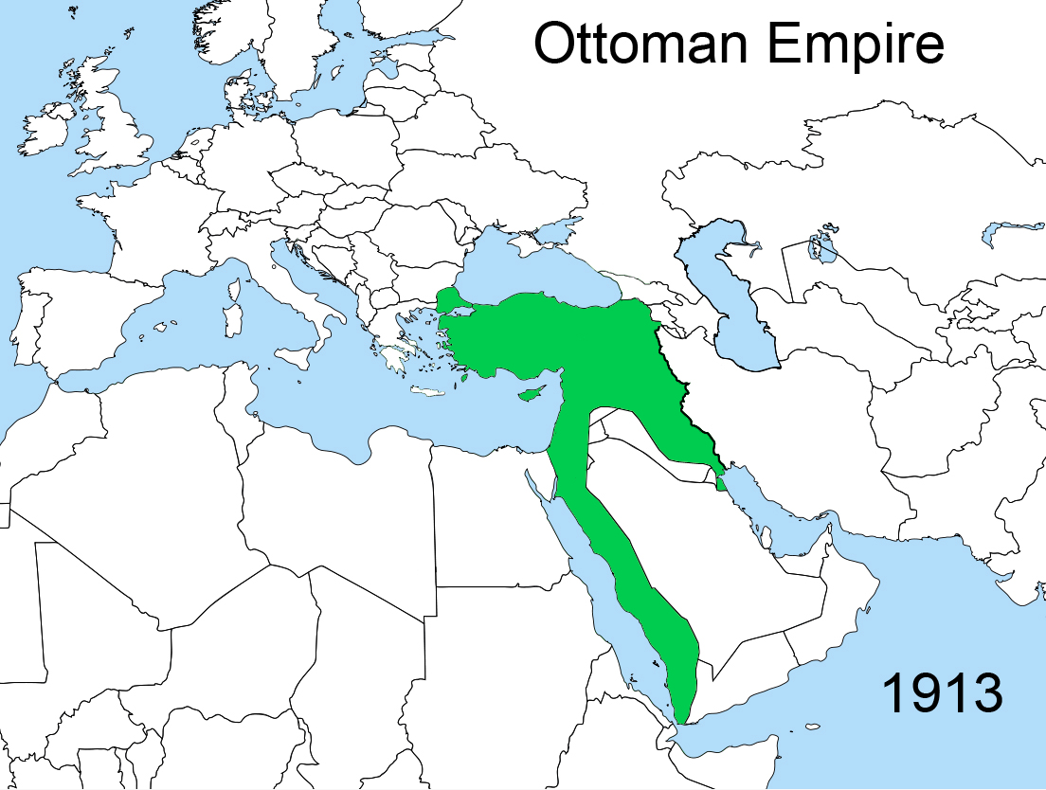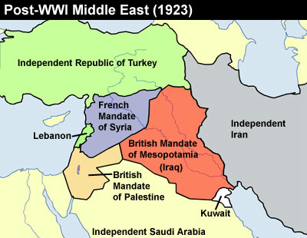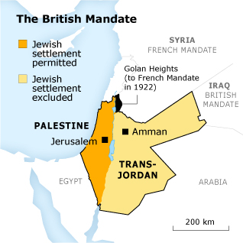

4.25 Aim: After the state of Israel was established, what became the nationalist goals of both the Israelis and the Palestinians?

1947- King David Hotel Bombing

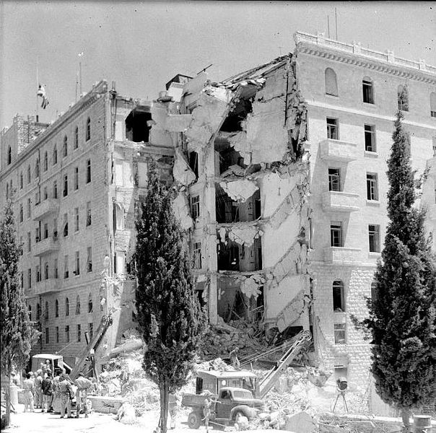

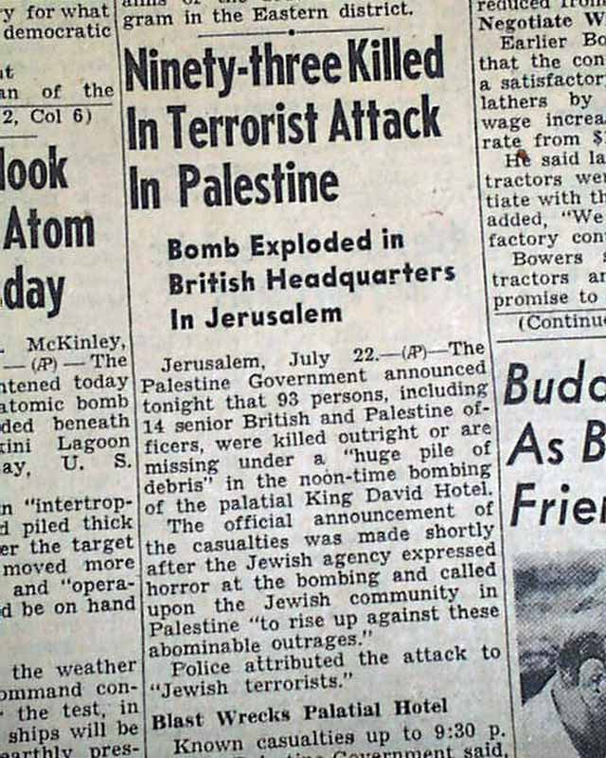

Friday 14th May 1948 - Erev Shabbat 5th Iyar 5708

Declaration of Independence (Israel)

Eretz Israel [Hebrew: The Land of Israel] was the birthplace of the Jewish people. Here their spiritual, religious and national identity was formed. Here they achieved independence and created a culture of national and universal significance. Here they wrote and gave the Bible to the world.

Exiled from their land, the Jewish people remained faithful to it in all the countries of their dispersion, never ceasing to pray and hope for their return and for the restoration in it of their national freedom.

Impelled by this historic association, Jews strove in every successive generation to to re-establish themselves in their ancient homeland. In recent decades they returned in masses. Pioneers, ma'pilim [Hebrew: immigrants coming to Eretz-Israel in defiance of restrictive legislation] and defenders, they made deserts bloom, revived the Hebrew language, built villages and towns, and created a thriving community controlling its own economy and culture. Loving peace but knowing how to defend itself, they brought the blessing of progress to all inhabitants of the country.

In the year 5657 (1897), at the summons of the spiritual father of the Jewish State, Theodore Herzl, the First Zionist Congress convened and proclaimed the right of the Jewish people to national rebirth in its own country.

This right was recognized in the Balfour Declaration of the 2nd November, 1917, and re-affirmed in the Mandate of the League of Nations which, in particular, gave explicit international recognition to the historic connection between the Jewish people and Eretz-Israel and to the right of the Jewish people to rebuild its National Home.

The Nazi holocaust, which engulfed millions of Jews in Europe, was another clear demonstration of the urgency of the re-establishment n Eretz-Israel of the Jewish State, which would open the gates of the homeland wide to every Jew and confer upon the Jewish people the status of a fully privileged member of the comity of nations.

The survivors of the European catastrophe, as well as Jews continued to migrate to Eretz-Israel, undaunted by difficulties, restrictions and dangers, and never ceased to assert their right to a life of dignity, freedom and honest toil in their national homeland.

In the Second World War the Jewish community of this country made a full contribution in the struggle of the freedom- and peace- loving nations against the forces of Nazi evil and by the blood of its soldiers and its war effort, gained the right to be reckoned among the peoples who founded the United Nations.
David Ben Gurion reading the Declaration

On November 29, 1947, the General Assembly of the United Nations adopted a Resolution calling for the establishment of an independent Jewish State in Eretz-Israel, and called upon the inhabitants of the country to take such steps as may be necessary on their part to put the plan into effect.

This recognition by the United Nations of the right of the Jewish people to establish their independent State is irrevocable. This right is the natural right of the Jewish people to be masters of their own fate, like all other nations, in their own sovereign State.

ACCORDINGLY, WE, MEMBERS OF THE PEOPLE'S COUNCIL, REPRESENTATIVES OF THE JEWISH COMMUNITY OF ERETZ-ISRAEL AND OF THE ZIONIST MOVEMENT, ARE HERE ASSEMBLED ON THE DAY OF THE TERMINATION OF THE BRITISH MANDATE OVER ERETZ-ISRAEL AND, BY VIRTUE OF OUR NATURAL AND HISTORIC RIGHT AND ON THE STRENGTH OF THE RESOLUTION OF THE UNITED NATIONS GENERAL ASSEMBLY, HEREBY DECLARE THE ESTABLISHMENT OF A JEWISH STATE IN ERETZ-ISRAEL, TO BE KNOWN AS THE STATE OF ISRAEL.

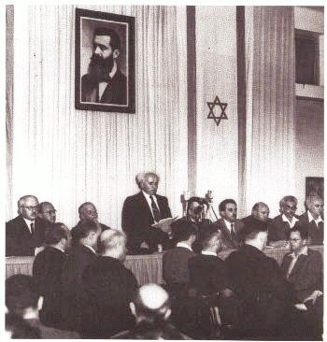
WE HEREBY DECLARE that, with effect from the moment of the termination of the Mandate being tonight, the eve of Sabbath, the 6th Iyar, 5708 (15th May, 1948), and until the setting up of the duly elected bodies of the State in accordance with a Constitution, to be drawn up by the Elected Constituent Assembly not later than the first day of October, 1948, the People's Council shall act as a Provisional Council of State, and its executive organ, the People's Administration, shall constitute the Provisional Government of the Jewish State, to be called "Israel".

THE STATE OF ISRAEL will be open to the immigration of Jews and for the Ingathering of the Exiles from all countries of their dispersion; will promote the development of the country for the benefit of all its inhabitants; will be based on the precepts of liberty, justice and peace as invisaged by the prophets of Israel; will uphold the full social and political equality of all its citizens, without distinction of race, creed or sex; will guarantee full freedom of conscience, worship, education and culture; will safeguard the sanctity and inviolability of the shrines and Holy Places of all religions; and will dedicate itself to the principles of the Charter of the United Nations.

THE STATE OF ISRAEL is prepared to cooperate with the agencies and representatives of the United Nations in the implementation of the Resolution of the General Assembly of November 29, 1947, and will take steps to bring about the economic union over the whole of Eretz-Israel.

WE APPEALto the United Nations to assist the Jewish people in the building-up of its State and to admit Israel into the family of nations.

WE APPEAL - in the very midst of the onslaught launched against us now for months - to the Arab inhabitants of the State if Israel to return to the ways of peace and play their part in the upbuilding of the State, on the basis of full and equal citizenship and due representation in all its bodies and institutions - provisional or permanent.

WE EXTEND our hand of peace and unity to all the neighbouring states and their peoples, and invite them to establish bonds of cooperation and mutual help with the sovereign Jewish people settled in its own land. The State of Israel is prepared to do its share in a common effort for the advancement of the entire Middle East.

WE APPEAL to the Jewish people throughout the Diaspora to rally round the Jews of Eretz-Israel in the task of immigration and development and to stand by them in the great struggle for the fulfillment of the age-old dream - the redemption of Israel.

PLACING OUR TRUST IN THE ROCK OF ISRAEL, WE AFFIX OUR SIGNATURES TO THIS PROCLAMATION AT THIS SESSION OF THE PROVISIONAL COUNCIL OF STATE, ON THE SOIL OF THE HOMELAND, IN THE CITY OF TEL-AVIV, ON THIS SABBATH EVE, THE 5TH DAY OF IYAR, 5708 (14TH MAY,1948).

David Ben-Gurion

1968 The Palestinian National Charter: Resolutions of the Palestine National Council July 1-17
Text of the Charter:
Article 1:
Palestine is the homeland of the Arab Palestinian people; it is an indivisible part of the Arab homeland, and the Palestinian people are an integral part of the Arab nation.
Article 2:
Palestine, with the boundaries it had during the British Mandate, is an indivisible territorial unit.
Article 3:
The Palestinian Arab people possess the legal right to their homeland and have the right to determine their destiny after achieving the liberation of their country in accordance with their wishes and entirely of their own accord and will.
Article 4:
The Palestinian identity is a genuine, essential, and inherent characteristic; it is transmitted from parents to children. The Zionist occupation and the dispersal of the Palestinian Arab people, through the disasters which befell them, do not make them lose their Palestinian identity and their membership in the Palestinian community, nor do they negate them.
Article 5:
The Palestinians are those Arab nationals who, until 1947, normally resided in Palestine regardless of whether they were evicted from it or have stayed there. Anyone born, after that date, of a Palestinian father - whether inside Palestine or outside it - is also a Palestinian.
Article 6:
The Jews who had normally resided in Palestine until the beginning of the Zionist invasion will be considered Palestinians.
Article 7:
That there is a Palestinian community and that it has material, spiritual, and historical connection with Palestine are indisputable facts. It is a national duty to bring up individual Palestinians in an Arab revolutionary manner. All means of information and education must be adopted in order to acquaint the Palestinian with his country in the most profound manner, both spiritual and material, that is possible. He must be prepared for the armed struggle and ready to sacrifice his wealth and his life in order to win back his homeland and bring about its liberation.
Article 8:
The phase in their history, through which the Palestinian people are now living, is that of national (watani) struggle for the liberation of Palestine. Thus the conflicts among the Palestinian national forces are secondary, and should be ended for the sake of the basic conflict that exists between the forces of Zionism and of imperialism on the one hand, and the Palestinian Arab people on the other. On this basis the Palestinian masses, regardless of whether they are residing in the national homeland or in diaspora (mahajir) constitute - both their organizations and the individuals - one national front working for the retrieval of Palestine and its liberation through armed struggle.
Article 9:
Armed struggle is the only way to liberate Palestine. This it is the overall strategy, not merely a tactical phase. The Palestinian Arab people assert their absolute determination and firm resolution to continue their armed struggle and to work for an armed popular revolution for the liberation of their country and their return to it . They also assert their right to normal life in Palestine and to exercise their right to self-determination and sovereignty over it.
Article 10:
Commando action constitutes the nucleus of the Palestinian popular liberation war. This requires its escalation, comprehensiveness, and the mobilization of all the Palestinian popular and educational efforts and their organization and involvement in the armed Palestinian revolution. It also requires the achieving of unity for the national (watani) struggle among the different groupings of the Palestinian people, and between the Palestinian people and the Arab masses, so as to secure the continuation of the revolution, its escalation, and victory.
Article 11:
The Palestinians will have three mottoes: national (wataniyya) unity, national (qawmiyya) mobilization, and liberation.
Article 12:
The Palestinian people believe in Arab unity. In order to contribute their share toward the attainment of that objective, however, they must, at the present stage of their struggle, safeguard their Palestinian identity and develop their consciousness of that identity, and oppose any plan that may dissolve or impair it.

Based on your primary source annotations, answer the following questions in a 2-3 paragraph response. Be sure to cite evidence from your readings.

How did the historical context of the events of the early-mid 20th century contribute to the Israel-Palestine conflict? Why do both nations believe that they have a right to the land?



