2) TASK CARD The creation of Israel and violence that ensued

Essential Question: What gains and losses did Israel and Palestine incur the decades following the creation of Israel?

a) Terrorism in Palestine?
b) Comparing the Israeli Declaration of Independence
with the Palestinian National Charter
c) The Six Day War
d) The Yom Kippur War
e) John Green and Map Analysis
f) Discussion
g) Answer Essential Question
****************After all tasks completed, Check In with Zander****************
Key Terms: Irgun, “othering”, 1948 Arab-Israeli War, nakba, P.L.O., Six Day War, Yom Kippur War, Anwar el-Sadat, UN Resolution 242, Yasser Arafat
A) Terrorism in Palestine?
Who was the target of this terrorist attack?

Who was responsible for the attack?

Why do you think this attack happened? What was the goal?

Review: What term do you think those responsible for the attack would prefer to be called? Why?

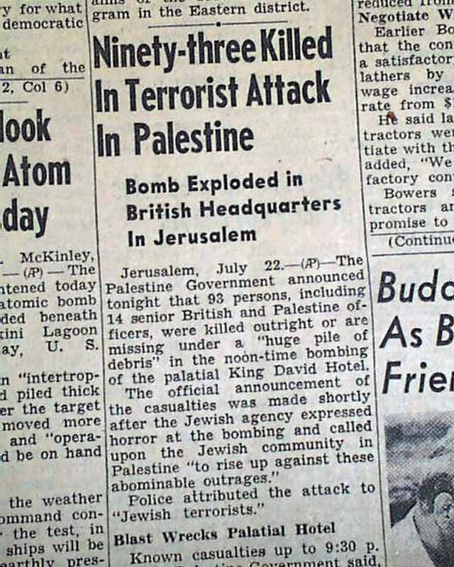

https://www.youtube.com/watch?v=BO5nNcuidmo

Watch the video above and take notes on key points on the events between 1947 and 1948:

Who or What is Irgun? __________________________________________________________________

Watch this VERY BIASED (ahem, possibly offensive) explanation of the UN Partition of Israel. Try to separate the facts from the opinion. What type of bias does this video have?
https://www.youtube.com/watch?v=IWM2rDI7Hh8

Facts | Opinion/Bias

Watch this clip from Vice about differing views about the Israeli day of independence.
https://www.youtube.com/watch?v=wmgiSdGComI

What do the Palestinians refer to this day as, and what does this mean? Why do they call it this?

Along with the different interpretations of the creation of Israel, each side of the conflict began to “other” the opposing side. Based on the following MYSTERY clip, what does it mean to “other?”
https://www.youtube.com/watch?v=QlzuWbDHZrU

Task B: Read the following conflicting documents about the creation of Israel. Find evidence in both that makes claims about the nations identity, the goals of the document, methods that will be used and any reference to the “other.”
Focus of Inquiry | Declaration of Independence  Friday 14th May 1948  (Evidence) | The Palestinian National Charter: Resolutions of the Palestine National Council July 1-17, 1968  (Evidence)
Claims about nation’s identity

Does the document mention anything about a “diaspora?”
Goals of this Document
Focus of Inquiry | Declaration of Independence  Friday 14th May 1948  (Evidence) | The Palestinian National Charter: Resolutions of the Palestine National Council July 1-17, 1968  (Evidence)
Methods that will be used to achieve this goal
What is said about the “other?”
Task C: The Six Day War
Click on the link and detail key events and outcomes day by day during this conflict.
http://www.npr.org/news/specials/mideast/history/map6.html

1967 Middle Eastern War (aka “Six Day War”) | Key Events/ Outcomes
June 5
June 6
June 7
June 8
June 9
June 10
Task D: 1973 YOM KIPPUR WAR: BACKGROUND- ANNOTATE THE FOLLOWING
Israel’s stunning victory in the Six-Day War of 1967 left the Jewish nation in control of territory four times its previous size. Egypt lost the 23,500-square-mile Sinai Peninsula and the Gaza Strip, Jordan lost the West Bank and East Jerusalem, and Syria lost the strategic Golan Heights. When Anwar el-Sadat (1918-81) became president of Egypt in 1970, he found himself leader of an economically troubled nation that could ill afford to continue its endless crusade against Israel. He wanted to make peace and thereby achieve stability and recovery of the Sinai, but after Israel’s 1967 victory it was unlikely that Israel’s peace terms would be favorable to Egypt. So Sadat conceived of a daring plan to attack Israel again, which, even if unsuccessful, might convince the Israelis that peace with Egypt was necessary.
In 1972, Sadat expelled 20,000 Soviet advisers from Egypt and opened new diplomatic channels with Washington, D.C., which, as Israel’s key ally, would be an essential mediator in any future peace talks. He formed a new alliance with Syria, and a concerted attack on Israel was planned.

YOM KIPPUR WAR: OCTOBER 1973
When the fourth Arab-Israeli war began on October 6, 1973, many of Israel’s soldiers were away from their posts observing Yom Kippur (or Day of Atonement), and the Arab armies made impressive advances with their up-to-date Soviet weaponry. Iraqi forces soon joined the war, and Syria received support from Jordan. After several days, Israel was fully mobilized, and the Israel Defense Forces began beating back the Arab gains at a heavy cost to soldiers and equipment. A U.S. airlift of arms aided Israel’s cause, but President Richard Nixon (1913-94) delayed the emergency military aid for a week as a tacit signal of U.S. sympathy for Egypt. On October 25, an Egyptian-Israeli cease-fire was secured by the United Nations.

YOM KIPPUR WAR: AFTERMATH
Israel’s victory came at the cost of heavy casualties, and Israelis criticized the government’s lack of preparedness. In April 1974, the nation’s prime minister, Golda Meir (1898-1978), stepped down.
Although Egypt had again suffered military defeat at the hands of its Jewish neighbor, the initial Egyptian successes greatly enhanced Sadat’s prestige in the Middle East and gave him an opportunity to seek peace. In 1974, the first of two Egyptian-Israeli disengagement agreements providing for the return of portions of the Sinai to Egypt were signed, and in 1979 Sadat and Israeli Prime Minister Menachem Begin (1913-92) signed the first peace agreement between Israel and one of its Arab neighbors. In 1982, Israel fulfilled the 1979 peace treaty by returning the last segment of the Sinai Peninsula to Egypt.
1) Describe the actions of Egyptian president Anwar el-Sadat between 1970-1979. What were some of the hard decisions that he had to make to achieve his goals? Did he achieve any of his goals?

Task E: John Green and map Analysis
Watch the following John Green video from 4:30- 7:23 (do not watch the whole thing!)

- What are the demands required by UN Resolution 242?

- Who is Yasser Arafat?

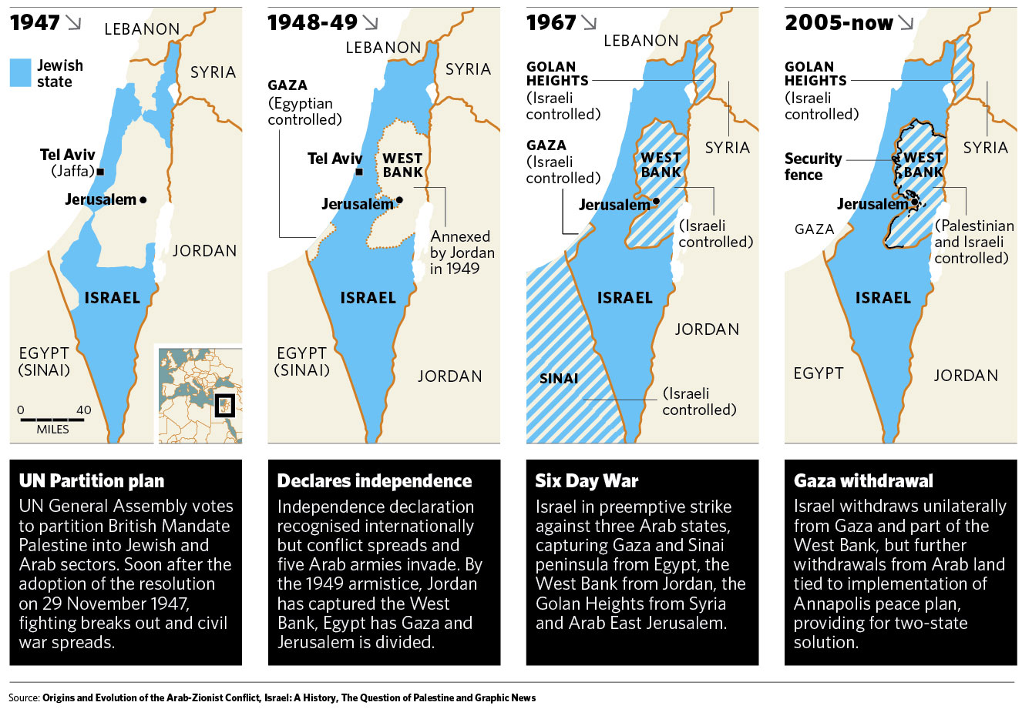

How did the borders change from 1947 to 1948?

How did the borders change from 1949 to 1967?

Task F: Group Discussion

Time discussion begins________ Time Discussion Ends ________

Before this, you need to have participated on Zander’s mini-lesson on thick questions…..
Guiding Questions….. | Interesting Points Made by…
Student created “thick questions”:

Task G) Answer Essential Question: What gains and losses did Israel and Palestine incur the decades following the creation of Israel?

Be sure to use all of the words in the word wall: Irgun, “othering”, 1948 Arab-Israeli War, nakba, Six Day War, Yom Kippur War, Anwar el-Sadat, UN Resolution 242, Yasser Arafat

