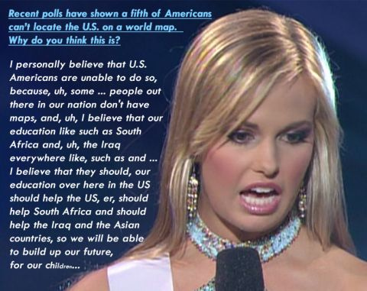
Driving Question: How can we help Miss Teen SC articulate a clear argument?
"Recent polls have shown a fifth of Americans can't locate the U.S. on a world map. Why do you think this is?"
Upton:
“I personally believe that U.S. Americans are unable to do so because, uh, some, uh, people out there in our nation don't have maps and, uh, I believe that our education like such as in South Africa and, uh, the Iraq, everywhere like such as, and, I believe that they should, our education over here in the U.S. should help the U.S., uh, or, uh, should help South Africa and should help the Iraq and the Asian countries, so we will be able to build up our future for our children.”

What are the biggest problems in Miss Teen SC’s response?

Ethnocentrism- the practice of judging another culture by the standards of one's own culture

Is Miss Teen SC being ethnocentric in her response? Why or why not?

Outcome | Exceeds | Meets | Not Yet
Argue I  Evidence supports a strong thesis and rationale. | ___ Student answers prompt in a strong and clear thesis  ___ Student chooses appropriate evidence from primary and secondary sources that supports thesis statement | ___ Student answers prompt with a clear thesis  ___ Student chooses appropriate evidence from primary and secondary sources that supports thesis statement
Discern  View, read and listen with focused attention to what matters. Examine closely and methodically, attending to easily overlooked details, logic and patterns. | ___ Student annotates sources for understanding  ___ In each document, student notes the author of each source. Student points out biases that exist within the text  ___ Annotations are in depth and analytical. Annotations contrast sources to each other. | ___ Student annotates sources for understanding
Be Precise  Accurately represents solutions, ideas and language.  Vocabulary:  Ethnocentrism, geography, primary source, secondary source  Bonus: cultural diffusion (!) | ___ Student accurately uses all of vocabulary  ____ Student demonstrates accurate understanding of timeline  ___ Student avoids use of 1st person, and grammar errors | ___ Student accurately uses most of the vocabulary  ____ Student demonstrates accurate understanding of timeline  ___ Student avoids use of 1st person, and grammar errors
Investigate  Ask and refine a researchable question, design a valid experiment or inquiry and gather appropriate info to complete the inquiry. | ___ Student researched an additional secondary and primary source in order to provide evidence for a thesis  ___ Student was thorough in collecting information including content, bias, and context of each source | ___ Student researched an additional secondary and primary source in order to provide evidence for a thesis  ___ Student collected information including content, bias, and context of each source
Communicate I  Make ideas and information understood, mindful of audience, purpose and setting. Listen and respond to what others communicate. | ___ Student clearly organizes essay so reader understands the “road map” of the author after reading the introduction  ___ Student includes clear topic sentences in body paragraphs | ___ Student organizes essay with introduction, body paragraphs and conclusion  ___ Student includes clear topic sentences in body paragraphs
Conclude  Infer meanings, analyze information and develop valid ideas based on evidence and analysis | ___ Student analyzes sources to defend thesis statement  ___ In each source, student evaluates the author’s bias in depiction of events  ___ Student evaluates the sources in relation to other sources in regards to bias and ethnocentrism | ___ Student analyzes sources to defend thesis statement  ___ In each source, student evaluates the author’s bias in depiction of events
Now, it is your job to help Miss Teen SC with revising her statement. Since the candidate decided to bring up different countries in her response, you are going to use specific countries or continents in your revision. You may use countries other than the ones mentioned by Miss Teen SC in your research. You need at least 3 sources in your response, and at least one of them needs to be a primary source.

This is your question:

"Recent polls have shown that many United States high school students are geographically illiterate. Why is it important for students to understand world geography?”

In order to adequately create our own rational argument, you must complete the following tasks in order to understand skills necessary to a historian’s craft.
^{TASKS}
- Annotate National Geographic Article [Discern]
- ^{Geography 101 [Be Precise]}
- ^{Timeline Analysis [Be Precise]}
- Research primary/secondary source [Investigate, Discern]
- ^{Develop Thesis [Argue]}
- ^{Outline Essay [Communicate]}
- Write Essay [Argue, Be Precise, Conclude]

Task a) Annotating Aim: How can we annotate a text for understanding?

Young Americans Geographically Illiterate, Survey Suggests

John Roach
for National Geographic News
May 2, 2006
Young adults in the United States fail to understand the world and their place in it, according to a survey-based report on geographic literacy released today.
Take Iraq, for example. Despite nearly constant news coverage since the war there began in 2003, 63 percent of Americans aged 18 to 24 failed to correctly locate the country on a map of the Middle East. Seventy percent could not find Iran or Israel.
Nine in ten couldn't find Afghanistan on a map of Asia.
And 54 percent were unaware that Sudan is a country in Africa.
Remember the December 2004 tsunami and the widespread images of devastation in Indonesia?
Three-quarters of respondents failed to find that country on a map. And three-quarters were unaware that a majority of Indonesia's population is Muslim, making it the largest Muslim country in the world.
"Young Americans just don't seem to have much interest in the world outside of the U.S.," said David Rutherford, a specialist in geography education at the National Geographic Society in Washington, D.C. (National Geographic News is part of the National Geographic Society.)
New York City-based Roper Public Affairs conducted the survey for the National Geographic Society. In total, Roper carried out 510 interviews between December 17, 2005, and January 20, 2006.
The average respondent answered 54 percent of the questions correctly.
"The Roper poll is alarming, as it has been continuously for the past several years," said Douglas Richardson, executive director of the Association of American Geographers in Washington, D.C.
Richardson added that geographic knowledge is essential for survival in our rapidly globalizing world, a notion that is beginning to gain traction at the university level, where enrollment in geography classes is up.

ANNOTATIONS

ANNOTATIONS

Young Americans Geographically Illiterate, Survey Suggests(continued)
"We need to really now catch up in offering the foundation for students in geography in the middle schools and the high schools," he said.
Survey results published in 2002 were also disappointing.
The 2002 project also surveyed 18- to 24-year-olds in Canada, France, Germany, Italy, Japan, Mexico, Sweden, and Great Britain. The U.S. trailed every other country in that survey, except Mexico, which did only slightly worse.
"It's discouraging that so many young Americans have so little understanding of the world," said Robert Pastor, vice president of international affairs at American University in Washington, D.C.
Geography Schmeography?
Perhaps even more worrisome is the finding that few U.S. young adults seem to care.
Fewer than three in ten think it's absolutely necessary to know where countries in the news are located. Only 14 percent believe speaking another language fluently is a necessary skill.
Fewer than one in five young Americans own a world map.
This geographic ineptitude was further emphasized when young Americans were asked questions on how the United States fits into the wider world.
Three in ten respondents put the U.S. population between one and two billion (it's just under 300 million, according the U.S. Census Bureau). Seventy-four percent said English is the most commonly spoken native language in the world (it's Mandarin Chinese).
Although 73 percent knew the U.S. is the world's largest consumer of oil, nearly as many (71 percent) did not know that the U.S. is also the world's largest exporter of goods and services, when measured in terms of monetary value; half think it's China.
And what about India, which features prominently in the job-outsourcing debate? Forty-seven percent of young Americans were unable to locate where their jobs may go on a map of Asia.

ANNOTATIONS

Young Americans Geographically Illiterate, Survey Suggests(continued)
Rutherford, who is also a graduate of the Ph.D. program in geographic education at Texas State University in San Marcos, said improving the geographic literacy of tomorrow's leaders is crucial.
"In our country—where the decisions we make on a daily basis have far-reaching ramifications—it is profoundly important for our people to have a better grasp of geographic literacy," he said.
Geography's Place
According to Richardson, of the Association of American Geographers, enrollment in geography courses at the university level is increasing. This indicates that "geography is assuming a more central place in our society."
Part of the upswing in enrollment is driven by increased use of technology, such as geographic information systems (GIS) and global positioning systems (GPS). In addition, rapid globalization is forcing students to open their eyes to the rest of the world, he says.
On a positive note, since 2002 the percentage of young Americans who use the Internet for news has more than doubled from 11 percent to 27 percent. Respondents who use the Internet were found to do better on the survey than those who do not.
To further increase geographic literacy at the middle and high school level, the National Geographic Society today announced the launch of a public-engagement campaign called My Wonderful World.
The campaign provides resources to parents and teachers to help children learn about their world.
And improving student engagement and interest seems to lead to improved knowledge, according to the Roper survey.
"The good news," American University's Pastor said, "is education, travel, and language matter. The young people who have more education, who have traveled outside the country, and who can speak a second language are more likely to answer more questions on the geography survey correctly."
"So it shows Americans are educable, and the only question is whether American teachers will do more to interest their students in more education, language, and study-abroad activities."

Task b) Geography 101
Aim: To identify continents and oceans on a map to better analyze geography.

Geography- the study of how the earth shapes people’s lives and is in turn shaped by people's activities.

"The study of geography is about more than just memorizing places on a map. It's about understanding the complexity of our world, appreciating the diversity of cultures that exists across continents. And in the end, it's about using all that knowledge to help bridge divides and bring people together."
- Barack Obama
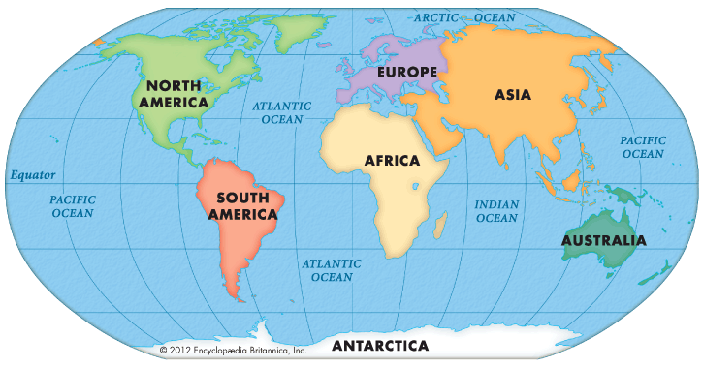

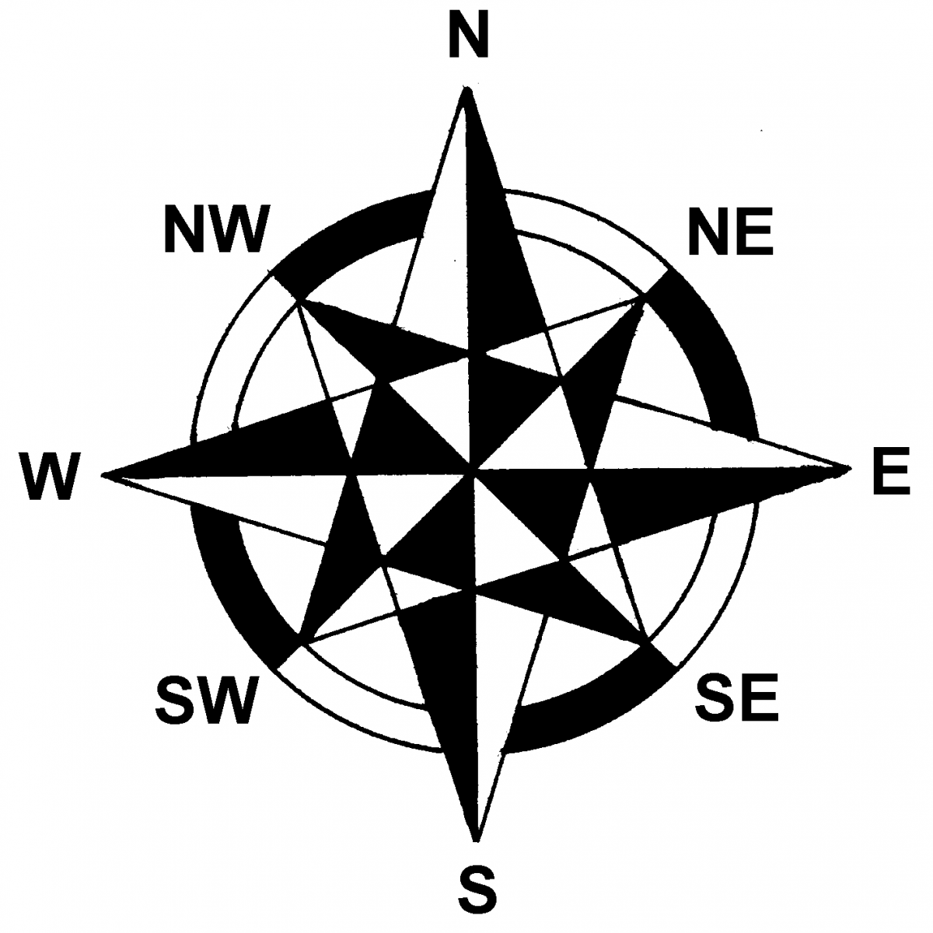
Continent- any of the world's main continuous expanses of land
(Africa, Antarctica, Asia, Australia, Europe, North America, South America).
You may be given a blank map on your quiz at the end of this project. Make sure that you are familiar with basic geographic features, such as the 7 continents and 4 oceans.

A few basic questions:
1. If you were traveling west from Africa to South America, what ocean would you have to cross?

2. If you were on the eastern coast of Asia (near Japan) and you began traveling directly south, what continent would you eventually hit?

3. The Mediterranean Sea separates Africa and Europe. What other continent touches the Mediterranean Sea?

Task c) Timeline Analysis
Aim: How can we analyze a timeline?

A timeline is a way of displaying a list of events in chronological order. It is typically a graphic design showing a long bar labeled with dates alongside itself and usually events labeled on points where they would have happened.

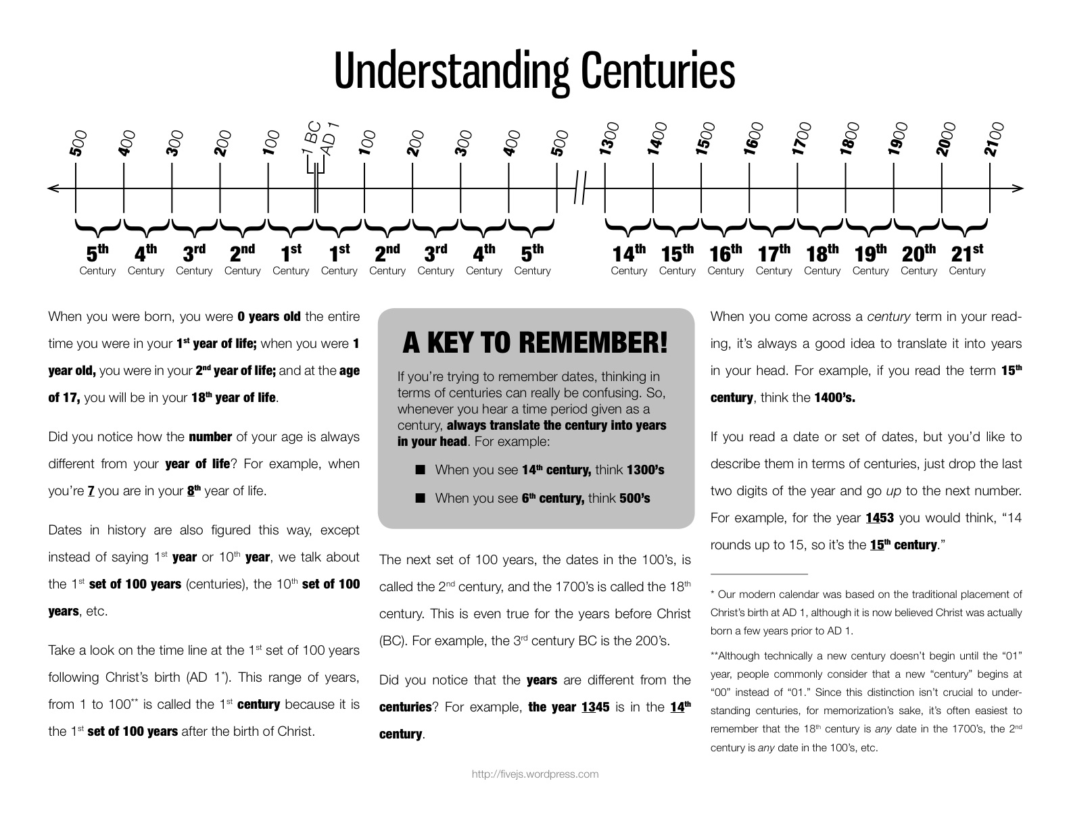

The history of time has historically been divided between BC [Before Christ] and AD [anno domini, meaning “in the year of our lord”]. This has simply been used to distinguish between the “old” and the “new” in history, with the birth of Jesus Christ as a significant turning point. Obviously, this is an ____________________ [insert vocab word from page 1 here] move by Christian Europe to decide that Jesus’s birth should be the defining moment that changed history.

These days, secular writers have begun to write before common era, or b.c.e. instead of BC. Instead of writing AD, writers have simply begun writing c.e. for common era.

-500 b.c.e.
Place the following dates on the timeline:

431 b.c.e.- beginning of Peloponnesian War between Athens and Sparta

632 c.e. death of the prophet Muhammad

Mid 4th century b.c.e.- Alexander the Great born

476 c.e. Rome “falls”

-400 b.c.e.

-300 b.c.e.

-200 b.c.e.

-100 b.c.e.

-1 b.c.e.
-1 c.e.

-100 c.e.

-200 c.e.

-300 c.e.

-400 c.e.

-500 c.e.

-600 c.e.

-700 c.e.

-800 c.e.

-1000 c.e.

-1100 c.e.
Place the following dates on the timeline:

1099 c.e. First crusade. Christian armies from Europe capture Jerusalem from Muslims

mid 14th century c.e. - Black Death is spread from fleas of rats from Central Asia to Europe. 1/3 of Europe’s population dies

1206 c.e. Genghis Khan proclaimed leader of the Mongol Empire

1517 c.e. Martin Luther nails 95 theses on church door. Luther disagreed with abuses within the Catholic Church.

2003 c.e. - President Bush declares war on Iraq, claiming that Saddam Hussein’s regime harbored weapons of mass destruction.

Mid 15th century c.e. printing press invented in Europe by Johannes Gutenberg. First printed book is the Bible.

-1200 c.e.

-1300 c.e.

-1400 c.e.

-1500 c.e.

-1600 c.e.

-1700 c.e.

-1800 c.e.

-1900 c.e.

-2000 c.e.

Can you find a cause and effect relationship between 2 events from 1400-1600? Why did the previous event influence the later one?

Task d) Researching Primary and Secondary Sources
Aim: How can you thoroughly investigate a source?

In addition to the National Geographic article that you have already annotated, you need to find another secondary source and a primary source to use as evidence for your argument.

What is a secondary source?
A secondary source interprets and analyzes primary sources. These sources are one or more steps removed from the event. Some types of secondary sources include: Textbooks, magazine articles, histories, criticisms, commentaries, encyclopedias…

*******Historians always look at the source FIRST before reading anything!******* This gives you an immediate idea of the biases that influenced the writing. For example, if you read a very anxious and sad passage that you do not understand, check the source. If you find out that it is from a NY Times editorial dated September 11, 2001, you should have a clearer picture.

Source (Author, Date, Publication) | Notes (key details) | Analysis (why does this help answer the question)
A primary source is a document or physical object that was written or created during the time under study. These sources were present during an experience or time period and offer an inside view of a particular event. Some types of primary sources include:
- ORIGINAL DOCUMENTS (excerpts or translations acceptable): Diaries, speeches, manuscripts, letters, interviews, news film footage, autobiographies, official records
- CREATIVE WORKS: Poetry, drama, novels, music, art
- RELICS OR ARTIFACTS: Pottery, furniture, clothing, buildings
Use the “6 Cs of Primary Sources” to help you interpret a primary source that you would like to analyze. Your analysis of this primary source will be used as evidence in your argument. When you analyze a primary source it is important to use all of the clues in the source to detect an author’s bias in a text.

Task e) Developing a Thesis Statement
Aim: How can we sum up our argument in a clear thesis statement?

Look at your notes: What is a common theme that you notice in your evidence? What is a debatable opinion that you can argue based on your evidence?

Now, develop your rationale to support your debatable opinion. What are 2-3 major points that you need to make to support your argument?

Point 1:

Point 2:

Point 3 (optional):

Now, put them together!

Thesis statement:

Extra Help Regarding Developing a Thesis (from the Writing Center at Harvard University)
Think of yourself as a member of a jury, listening to a lawyer who is presenting an opening argument. You'll want to know very soon whether the lawyer believes the accused to be guilty or not guilty, and how the lawyer plans to convince you. Readers of academic essays are like jury members: before they have read too far, they want to know what the essay argues as well as how the writer plans to make the argument. After reading your thesis statement, the reader should think, "This essay is going to try to convince me of something. I'm not convinced yet, but I'm interested to see how I might be."
An effective thesis cannot be answered with a simple "yes" or "no." A thesis is not a topic; nor is it a fact; nor is it an opinion. "Reasons for the fall of communism" is a topic. "Communism collapsed in Eastern Europe" is a fact known by educated people. "The fall of communism is the best thing that ever happened in Europe" is an opinion. (Superlatives like "the best" almost always lead to trouble. It's impossible to weigh every "thing" that ever happened in Europe. And what about the fall of Hitler? Couldn't that be "the best thing"?)
A good thesis has two parts. It should tell what you plan to argue, and it should "telegraph" how you plan to argue—that is, what particular support for your claim is going where in your essay.
Steps in Constructing a Thesis
First, analyze your primary sources. Look for tension, interest, ambiguity, controversy, and/or complication. Does the author contradict himself or herself? Is a point made and later reversed? What are the deeper implications of the author's argument? Figuring out the why to one or more of these questions, or to related questions, will put you on the path to developing a working thesis. (Without the why, you probably have only come up with an observation—that there are, for instance, many different metaphors in such-and-such a poem—which is not a thesis.)
Once you have a working thesis, write it down. There is nothing as frustrating as hitting on a great idea for a thesis, then forgetting it when you lose concentration. And by writing down your thesis you will be forced to think of it clearly, logically, and concisely. You probably will not be able to write out a final-draft version of your thesis the first time you try, but you'll get yourself on the right track by writing down what you have.
Keep your thesis prominent in your introduction. A good, standard place for your thesis statement is at the end of an introductory paragraph, especially in shorter (5-15 page) essays. Readers are used to finding theses there, so they automatically pay more attention when they read the last sentence of your introduction. Although this is not required in all academic essays, it is a good rule of thumb.
Anticipate the counterarguments. Once you have a working thesis, you should think about what might be said against it. This will help you to refine your thesis, and it will also make you think of the arguments that you'll need to refute later on in your essay. (Every argument has a counterargument. If yours doesn't, then it's not an argument—it may be a fact, or an opinion, but it is not an argument.)
Michael Dukakis lost the 1988 presidential election because he failed to campaign vigorously after the Democratic National Convention.
This statement is on its way to being a thesis. However, it is too easy to imagine possible counterarguments. For example, a political observer might believe that Dukakis lost because he suffered from a "soft-on-crime" image. If you complicate your thesis by anticipating the counterargument, you'll strengthen your argument, as shown in the sentence below.
While Dukakis' "soft-on-crime" image hurt his chances in the 1988 election, his failure to campaign vigorously after the Democratic National Convention bore a greater responsibility for his defeat.
Some Caveats and Some Examples
A thesis is never a question. Readers of academic essays expect to have questions discussed, explored, or even answered. A question ("Why did communism collapse in Eastern Europe?") is not an argument, and without an argument, a thesis is dead in the water.
A thesis is never a list. "For political, economic, social and cultural reasons, communism collapsed in Eastern Europe" does a good job of "telegraphing" the reader what to expect in the essay—a section about political reasons, a section about economic reasons, a section about social reasons, and a section about cultural reasons. However, political, economic, social and cultural reasons are pretty much the only possible reasons why communism could collapse. This sentence lacks tension and doesn't advance an argument. Everyone knows that politics, economics, and culture are important.
A thesis should never be vague, combative or confrontational. An ineffective thesis would be, "Communism collapsed in Eastern Europe because communism is evil." This is hard to argue (evil from whose perspective? what does evil mean?) and it is likely to mark you as moralistic and judgmental rather than rational and thorough. It also may spark a defensive reaction from readers sympathetic to communism. If readers strongly disagree with you right off the bat, they may stop reading.
An effective thesis has a definable, arguable claim. "While cultural forces contributed to the collapse of communism in Eastern Europe, the disintegration of economies played the key role in driving its decline" is an effective thesis sentence that "telegraphs," so that the reader expects the essay to have a section about cultural forces and another about the disintegration of economies. This thesis makes a definite, arguable claim: that the disintegration of economies played a more important role than cultural forces in defeating communism in Eastern Europe. The reader would react to this statement by thinking, "Perhaps what the author says is true, but I am not convinced. I want to read further to see how the author argues this claim."
A thesis should be as clear and specific as possible. Avoid overused, general terms and abstractions. For example, "Communism collapsed in Eastern Europe because of the ruling elite's inability to address the economic concerns of the people" is more powerful than "Communism collapsed due to societal discontent."
Task f) Outlining your Essay
Aim: How can we communicate our argument through organization?
Introduction:

Thesis:

Body Paragraph 1 Topic Sentence ____________________________________________________________________________________________________________

Evidence 1:

Evidence 2:

Body Paragraph 2 Topic Sentence ____________________________________________________________________________________________________________

Evidence 1:

Evidence 2:
***************Body Paragraph 3 is optional***************

Conclusion
Task g) Writing your Essay
Aim: How can we synthesize our thesis, evidence, and analysis in an essay?

Your final essay should be at least 500 words, typed, and double-spaced. Please use Times New Roman font, because we are living in a post-Comic Sans world. Your essay should be turned in on Monday, September 15th.

"Recent polls have shown that many United States high school students are geographically illiterate. Why is it important for students to understand world geography?”
Essay Planning space if laptops are unavailable:

