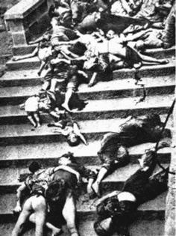
Imperial Japan and the Rape of Nanking
The Second World War began in Asia. Japan's military dictators had long viewed China as the main outlet for their imperial and expansionist ambitions (for an overview, see Saburo Ienaga, The Pacific War 1931-1945). Japanese forces invaded and occupied Manchuria in northeast China in 1931, setting up the puppet state of Manchukuo. After the manufactured "Marco Polo Bridge Incident" of July 1937, the Japanese launched a fullscale invasion of China, capturing Shanghai on 12 November and the imperial capital, Nanjing, on 13 December. Numerous atrocities were committed en route to Nanjing, but they could not compare with the epic carnage and destruction the Japanese unleashed on the defenseless city after Chinese forces abandoned it to the enemy.
Women were killed in indiscriminate acts of terror and execution, but the large majority died after extended and excruciating gang-rape. "Surviving Japanese veterans claim that the army had officially outlawed the rape of enemy women," writes Iris Chang. But "the military policy forbidding rape only encouraged soldiers to kill their victims afterwards." She cites one soldier's recollection that "It would be all right if we only raped them. I shouldn't say all right. But we always stabbed and killed them. Because dead bodies don't talk ... Perhaps when we were raping her, we looked at her as a woman, but when we killed her, we just thought of her as something like a pig."

Francisco Franco, Ruler of Spain 1939-1975

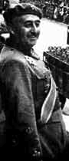
A young, unstable, left-wing Republic governed Spain in 1936. The armed forces, led by General Francisco Franco, overthrew the government.

Spain was plunged into a vicious Civil War. The cause of the Spanish Republicans and workers was taken up by intellectuals and left-wingers all over Europe and America. Sympathizers flocked to Spain to join the struggle. Meanwhile, Franco’s nationalists were assisted by the German air force and the Italian military.

By 1938 the civil war had spread across the country. The Republicans began to suffer from their lack of military training and equipment. The last city to fall to Franco was the capital Madrid. Many Republicans fled to France and Franco began his long rule.
During Franco’s rule trade unions and all political opponents across the political spectrum, from communist and anarchist organizations to liberal democrats and Catalan or Basque separatists, were either suppressed or tightly controlled by all means, up to and including violent police repression.
The few consistent points in Franco's long rule were above all authoritarianism, nationalism, Catholicism, and anti-Communism.

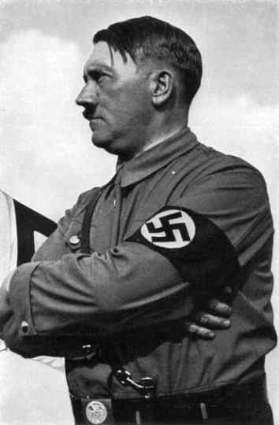
The Party Program of the NSDAP (National Socialist German Worker’s Party) was proclaimed on the 24 February 1920 by Adolf Hitler at the first large Party gathering in Munich and since that day has remained unaltered. Within the national socialist philosophy is summarized in 25 points:
1. We demand the unification of all Germans in the Greater Germany on the basis of the right of self-determination of peoples.
3. We demand land and territory (colonies) for the sustenance of our people, and colonization for our surplus population.
4. Only a member of the race can be a citizen. A member of the race can only be one who is of German blood, without consideration of creed. Consequently no Jew can be a member of the race.
18. We demand struggle without consideration against those whose activity is injurious to the general interest. Common national criminals, usurers, Schieber and so forth are to be punished with death, without consideration of confession or race.

“The last capitalist we hang shall be the one who sold us the rope.”
“My object in life is to dethrone God and destroy capitalism.”
“Religion is the sigh of the oppressed creature, the heart of a heartless world, and the soul of soulless conditions. It is the opium of the people. The abolition of religion as the illusory happiness of the people is the demand for their real happiness.”
“Let the ruling classes tremble at a Communist revolution. The proletarians have nothing to lose but their chains. They have a world to win. Working men of all countries, unite!”
― Karl Marx, German political philosopher/economist
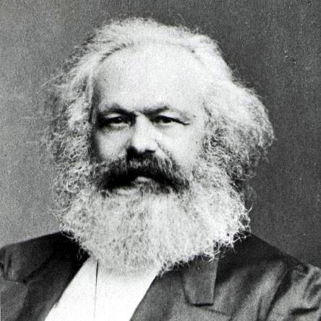

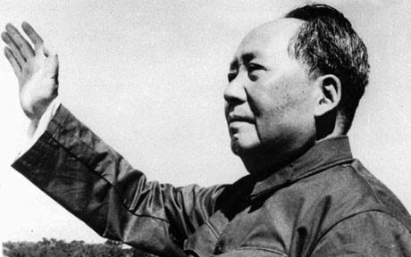

Quotes from Mao Tse-tung, ruler of China 1949-1976

“If the U.S. monopoly capitalist groups persist in pushing their policies of aggression and war, the day is bound to come when they will be hanged by the people of the whole world. The same fate awaits the accomplices of the United States.”

“A revolution is not a dinner party, or writing an essay, or painting a picture, or doing embroidery; it cannot be so refined, so leisurely and gentle, so temperate, kind, courteous, restrained and magnanimous. A revolution is an insurrection, an act of violence by which one class overthrows another.”

“...the evil system of colonialism and imperialism arose and throve with the enslavement of Negroes and the trade in Negroes, and it will surely come to its end with the complete emancipation of the Black people.”

Country/Leader | Left? Right? | Why?
Imperial Japan
Karl Marx, political philosopher/
economist
Francisco Franco, Spain
Adolf Hitler, founder of National Socialist (Nazi Party), Germany
Chairman Mao, China

