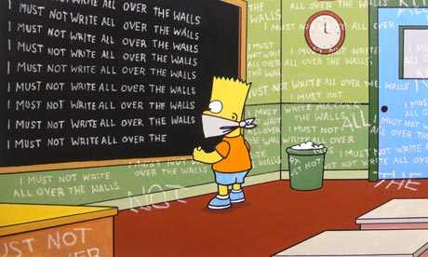
Satire Syllabus
Zander Lyvers
zander@tywls-astoria.org
www.historicalfriction.weebly.com

The satirist uses ridicule and wit to expose human weakness and vice; the satirist’s aim is to change or reform what he/she sees as correctable faults in society. Often the selections we read are humorous, but sometimes they will be extremely serious. Since the satirist relies on indirection, rarely stating straightforwardly what he intends, our classroom focus will be on what the satirist is “saying,” what point he/she is making, and what change he/she is advocating.
We will continually evaluate our thinking processes—how we arrive at our conclusions—sharing those with others in the class as we work individually, in small groups, and in the large group to unlock the satirist’s intent. As our skill and sophistication increases, we will deal with longer works, including TV shows, feature-length films and novels involving multiple layering of ideas, main points and sub-points.
The ultimate test of understanding satire is the ability to plan, design, and develop satirical pieces. Thus, students will produce and present satirical pieces, individually and in small groups. Students will have the opportunity to do some in-depth research on a satire-related subject of their choice. Over the course of the semester, students will research, reflect, create a product, and eventually present their findings to the class.

Objectives and activities of the course include the following:
- Reading and discussion of selected writings from the field of satire.
- Writing one-sentence summaries of a satirist’s point, writing papers analyzing technique, developing a position, or comparing a selection to current society.
- Participating in class discussions evaluating a satirist’s ideas.
- Evaluating the thinking processes involved in arriving at a satirist’s intent.
- Writing and producing student-developed satires.
- Selecting an area of interest to research

Course Overview
We will begin the course by looking at the mayoral race through different campaign ads/articles. Our goal is to prepare a satirical newspaper/website (a la The Onion) that focuses on the Mayoral race. The website will include individual articles as well as music, film and other media that you wish to utilize to invoke satire.
If you have a suggestion for a unit or a focus, please bring it to my attention. This class is very flexible and I want you to keep in mind that you hold stock in it, as long as you are committed to creating work that you are proud of.
Also, it is a dream of mine to go on an after-school trip to a taping of The Colbert Report. Please let me know if you are interested in such an excursion!
Satirical works that we will be analyzing in this class:
Print:
The Onion

TV:
“The Colbert Report”
“The Daily Show”

Film:
Bamboozled
Exit Through the Gift Shop (Banksy)
Night of the Living Dead
Borat
South Park

Literature:
A Modest Proposal- Jonathan Swift
The Works of Kurt Vonnegut

I'm a satirist, so I've got boxing gloves on if the person is worthy of satire. But I'm not an assassin.
Stephen Colbert

There is a place in this world for satire, but there is a time when satire ends and intolerance and bigotry toward religious beliefs... begins.
Isaac Hayes

SHARED OUTCOMES
Create
Construct or develop a product for expression.
Innovate
Develop new and helpful ways of looking at opportunities, challenges and problems.
Discern
View, read and listen with focused attention to what matters. Examine closely and methodically, attending to easily overlooked details, logic and patterns
Conclude
Infer meanings, analyze information and develop valid ideas based on evidence and analysis.
Argue
Build a case for and defend conclusions reached, based in sound logic and valid evidence. Question and critique the arguments of others as warranted.
Communicate
Make ideas and information understood, mindful of audience, purpose and setting. Listen and respond to what others communicate.
Investigate
Ask and refine a researchable question, design a valid experiment or inquiry and gather appropriate info to complete the inquiry.
Collaborate
Work effectively with others to achieve common goals.
Plan
Frame and clarify goals and make deliberate plans for how to achieve them. Seek and obtain feedback and assess progress, make adjustments, as needed, to achieve goals. Persevere in the face of difficulty to search for multiple solutions.
Be Precise: Accurately represents solutions, ideas and language.

