Cuba
The Cuban state adheres to _________ principles in organizing its largely state-controlled planned economy. Most of the means of production are owned and run by the government and most of the labor force is employed by the state. Recent years have seen a trend toward more private sector employment. By 2006, public sector employment was 78% and private sector 22%, compared to 91.8% to 8.2% in 1981. Capital investment is restricted and requires approval by the government. The Cuban government sets most prices and rations goods. Any firm wishing to hire a Cuban must pay the Cuban government, which in turn will pay the employee in Cuban pesos.

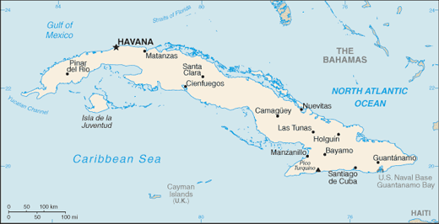
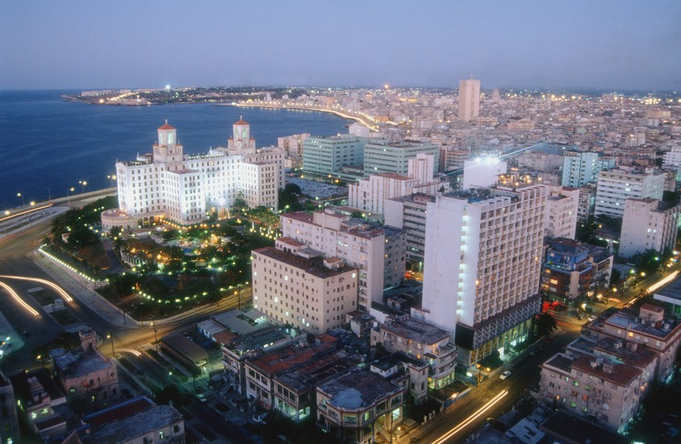

Hong Kong
The Hong Kong Government has traditionally played a mostly passive role in the economy, with little by way of industrial policy and almost no import or export controls. Market forces and the private sector were allowed to determine practical development. Under the official policy of "positive non-interventionism", Hong Kong is often cited as an example of laissez-faire ____________. Following the Second World War, Hong Kong industrialised rapidly as a manufacturing centre driven by exports, and then underwent a rapid transition to a service-based economy in the 1980s. Since then, it has grown to become a leading center for management, financial, IT, business consultation and professional services.
Hong Kong matured to become a financial centre in the 1990s, but was greatly affected by the Asian financial crisis in 1998, and again in 2003 by the SARS outbreak. A revival of external and domestic demand has led to a strong recovery, as cost decreases strengthened the competitiveness of Hong Kong exports and a long deflationary period ended.

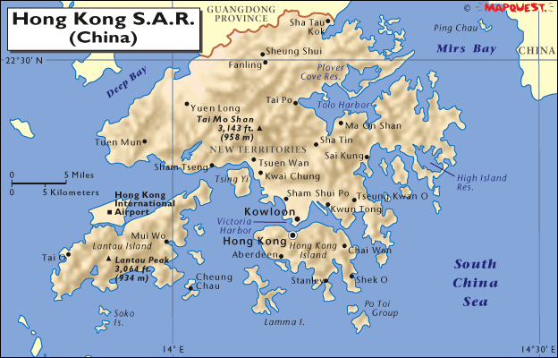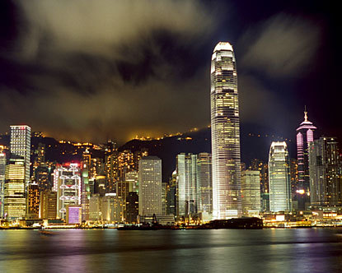

North Korea
The economy of North Korea operates under the Central Bank of the Democratic People's Republic of Korea and issues the North Korean won. North Korea has an industrialised, highly centralized command economy. North Korea is one of only two states (along with Cuba) with an almost entirely government-planned, state-owned economy. The Central Planning Committee prepares, supervises and implements economic plans, while a General Bureau of Provincial Industry in each region is responsible for the management of local manufacturing facilities, production, resource allocation and sales.
The average salary was about $47 per month in 2004. The average official salary in 2011 was equivalent to $2 per month while the actual monthly income seems to be around $15 because most North Koreans earn money in illegal small businesses: trade, subsistence farming, and handicrafts. The illegal economy is dominated by women because men have to attend their places of official work even though most of the factories are non-functioning. It is estimated that in the early 2000s, the average North Korean family drew some 80% of its income from small businesses that are legal in market economies but illegal in North Korea.

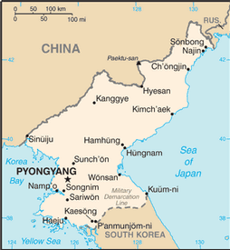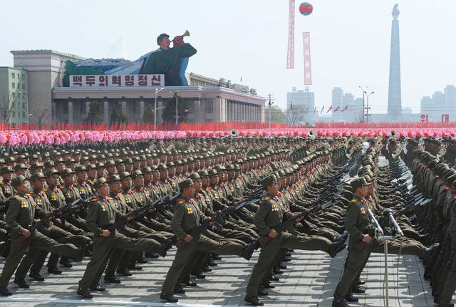

South Korea
South Korea has a market economy which ranks 15th in the world by nominal GDP and 12th by purchasing power parity (PPP), identifying it as one of the G-20 major economies. It is a high-income developed country and is a member of OECD. It is the most industrialised member country of the OECD. South Korea is the only developed country so far to have been included in the group of Next Eleven countries. South Korea had one of the world's fastest-growing economies from the early 1960s to the late 1990s, and South Korea is still one of the fastest-growing developed countries in the 2000s, along with Hong Kong, Singapore, and Taiwan, the other three Asian Tigers. South Koreans refer to this growth as the Miracle on the Han River. The South Korean economy is heavily dependent on international trade, and in 2010 South Korea was the sixth largest exporter and tenth largest importer in the world.

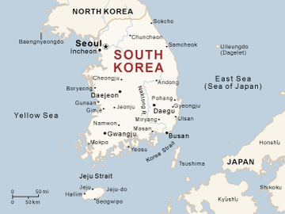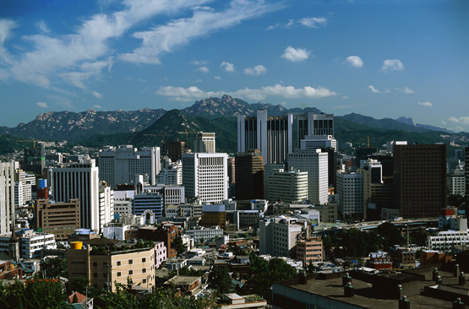

Japan
Some of the structural features for Japan's economic growth developed in the Edo period, such as the network of transport routes, by road and water, and the futures contracts, banking and insurance of the Osaka rice brokers. During the Meiji period from 1868, Japan expanded economically with the embrace of the market economy. Many of today's enterprises were founded at the time, and Japan emerged as the most developed nation in Asia. The period of overall real economic growth from the 1960s to the 1980s has been called the Japanese post-war economic miracle: it averaged 7.5 percent in the 1960s and 1970s, and 3.2 percent in the 1980s and early 1990s.
Some of the largest enterprises in Japan include Toyota, Nintendo, NTT DoCoMo, Canon, Honda, Takeda Pharmaceutical, Sony, Panasonic, Toshiba, Sharp, Nippon Steel, Nippon Oil, and Seven & I Holdings Co.^{[115]} It has some of the world's largest banks, and the Tokyo Stock Exchange stands as the second largest in the world by market capitalization. Japan is home to 326 companies from the Forbes Global 2000 or 16.3 percent (as of 2006).
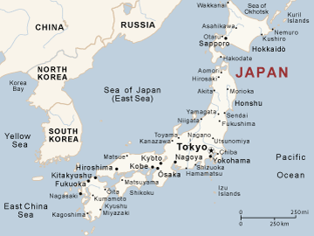

Based on your reading of Marx, complete this chart:
Communist | Capitalist

Country | Communist/  Capitalist? | Why?
Cuba
Hong Kong
North Korea
South Korea
Japan

