Event | Key Details | What is motivating this event- economics or Enlightenment ideas? Why?
1775-1781: France assists in American Revolution
Winter of 1789: Bread Riots
June 20, 1789:
Tennis Court Oath
July 14, 1789: The Fall of the Bastille
Late July, 1789:
The Great Fear
August 4, 1789:
The Creation of the Declaration of Rights of Man and Citizen

Society in pre-revolutionary France

The Estates-General was a general assembly representing the French estates of the realm: the clergy (First Estate), the nobles (Second Estate), and the common people (Third Estate). Each estate was granted 1 vote in the Estates-General.
The Third Estate consisted of 98% of the population in France. They represented the peasants to the middle class, or “bourgeoisie.” The Third Estate paid all of the taxes, while the first 2 estates were not taxed.
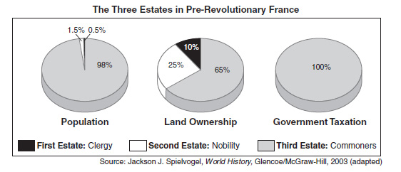

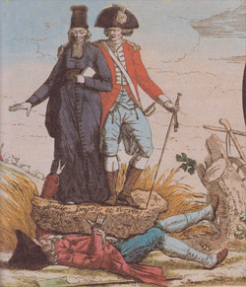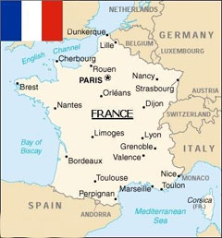

What led to these radical changes between the winter and the late summer of 1789? Were these changes motivated more by Enlightenment ideas or economics?

