1) TASK CARD May 6th - May 11th

a) Interpretations to 9/11 annotations
Left/Right spectrum
b) History of Osama bin Laden
c) Map of the War on Terror
d) Terrorists or Freedom Fighters?
e) Crusades article
f) Answer Aim
****************After all tasks completed, Check In with Zander****************

Key Terms: Left-wing, Right-wing, Taliban, Al-Qaeda, jihad, Mujahideen, terrorism, freedom fighter
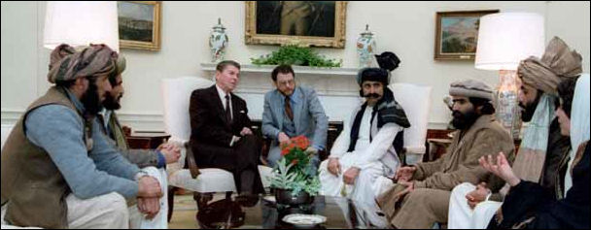
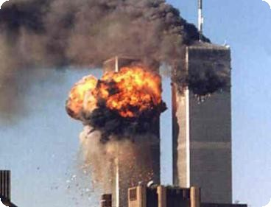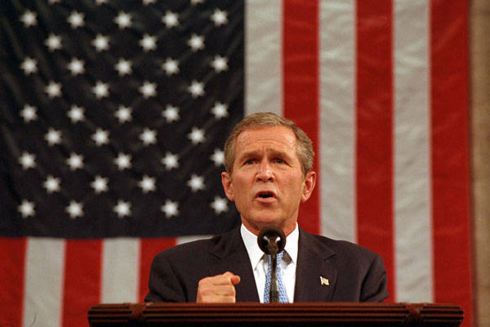
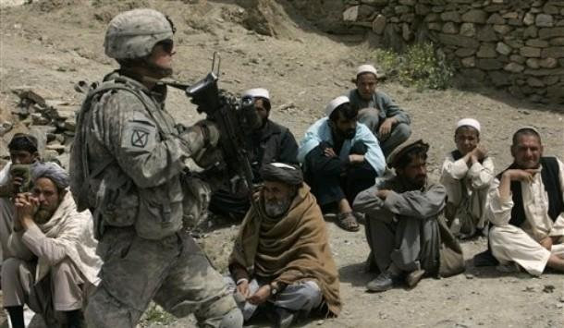

Task 1a

1. Based on the different perspectives of the terrorist attacks on 9/11, map out the different points of view on the on the spectrum.
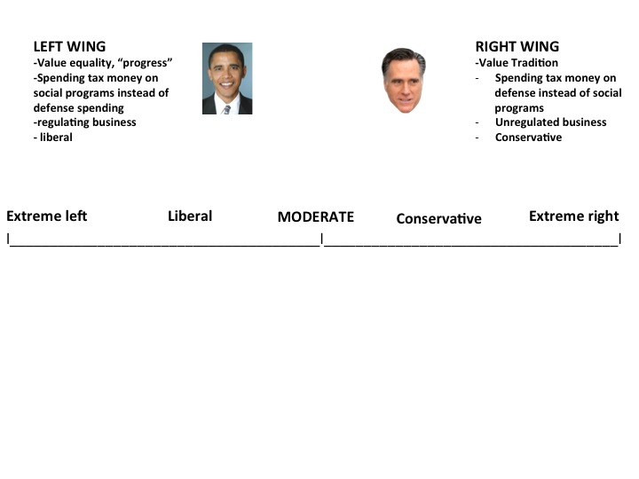

2. What is the main difference between the voices on the left and right regarding the causes of 9/11? Be sure to cite at least 2 sources in your response.

3. Who do you think makes the best argument? Why?

BIN LADEN OBJECTIVES
• Religious war against America and American interests
• Remove US forces from Saudi Arabia and the Gulf
• Liberate Jerusalem from Israelis
• Overthrow the "un-Islamic" governments of the region
• Restore the Caliphate, or pan-Islamic ruler

Task 1b

Who is Osama Bin Laden? 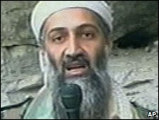
Osama Bin Laden is top of the US most wanted list.
ANNOTATIONS

Those who have met Bin Laden describe him as a mild-mannered man, who is generally polite and hospitable to strangers, yet he has become the most hated and implacable opponent of the US and all it stands for.
Born in Saudi Arabia in 1957 to a wealthy Yemeni father and a Syrian mother, he had a comfortable childhood.
Like his father, who had made his fortune from the construction business and had close ties with the Saudi royal family, the young Bin Laden had religious leanings.
At school and university, he was a member of the Muslim Brotherhood.
When the Soviets invaded Afghanistan in 1979, he went to Pakistan, where he met Afghan rebel leaders resisting the occupation.
Later, he returned to Saudi Arabia to collect money and supplies for the Afghan resistance, the mujahideen.
He made further trips, delivering aid and arms, and eventually joining the fight against the Soviets.
Rebel commander
As a wealthy Saudi, he stood out and acquired a following.
Egyptians, Lebanese, Turks and others - numbering thousands in Bin Laden's estimate - joined their Afghan Muslim brothers in the struggle against a Soviet ideology that was hostile to religion.
ANNOTATIONS

Bin Laden opened a guesthouse in Peshawar - a stopping-off point for Arab mujahideen fighters. Eventually, their numbers became so large he built camps for them inside Afghanistan.
He gave the umbrella group for his guesthouse and camps a name: al-Qaeda, Arabic for "the base".
As a military commander, Bin Laden was respected for his organizational skills, his bravery and, above all, for his ability to survive.
American backing
The Afghan jihad against the Soviet army was backed by American dollars and had the blessing of the governments of Saudi Arabia and Pakistan.
After the Soviet withdrawal, the "Arab Afghans", as Bin Laden's faction came to be called, looked forward to a warm welcome at home.
But Bin Laden quickly became disillusioned by the lack of recognition for his achievements.
This turned to anger when the Saudis turned down his offer to provide an army of mujahideen to defend the kingdom after the Iraqi invasion of Kuwait.
Instead, half a million US soldiers were invited on to Saudi soil - a historic betrayal in Bin Laden's eyes.
Bin Laden became an out-and-out opponent of the Saudi regime and began to direct his efforts against the US and its allies in the Middle East.
In 1991, he was expelled from the country because of his anti-government activities.
Period of radicalization
He spent the next five years in Sudan, where he used his money to fund a number of infrastructure projects for the Islamist government in Khartoum.
ANNOTATIONS

The Saudi government is reported to have sought reconciliation but, when this failed, it froze his bank accounts and stripped him of his Saudi citizenship.
The US put pressure on Sudan's government to expel him, prompting Bin Laden's return to Afghanistan where he became increasingly radical.
By the mid-1990s, he was calling for a global war against Americans and Jews and in 1998, he issued his famous fatwa (religious ruling), amounting to a declaration of war against the US.
Two simultaneous bomb attacks against US embassies in Kenya and Tanzania followed a few months later.
Bin Laden never acknowledged responsibility, but several of those arrested for their part in the bombings named him as a backer.
Islamic front
Al-Qaeda's motivations and aims are varied, but include avenging perceived wrongs against Muslims, imposing a single Islamic political leadership over the Muslim world, and driving Americans and other non-Muslims from Saudi Arabia, the home of Islam's holiest sites.
After the 2001 attacks Bin Laden made a number of recorded statements.
Later these became much less frequent, though several recent audio messages have been attributed to him - including one in September 2009 that called on US to stop its military campaign against al-Qaeda.
Audio messages have carried still images thought to show Bin Laden. The al-Qaeda leader is believed to have stopped making video messages, possibly as a security precaution or because of poor health.
But many analysts believe that even if Bin Laden were to die or be killed, his organization has taken on a life of its own, and would continue to inspire Islamic militancy around the world.
Story from BBC NEWS:
http://news.bbc.co.uk/go/pr/fr/-/2/hi/south_asia/1551100.stm

Task 1c

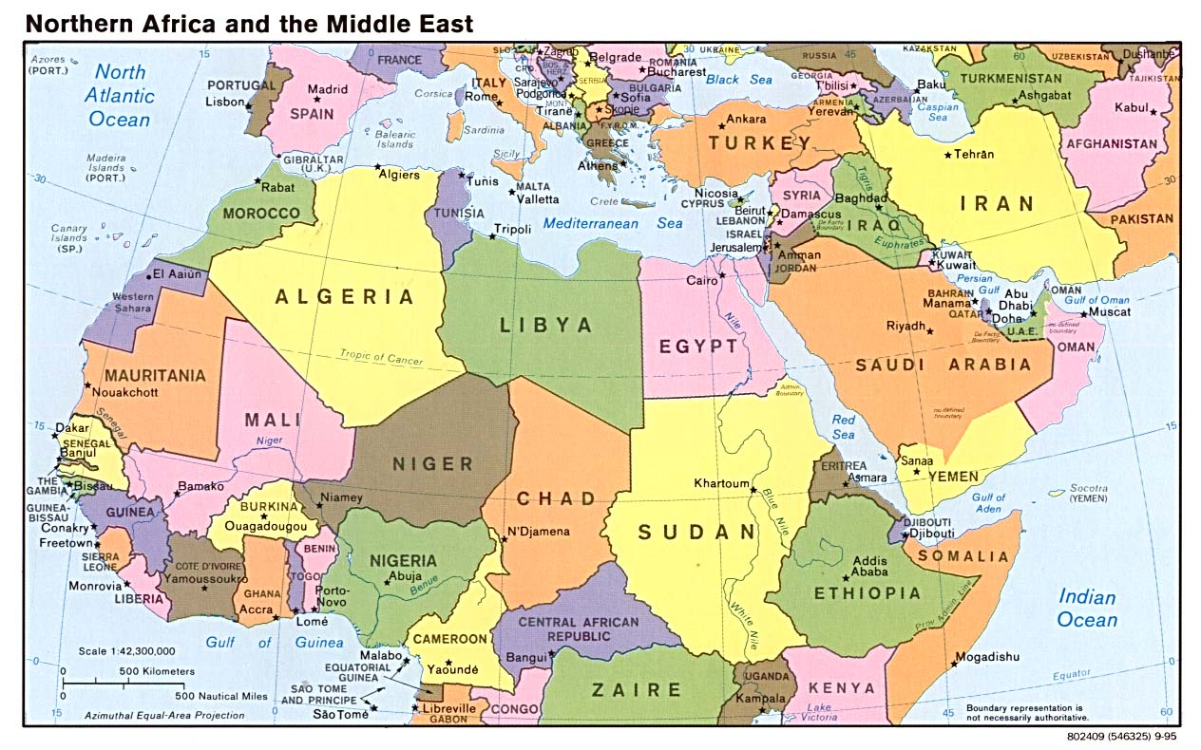Annotate this map based on your reading of Osama’s biography from the BBC. Mark which countries that are part of Osama’s history.

Based on your annotations, answer the questions: How did Osama bin Laden’s goals change from the 1980s to 2001? How and why did his relationship with the United States change from the 1980s to the 2000s. What were bin Laden’s main goals?

Task 1d
Terrorists or Freedom Fighters?

terrorism - the use of violence and intimidation in the pursuit of political aims.
freedom fighter- a person who takes part in a violent struggle to achieve a political goal

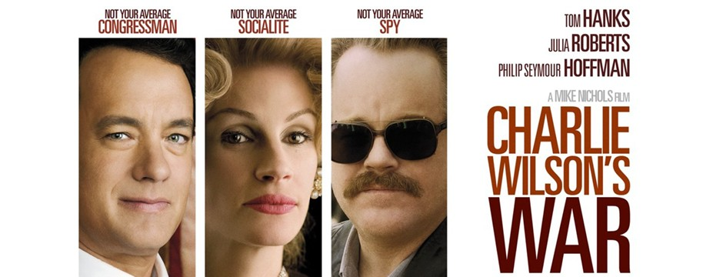

https://www.youtube.com/watch?v=-WmDszVxti0

Watch this clip from the film Charlie Wilson’s War. Charlie Wilson’s War tells the story in which the United States semi-secretly armed Afghan mujahideen “freedom fighters” against the Soviet (Russian) invasion for much of the 1980s, which was a prequel to later trouble with anti-Western Islamic terrorists in Afghanistan and elsewhere. In this clip, you will see Afghans using scud missiles to shoot down Soviet helicopters. The U.S. main enemy from 1945-1989 was the Soviet Union [communist Russia]. The U.S. helped the mujahideen since they also shared an enemy in the Russians.

What is happening in this clip?

https://www.youtube.com/watch?v=y3f9mlUQzJA
What is the word that President Reagan call the Mujahideen? ________________________________
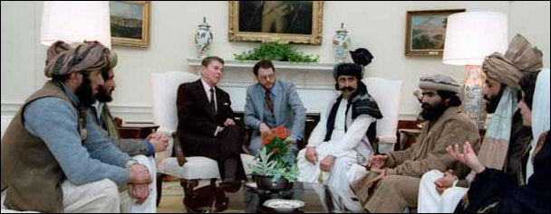
In 1985, President Reagan met with the Mujahideen, an Afghan resistance group that would later make up the Taliban government in Afghanistan. Reagan called the Mujahideen the “moral equivalents of the Founding Fathers.”

Terror and tyranny Seumus Milne, The Guardian 24 October 2001
What powerful states call terrorism may be an inevitable response to injustice
For a war that, in the words of US Vice-President Dick Cheney, "may never end", the enemy is proving embarrassingly hard to define. Of course, we know all about Osama bin Laden, supposed mastermind of the twin towers attacks, and his Taliban protectors, and we have become ominously aware of the demands from within the US administration that Iraq be brought into the frame. But this campaign is intended to be something grander still. The bombs and missiles now raining down on Afghanistan have been proclaimed as the curtain-raiser of a war against terror itself, which will not cease until the scourge of political violence is dealt with once and for all.
If paramilitary groups become terrorists because they kill or injure civilians, what of those states which bomb television stations, bridges and power stations, train and arm death squads or authorize assassinations? After days when hundreds of Afghan civilians are reported to have died as a result of Anglo-American bombardment - while hundreds of thousands are fleeing for their lives - Defence Secretary Donald Rumsfeld's remark that the aim was to "frighten" the other side couldn't have more sharply posed the contradiction of terror.
In his City of God, Saint Augustine tells a story about an encounter between Alexander the Great (the last ruler successfully to conquer Afghanistan) and a pirate captain he had caught on the high seas. Alexander demands: "How dare you molest the seas as a pirate?" "How dare you molest the whole world?" retorts the plucky pirate. "I have a small boat, so I am called a thief and a pirate. You have a great navy, so you are called an emperor, and can call other men pirates." Substitute terrorist or rogue state for pirate and the episode neatly encapsulates the morality of the new world order.
Political violence emerges when other avenues are closed. Where people suffer oppression, are denied a peaceful route to justice and social change and have exhausted all other tactics. Certainly, the September 11 atrocity was an unprecedented act of non-state terror. But such groups are also the product of conditions in the Arab and Muslim world for which both Britain and the US bear a heavy responsibility, through their support of despotic regimes [cruel governments] for over half a century. It was precisely that blockage of democratic development that led to the failure of secular politics, which in turn paved the way for the growth of Islamist radicalism. Groups like al-Qaida offer no future to the Muslim world, but Bin Laden and his supporters have their boots sunk deep in a swamp of grievance. As the assault on Afghanistan continues, no one should delude themselves that cutting off al-Qaida's head or destroying its Afghan lair will put an end to this eruption.
Based on the film clips and article that you read in this section, answer this questions:
1. Is there a difference between a terrorist and a freedom fighter? Use evidence to back up your claims.

2. Why does Milne argue that the term “terrorism” is problematic? Do you agree with Milne? Why or why not?

Task 1e

The Tenth Crusadeby Alexander Cockburn September 2002 [a year after 9/11 and the beginning of the War in Afghanistan, and a few months before the war in Iraq]
ANNOTATIONS

Amid the elegies for the dead and the ceremonies of remembrance, the question must be asked: Is there really a war on terror; and if one is indeed being waged, what are its objectives?
The terrorists in those planes a year ago nourished specific grievances, all available for study in the speeches and messages of Osama bin Laden. They wanted US troops out of Saudi Arabia. They saw the US as Israel’s prime backer and financier in the oppression of Palestinians. They railed against the sanctions [economic penalties] grinding down upon the civilian population of Iraq.
A year later the troops are still in Saudi Arabia, US backing for Israel is more ecstatic than ever and scenarios for a blitzkrieg against Saddam Hussein mostly start with a saturation bombing campaign which will plunge civilians in Iraq back into the worst miseries of the early 1990s.
Terror against states springs from the mulch of political frustration. We live in a world where about half the population of the planet, 2.8 billion people, live on less than two dollars a day. The richest 25 million people in the United States receive more income than the 2 billion poorest people on the planet. Across the past year world economic conditions have mostly got worse, nowhere with more explosive potential than in Latin America, where Peru, Argentina and Venezuela all heave in crisis.
Is the world impressed with America’s commander-in-chief? The answer is mostly, No. But wars need leaders, and for George Bush it’s been a wobbly slide downhill from the terse defiance of that first emergency joint session of Congress, to the strange on-again, off-again proclamations about an attack on Iraq.
How could an attack on Iraq be construed as a blow against terror? The administration abandoned early on, probably to its immediate regret, the claim that Iraq was complicit on the attacks of September 11. Aside from the Taliban’s Afghanistan the prime nation that could be blamed was Saudi Arabia, point of origin for so many of the Al Qaeda terrorists on the planes.
Would an attack on Iraq be a reprisal? If it degraded Saudi Arabia’s role as prime swing producer of oil, if it indicated utter contempt for Arab opinion, then Yes. But does anyone doubt that if the Bush administration does indeed topple Saddam Hussein and occupy Baghdad, this will be truly a plunge into the unknown, one that would fan once more the fires of Islamic radicalism that peaked as long ago as the end of the 1980s.
Islamic fanatics flew those planes a year ago and here we are with a terrifying alliance of Judaeo-Christian fanatics, driven by their dreams of the recovery of the Holy Lands of the West Bank, Judaea and Samaria. War on Terror? It’s back to the late thirteenth century, picking up where Prince Edward left off with his ninth crusade after St Louis had died in Tunis with the word Jerusalem on his lips.

ANNOTATIONS

Why is this article called “The Tenth Crusade”? What argument is the author trying to make?

This article was written months after the War on Terrorism began. What will you have to know by the end of the unit to be able to confirm or deny Cockburn’s argument?
What I need to know about the War on Terrorism to answer the Driving Question: Is the War on Terrorism a continuation of the Crusades?
What I remember about the Crusades…..

Task 1f
Answer the aim: What were the historical causes and effects of 9/11?

**********CHECK IN WITH ZANDER BEFORE MOVING ON TO TASK CARD 2***************

Mujahideen- guerrilla fighters in Afghanistan in the 1980s who were fighting against the Soviet Union [communist Russia]. Veterans of the Mujahideen eventually set up the Taliban government in Afghanistan in the 1990s, which protected al-Qaeda

