2) TASK CARD Imperialism

a) “Old school” Imperialism
b) The New Imperialism
c) The British in India
d) The British in China
e) The Berlin Conference
f) Scientific Racism
g) Meiji Restoration
h) Resistance to Imperialism
i) Discussion
j) Answer Essential Question
****************After all tasks completed, Check In with Zander****************
Key Terms: imperialism, triangle trade, mercantilism, social Darwinism, paternalism, Opium Wars, gunboat diplomacy, Sepoy Rebellion, Boxer Rebellion, Meiji Restoration, sphere of influence, maxim gun, Berlin Conference, Leopold II

2a) Old School Imperialism
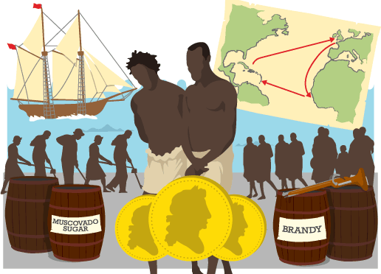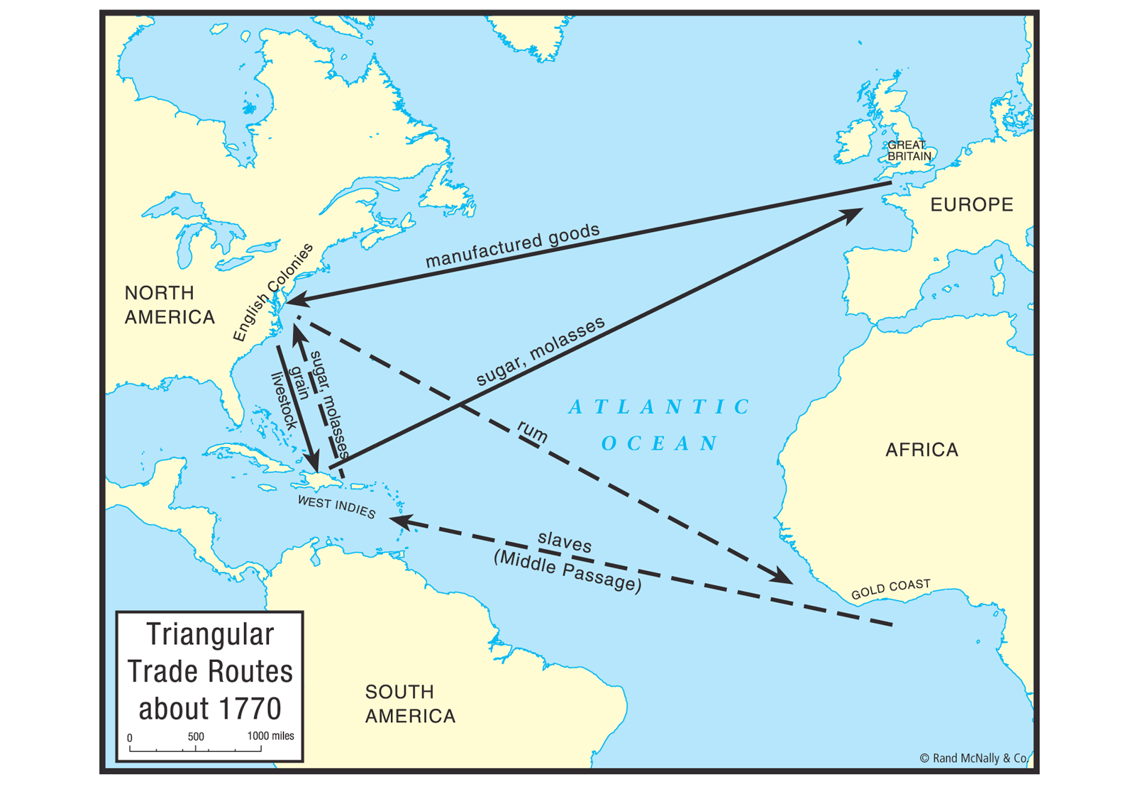

The old imperialism of the Absolutist Monarchies of the 16th and 17th centuries

The Triangular trade
The slave trade began with Portuguese, and some Spanish, traders taking African slaves to the American colonies they had conquered in the 15th century. British sailors became involved in the trade in the 16th century, and the Treaty of Utrecht (1713) gave them the right to sell slaves in the Spanish Empire. In the 18th century, perhaps 6 million Africans were taken to the Americas as slaves, at least a third of them in British ships. For the British slave traders it was a three-legged journey, called the 'triangular trade':
- Taking trade goods, such as guns and brandy, to Africa to exchange for slaves.
- Then taking the slaves on the 'Middle Passage' across the Atlantic to sell in the West Indies and North America.
- Finally, taking a cargo of rum and sugar back to sell in England.
Conditions on the Middle Passage were terrible, and 10-15% died on this leg of the trip.
Probably the best definition of slavery is “the permanent, violent, and personal domination of natally alienated and generally dishonored persons.”
Watch this clip from Steven Spielberg’s Amistad in order to understand the horrors of the Middle Passage. How does this clip represent the above definition of slavery?
https://www.youtube.com/watch?v=fCHvD2DyWeY

Slavery existed at a time when monarchs engaged in an economic system known as mercantilism.
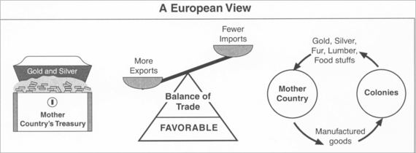
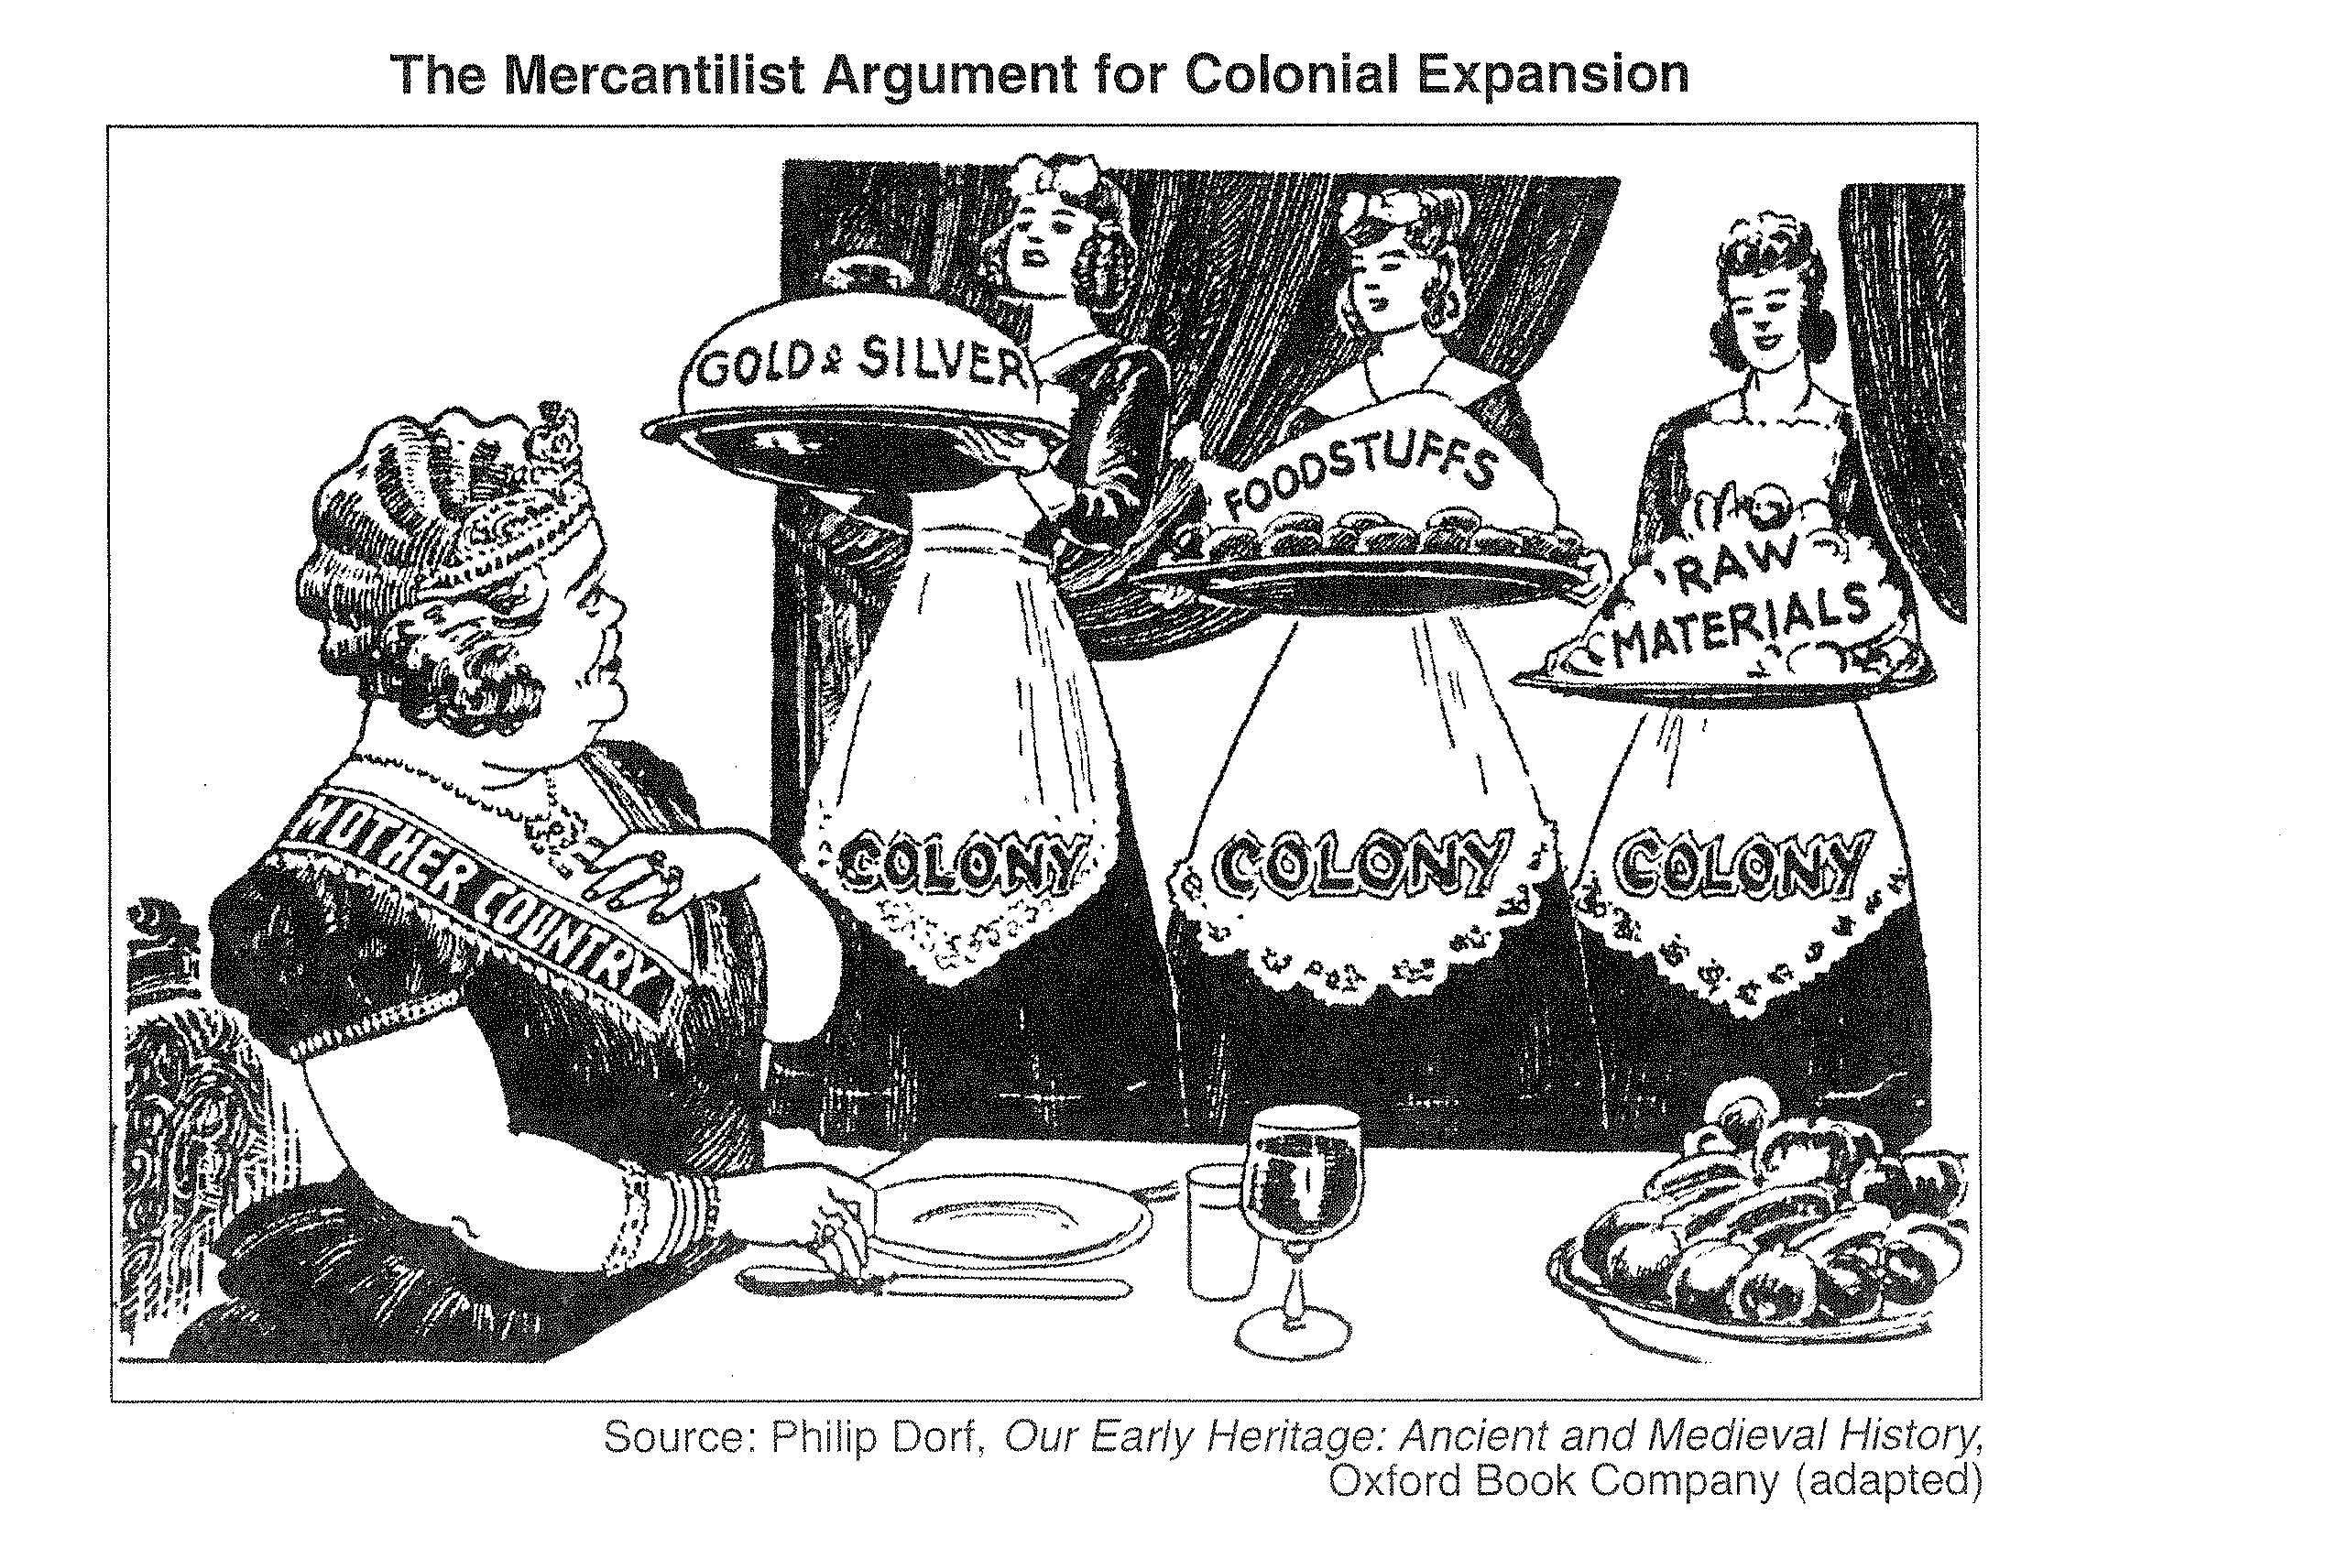

Based on the graphic and the political cartoon, what is your definition of mercantilism?

2b) The New Imperialism

- Imperialism- domination by one country of the political, economic, or cultural life of another country or region
European countries had engaged in imperialism to suit their mercantilist needs during the 16th, 17th and 18th centuries. This older imperialism was typically carried out through coastal colonies on in the Americas and western Africa. New advancements in technology and industrialization allowed Europeans to go where they were unable to go before- the interiors of the continents of Africa and Asia. Quinine medicine, a drug that protects against malaria, allowed Europeans to penetrate the interior of Africa. New methods of transportation and weaponry also allowed the Europeans to engage in this movement known as the New Imperialism.

Read the following primary sources and determine the causes of the New Imperialism:

2 Primary Sources from Jules Ferry, Prime Minister of France, 1883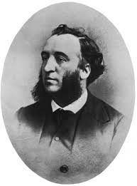
“Nations are great in our times only by means of the activities which they develop…(France) ought to propagate this influence throughout the world and carry everyone that she can her language, her customs, her flag, her arms, and her genius.”

“I repeat, that the superior races have a right because they have a duty. They have the duty to civilize the inferior races .... In the history of earlier centuries these duties, gentlemen, have often been misunderstood. . . But, in our time, I maintain that European nations acquit themselves with generosity, with grandeur, and with sincerity of this superior civilizing duty.”

Using both excerpts from Jules Ferry, discuss the causes of the New Imperialism:

What cause is conspicuously [noticeably] left out? What would be the most obvious cause of imperialism? Why?

2c: Chris Harman, “Britain’s Indian Empire.” A People’s History of the World, 2008. | ANNOTATIONS
India was the first of the great empires to fall into western hands. After the collapse of the Mogul Empire six warring kingdoms fought for control of India. This opened the door to the intervention of the British East India Company [trading company], with its troops and its arms. Over time it established increasingly strong ties with the Indian merchants who sold textiles and other goods. The Company aimed to cover all its costs from taxing the Indian population and relied on an army made up overwhelmingly of ‘Sepoy’ Indian troops.

Many Indian rulers saw the Company as a useful ally. Indian merchants welcomed its increased
influence, as it bought growing quantities of textiles from them and helped guarantee their property against inroads by Indian rulers. It was not difficult for the British to consolidate their position further,
when necessary, by dispensing with stubborn local rulers and establishing direct Company rule.
By 1850 a policy of conquering some rulers and buying off others had extended the area of British domination throughout the whole sub-continent.
British ministers boasted that the Company’s approach was modeled on the Roman principle of
“divide et impera” —divide and conquer. Using bribery in some instances and violence in others, it played ruler off against ruler, kingdom against kingdom, privileged class against privileged class, caste against caste, and religion against religion, finding local allies wherever it moved. This enabled it to conquer an empire of 200 million people with a native army of 200,000 men, officered by Englishmen and…kept in check by an English army numbering only 40,00’.

Enormous wealth flowed to the Company’s agents.
This wealth was created by the mass of peasants.
This was shown dramatically in the first decades of the 19th century. The industrialization of the English cotton mills suddenly enabled them to produce cloth more cheaply than India’s handicraft industry. Instead of India’s products playing a central role in British markets, British cloth took over India’s markets, destroying much of the Indian textile industry, devastating the lives of millions of textile workers, and damaging the profits of the Indian merchants. Without a government of their own, they had no means to protect their interests as the country underwent de-industrialization and British capitalists displaced them from areas of profit making like shipbuilding and banking. Meanwhile the thin, highly privileged class of British officials became more arrogant, more bullying, more condescending, and more racist. They reaped the consequences of their behavior in 1857. The
Company’s Sepoy Indian troops turned on their officers after they ignored the troops’ religious convictions, ordering them to use cartridges greased with beef fat (offensive to Hindus) and pork fat (offensive to Muslims). Within weeks mutineers had seized control of a huge portion of northern India, killing those British officers and officials they could lay their hands on and besieging the remainder in a few isolated fortified posts. Hindus and Sikhs forgot any animosity towards Muslims, installing an heir of the Moguls as emperor in the historic capital of Delhi.

The uprising was eventually crushed. A panicking government rushed British troops to the sub-continent, and officers succeeded in persuading Indian soldiers in Madras and Bombay to put down the mutineers in the north. The most savage measures were then used to deter any future threat of mutiny. However, the government saw that repression alone could not pacify India. There had to be some institutionalizing of societal and religious divisions even if it meant dropping attempts to make Indian social behavior accord with bourgeois norms. Direct rule from Britain replaced that of the East India Company, Queen Victoria was proclaimed Empress of India, and every effort was made to include local Indian rulers and landowners into the imperial system. But if the administration was regularized, the impoverishment of the mass of people continued. The proportion of the population dependent upon agriculture for a living rose from 50 percent to 75 percent. While 25 percent of the tax revenues went on paying for the army to keep the Indians down, education, public health and agriculture got a bare 1 percent each. Famines swept the country. Over a million people died in the 1860s, three and a half million in the 1870s, and as many as ten million in the 1890s. Meanwhile there were comfortable careers, paid for out of the taxes on the peasants, for the sons of the British upper middle class. They brought over their wives and created the snob-ridden racist enclaves that maintained power for another half a century.

The Sepoy Rebellion, 1857
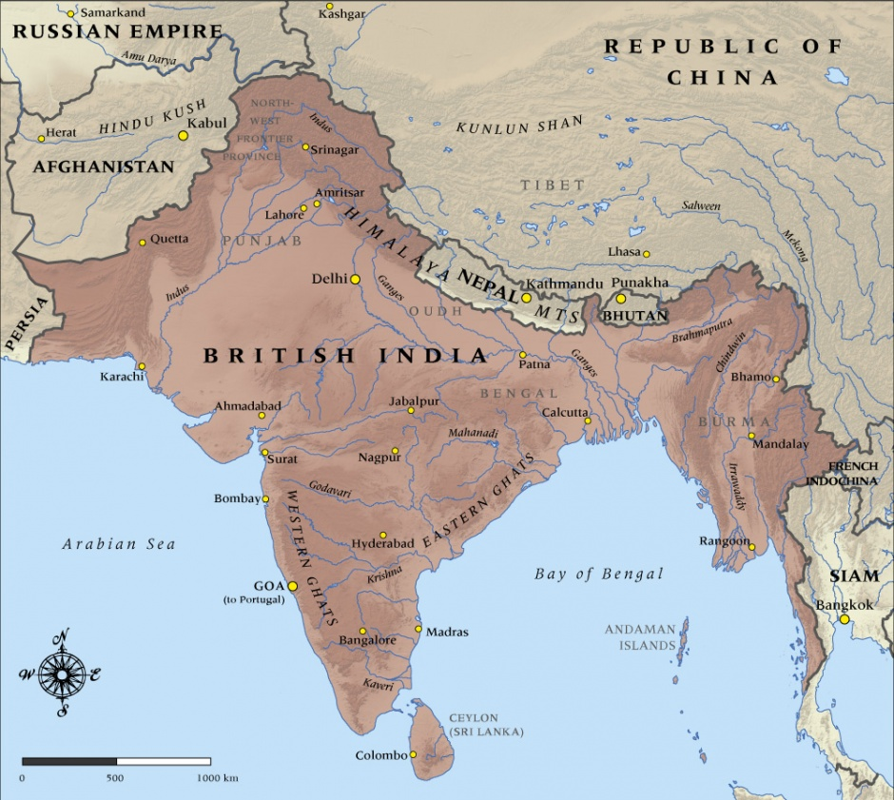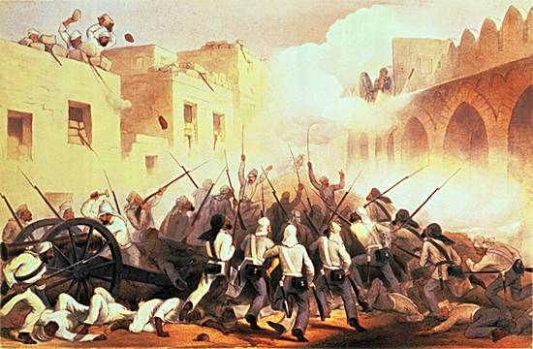
Use your evidence from your annotations and the video clip to answer the questions: Name at least 3 turning points that led to England’s control over India.

Task 2d
Case Study 2: The British in China
Chris Harman, “The Subjection of China.” A People’s History of the World, 2008. | ANNOTATIONS
China avoided being absorbed like India into a European empire.
Yet the fate of the mass of its people was hardly more desirable.
The wealth of China had excited the greed of western merchants
from the time of Marco Polo in the 13th century. But they faced a
problem. While China produced many things Europeans wanted,
Europe did not produce much the Chinese wanted. The British East India Company set out to rectify this by turning wide areas of the newly conquered lands in India over to the cultivation of a product that creates its own demand—opium. By 1810 it was selling 325,000 kilos of the drug a year through Canton, and soon turned China’s centuries old trade surplus into a deficit. When Chinese officials tried to halt the flow of opium, Britain went to war in 1839 for the right to create addiction.

China had only ever been conquered by nomad hordes from the north. Its rulers expected to be able to defeat a seaborne challenge from a country more than 7,000 miles away easily. They did not realize that economic developments at the other end of Eurasia—developments which owed an enormous debt to Chinese innovation in centuries past—had given rise to a country more powerful than anyone had ever imagined.
A memo to the emperor from a leading official predicted easy victory:

“The English barbarians are an insignificant and detestable race, trusting
to their strong ships and big guns; the immense distances they have
traversed will render the arrival of seasonable supplies impossible, and
their soldiers, after a single defeat…will become dispirited and lost.”

But after three years of occasional fighting and negotiations in the 1830s it was the Chinese who acceded to British terms—opening a number of ports to the opium trade, paying an indemnity, ceding the island of Hong Kong and granting extra-territorial rights to British subjects. It was not long before the British decided these concessions were insufficient.
They launched a second war in 1857, when 5,000 troops
laid siege to Canton and forced a further opening up of trade. Still dissatisfied, they then joined with the French to march 20,000 troops to Beijing and burn the summer palace. China scholars disagree about the reasons for the easy British victories.
Some ascribe them to superior weaponry and warships, a product
of industrial advance. Others stress the internal weaknesses of
the Manchu state, claiming the difference between the industrial
levels of the two countries was not yet enough to explain the victory.
But there is no dispute about the outcome. The concessions gained by Britain weakened the Chinese state’s ability to control trade and to prevent a growing outflow of the silver it used for currency. The defeats also opened the door to demands for similar concessions from other powers, until European states had extra-territorial enclaves or ‘concessions’ (in effect, mini-colonies) all along the Chinese coast. The English thereby developed a sphere of influence in China.

The Opium Wars still define relations between the UK and China.
By Julian Kossoff World Last updated: November 10th, 2010
English Prime Minister David Cameron toasts a contract signing with cabinet ministers in Beijing

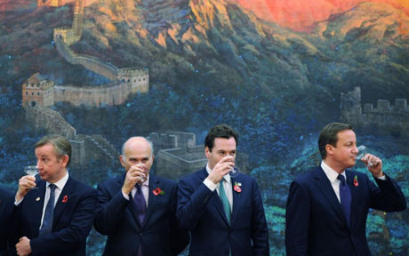

"David Cameron leads largest trade delegation to China in 200 years", hollered the headlines this week, with an almost subconscious allusion to the fact that two centuries of Anglo-Chinese trade includes the most demonic chapter in the history of the British Empire: the Opium Wars.
The effects of the Opium Wars still cascade through time. Then, like now, China produced what Europe and the USA desperately wanted. Rather than iPods and Primark's latest autumn/winter range, it was tea, silk and porcelain.
As the Emperor Ch'ien-Lung, a famous scholar and able ruler, told another British trade delegation in 1793. "Our Celestial Kingdom possesses all things in abundance and wants for nothing within its frontiers. Hence there is no need to bring in the wares of foreign barbarians to exchange for our own products."
Like David Cameron and his corporate cohorts today, that's the last thing the traders from the West wanted to hear. China, the British government and the East India Company agreed, needed to "get its mind right" and that was to be achieved by sending it dotty with an epidemic of opium addiction. A nation of zonked-out drug fiends would finance Sino-British trade and do what it was told.
Drug smuggling became official foreign policy. (The mafia – a bunch of lightweights. Mexican narco-gangsters – small-time. We're talking the British Empire.) Sure there was a "turf war"' but – despite the fact the Chinese invented gunpowder – there was only going to be one winner.
The First Opium War (1839) was condemned in the House of Commons by a newly elected young member of Parliament, William Ewart Gladstone, who wondered if there had ever been "a war more unjust in its origin, a war more calculated to cover this country with permanent disgrace". When Anglo-French forces sacked and looted Peking, burning the the beautiful and ancient imperial Summer Palace, the Second Opium War (1860) concluded and China's demotion to drug-addled subservience was complete.
Thus in 1842, China's population was 416,118,200, of whom 2 million were drug addicts. But by some estimates, in 1881, of a population of 369,183,000, 120 million were addicts.
While China was being exploited, Karl Marx arrived in London in 1849 and began work on his opus "Das Kapital", based on his observations of the first Industrial Revolution and capitalism's insatiable hunger for cheap labor and new markets. A century later, in 1949, driven by Marx's radical ideas, Mao seized power in China.
A 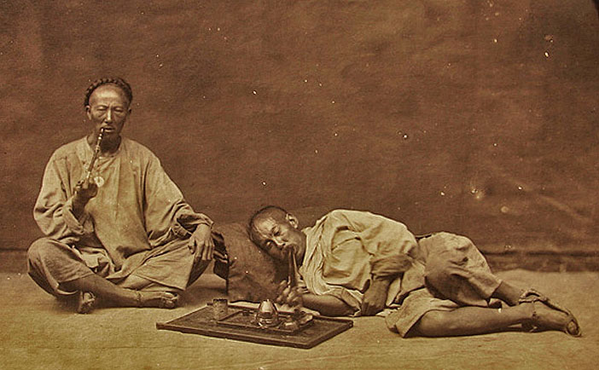 B 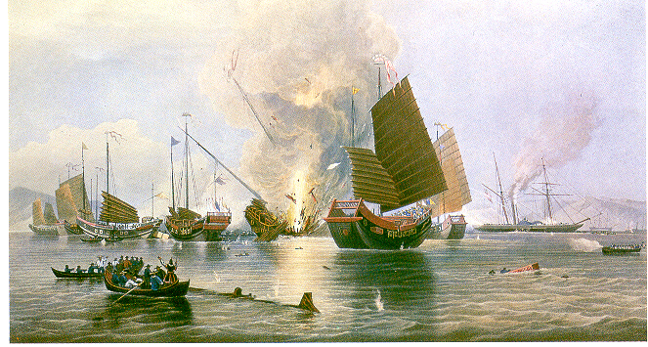
C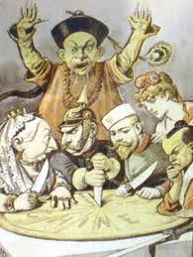 D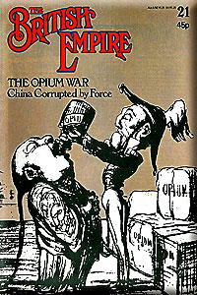

Using your annotations from the Chris Harman writing, analyze images C and D to answer the question. The way in which the Opium Wars were fought represents a type of foreign policy known as “gunboat diplomacy.” Based on your inquiry, what do you think “gunboat diplomacy” means?

Task 2e: The Berlin Conference and the “Scramble for Africa”
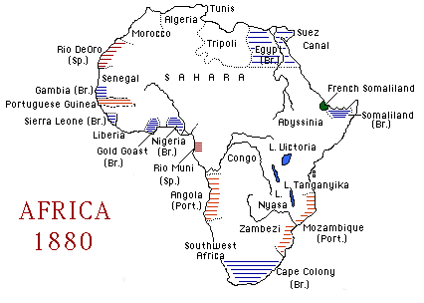
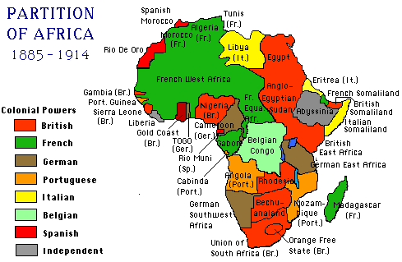
How did the continent of Africa change in the decades following 1880? Why do you think this happened?

Case Study 3: The Berlin Conference and the Belgian Congo
Watch the following clip on the Berlin Conference. The Berlin Conference was a turning point in late 19th century geopolitics.
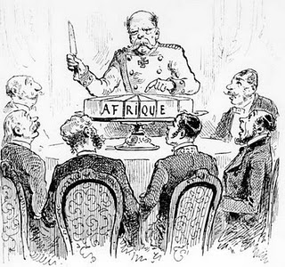. 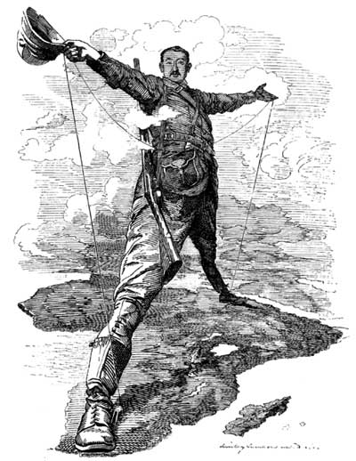

https://www.youtube.com/watch?v=FTjBNppdk-M

What were the causes of the Berlin Conference?

What were the effects of the Berlin Conference?

Read the following account of Rubber Production in the Belgian Congo and watch the Bourdain clip on the Congo.

“It has reduced the people to a state of utter despair. Each town in the district is forced to bring a certain quantity [of rubber] to the headquarters of the commissaire every Sunday. It is collected by force. The soldiers drive the people into the bush. If the will not go they are shot down, and their left hands cut off and taken as trophies to the commissaire. The soldiers do not care who they shoot down, and they more often shoot poor helpless women and harmless children. These hands, the hands of men, women and children, are placed in rows before the commissaire, who counts them to see that the soldiers have not wasted their cartridges.”
Sir Arthur Conan Doyle, “The Crime of the Congo”

https://www.youtube.com/watch?v=7CuPOCqsaW8
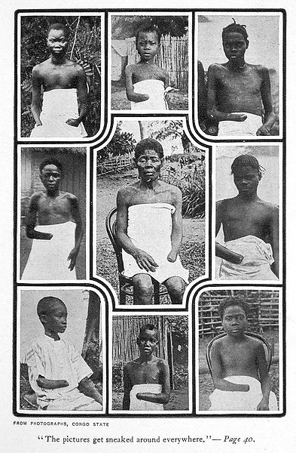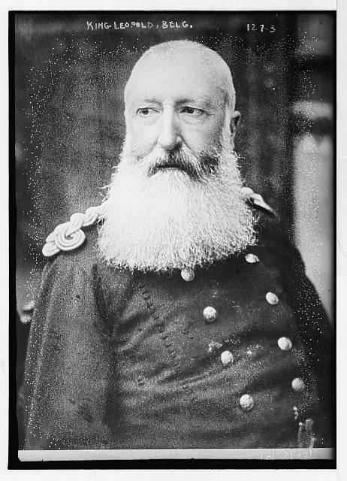

What was Belgian leader Leopold II’s business in the Congo? How did he go about achieving this goal? Cite the primary source and the video in your response.

Task 2f: Scientific Racism and the New Imperialism

Watch this clip from Quentin Tarantino’s Django Unchained. This film portrays slavery in pre-Civil War America, but the ideas that Leo’s character, plantation owner Calvin Candie, communicates were also used to justify European imperialism in Africa and Asia.

https://www.youtube.com/watch?v=72nK7APr6Xs
What argument is Calvin Candie making? What does he use as evidence to make this argument? Why do you think that people might have believed these ideas?

Many of the Europeans who engaged n the New Imperialism adopted an attitude known as paternalism. Watch the video to come up with your own definition of paternalism. Based on the comedic interactions between Bill Hader and the “inhabitants”, how is the main character (the old white dude) treating the other characters in a “paternalistic” manner? https://www.youtube.com/watch?v=MEb_epsuLqA

Read and annotate the first stanza from this famous poem by Rudyard Kipling (author of The Jungle Book).
ANNOTATIONS

White Man’s Burden, Rudyard Kipling

Take up the White Man's burden--
Send forth the best ye breed--
Go bind your sons to exile
To serve your captives' need;
To wait in heavy harness,
On fluttered folk and wild--
Your new-caught, sullen peoples,
Half-devil and half-child.

What is the “White Man’s Burden?”

Image | What is happening in the image? | What is the message of this particular image?
Doc A: White Man’s Burden
Doc B: Pears Soap Ad
Doc C: “White (?) Man’s Burden”

These ideas of scientific racism was also related to a concept known as Social Darwinism. Social Darwinists held that the life of humans in society was a struggle for existence ruled by “survival of the fittest.” Weaker humans were meant to be dominated by stronger humans. This was part of the rationale for the New Imperialism.

THE ECONOMIC ORIGINS OF RACISM
Dedrick Muhammad, Sr. Director of NAACP Economic Programs
Most people assume that racism is as old as humanity itself. Yet racism as we understand it today is a relatively modern ideology that first took shape in the 17th and 18th century as a moral justification for European conquest, particularly the enslavement of African people, which had become a significant source of wealth for Western imperialist nations.
Do you agree or disagree with the above claim? Make an argument using the poem and 1 of the images as evidence.

Task 2g
The Meiji Restoration: How a victim of imperialism became an imperial nation….

https://www.youtube.com/watch?v=RdS6FgmO4j8

Based on the above trailer, what do you think Meiji Restoration consisted of?

This John Green video is optional if you want extra help with the reading below.
Start at 4:46-11:19

https://www.youtube.com/watch?v=Nosq94oCl_M

Chris Harman, “The Meiji Restoration.” A People’s History of the World, 2008. | ANNOTATIONS
In 1853 Commander Perry of the US Navy arrived off the coast of Japan with four warships to demand the Japanese government to open the country to foreign trade. The whole ruling class in society was thrown into turmoil. The Tokugawa government looked at the balance of military weaponry and decided things could no longer continue in the old way—it had to make changes if it was to avoid the sort of defeats China had just suffered in the Opium Wars. But for other sections of the ruling class the old ways were sacred, and any concessions to foreigners were a betrayal of the highest ideals. Caught between them, groups of lower samurai formed an association committed ‘to revere the emperor and repel barbarians’ by militant, even revolutionary means. At one level, their demands were deeply traditional—they looked to restore to the emperor the power which his predecessors had not enjoyed for hundreds of years. But some samurai understood that there had to be changes in Japanese society if it was to be capable of matching the economic and military strength of the ‘barbarians’.
Their chance to achieve their aims came with the ‘Meiji Restoration’
of the late 1860s, when two of the great feudal lords attacked the
Tokugawa Shogun with samurai support and formed a new government in the name of the emperor.

This was a revolution from above. Its slogans were traditionalist and
the condition of the mass of people was not improved at all by the
change. But those leading it understood they had to embrace capitalism if they were going to maintain anything of the past. They
abolished the power of the rival feudal lords, making them dependent
on the state for their privileges. They did away with the old distinctions
of rank between samurai , peasants, merchants and artisans. The
incomes samurai used to enjoy from exploitation of the peasantry
now went straight to the state; any samurai who wanted more than a
minimal livelihood had to look to employment with the state or private
firms. Most importantly, the government embarked upon setting
up new industries, under its control and subsidised out of taxation.
When these were strong enough to stand on their own feet, it handed
them over to merchant or banking families with close connections to
the state.

The Meiji Revolution was doubly significant for the future development
of capitalism, not just in Japan but internationally. It showed
that the initiative in opening society to full-blooded capitalist relations
of production did not have to come from the bourgeoisie. What
the ‘bourgeoisie’ had achieved in the French Revolution was completed in Japan by sections of the old exploiting classes.

Meanwhile, the newly born Japanese capitalism was able to show
its strength 27 years after the Meiji Revolution by launching a war of
its own against China. The former victim of foreign interventions had turned into one of the oppressor nations.

Watch the clip from the film The Last Samurai starting at 3:45. Listen to what the Meiji Emperor says. How does this clip represent the Meiji Restoration? Use the clip and the Chris Harman reading in your response.

https://www.youtube.com/watch?v=HWf6KvoGgAI

Task 2h: New Technology and the Resistance to European Imperialism
The Maxim gun was first used by Britain's colonial forces in the 1893–1894 First Matabele War in Rhodesia. It played an important role in the swift European colonization of Africa in the late 19th century. The extreme lethality was employed to devastating effect against obsolete charging tactics, when native opponents could be lured into pitched battles in open terrain. As it was put by Hilaire Belloc, in the words of the figure "Blood" in his poem "The Modern Traveller":

“Whatever happens, we have got
The maxim gun, and they have not”

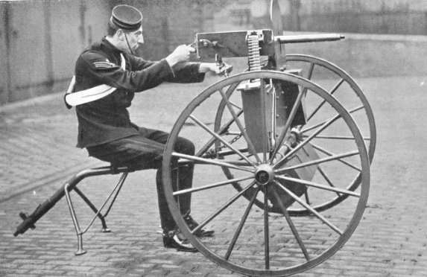

Modern historians suggest that, although it was effective in battles such as the 1898 Battle of Omdurman, the maxim gun’s significance owed much to the psychological impact the weapon had. Read the following 4 case studies on resistance to European imperialism. What was the significance of each outcome?
Event | Who fought and who won? | Lasting Significance for Winners and Losers
1896, The Battle of Adwa
Ethiopia
1898, The Battle of Omduran
Sudan
1900, The Boxer Rebellion
China
1905, the Russo-Japanese War
Manchuria (China) and Korea

2i) Discussion

Group Discussion: Find the slideshow of questions on my weebly under task 3h. Use these questions to guide your discussion. Be sure to use evidence from the task to make your point!

Time discussion begins________ Time Discussion Ends ________
Guiding Questions….. | Interesting Points Made…

2j) Answer Essential Question: How did nationalism and industrialization lead to the expansion of Europe’s hegemony around the world?

Be sure to use all of the words in the word wall: New Imperialism, triangle trade, mercantilism, Social Darwinism, paternalism, Opium Wars, gunboat diplomacy, Sepoy Rebellion, Boxer Rebellion, Meiji Restoration, sphere of influence, maxim gun, Berlin Conference, Leopold II

Sphere of influence- a country or area in which another country has power to affect developments although it has no formal authority.
Geopolitics- politics, especially international relations, as influenced by geographical factors.

