Thomas Hobbes, England  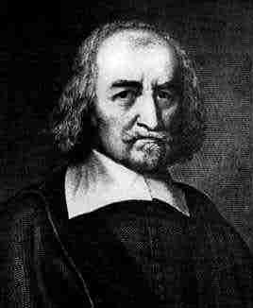 | In 1651, you published your best-known work, Leviathan. You believe that the only way for man to lift himself out of his natural state of fear and violence was to give up his freedom and make a social contract with others to accept a central authority. You obviously feel strongly that an absolutist monarchy provided the best authority. You also argued that a sovereign power was absolute, the sovereign must also be head of the national religion.
Jean-Jacques Rousseau  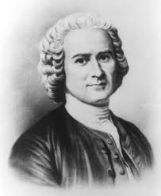 | 1750 you published your first important work, A Discourse on the Sciences and the Arts. Its central theme was that man had become corrupted by society and civilization. In 1755, you published Discourse on the Origin of Inequality. You claimed that original man, while solitary, was happy, good and free. The Social Contract of 1762 suggested how man might recover his freedom in the future. It argued that a state based on a genuine social contract would give men real freedom in exchange for their obedience to a self-imposed law. You described his civil society as united by a general will, furthering the common interest while occasionally clashing with personal interest.
John Locke  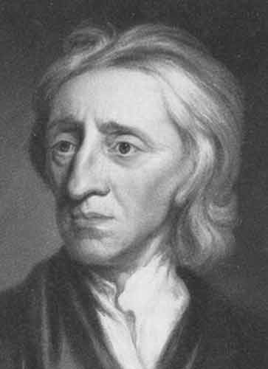 | Your political theory was founded on social contract theory. Unlike Thomas Hobbes, you believe that human nature is characterized by reason and tolerance. Like Hobbes, you believed that human nature allowed men to be selfish. In a natural state all people were equal and independent, and everyone had a natural right to defend his “Life, health, Liberty, or Possessions”. Most scholars trace the phrase "life, liberty, and the pursuit of happiness," in the American Declaration of Independence, to your theory of natural rights.  You believed that revolution is not only a right but an obligation in some circumstances. These ideas would come to have profound influence on the Declaration of Independence and the Constitution of the United States.
Baron de Montesquieu  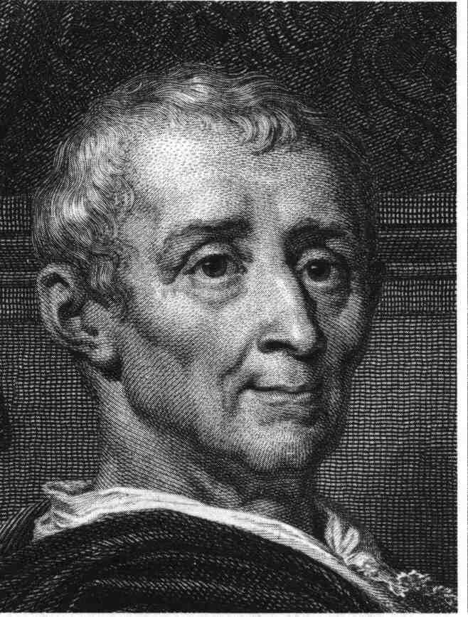 | You are a French Enlightenment political philosopher named Baron de Montesquieu. In The Spirit of the Laws (1748), you described the separation of political power among a legislature, an executive, and a judiciary. Your approach was to present and defend a form of government which was not excessively centralized in all its powers to a single monarch or similar ruler. You based this model on the Constitution of the Roman Republic and the British constitutional system. You took the view that the Roman Republic had powers separated so that no one could usurp [abuse] complete power. In the British constitutional system, you discerned a separation of powers among the monarch, Parliament, and the courts of law.
Voltaire  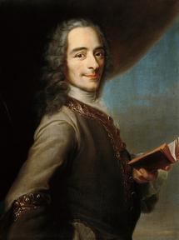 | You originally studied law but abandoned it to become a writer. You won success with his plays-mostly classical tragedies at first. However, your epic poem La Henriade, a satirical attack on politics and religion, infuriated the government and landed you in the Bastille [an infamous French prison in Paris] for nearly a year in 1717. Your time in prison failed to quench his satire. In 1726, you again displeased authorities and fled to England. You returned several years later and continued to write plays. In 1734, your Lettres Philosophiques criticized established religions and political institutions, and you were forced to flee once more. In 1750, you moved to Berlin on the invitation of Frederick II of Prussia and later settled in Switzerland, where you wrote your best-known work, Candide.

John Locke believed humans are born with ______________________ because they are a part of nature. At birth, people have the right to life, liberty, and property.

social contract: an implicit agreement between members of a society that they would cooperate for social benefits. For example, Hobbes believed they would give up their freedom in return for the safety and order of an organized society.
Quote from Enlightenment | How is this idea a break from the past? What rights are being represented?
“I do not agree with what you have to say, but I'll defend to the death your right to say it.”
Voltaire
“When the legislative and executive powers are united in the same person, there can be no liberty.”
Baron de Montesquieu

“All mankind... being all equal and independent, no one ought to harm another in his life, health, liberty or possessions.”
John Locke
“Man is born free but everywhere he is in chains.”

“No man has any natural authority over his fellow men.”
Jean-Jacques Rousseau

“The condition of man... is a condition of war of everyone against everyone.”
“Every subject is author of the acts of the sovereign [king]: hence the sovereign cannot injure any of his subjects and cannot be accused of injustice.
Thomas Hobbes
How did the Scientific Revolution impact the thinking of the Enlightenment philosophers? Be sure to mention natural rights, Hobbes, Locke, Voltaire, Montesquieu and Rousseau in your response.

