TASK CARD 1: Intersecting Jewish, Arab and European histories

Essential Question: How did the intersecting histories between Jews, Arabs and Europeans lead to the idea of a Jewish state?

a) Jewish Diaspora in Europe and the Ottoman Empire
b) What is Zionism?
c) WWI Promises
d) Sykes-Picot Agreement and Mandate System
e) Answer Essential Question
****************After all tasks completed, Check In with Zander****************
Key Terms: diaspora, Anti-Semitism, pogrom, Zionism, head-tax [Ottoman Empire], Theodor Herzl, WWI, Balfour Declaration, McMahon-Hussein Correspondence, Sykes-Picot Agreement, Mandate System
A) The Jewish Diaspora in Europe and the Ottoman Empire

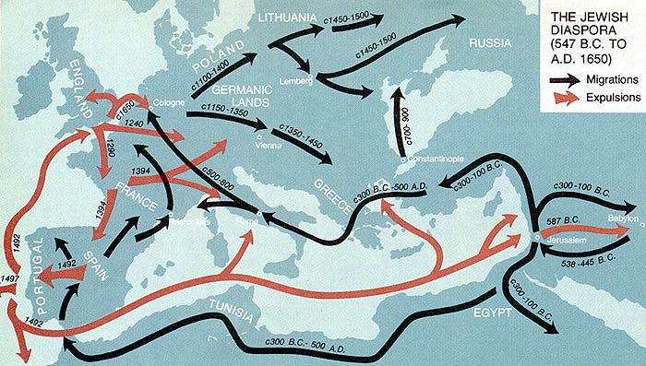

This is a map of the Jewish diaspora. Based on the map legends, what do you think “diaspora” signifies? Why?

Document 1: Etching of Jewish Massacre* in Europe, 1493

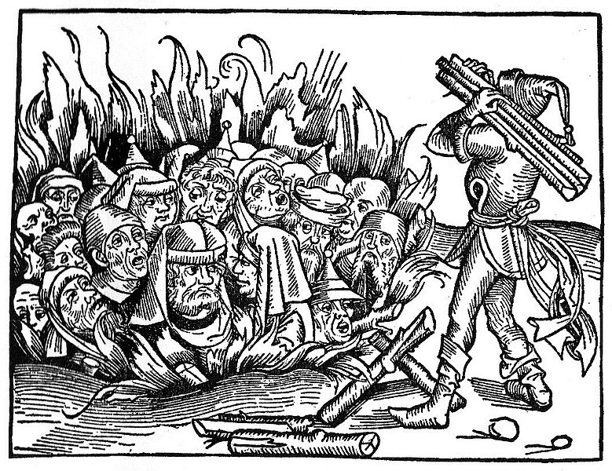
Document 2: The Answer Of The Shaikh Hasan Al Kafrawi, The Shafiite [Professor of canon law in Cairo, d. 1788 CE]
"Entrance into Muslim territory by infidels of foreign lands under the pact guaranteeing protection to the tolerated peoples is permitted only for the time necessary to settle their business affairs. If they exceed this period, their safe-conduct having expired, they will be put to death or be subject to the payment of the head-tax. [Jews and Christians of foreign lands must pay a special head-tax if they wish to remain permanently in Muslim lands.] As to those with whom the ruler may have signed treaties, and with whom he, for whatever motive, may have granted a temporary truce, they form only the smallest fraction. But they, too, must not pass the fixed limit of more than four months [without paying the tax], particularly if this occurs at a time when Islam is prosperous and flourishing. The Most-High has said [Qu'ran 2: 2341: 'They should wait four months,' and he has again said [47:37]: 'Do not show any cowardice, and do not at all invite the unbelievers to a peace when you have the upper-hand and may God be with you.'
"Their men and women are ordered to wear garments different from those of the Muslims in order to be distinguished from them. They are forbidden to exhibit anything which might scandalize us, as, for instance, their fermented liquors, and if they do not conceal these from us, we are obliged to pour them into the street.
Written by the humble Hasan al Kafrawi, the Shafiite. [1772 CE]

Based on your analysis of documents 1 and 2, how did the Jewish diaspora fare in Europe compared to Muslim lands centuries before the creation of Israel? Use both documents to make your claim.

B) What is Zionism?
There were Jew leaders who called for the return of the Jews to Palestine for decades before Theodor Herzl (1860 1904) wrote his influential pamphlet, The Jewish State. But Herzl's work pushed the formation of a political movement to establish a Jewish homeland in Palestine. The first Zionist Congress, convened by Herzl, was held in Basel, Switzerland, in 1897. Herzl was less attached to Palestine than some other "Zionists", and considered at one stage the creation of a Jewish state in what is now Uganda.

Theodor Herzl: On the Jewish State, 1896 | ANNOTATIONS
The idea which I have developed in this pamphlet is a very old one: it is the restoration of the Jewish State.
The world resounds with outcries against the Jews, and these outcries have awakened the slumbering idea.
We are a people-one people.
We have honestly endeavored everywhere to merge ourselves in the social life of surrounding communities and to preserve the faith of our fathers. We are not permitted to do so. In vain are we loyal patriots, our loyalty in some places running to extremes; in vain do we make the same sacrifices of life and property as our fellow citizens; in vain do we strive to increase the fame of our native land in science and art, or her wealth by trade and commerce. In countries where we have lived for centuries we are still cried down as strangers, and often by those whose ancestors were not yet domiciled in the land where Jews had already had experience of suffering. The majority may decide which are the strangers; for this, as indeed every point which arises in the relations between nations, is a question of might. If we could only be left in peace....
[However,] oppression and persecution cannot exterminate us. No nation on earth has survived such struggles and sufferings as we have gone through. Jew-baiting has merely stripped off our weaklings; the strong among us were invariably true to their race when persecution broke out against them....
The Plan
The creation of a new State is neither ridiculous nor impossible. We have in our day witnessed the process in connection with nations which were not largely members of the middle class, but poorer, less educated, and consequently weaker than ourselves. The Governments of all countries scourged by Anti-Semitism will be keenly interested in assisting us to obtain the sovereignty we want.
The plan, simple in design, but complicated in execution, will be carried out by two agencies: The Society of Jews and the Jewish Company.
The Society of Jews will do the preparatory work in the domains of science and politics, which the Jewish Company will afterwards apply practically. The Jewish Company will be the liquidating agent of the business interests of departing Jews, and will organize commerce and trade in the new country.
We must not imagine the departure of the Jews to be a sudden one. It will be gradual, continuous, and will cover many decades. The poorest will go first to cultivate the soil. In accordance with a preconceived plan, they will construct roads, bridges, railways and telegraph installations; regulate rivers; and build their own dwellings; their labor will create trade, trade will create markets and markets will attract new settlers, for every man will go voluntarily, at his own expense and his own risk. The labor expended on the land will enhance its value, and the Jews will soon perceive that a new and permanent sphere of operation is opening here for that spirit of enterprise which has heretofore met only with hatred and obloquy [contempt].
Theodor Herzl, The Jewish State, An Attempt at a Modern Solution of the Jewish Question

C) WWI Promises

Document 1: The Balfour Declaration

This letter to Lord Rothschild, by the British Foreign Secretary Arthur James Balfour, was aimed at Jewish support for the Allies in the First World War. The letter, known as the "Balfour Declaration" became the basis movement to create a Jewish state in Palestine. The letter was published a week later in The Times (London) of London.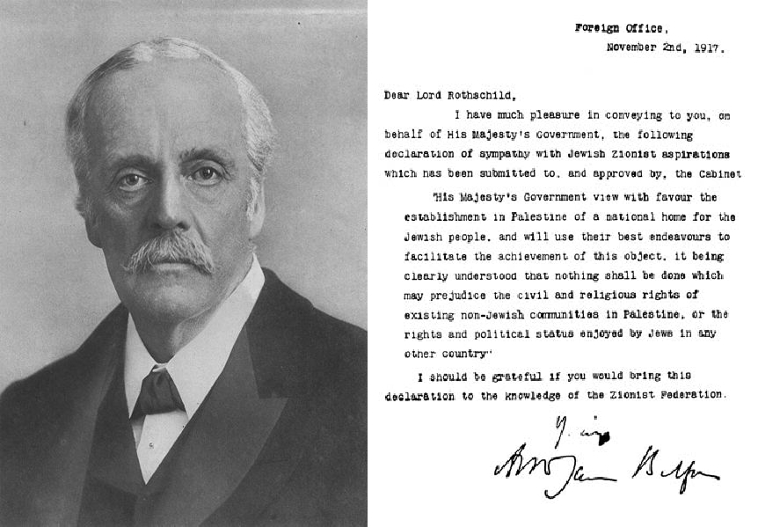
What is the promise being made in the Balfour Declaration? What is significant about this promise?

Document 2: Sir Henry McMahon- Letter to Ali ibn Husain, 1915

McMahon was British High Commissioner in Egypt and Ali Ibn Husain was the Sherif of Mecca during the First World War. In a series of ten letters from 1915 to 1916 McMahon tried to attract Arab support against the Ottoman Empire. The following excerpt is from a letter from October 24, 1915. The implied promise is of British support of an independent Arab state.

As for those regions lying within those frontiers wherein Great Britain is free to act without detriment to the interests of her ally, France, I am empowered in the name of the Government of Great Britain to give the following assurances [promises] and make the following reply to your letter:(1) Subject to the above modifications, Great Britain is prepared to recognize and support the independence of the Arabs in all the regions within the limits demanded by the Sherif of Mecca.(2) Great Britain will guarantee the Holy Places against all external aggression and will recognize their inviolability.(3) When the situation admits, Great Britain will give to the Arabs her advice and will assist them to establish what may appear to be the most suitable forms of government in those various territories.(4) On the other hand, it is understood that the Arabs have decided to seek the advice and guidance of Great Britain only, and that such European advisers and officials as may be required for the formation of a sound form of administration will be British.(5) With regard to the vilayets of Bagdad and Basra, the Arabs will recognize that the established position and interests of Great Britain necessitate special administrative arrangements in order to secure these territories from foreign aggression, to promote the welfare of the local populations and to safeguard our mutual economic interests. I am convinced that this declaration will assure you beyond all possible doubt of the sympathy of Great Britain towards the aspirations of her friends the Arabs and will result in a firm and lasting alliance, the immediate results of which will be the expulsion of the Turks from the Arab countries and the freeing of the Arab peoples from the Turkish yoke [oppression], which for so many years has pressed heavily upon them.

What is the promise being made in this letter from McMahon to Husain? What is significant about this promise?

D) The Sykes-Picot Agreement : 1916
It is accordingly understood between the French and British governments:
That France and Great Britain are prepared to recognize and protect an independent Arab states or a confederation of Arab states (a) and (b) marked on the annexed map, under the suzerainty of an Arab chief. That in area (a) France, and in area (b) Great Britain, shall have priority of right of enterprise and local loans. That in area (a) France, and in area (b) Great Britain, shall alone supply advisers or foreign functionaries at the request of the Arab state or confederation of Arab states.
That in the blue area France, and in the red area Great Britain, shall be allowed to establish such direct or indirect administration or control as they desire and as they may think fit to arrange with the Arab state or confederation of Arab states.
That Great Britain be accorded (1) the ports of Haifa and Acre, (2) guarantee of a given supply of water from the Tigres and Euphrates in area (a) for area (b).
That Alexandretta shall be a free port as regards the trade of the British empire, and that there shall be no discrimination in port charges or facilities as regards British shipping and British goods; that there shall be freedom of transit for British goods through Alexandretta and by railway through the blue area, or (b) area, or area (a); and there shall be no discrimination, direct or indirect, against British goods on any railway or against British goods or ships at any port serving the areas mentioned.
The negotiations with the Arabs as to the boundaries of the Arab states shall be continued through the same channel as heretofore on behalf of the two powers.
It is agreed that measures to control the importation of arms into the Arab territories will be considered by the two governments.
What is the purpose of this agreement? Who benefits politically and economically from this agreement? Who doesn’t benefit politically and economically from this agreement?

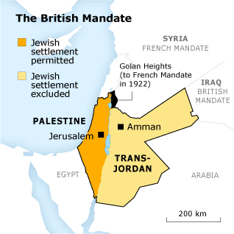

Analyze this map:

What is the Mandate system?

Were both promises [the Balfour Declaration and the McMahon-Husain correspondence] kept? How do you know?

A.J. Balfour (1848-1930): Defense of the Palestine Mandate, 1922

A.J. Balfour (1848-1930) was British Prime Minister from 1902-1905 and later the Foreign Secretary responsible for the "Balfour Declaration". In 1922 he responded to an attack on the British promise to the Jewish People in this speech.

My noble friend told us in his speech, and I believe him absolutely, that he has no prejudice against the Jews. I think I may say that I have no prejudice in their favour. But their position and their history, their connection with world religion and with world politics is absolutely unique. There is no parallel to it, there is nothing approaching to a parallel to it, in any other branch of human history. Here you have a small race originally inhabiting a small country, I think of about the size of Wales or Belgium, at any rate of comparable size to those two, at no time in its history wielding anything that can be described as material power, sometimes crushed in between great Oriental monarchies, its inhabitants deported, then scattered, then driven out of the country altogether into every part of the world, and yet maintaining a continuity of religious and racial tradition of which we have no parallel elsewhere. Consider how they have been subjected to tyranny and persecution; consider whether the whole culture of Europe, the whole religious organization of Europe, has not from time to time proved itself guilty of great crimes against this race.

I quite understand that some members of this race may have given, doubtless did give, occasion for much ill-will, and I do not know how it could be otherwise, treated as they were; but, if you are going to lay stress on that, do not forget what part they have played in the intellectual, the artistic, the philosophic and scientific development of the world. As it was in the Middle Ages, as it was in earlier times, so it is now. And yet, is there anyone here who feels content with the position of the Jews? They have been able, by this extraordinary tenacity of their race, to maintain this continuity, and they have maintained it without having any Jewish Home.

I could defend - I have endeavoured, and I hope not unsuccessfully, to defend this scheme of the Palestine Mandate from the most material economic view, and from that point of view it is capable of defence. I hope with some effect, that their prosperity also is intimately bound up with the success of Zionism.

It may fail. I do not deny that this is an adventure. Are we never to have adventures? Are we never to try new experiments? We desire to the best of our ability to give them that opportunity of developing, in peace and quietness under British rule, those great gifts which hitherto they have been compelled from the very nature of the case only to bring to fruition in countries which know not their language, and belong not to their race.

Response to Balfour:
1) Why does Balfour, an English politician and statesman, argue for the creation of a Jewish nation-state in Palestine?
2) What are 2 points that he is making in his argument?
3) Also, does he make a good case for the creation of a Jewish state? Why or why not?

1h) Essential Question: How did the intersecting histories between Jews, Arabs and Europeans lead to the idea of a Jewish state?
Key Terms: diaspora, Anti-Semitism, pogrom, Zionism, head-tax, Theodor Herzel, WWI, Balfour Declaration, McMahon-Hussein Correspondence, Sykes-Picot Agreement, Mandate System
Be sure to us all the above terms in answering the Essential Question.

Pogrom- an organized massacre of a particular ethnic group, in particular that of Jews in Russia or eastern Europe.
Anti-Semitism: hostility or prejudice against Jews

