Excerpt from Karl Marx and Frederick Engels, The Communist Manifesto 1848
The following is an excerpt from the first chapter of Karl Marx and Frederick Engels, The Communist Manifesto (1848)
THE BOURGEOISIE AND PROLETARIANS
The history of all hitherto existing societies is the history of class struggles.
Freeman and slave, patrician and plebeian, lord and serf, guild-master and journeyman, in a word, oppressor and oppressed, stood in constant opposition to one another, carried on an uninterrupted, now hidden, now open fight, a fight that each time ended, either in a revolutionary re-constitution of society at large, or in the common ruin of the contending classes.
In the earlier epochs of history, we find almost everywhere a complicated arrangement of society into various orders, a manifold gradation of social rank. In ancient Rome we have patricians, knights, plebeians, slaves; in the Middle Ages, feudal lords, vassals, guild-masters, journeymen, apprentices, serfs; in almost all of these classes, again, subordinate gradations.
The modern bourgeois society that has sprouted from the ruins of feudal society has not done away with clash antagonisms. It has but established new classes, new conditions of oppression, new forms of struggle in place of the old ones. Our epoch, the epoch of the bourgeoisie, possesses, however, this distinctive feature: it has simplified the class antagonisms: Society as a whole is more and more splitting up into two great hostile camps, into two great classes, directly facing each other: Bourgeoisie and Proletariat.. . .

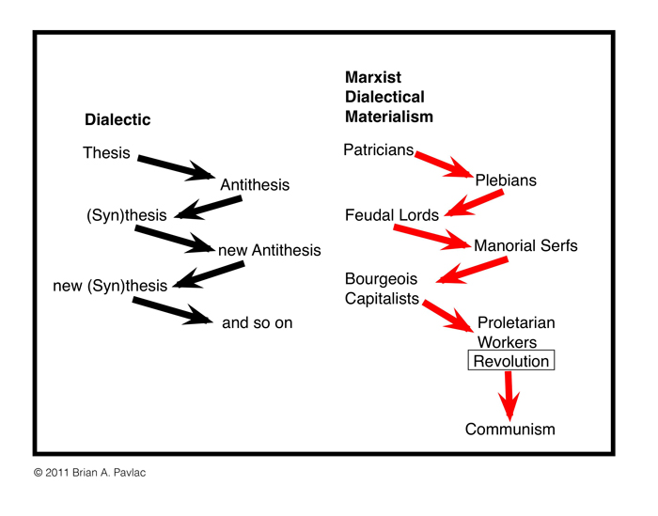

[On Property]
1) The distinguishing feature of communism is not the abolition of property generally, but the abolition of bourgeois property. But modern bourgeois private property is the final and most complete expression of the system of producing and appropriating products that is based on class antagonisms, on the exploitation of the many by the few.
In this sense, the theory of the Communists may be summed up in the single sentence: Abolition of private property.
We Communists have been reproached with the desire of abolishing the right of personally acquiring property as the fruit of a man's own labor, which property is alleged to be the groundwork of all personal freedom, activity and independence.
Hard-won, self-acquired, self-earned property! Do you mean the property of petty artisan and of the small peasant, a form of property that preceded the bourgeois form? There is no need to abolish that; the development of industry has to a great extent already destroyed it, and is still destroying it daily.
Or do you mean the modern bourgeois private property?
But does wage labor create any property for the laborer? Not a bit. It creates capital, i.e., that kind of property which exploits wage labor, and which cannot increase except upon conditions of begetting a new supply of wage labor for fresh exploitation. Property, in its present form, is based on the antagonism of capital and wage labor. Let us examine both sides of this antagonism.
To be a capitalist, is to have not only a purely personal, but a social STATUS in production. Capital is a collective product, and only by the united action of many members, nay, in the last resort, only by the united action of all members of society, can it be set in motion.
Capital is therefore not only personal; it is a social power.
When, therefore, capital is converted into common property, into the property of all members of society, personal property is not thereby transformed into social property. It is only the social character of the property that is changed. It loses its class character.

2) You are horrified at our intending to do away with private property. But in your existing society, private property is already done away with for nine-tenths of the population; its existence for the few is solely due to its non-existence in the hands of those nine-tenths. You reproach us, therefore, with intending to do away with a form of property, the necessary condition for whose existence is the non-existence of any property for the immense majority of society.
In one word, you reproach us with intending to do away with your property. Precisely so; that is just what we intend.
From the moment when labor can no longer be converted into capital, money, or rent, into a social power capable of being monopolized, i.e., from the moment when individual property can no longer be transformed into bourgeois property, into capital, from that moment, you say, individuality vanishes.
You must, therefore, confess that by "individual" you mean no other person than the bourgeois, than the middle-class owner of property. This person must, indeed, be swept out of the way, and made impossible.
Communism deprives no man of the power to appropriate the products of society; all that it does is to deprive him of the power to subjugate the labor of others by means of such appropriations.
4) It has been objected that upon the abolition of private property, all work will cease, and universal laziness will overtake us.
According to this, bourgeois society ought long ago to have gone to the dogs through sheer idleness; for those who acquire anything, do not work. The whole of this objection is but another expression of the tautology: There can no longer be any wage labor when there is no longer any capital.
All objections urged against the communistic mode of producing and appropriating material products, have, in the same way, been urged against the communistic mode of producing and appropriating intellectual products. Just as to the bourgeois, the disappearance of class property is the disappearance of production itself, so the disappearance of class culture is to him identical with the disappearance of all culture.
That culture, the loss of which he laments, is, for the enormous majority, a mere training to act as a machine.
5) Abolition of the family! Even the most radical flare up at this infamous proposal of the Communists.
On what foundation is the present family, the bourgeois family, based? On capital, on private gain. In its completely developed form, this family exists only among the bourgeoisie. But this state of things finds its complement in the practical absence of the family among proletarians, and in public prostitution.
The bourgeois family will vanish as a matter of course when its complement vanishes, and both will vanish with the vanishing of capital.
Do you charge us with wanting to stop the exploitation of children by their parents? To this crime we plead guilty.
6) But you Communists would introduce community of women, screams the bourgeoisie in chorus.
The bourgeois sees his wife a mere instrument of production. He hears that the instruments of production are to be exploited in common, and, naturally, can come to no other conclusion that the lot of being common to all will likewise fall to the women.
He has not even a suspicion that the real point aimed at is to do away with the status of women as mere instruments of production.
For the rest, nothing is more ridiculous than the virtuous indignation of our bourgeois at the community of women which, they pretend, is to be openly and officially established by the Communists. The Communists have no need to introduce free love; it has existed almost from time immemorial.
Our bourgeois, not content with having wives and daughters of their proletarians at their disposal, not to speak of common prostitutes, take the greatest pleasure in seducing each other's wives. (Ah, those were the days!)
Bourgeois marriage is, in reality, a system of wives in common and thus, at the most, what the Communists might possibly be reproached with is that they desire to introduce, in substitution for a hypocritically concealed, an openly legalized system of free love. For the rest, it is self-evident that the abolition of the present system of production must bring with it the abolition of free love springing from that system, i.e., of prostitution both public and private.
7) The Communists are further reproached with desiring to abolish countries and nationality.
The workers have no country. We cannot take from them what they have not got. Since the proletariat must first of all acquire political supremacy, must rise to be the leading class of the nation, must constitute itself the nation, it is, so far, itself national, though not in the bourgeois sense of the word.
National differences and antagonism between peoples are daily more and more vanishing, owing to the development of the bourgeoisie, to freedom of commerce, to the world market, to uniformity in the mode of production and in the conditions of life corresponding thereto.
The supremacy of the proletariat will cause them to vanish still faster. United action of the leading civilized countries at least is one of the first conditions for the emancipation of the proletariat.
In proportion as the exploitation of one individual by another will also be put an end to, the exploitation of one nation by another will also be put an end to. In proportion as the antagonism between classes within the nation vanishes, the hostility of one nation to another will come to an end.
But let us have done with the bourgeois objections to communism.
We have seen above that the first step in the revolution by the working class is to raise the proletariat to the position of ruling class to win the battle of democracy.
The proletariat will use its political supremacy to wrest, by degree, all capital from the bourgeoisie, to centralize all instruments of production in the hands of the state, i.e., of the proletariat organized as the ruling class; and to increase the total productive forces as rapidly as possible.
The Communists disdain to conceal their views and aims. They openly declare that their ends can be attained only by the forcible overthrow of all existing social conditions. Let the ruling classes tremble at a communist revolution. The proletarians have nothing to lose but their chains. They have a world to win.
Proletarians of all countries, unite!

- Capital is dead labor, which, vampire-like, lives only by sucking living labor, and lives the more, the more labor it sucks.
Karl Marx

- Let the ruling classes tremble at a communist revolution. The proletarians have nothing to lose but their chains. They have a world to win. Workingmen of all countries, unite!
Karl Marx

- Religion is the sigh of the oppressed creature, the heart of a heartless world, and the soul of soulless conditions. It is the opium of the people.
Karl Marx

- In bourgeois society capital is independent and has individuality, while the living person is dependent and has no individuality.
Karl Marx

