Centripetal Forces during the Persian War

The Persian Wars were fought between Greece and Persia in the 5th century b.c.e., in which the Persians sought to extend their rule over the Greek world.
The wars began in 490 b.c.e. when Darius I sent an expedition to punish the Greeks for having supported the Ionian cities in their unsuccessful revolt against Persian rule; the Persians were defeated by a small force of Athenians at Marathon.

Ten years later, Darius's son Xerxes I attempted an invasion. He devastated Athens, but Persian forces were defeated on land at Plataea and in a sea battle at Salamis (480 b.c.e.), and retreated. Intermittent war continued until peace was signed in 449 b.c.e.

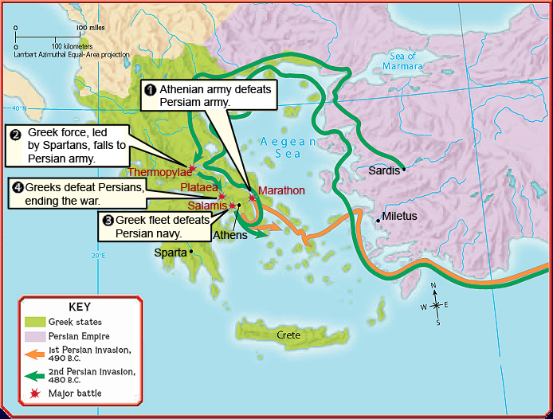

Demaratus was the king of Sparta in the 5th century b.c.e. He was dethroned on a false charge of illegitimacy, upon which he fled to Persia and was given some small cities in northwestern Asia Minor (Turkey). The historian Herodotus told several stories of Demaratus’ advice and warnings to Xerxes, whom he accompanied on his expedition to Greece in 480 b.c.e.

*centripetal force- a force brings society together (e.g. religion…)
Annotate the following dialogue between Demaratus and Xerxes. When you annotate- underline important information, summarize main ideas, and note the centripetal forces in both the Persian and Greek societies.

From Herodotus’ The Histories: Annotations
Xerxes sent for Demaratus, who had accompanied him in his march upon Greece, and said to him:
XERXES: Demaratus, I would like you to tell me something. As I hear, you are a Greek and a native of a powerful city. Tell me, will the Greeks really fight against us? I think that even if all the Greeks and all the barbarians of the West were gathered together in one place, they would not be able to stop me, since they are so disunited. But I would like to know what you think about this.
DEMARATUS: Oh king! Do you really want me to give a true answer, or would you rather that I make you feel good about all this?
The king commanded him to speak the plain truth, and promised that he would not on that account hold him in less favor than before.
DEMARATUS: Oh king! Since you command me to speak the truth, I will not say what will one day prove me a liar. Difficulties have at all times been present in our land, while courage is an ally whom we have gained through wisdom and strict laws. Her aid enables us to solve problems and escape being conquered. All Greeks are brave, but what I am about to say does not concern all, but only the Spartans.
First then, no matter what, the Spartans will never accept your terms. This would reduce Greece to slavery. They are sure to go to battle with you even if all the rest of the Greeks surrendered to you. As for Spartan numbers, do not ask how many or few they are, hoping for them to surrender. For if a thousand of them should take the field, they will meet you in battle, and so will any other number, whether it is less than this, or more."
XERXES: (laughs) What wild words, Demaratus! A thousand men join battle with such an army as mine! Come then, will you -- who were once, as you say, their king -- fight alone right now against ten men? I think not. And yet, if your fellow-citizens really are as you say, then according to your laws as their king, you should be twice as tough and take on twenty all by yourself!
But, if you Greeks, who think so highly of yourselves, are simply the size and kind of men as those I have seen at my court, or as yourself, Demaratus, then your bragging is weak. Use common sense: how could a thousand men, or ten thousand, or even fifty thousand -- particularly if they are all free, and not under one lord -- how could such a force stand against a united army like mine? Even if the Greeks have larger numbers than our highest estimate, we still would outnumber them 100 to 1.
If they had a single master as our troops have, their obedience to him might make them courageous beyond their own desire. But left to their own free choice, they will surely act differently. For my part, I believe that if the Greeks had to contend with the Persians only, and the numbers were equal on both sides, the Greeks would still find it hard to stand their ground. We too have men among us as tough as those you described -- not many perhaps, but enough. For instance, some of my bodyguard would willing engage singly with three Greeks. But this you did not know; and so you talked foolishly.
DEMARATUS: I knew, O king, that if I told you the truth, I would displease you. But since you wanted the truth, I am telling you what the Spartans will do. I am not speaking out of any love that I have for Sparta -- you know better than anyone how I feel about those who robbed me of my rank, of my ancestral honors, and made me a homeless exile.... Look, I am no match for ten men or even two, and given the choice, I would rather not fight at all. But if necessary, I would rather go against those who boast that they are a match for any three Greeks.
The same goes for the Spartans. One-against-one, they are as good as anyone in the world. But when they fight in a body, they are the best of all. For though they are free men, they are not entirely free. They accept Law as their master. And they respect this master more than your subjects respect you. Whatever he commands, they do. And his command never changes: It forbids them to flee in battle, whatever the number of their foes. He requires them to stand firm -- to conquer or die. O king, if I seem to speak foolishly, I am content from this time forward to remain silent. I only spoke now because you commanded me to. I do hope that everything turns out according to your wishes."
This was the answer of Demaratus, and Xerxes was not angry with him at all, but only laughed, and sent him away with words of kindness.
Now, using your annotations as a jumping off point, answer the question: Which society has a more powerful centripetal force? Greece, or Persia? Analyze text evidence to support your conclusions.
__________________________________________________________________________________________________________________________________________________________________________________________________________________________________________________________________________________________________________________________________________________________________________________________________________________________________________________________________________________________________________________________________________________________________________________________________________________________________________________________________________________________________________________________________________________________________________________________________________________________________________________________________________________

