Primary Source | How does this text/image represent the Age of Anxiety?
John Maynard Keynes:
The Economic Consequences of the Peace, 1920

“This chapter must be one of pessimism. The Treaty includes no provisions for the economic rehabilitation of Europe, - nothing to make the defeated Central Empires into good neighbors, nothing to stabilize the new States of Europe….”
“The Second Coming”, (1919)
William Butler Yeats

“Turning and turning in the widening gyre
The falcon cannot hear the falconer;
Things fall apart; the center cannot hold;
Mere anarchy is loosed upon the world,
The blood-dimmed tide is loosed, and everywhere
The ceremony of innocence is drowned;
The best lack all conviction, while the worst
Are full of passionate intensity.”
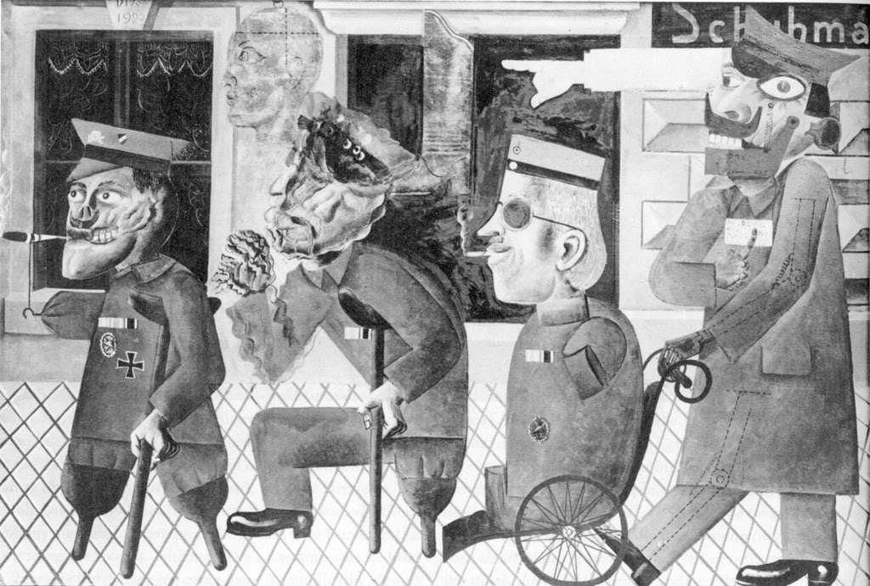
Otto Dix, “The War Cripples” (1920)
Marcel Duchamp, “The Fountain”
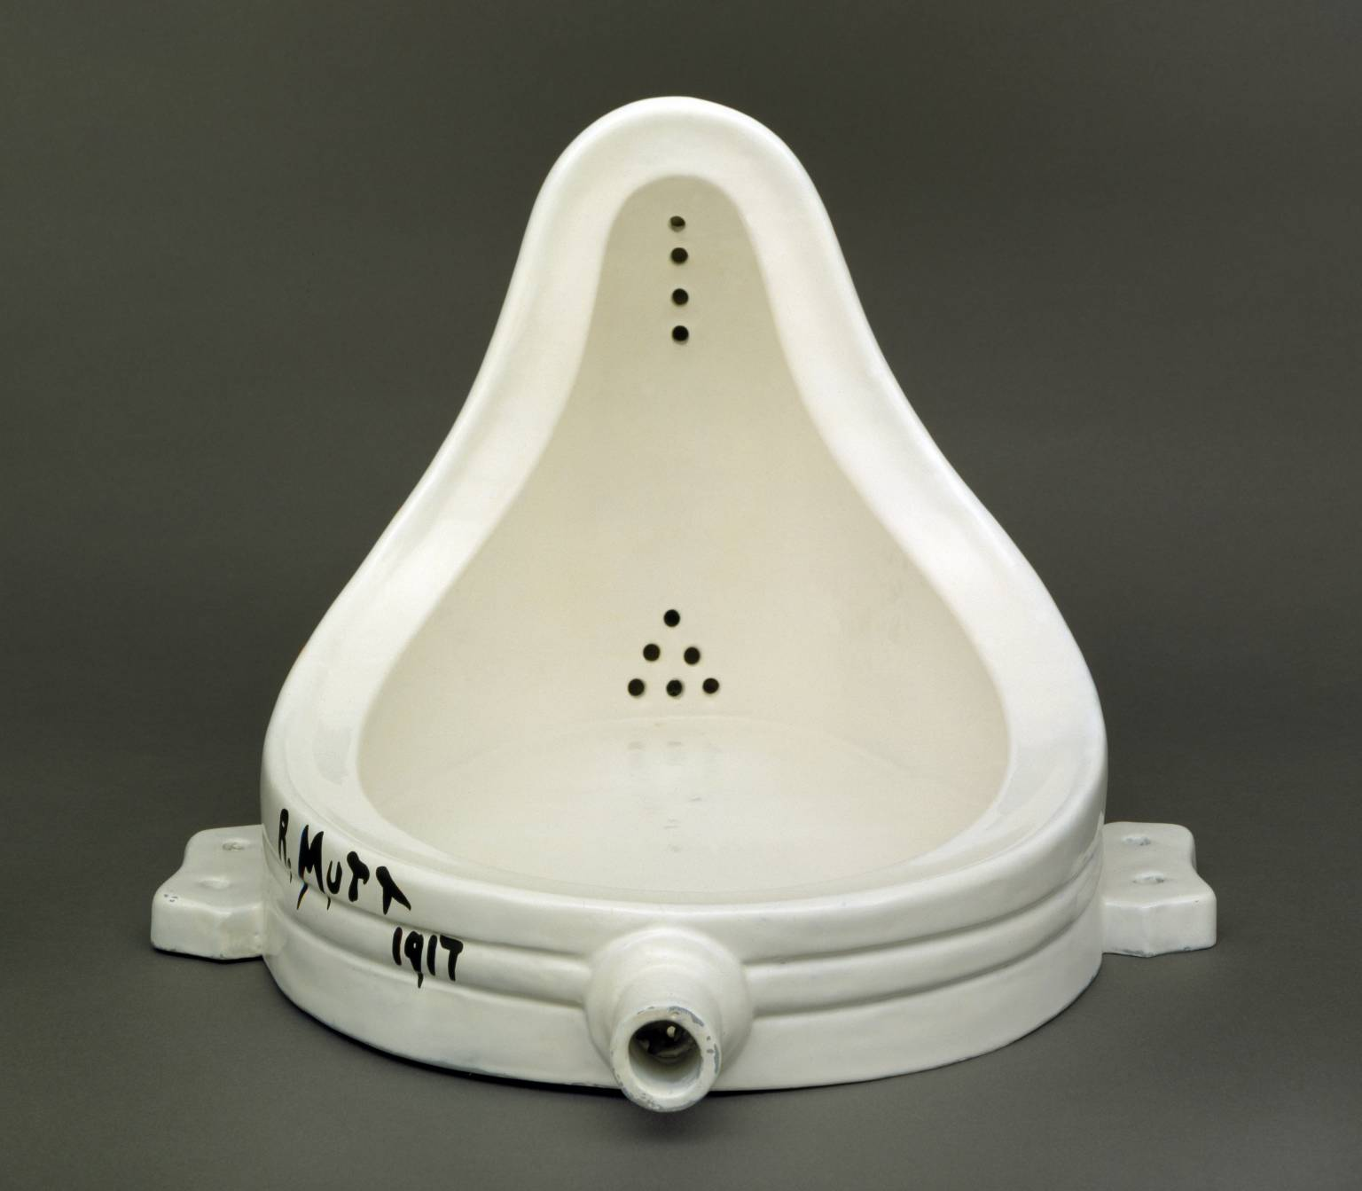

dada
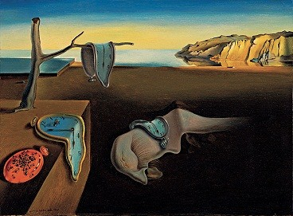
Salvador Dali, “The Persistence of Memory” (1931)

Surrealism

Modernism- the early 20th-cent. movement or trend in which certain artists and writers, esp. those (as Joyce, T. S. Eliot, and Picasso) of the period between WWI and WWII, broke with established traditions and sought new modes of expression

Inflation: _____________________________________________________________

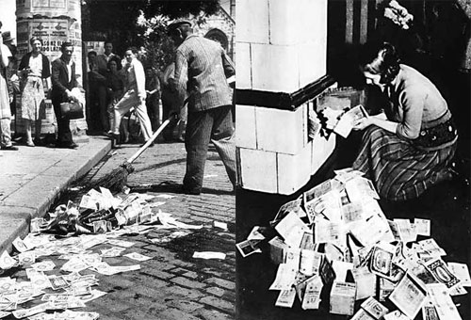

In order to pay the Allies reparations, Germany enrolled in the Dawes Plan:

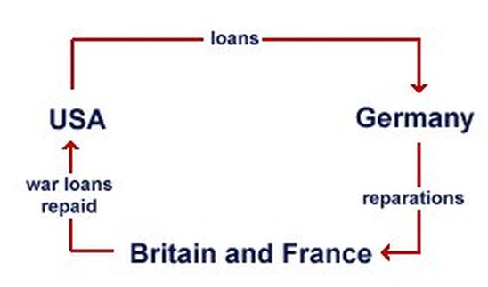__________________________________________________________________________________________________________________________

Why did the Dawes Plan fail?

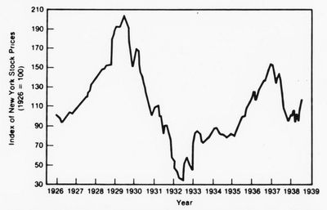

What could this global economic depression lead to?

Totalitarianism:

Why were the years after WWI called the “Age of Anxiety?” What could the social and economic climate of war-ravaged Europe lead to?

