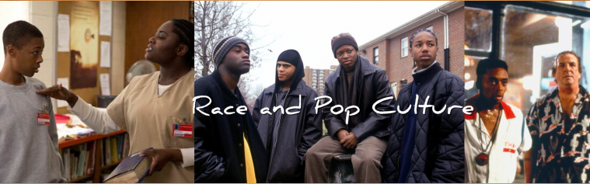

Film Clip | Analysis: Who do the characters represent? What are the character’s motives? What was the author’s purpose in this film clip? Can you connect anything you see or hear to anything that has happened in the past year?
SNL- “28 Reasons”
The Wire- Dinner Scene
25th Hour- ______ You Scene
When has race been an issue within the past year? What were different reactions to the events surrounding the deaths of Michael Brown and Eric Garner? To what extent did race play a role in these events?

What would you like to see discussed in this class? What are some examples of books, tv, or films that you enjoy that might be relevant to class discussion?

