Finding peer-reviewed sources in a database cheat sheet:

- Go to www.nypl.org
- Click on the “Research” tab

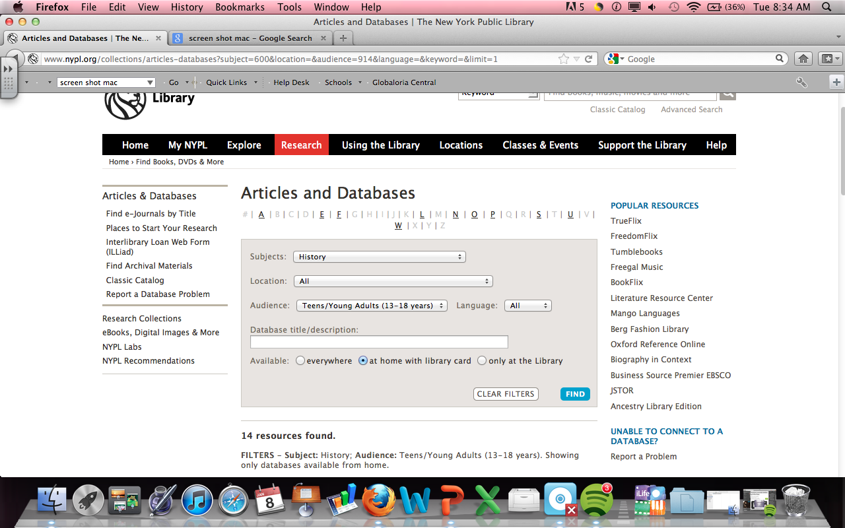
- Make sure the you click on “History” in the Subject dropdown menu
- For Audience, click Teens/Young Adults
- Check “Available: at home with library card”
- Click “FIND”
- Choose database (I highly recommend Academic Search Premier, World History in Context, and Opposing Viewpoints)
- You are then routed to a page that says “Infotrac” and it asks for your library card number. Enter your NYPL card number or just use mine: 23333978304563
- Make sure you have at least 6 peer-reviewed secondary sources. A reference book/article does not count. Make sure you check “Scholarly journals” when completing search options for your topic to avoid anything that is not peer-reviewed. Your final product should address at least one counter-claim to your argument.

1) Go to: http://qcpages.qc.cuny.edu/library/research/databases.php
2)
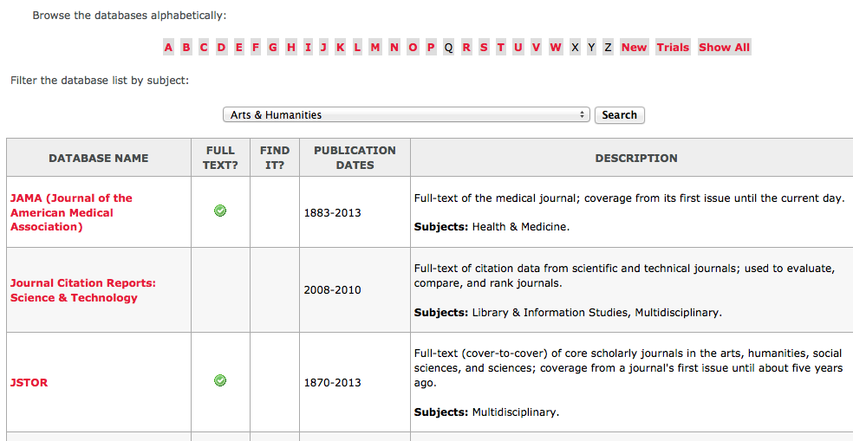
Click on the letter J at the top. Find the JSTOR database under your results. JSTOR is the MOTHERLOAD for scholarly peer-reviewed journals. JSTOR will make your college life much easier. What better time to start than now?

