1861 | 3 March | Emancipation reform of 1861: Alexander issued a manifesto emancipating the serfs;
1881 |  | Constitution proposed, Alexander II agrees to it but doesn't get a chance to sign it
 | 10 March | Alexander was assassinated by Ignacy Hryniewiecki of the People's Will.  His son, Alexander III, becomes tsar.
1894 | 1 November | Alexander III dies. His son Nicholas II succeeds him as tsar.
 | 17 November | At the second congress of the RSDLP, the party split into two factions:  the Bolsheviks, led by Vladimir Lenin, and the less radical Mensheviks.
 | 9 January | Bloody Sunday (1905): Peaceful demonstrators arrived at the Winter Palace  in Saint Petersburg to present a petition to the tsar. The Imperial Guard fired  on the crowd, killing around 200 and wounding 800.
 | 17 October | Russian Revolution of 1905: Nicholas signed the October Manifesto,  expanding civil liberties and establishing and  empowering the first State Duma (Parliament) of the Russian Empire.
1906 | March | Russian legislative election, 1906: The first free elections to the Duma  gave majorities to liberal and socialist parties.
 | 23 April | The Fundamental Laws were issued, reaffirming the autocratic  supremacy of the tsar.
 |  | The First Duma was called.
 | 21 July | The First Duma was dissolved.
 | 20 February | The Second Duma began.
 | 3 June | The Second Duma was dissolved.
Nicholas changed the electoral law and gave greater electoral
value to the votes of nobility and landowners.
 | 1 November | The Third Duma began.
1912 | 4 April | Lena goldfields massacre: The Russian army fired on a crowd of  striking miners, killing 150.
 | 9 June | The Third Duma ended.
 | 15 November | The Fourth Duma was called.
1914 | 28 June | Assassination of Archduke Franz Ferdinand: Archduke Franz Ferdinand of Austria  was assassinated by Gavrilo Princip of  the Bosnian separatist group Young Bosnia.
 | 28 July | World War I: Austria-Hungary declared war on Serbia.
 | 30 July | World War I: Russia mobilized its army to defend Serbia.
 | 1 August | World War I: Germany declared war on Russia in defense of Austria-Hungary.
1915 | 2 May | Gorlice-Tarnów Offensive: The German army launched an offensive  across the length of the Eastern Front.
1917 | 22 February | February Revolution: The workers at the Putilov Plant in Petrograd went on strike.
 | 23 February | February Revolution: A series of demonstrations were held, demanding  the end of the Russian autocracy and the end of Russian participation in World War I.
 | 25 February | February Revolution: A battalion of soldiers was sent to Petrograd to  end the uprising.
 | 26 February | February Revolution: Nicholas ordered the dissolution of the  Fourth Duma.  The Duma ignored his order and decreed the establishment of a  Provisional Government with Georgy L'vov as Prime Minister.
 | 27 February | February Revolution: The soldiers sent to suppress the protestors  defected and joined them.  Menshevik leaders were freed from the Peter and Paul Fortress and  founded the Petrograd Soviet.
 | 2 March | February Revolution: Tsar Nicholas abdicated.

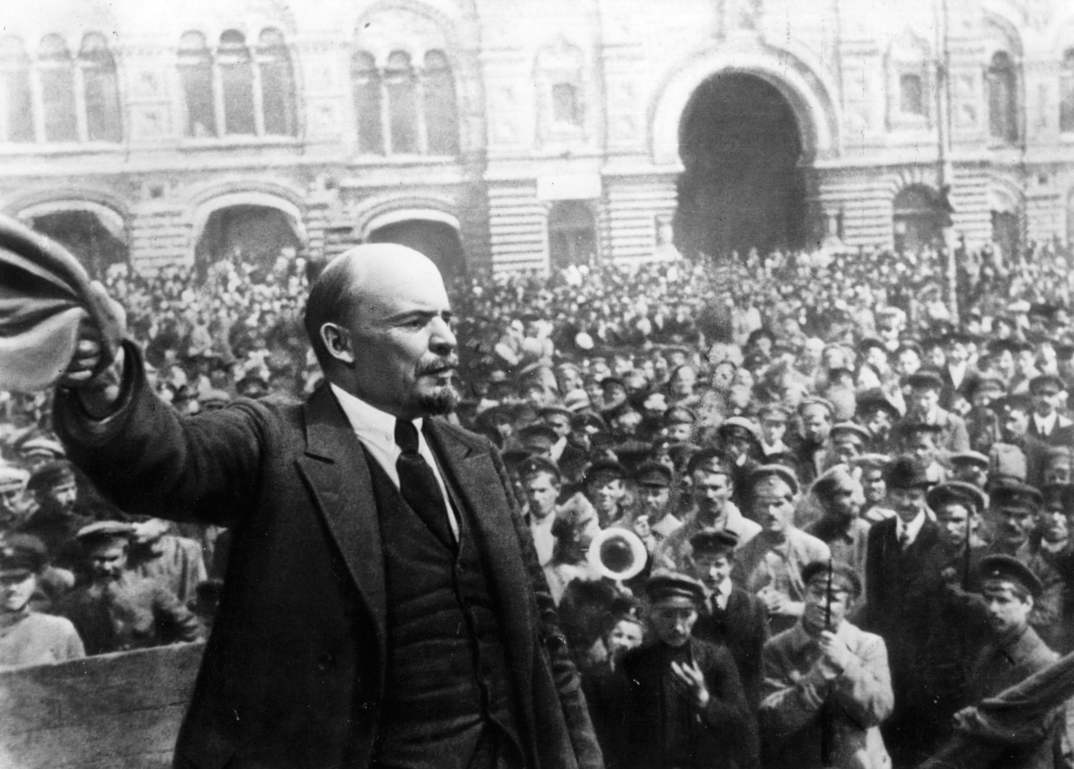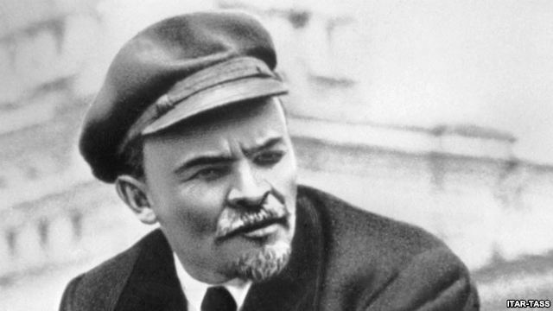
Vladimir Illyich Lenin: What is to be Done, 1902
1) The history of all countries shows that the working class, exclusively by its own effort, is able to develop only trade union consciousness, i.e, it may itself realise the necessity for combining in unions, for fighting against the employers and for striving to compel the government to pass necessary labour legislation, etc. The theory of socialism, however, grew out of the philosophic, historical and economic theories that were elaborated by the educated representatives of the propertied classes, the intellectuals. According to their social status, the founders of modern scientific socialism, Marx and Engels, themselves belonged to the bourgeois intelligentsia.

2) A workers' organisation must in the first place be a trade organisation; secondly, it must be as wide as possible; and thirdly, it must be as public as conditions will allow (here, and further on, of course, I have only autocratic Russia in mind). On the other hand, the organisations of revolutionaries must consist first and foremost of people whose profession is that of a revolutionary (that is why I speak of organisations of revolutionaries, meaning revolutionary Social Democrats). In view of this common feature of the members of such an organisation, all distinctions as between workers and intellectuals, and certainly distinctions of trade and profession, must be obliterated. Such an organisation must of necessity be not too extensive and as secret as possible.
***
I assert:
- that no movement can be durable without a stable organisation of leaders to maintain continuity;
- that the more widely the masses are spontaneously drawn into the struggle and form the basis of the movement and participate in it, the more necessary is it to have such an organisation, and the more stable must it be (for it is much easier for demogogues to sidetrack the more backward sections of the masses);
- that the organisation must consist chiefly of persons engaged in revolutionary activities as a profession;
- that in a country with an autocratic government, the more we restrict the membership of this organisation to persons who are engaged in revolutionary activities as a profession and who have been professionally trained in the art of combating the political police, the more difficult will it be to catch the organisation, and
- the wider will be the circle of men and women of the working class or of other classes of society able to join the movement and perform active work in it....
3) The active and widespread participation of the masses will not suffer; on the contrary, it will benefit by the fact that a "dozen" experienced revolutionaries, no less professionally trained than the police, will centralise all the secret side of the work-prepare leaflets, work out approximate plans and appoint bodies of leaders for each urban district, for each factory district and to each educational institution, etc. (I know that exception will be taken to my "undemocratic" views, but I shall reply to this altogether unintelligent objection later on.) The centralisation of the more secret functions in an organisation of revolutionaries will not diminish, but rather increase the extent and the quality of the activity of a large number of other organisations intended for wide membership and which, therefore, can be as loose and as public as possible, for example, trade unions, workers' circles for self-education and the reading of illegal literature, and socialist and also democratic circles for all other sections of the population. etc, etc We must have as large a number as possible of such organisations having the widest possible variety of functions, but it is absurd and dangerous to confuse those with organisations of revolutionaries, to erase the line of demarcation between them, to dim still more the masses already incredibly hazy appreciation of the fact that in order to "serve" the mass movement we must have people who will devote themselves exclusively to Social Democratic activities, and that such people must train themselves patiently and steadfastly to be professional revolutionaries.

4) Aye, this appreciation has become incredibly dim. The most grievous sin we have committed in regard to organisation is that by our primitiveness we have lowered the prestige o revolutionaries in Russia. A man who is weak and vacillating on theoretical questions, who has a narrow outlook who makes excuses for his own slackness on the ground that the masses are awakening spontaneously; who resembles a trade union secretary more than a people's tribune, who is unable to conceive of a broad and bold plan, who is incapable of inspiring even his opponents with respect for himself, and who is inexperienced and clumsy in his own professional art-the art of combating the political police-such a man is not a revolutionary but a wretched amateur! Let no active worker take offense at these frank remarks, for as far as insufficient training is concerned, I apply them first and foremost to myself. I used to work in a circle that set itself great and all embracing tasks; and every member of that circle suffered to the point of torture from the realisation that we were proving ourselves to be amateurs at a moment in history when we might have been able to say, paraphrasing a well known epigram: "Give us an organisation of revolutionaries, and we shall overturn the whole of Russia!"

In this text, Lenin makes his argument for a coherent, strictly controlled party of dedicated revolutionaries as a basic necessity for a revolution. One may see in Lenin's proposals a deep insight into to necessary requisites for a revolution, or a deep contempt for the working classes.
Abdication of Nikolai II, March 15, 1917

By the Grace of God, We, Nikolai II, Emperor of All the Russias, Tsar of Poland, Grand Duke of Finland, and so forth, to all our faithful subjects be it known:
In the days of a great struggle against a foreign enemy who has been endeavouring for three years to enslave our country, it pleased God to send Russia a further painful trial.
Internal troubles threatened to have a fatal effect on the further progress of this obstinate war. The destinies of Russia, the honour of her heroic Army, the happiness of the people, and the whole future of our beloved country demand that the war should be conducted at all costs to a victorious end.
The cruel enemy is making his last efforts and the moment is near when our valiant Army, in concert with our glorious Allies, will finally overthrow the enemy.
In these decisive days in the life of Russia we have thought that we owed to our people the close union and organisation of all its forces for the realisation of a rapid victory; for which reason, in agreement with the Imperial Duma, we have recognized that it is for the good of the country that we should abdicate the Crown of the Russian State and lay down the Supreme Power.
Not wishing to separate ourselves from our beloved son, we bequeath our heritage to our brother, the Grand Duke Mikhail Alexandrovich, with our blessing for the future of the Throne of the Russian State.
We bequeath it our brother to govern in full union with the national representatives sitting in the Legislative Institutions, and to take his inviolable oath to them in the name of our well-beloved country.
We call upon all faithful sons of our native land to fulfill their sacred and patriotic duty of obeying the Tsar at the painful moment of national trial and to aid them, together with the representatives of the nation, to conduct the Russian State in the way of prosperity and glory.
May God help Russia.

Declaration from the Throne by Grand Duke Mikhail, March 16, 1917
A heavy task has been entrusted to me by the will of my brother, who has given me the Imperial Throne at a time of unprecedented war and domestic strife.
Animated by the same feelings as the entire nation - namely, that the welfare of the country overshadows all other interests - I am firmly resolved to accept the Supreme Power only if this should be the desire of our great people, which must, by means of a plebiscite, through their representatives in the Constituent Assembly, establish the form of government and the new fundamental law of the Russian State.
Invoking God's blessing, I therefore request all citizens of Russia to obey the Provisional Government, set up on the initiative of the Duma and invested with plenary powers, until, within as short a time as possible, the Constituent Assembly, elected on a basis of universal, equal, and secret suffrage, shall express the will of the nation regarding the form of government to be adopted.
Source: The Times, 19 March 1917.
