TASK CARD 1: How did the concept of “whiteness” impact the globe?

Essential Question: How did the concept of “whiteness” impact the globe?

1A Aim: What is colorism?
1B Aim: How has the concept of whiteness impacted Latin America?
1C Aim: What is orientalism?
1D Discussion
1E Answer Essential Question
****************After all tasks completed, Check In with Zander****************
Key Terms: colorism, whitening, Social Darwinism, Orientalism

Task 1A Aim: What is colorism?

Dark Girls documentary Trailer
https://www.youtube.com/watch?v=DOjgTIN9pTE

Oprah and Colorism
https://www.youtube.com/watch?v=rIwnbcK1dZI

- Based on the 2 film clips, what is your definition of colorism?

- Have you ever witnessed or an experienced an example of colorism? Why do you think that colorism exists?

Task 1B: How has the concept of “whiteness” impacted Latin America?

Visit the following website and determine how and why the concept of “whiteness” impacted Latin America and other countries in the region.

http://atlantablackstar.com/2014/03/10/5-black-nations-that-imported-europeans-to-whiten-the-population/

Country | Why and how did these societies try to “whiten?” | Was the whitening a success?
What is “whitening?”
Brazil
Word Wall:
What is social Darwinism?

Cuba
Jamaica
**** If you want to watch more about how this has impacted Brazil today, watch the following clip*****
Racial Democracy in Brazil?
https://www.youtube.com/watch?v=CBNUOsrIiAs
Annotate the following article

Blackout: How Argentina ‘Eliminated’ Africans From Its History And Conscience  By Palash Ghosh June 04 2013 | ANNOTATIONS of major points/claims
In Buenos Aires, neighborhoods like Monserrat and San Telmo housed many black slaves, some of whom were engaged in craft-making for their masters. Indeed, blacks accounted for an estimated one-third of the city’s population, according to surveys taken in the early 1800s.  Slavery was officially abolished in 1813, but the practice remained in place until about 1853. Ironically, at about this time, the black population of Argentina began to plunge. Historians generally attribute two major factors to this sudden “mass disappearance” of black Africans from the country – the deadly war against Paraguay from 1865-1870 (in which thousands of blacks fought on the frontlines for the Argentine military) as well as various other wars; and the onset of yellow fever in Buenos Aires in 1871.  The heavy casualties suffered by black Argentines in military combat created a huge gender gap among the African population – a circumstance that appears to have led black women to mate with whites, further diluting the black population. Many other black Argentines fled to neighboring Brazil and Uruguay, which were viewed as somewhat more hospitable to them.  Others claim something more nefarious at work. It has been alleged that the president of Argentina from 1868 to 1874, Domingo Faustino Sarmiento, sought to wipe out blacks from the country in a policy of covert genocide through extremely repressive policies (including possibly the forced recruitment of Africans into the army and by forcing blacks to remain in neighborhoods where disease would decimate them in the absence of adequate health care).  Tellingly, Sarmiento wrote in his diary in 1848: “In the United States… 4 million are black, and within 20 years will be 8 [million]…. What is [to be] done with such blacks, hated by the white race? Slavery is a parasite that the vegetation of English colonization has left attached to leafy tree of freedom.”  By 1895, there were reportedly so few blacks left in Argentina that the government did not even bother registering African-descended people in the national census.  The CIA World Factbook currently notes that Argentina is 97 percent white (primarily comprising people descended from Spanish and Italian immigrants), thereby making it the “whitest” nation in Latin America.  But blacks did not really vanish from Argentina – despite attempts by the government to eliminate them (partially by encouraging large-scale immigration in the late 19th and 20th century from Europe and the Near East). Rather, they remain a hidden and forgotten part of Argentine society.  As in virtually all Latin American societies where blacks mixed with whites and with local Indians, the question of race is extremely complex and contentious.  “People of mixed ancestry are often not considered ‘black’ in Argentina, historically, because having black ancestry was not considered proper,” said Alejandro Frigerio, an anthropologist at the Universidad Catolica de Buenos Aires, according to Planete Afrique.  “Today the term ‘negro’ is used loosely on anyone with slightly darker skin, but they can be descendants of indigenous Indians [or] Middle Eastern immigrants.”  "People for years have accepted the idea that there are no black people in Argentina," Miriam Gomes, a professor of literature at the University of Buenos Aires, who is part black herself, told the Post. "Even the schoolbooks here accepted this as a fact. But where did that leave me?" She also explained that almost no one in Argentina with black blood in their veins will admit to it.  "Without a doubt, racial prejudice is great in this society, and people want to believe that they are white," she said. "Here, if someone has one drop of white blood, they call themselves white." Gomes also told the San Francisco Chronicle that after many decades of white immigration into Argentina, people with African blood have been able to blend in and conceal their origins.  "Argentina's history books have been partly responsible for misinformation regarding Africans in Argentine society," she said. "Argentines say there are no blacks here. If you're looking for traditional African people with very black skin, you won't find it. African people in Argentina are of mixed heritage."  Ironically, Argentina’s most famous cultural gift to the world – the tango – came from the African influence. "The first paintings of people dancing the tango are of people of African descent," Gomes added.  On a broader scale, the “elimination” of blacks from the country’s history and consciousness reflected the long-cherished desire of successive Argentine governments to imagine the country as an “all-white” extension of Western Europe in Latin America.  “There is a silence about the participation of Afro-Argentines in the history and building of Argentina, a silence about the enslavement and poverty,” said Paula Brufman, an Argentine law student and researcher. She continued, “The denial and disdain for the Afro community shows the racism of an elite that sees Africans as undeveloped and uncivilized.” | What are 2 major factors that led to the decrease in Argentina’s black population?  Do you think this policy amounts to a genocide?  What is Sarmiento’s main problem with slavery?  Why do you think people still wish to identify as white rather than black?  Does the claim that “there are no blacks in Argentina” amount to a racist statement? Why or why not?  What vocabulary term in this unit does this relate to? Why?

Task 1c Aim: WHAT IS ORIENTALISM?

Conduct a google image search of “Orientalist painting.” What types of images/themes do you see repeated as you scan the images?

Based on the content of the paintings, what do you think the term Orientalism means?

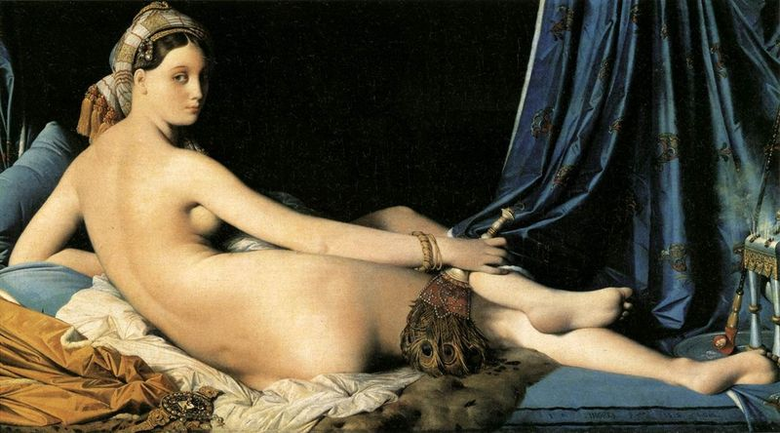

Jean Auguste Dominique Ingres, La Grande Odalisque, 1814, France

This is one of the most famous Orientalist paintings. What do you notice about its content? What types of fashions and objects do you see?

Who painted this work of art? What might the artist’s home country tell us about the definition of “orientalism?”

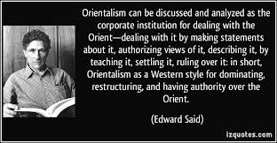
This is Edward Said, a Palestinian-American who wrote his most famous book, Orientalism, over three decades ago. In your own words, what is Said saying about the nature of orientalism?

Read and annotate the following description of Said’s thesis.
Description of Edward Said’s Orientalism | ANNOTATIONS
"Orientalism” is a way of seeing that imagines, emphasizes, exaggerates and distorts differences of Arab peoples and cultures as compared to that of Europe and the U.S. It often involves seeing Arab culture as exotic, backward, uncivilized, and at times dangerous. Edward W. Said, in his groundbreaking book, Orientalism, defined it as the acceptance in the West of “the basic distinction between East and West as the starting point for elaborate theories, epics, novels, social descriptions, and political accounts concerning the Orient, its people, customs, ‘mind,’ destiny and so on.”
According to Said, Orientalism dates from the period of European Enlightenment and colonization of the Arab World. Orientalism provided a rationalization for European colonialism based on a self-serving history in which “the West” constructed “the East” as extremely different and inferior, and therefore in need of Western intervention or “rescue”.
Examples of early Orientalism can be seen in European paintings and photographs and also in images from the World’s Fair in the U.S. in the 19th and early 20th centuries.
The paintings, created by European artists of the 19th and early 20th centuries, depict the Arab World as an exotic and mysterious place of sand, harems and belly dancers, reflecting a long history of Orientalist fantasies which have continued to permeate our contemporary popular culture.
France colonized Algeria from 1830 to 1962. From roughly 1900 to 1930, French entrepreneurs produced postcards of Algerian women that were circulated in France. While Algerian women are portrayed in these photographs as if the camera is capturing a real moment in their everyday lives, the women are actually set up in the photographer’s studio. As demonstrated in Malek Alloula’s book, The Colonial Harem, these photographs were circulated as evidence of the exotic, backwards and strange customs of Algerians, when, in fact, they reveal more about the French colonial perspective than about Algerian life in the early 1900s. This is an example of how Arab women have been exoticized and eroticized for the pleasure of the European male voyeur, as these photographs make visible French colonial fantasies of penetrating the harem and gaining access to Arab women’s private spaces.

Baed on the following film clips, do you think that “Orientalist” attitudes still exist in our society today? Why or why not?
Islamophobia?
https://www.youtube.com/watch?v=6m4kvrAikuA

Bill Maher, Sam Harris and Ben Affleck on Islam

https://www.youtube.com/watch?v=FG4WCLOBPbo

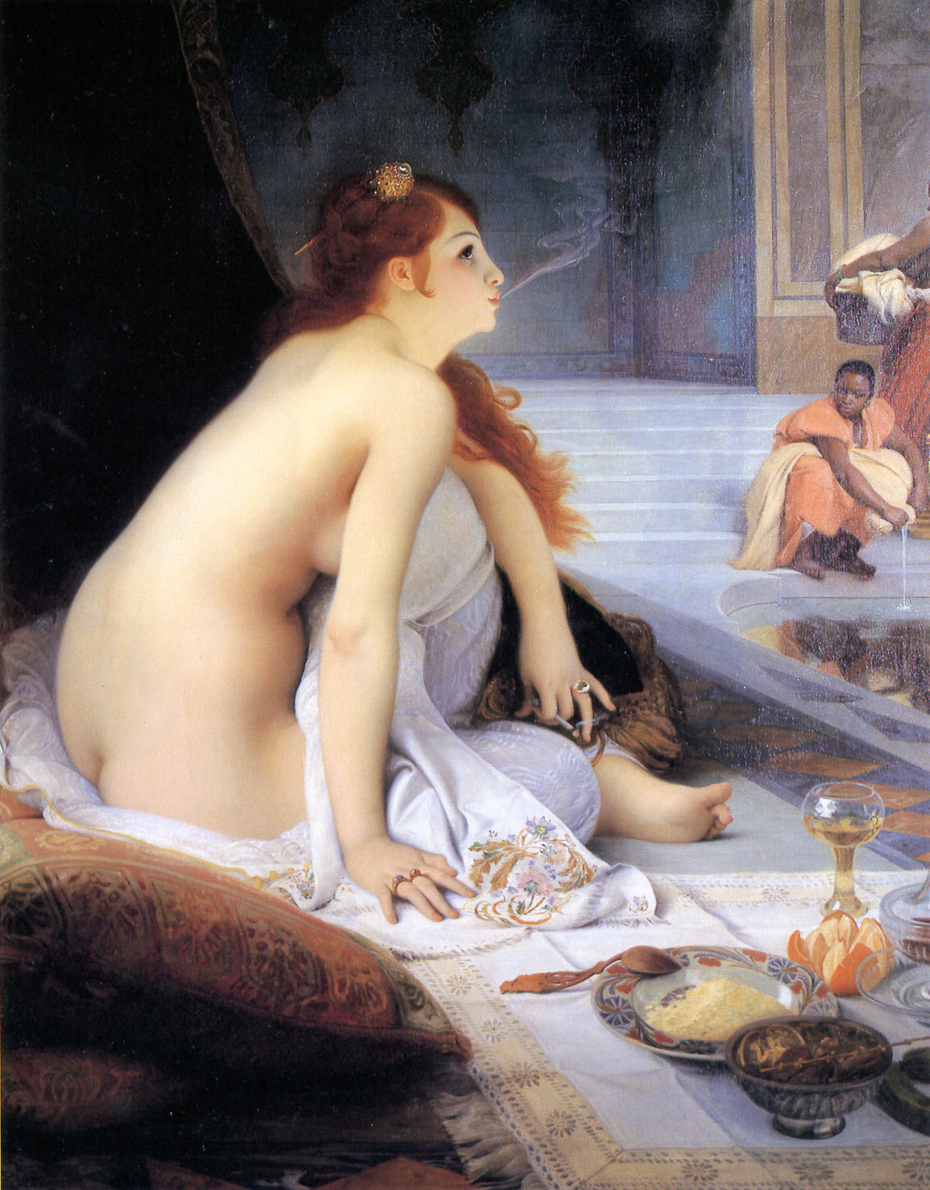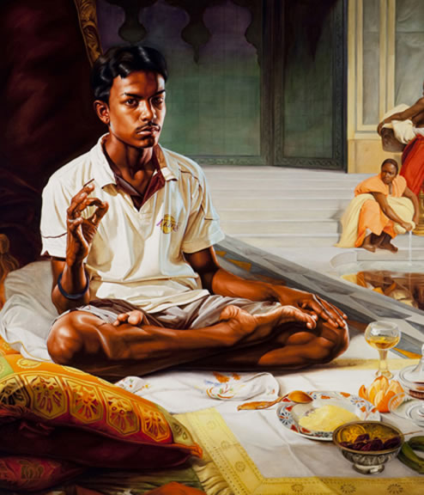
“The White Slave”
Analyze Jean-Jules-Antoine Lecomte’s painting entitled “The White Slave” and Kehinde Wiley’s modern rendition of it. What could Kehinde possibly be saying about orientalism based on this comparison?

Task 1D: Group Discussion

Time discussion begins________ Time Discussion Ends ________

Before this, you need to have participated on Zander’s mini-lesson on thick questions…..
Guiding Questions….. | Interesting Points Made by…
How did the concept of “whiteness” impact the globe?

Student created “thick questions”:

Task 1E
Answer the Essential Question using a piece of evidence from all of the Aims:
How did the concept of “whiteness” impact the globe?

*************Check in with Zander before moving on to Task 2********

Plunge- decrease rapidly
nefarious-wicked
alleged- claimed without proof
(If you need extra help understanding this, check out this video! https://www.youtube.com/watch?v=3pmkfvzmLdU )

