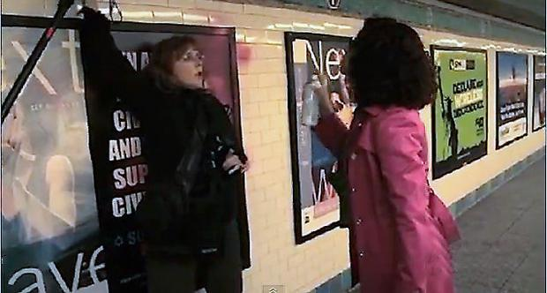

An Egyptian-American award-winning journalist was arrested 2 years ago after spray-painting one of the controversial new ads equating Muslims with 'savages' that debuted last year in NYC subway stations.

Police said Mona Eltahawy, an international lecturer on Arab and Muslim issues, was arrested Tuesday on charges allegedly including criminal mischief, making graffiti and possession of a graffiti instrument.

Pamela Geller, the executive director of American Freedom Defense Initiative (AFDI) -- classified as an anti-Muslim hate group by the Southern Poverty Law Center and the Anti-Defamation League -- orchestrated the ad campaign.

In this unit we will research major events in the Middle East since the creation of Israel. In pairs, you will create an ad proposal and a final ad campaign that is intended to promote understanding of the conflict rather than simplified slogans.

Project: Subway Ad Proposal
English street artist/provocateur described the wall in the West Bank separating Israel from Palestine as a “the ultimate activity holiday destination for graffiti writers”. Since the building of the wall he and many artists on both sides of the wall have expressed feelings of hope, despair, hatred, love and peace through art. After looking at graffiti surrounding the barrier, the controversial subway ad from Pamela Gellar, primary sources and your own research you will design your own subway ad proposal and advertisement that is meant to promote pragmatism and understanding of “the other” rather than myopic resentments. Research for this project will inform your discussion when we have the culminating Socratic Seminar.
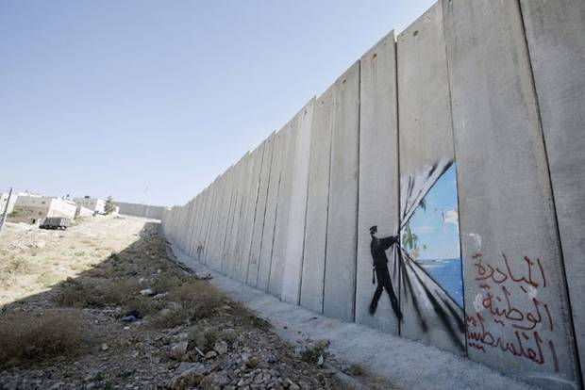Banksy!

Subway Ad Proposal/Ad Rubric
Outcome | Exceeds | Meets
Innovate  Develop new and helpful ways of looking at opportunities, challenges and problems.  Subway Ad promotes understanding and moving forward, without letting old resentments cloud objective | Students created an Ad Proposal that includes a(n)  - Issue  - Objective  - Target  After the Ad proposal is approved, students create an Ad that  - Addresses the Issue  - The objective is clear (without spelling it out, subtext can be easily read)  - Is made for the target audience  ___ tailors or integrates evidence to formulate a more nuanced or original conclusion | Students created an Ad Proposal that includes a(n)  - Issue  - Objective  - Target  After the Ad proposal is approved, students create an Ad that  - Addresses the Issue  - The objective is clear  - Is made for the target audience  ___ conclusions are valid but are expected or straightforward
Be Precise: Accurately represents solutions, ideas and language. | ___ Sources in Ad Proposal footnoted in Chicago Style  ___ Proposal demonstrates accurate/adequate research in bolded events and 1 other event  - Suez Crisis of 1956  - Six Day War (1967)  - 1973 Arab-Israeli War (a.k.a. Yom Kippur War, Ramadan War, or October War)  - P.L.O. activities 1970s-present  - Camp David Accords  - Oslo Accords 1993  - Creation of West Bank Barrier (mid 1990s-present)  - Current news relating to conflict ( NY Times/ The Economist from 2012 forward) | ___ Sources in Ad Proposal footnoted in Chicago Style  ___ Proposal demonstrates accurate/adequate research of the following events  - Six Day War (1967)  - Camp David Accords  - Oslo Accords 1993  - Creation of West Bank Barrier (mid 1990s-present)  - Current news relating to conflict ( NY Times/The Economist from 2012 forward)
Conclude  Infer meanings, analyze information and develop valid ideas based on evidence and analysis | ___ Student analyzes evidence to support ad campaign  ___ Student analyzes how historiography [the writing of history and who is writing it] has played a role in past or current conflicts | ___ Student analyzes evidence to support ad campaign  ___ Student analyzes how historiography [the writing of history and who is writing it] has played a role in past or current conflicts

Thematic Essay June 2006
Conflicts between groups of people have threatened peace in many nations and regions.
Task: Identify one conflict (The Arab-Israeli Conflict) that has threatened peace in a nation or region and
- Discuss one major cause of that conflict
- Identify two opposing groups involved in the conflict and discuss one viewpoint of each group
- Discuss the extent to which the conflict was or was not resolved
Outcome | Exceeds | Meets
Argue I  Evidence supports a strong thesis and rationale. | ___ Student addresses tasks in a strong and clear thesis with corresponding topic sentences  ___ Student provides rich details that support thesis statement | ___ Student addresses tasks with a clear thesis with corresponding topic sentences  ___ Student provides details that support thesis statement
Be Precise  Accurately represents solutions, ideas and language. | ___Student address ALL aspects of the task  ___ Student accurately represents concepts behind the revolutions in question  ___ Student’s analysis shows that the student has a strong command of the unit’s vocabulary, concepts and key individuals to support thesis | ___Student address ALL aspects of the task  ___ Student accurately represents concepts behind the revolutions in question  ___ Student’s analysis includes appropriate vocabulary and key individuals to support thesis
Communicate I  Make ideas and information understood, mindful of audience, purpose and setting. Listen and respond to what others communicate. | ___ Student clearly organizes essay so reader understands the “road map” of the author after reading the introduction  ___ Student includes clear topic sentences in body paragraphs | ___ Student organizes essay with introduction, body paragraphs and conclusion  ___ Student includes clear topic sentences in body paragraphs
Conclude  Infer meanings, analyze information and develop valid ideas based on evidence and analysis | ___ Student analysis of the 2 events/examples defends thesis statement  __ Student gives clear analysis of the causes and effects of each example  ___ Student analyzes how historiography [the writing of history] has played a role in past or current conflicts | ___ Student analysis of the 2 events/examples defends thesis statement  __ Student gives clear analysis of the causes and effects of each example

Rubric for individual tasks

Outcome | Exceeds Standards | Meets Standards | Tasks to be Assessed
PLAN  Make deliberate plans, reflect, and persevere in order to achieve goals. | Thoroughly completes all elements of assignment on time. Observed work sessions and planning materials demonstrate a thorough attempt to engage all elements of the assignment process.  __ completes all assigned tasks ahead of schedule | Completes all elements of assignment on time. Observed work sessions and planning materials demonstrate an attempt to engage all elements of the assignment process.  __ completes all assigned tasks at an appropriate pace and meets deadline in curriculum map | 1-4
COLLABORATE  Work effectively with others to achieve common goals. | Contributes to creating a positive work environment by remaining on task at all times, offering support to fellow classmates and peers (voluntarily posts name on “I GOT THIS!” board), and, when working in small groups, participates as a leader of the group. | Contributes to creating a positive work environment by remaining on task. | 1-4
DISCERN  View, read, and listen with focused attention to what matters. | Examines the text closely, making inferences that express a sophisticated understanding of the text  __ Responses to discussion comprehension questions demonstrate a strong engagement with and understanding of the text | Shows a basic understanding of a text(s)  ___ Responses to discussion and reading comprehension questions demonstrate a basic or cursory engagement with the text | 1-3
CONCLUDE  Infer meanings, analyze information and develop valid ideas based on evidence and analysis. | Form conclusions based on inferences supported by textual evidence.  ___tailors or integrates evidence to formulate a more nuanced or original conclusion | Forms conclusions that are supported by textual evidence.  ___ conclusions are valid but are expected or straightforward | 1-4
ARGUE  Build a case for and defend conclusions reached, based in sound logic and valid evidence. | Student makes compelling argument supported by specific evidence in final product and written responses. | Student makes clear argument supported by evidence in final product and written responses. | 1-4
COMMUNICATE  Make ideas and information understood, mindful of audience, purpose and setting. Listen and respond to what others communicate. | All student responses are well crafted and original. Student understands that all answers should be in complete sentences and be written formally. | All student responses are well crafted and original. Student understands that all answers should be in complete sentences and be written formally. | 1-3
Schedule
This above is a suggested schedule for this unit. If you happen to finish your tasks, ad proposal, and final product (advertisement) early, you may move on to regents prep with my approval. My friend Shaina will be coming in to share and look at your projects on May 14th, and we will all write the Thematic Essay on May 18th, thus ending the unit!
 | Monday | Tuesday | Wednesday | Thursday | Friday
Week 1 | 4.20 | 4.21  Entry Event  5 Broken Cameras | 4.22  5 Broken Cameras | 4.23  Task 1 | 4.24  Task 1
Week 2 | 4.27  Task 1 | 4.28  Task 2 | 4.29  Task 2 | 4.30  Task 2  Watch Munich? | 4.31  Task 3
Week 3 | 5.4  Task 3 | 5.5  Begin Project | 5.6  Project | 5.7  Project  Watch Omar? | 5.8  Project  Zander out!
Week 4 | 5.11  College Day? | 5.12  Project | 5.13  Project | 5.14  Shaina (awesome person who has lived in Palestine for a good deal of her life) comes in to share and evaluate projects! | 5.15  Socratic Seminar
Week 5 | 5.18  Thematic Essay on Conflict | 5.19  Natural History Museum! | 5.20  REGENTSREGENTSREGENTSREGENTSREGENTSREGENTSAHHHHHHIT’SHAPPENING! | 5.21  REGENTSREGENTSREGENTSREGENTSREGENTSREGENTSAHHHHHHIT’SHAPPENING! | 5.22  REGENTSREGENTSREGENTSREGENTSREGENTSREGENTSAHHHHHHIT’SHAPPENING!

Myopic-nearsighted; lacking imagination, foresight, or intellectual insight

