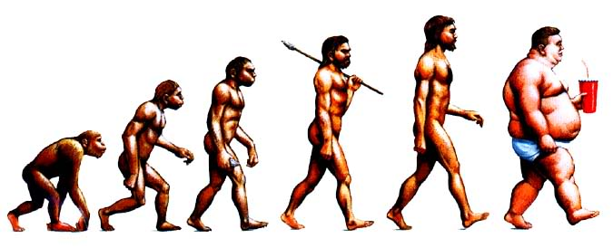

What is the truth about civilization?

Have we really benefited from abandoning our hunter-gatherer roots to embrace cities and agriculture? In embracing complex societies, have we abandoned a much simpler paradise? In this project, we will examine the human animal’s shift to civilizations and what has been lost and gained in the process for different classes of society.

In this project, we will assume the role of anthropologists, ethnographers, and sociologists to be able to answer the Driving Question:

Does the advent of “civilization” signify progress in human history?

After we study the characteristics of hunter-gatherer lifestyle, we will divide into groups to understand the sociological effects of civilization. After we have gathered enough data, each group member will be assigned a role from one of the classes of the 4 river valley civilizations (Mesopotamia, Yellow River Valley, Nile River Valley, Indus River Valley). Once you have your role, you will need to film a “truth booth” that answers the driving question. In answering the question, each character will be making an argument with 3 main points, one of them that addresses and dismisses a counterclaim. Once you are assigned a river valley civilization and a role, your group will film each stratum of society answering the driving question.

Once the films are edited into one unified truth booth, we will have a film festival that will demonstrate the sociological phenomena that resulted from the advent of civilization.

Make sure you:
- Find a quiet, private space, with a clean / empty background.
- Film yourself and others from the middle of the shoulders up.
- Speak into the camera.

Options for Filming:

- FlipCam (Should be steady when filming)
- IPhone Video Recording
- Photobooth
- QuickTime
- Use QuickTime: File: New Movie Recording
- Press the Record Button to pick up sound
- Use iPhone microphone to pick up better sound
- Save as an mP3/4 on your desktop and email it to yourself.

FINAL PRODUCT: When all of your members’ truth booths are complete, edit on iMovie as a group in order to have one unified TRUTH BOOTH. Make sure to:
- Divide up tasks for group members and share the editing
- Pick a title for your project
- Include the title and the names of all participants in the credits (Choose to have either beginning or ending credits)
- Edit your videos seamlessly! (You will have time to do all your editing in class)

Scope of the Project:

- Study the shift from hunter-gatherer societies to complex civilizations
- Research the advantages and disadvantages of complex societies from the perspectives of different roles in a river valley civilization
- Film, Edit, and Publish Truth Booth
- Socratic Seminar
- Essay
 | Monday | Tuesday | Wednesday | Thursday | Friday
Week 1 |  |  |  | 10.24  Entry Event  Aim: What can we expect from our project? | 10.25  Aim: How have humans changed over time?
Week2 | 10.28  Aim: How can we become ethnographers to understand the hunter gatherer lifestyle? | 10.29  Aim: How can we become ethnographers to understand the hunter gatherer lifestyle?  -ethnography  -sociology  Assign Groups  5 groups based on characteristics of civilization | 10.30  Aim: Why was the Neolithic Revolution a turning point? | 10.31  Aim: How can we use a primary source as a way to understand the shift to complex civilizations? | 11.1  Intensives Planning Day
Week 3 | 11.4  Aim: What traits did the River Valley Civilizations share? | 11.5  Election Day | 11.6  Aim: How can we make our thesis for our truth booth? | 11.7  Research | 11.8  Research
Week 4 | 11.11  Veteran’s Day | 11.12  Research | 11.13  Write Truth Booth | 11.14  Film Truth Booth | 11.15  Edit Truth Booth

Truth Booth Rubric

Outcome | Exceeds | Meets | Not Yet
Create  Construct or develop a product for expression. | ____ When all of the members’ truth booths are complete, students edit the footage on iMovie as a group in order to have one unified TRUTH BOOTH.  ____ Films need to have a title, and opening OR closing credits  ____ Presentation/format is exemplary | ____ When all of the members’ truth booths are complete, students edit the footage on iMovie as a group in order to have one unified TRUTH BOOTH.  ____ Films need to have a title, and opening OR closing credits
Argue  Build a case for and defend conclusions reached, based in sound logic and valid evidence. Question and critique the arguments of others as warranted. | ____ Each character from the river valley civilization needs to present an argument in the form of a thesis (debatable opinion+rationale)  ____ Rationale needs to include main points, one of them addressing and dismissing a counterclaim  ____ Arguments demonstrate in depth understanding of civilization being studied | ____ Each character from the river valley civilization needs to present an argument in the form of a thesis (debatable opinion+rationale)  ____ Rationale needs to include main points, one of them addressing and dismissing a counterclaim
Communicate  Make ideas and information understood, mindful of audience, purpose and setting. Listen and respond to what others communicate. | Make ideas and information understood, mindful of audience, purpose and setting.  ____ Truth booth role is completed in character  ____ Student clearly gives argument from character’s perspective | Make ideas and information understood, mindful of audience, purpose and setting.  ____ Truth booth role is completed in character  ____ Student clearly gives argument from character’s perspective
Be Precise  Accurately represents solutions, ideas and language of content | ___ Accurately represents solutions, ideas and language of content  ___ Painstaking detail goes into making Truth Booth as descriptive and analytical as possible | ___ Accurately represents solutions, ideas and language of content

